Visualizing Relationships Between Earthquakes, Volcanoes, and Plate Boundaries in the Western U.S.
Student worksheet
Ruth Powers, UNAVCO Master Teacher-In-Residence; Becca Walker and Shelley Olds, UNAVCO

Overview: How do we know there are different tectonic plates? Which way(s) are the plates moving? How are earthquakes and volcanoes involved? In this activity you will use a web-based mapping tool, EarthScope Voyager Jr., to explore earthquakes and volcanoes in the western United States and study the motion of the Earth’s crust using high-precision GPS data.

Materials:
Computer with Internet access OR the map packet provided by your teacher
Transparency film
Dry erase pens of different colors

Part 1: Prepare your map for study

Starting at www.unavco.org

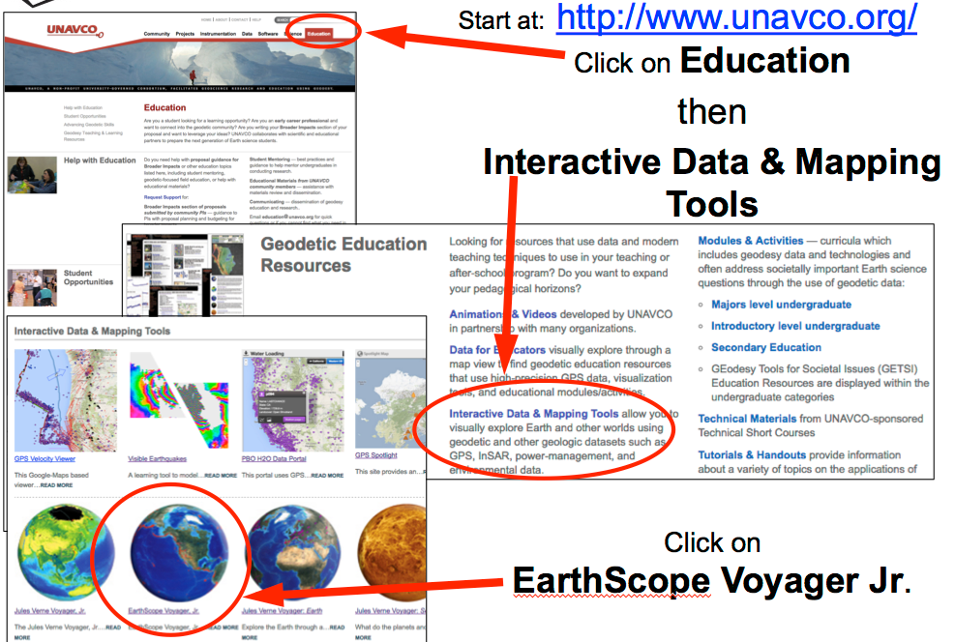

2. Orient yourself to the tool.
Selecting a plate velocity adds observed or modeled velocity vectors in the chosen frame of reference
Clicking one or more features adds them on top of your base map
Selecting a base map provides your base layer
Clicking here turns legend on/off
(hint: you will need to use this)
Clicking here makes changes to your map
Clicking on the teal buttons takes you to a help page
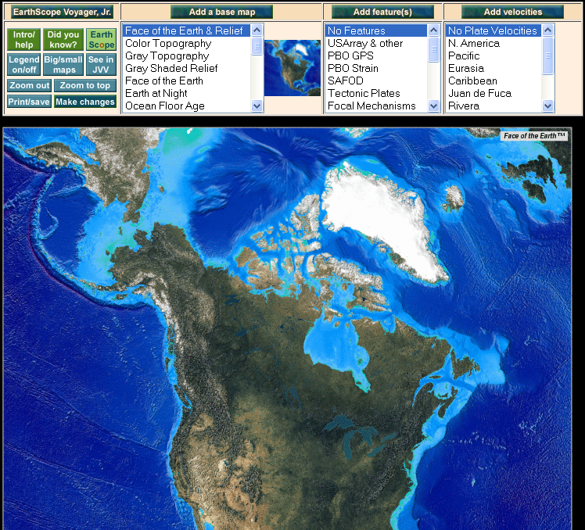

3. Zoom into the Western United States.
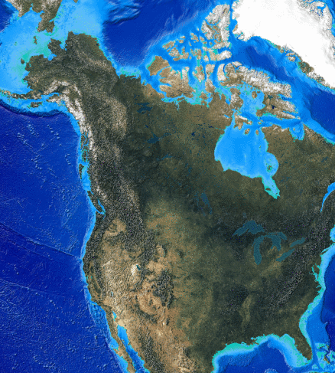
Click the map twice to zoon into Western United States.

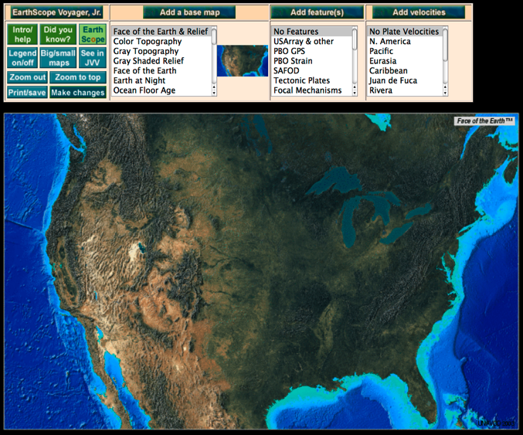

5. Check that the map view matches the map below. The base map should have Face of the Earth & Relief selected.
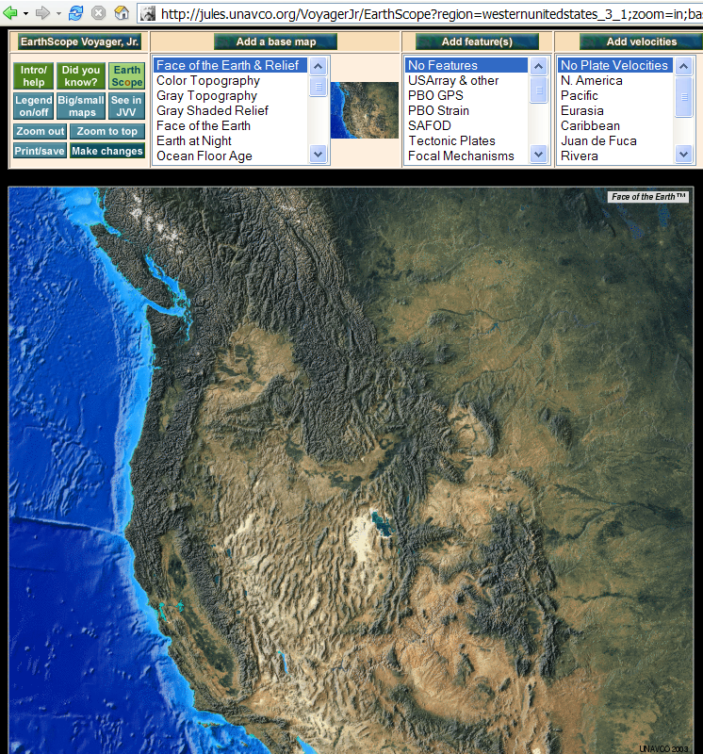

6. Under the Add feature(s) menu, scroll down the list and select Political, Lat/Long.

7. Click the Make changes button. In a few seconds, the map will reload with political boundaries, latitude and longitude lines, and major cities.

Part 2: Compare earthquake and volcano locations

Earthquake Expert go to page 4.

Volcano Expert go to page 5.
Part 2: Compare earthquake and volcano locations

Earthquake expert:
- Scroll down the Add features menu to Earthquakes. Hold the Ctrl key down (on a PC; on a Mac, hold the Command key down) and select Earthquakes. The feature Political, Lat/Long should stay highlighted.
- Click Make changes once. In a few seconds, the map will reload with the locations of earthquakes displayed as dots.
- On your own, study the map and answer the questions below:

Earthquake Data Questions: Examine the earthquake data plotted on the map and notice where earthquakes are located as well as where they are not located.

- How are earthquakes distributed? If there is a pattern, how would you describe it? Where are there no earthquakes? Are they located near the edges of the continents, mid-continent, in the ocean?

- At what depth(s) do the earthquakes occur? (hint: look at the legend)

Go to Map your data on Page 6 when finished.

Part 2: Compare earthquake and volcano locations

Volcano expert:
- Scroll down the Add features menu (hold the Apple key down on Macs) and select Volcanoes. Political, Lat/Long should stay highlighted.
- Click Make changes once. In a few seconds, the map will reload with the locations of volcanoes displayed in red.
- Study the map and fill out the questions below:

Volcano Map Questions: Examine the volcano data plotted on the map and notice where volcanoes are located as well as and where they are not located.

- How are volcanoes distributed? Where are there no volcanoes? Are they located near the edges of the continents, mid-continent, in the ocean?

- If there is a pattern, how would you describe it?

Go to Map your data on Page 6 when finished.

Part 2 (continued)
- Map your data
Using a marker or colored pencil, sketch the general locations of the majority of the volcanoes/earthquakes on this map. You do not need to make individual symbols. Lines or shading of the correct color in the general areas will be sufficient.

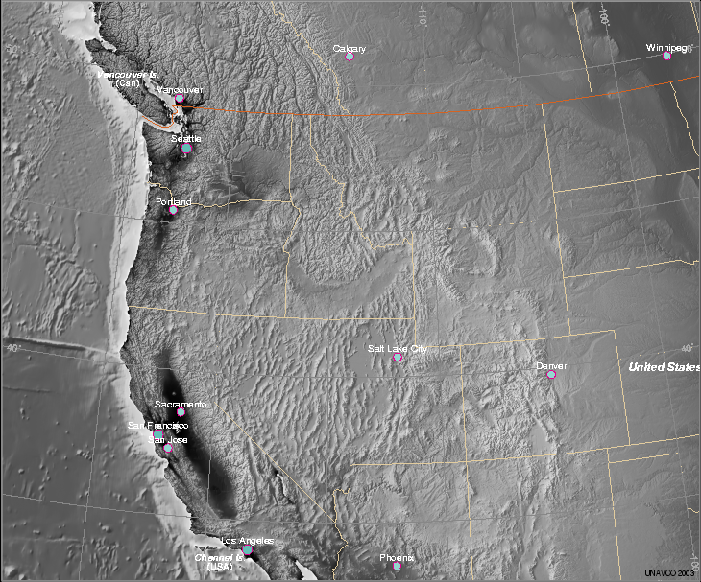

Get together with your teammate and compare your findings. Sketch on your map the locations of the earthquakes and volcanoes from your partner’s map. Compare your data.

- What geographic features (mountains, plains, valleys, etc) are frequently found where there are only: Earthquakes? Volcanoes?

- In which regions do you find earthquakes and volcanoes near each other? Describe the geographic features of these regions.

- Summarize the relationships you discovered. Are the features you looked at (earthquakes and volcanoes) more commonly found together or separate?

- What explanation can you provide for the observed relationships?

Part 3: Examine GPS Vector Data
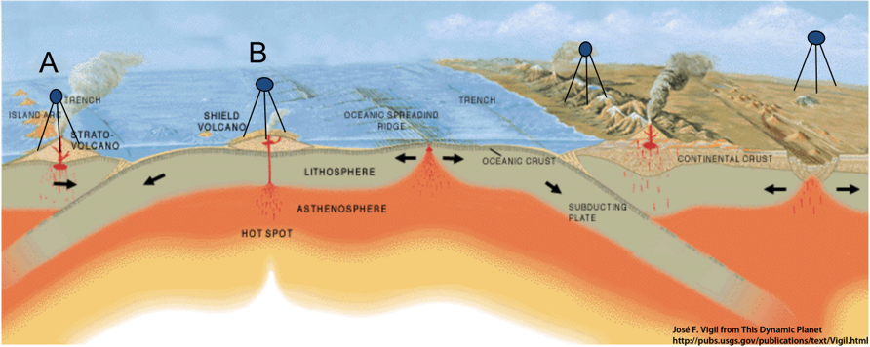

How will GPS Station B’s position change relative to GPS Station A? Draw an arrow showing the direction.

About velocity vectors

A vector is a special kind of arrow that shows the direction and speed of an object. In this case, GPS stations are anchored into rock or deep into soil so we can see how the whole area is moving. If the GPS stations are moving, then the ground is moving.
Each vector arrow originates at a GPS station, and points in the direction that the station is moving. Its length is proportional to the station’s speed (velocity). The longer the arrow, the faster the GPS and ground is moving.

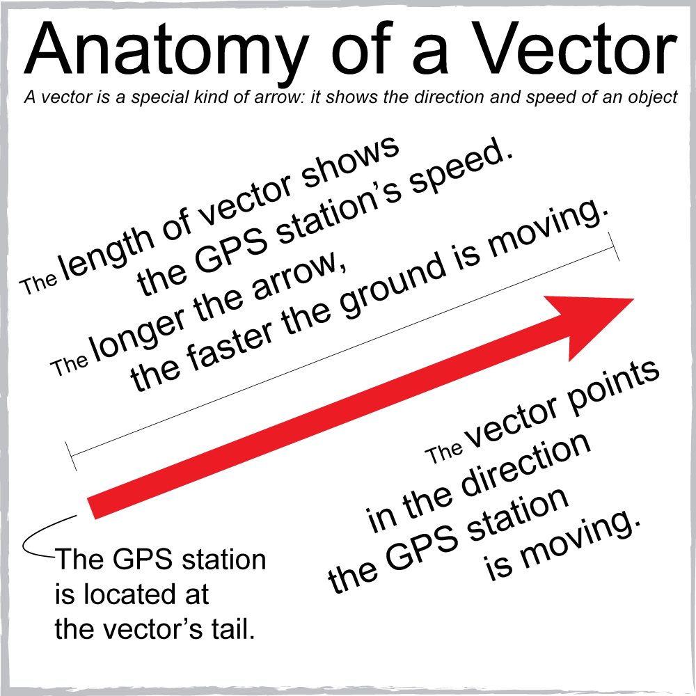
About reference frames
Every tectonic plate on Earth is in motion. Scientists compare the motion of one tectonic plate or region relative to another tectonic plate. In this activity, the vectors displayed on these maps are in the North American Reference Frame - the interior region of North America, such as Kansas and Nebraska is fixed and not moving.
This allows scientists to more easily view the differences in motions on the North American tectonic plate and other adjoining plates, such as the Pacific plate. Sometimes you see surprising and subtle features. For instance, by using the North American reference frame, we can see that the very edge of the North American plate in California, Oregon, Washington, and Alaska is moving.

Return to the EarthScope Voyager Jr. tool and work on your own.
- Under Add Features menu, click Political, Lat/Long and then click on Make Changes. This removes the earthquakes and/or volcanoes icons.
- Under the Add velocities menu, select N. America and Obs (for observed data). Click Make changes once. In a few seconds, the map will reload with plate motion vectors (arrows) in purple.
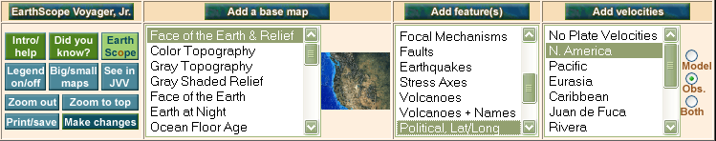

Part 3: Examine GPS Vector Data continued

- Sketch some of the vector arrows on your map on Page 6; click on the map to zoom in and use the zoom out button to zoom out. Pay special attention to what direction the arrows are pointing (e.g. the direction the ground is moving and the lengths of the vector arrow (velocity). Answer the questions and then join your teammate to discuss your answers and come to a consensus on the answers.

- What do you notice about the length of the vectors (the velocities) in the Pacific Northwest compared to those in coastal California? What is the scale for the vectors on this map? What direction(s) do the vectors point in the Pacific Northwest and California? What does this indicate?

- How does the velocity of each GPS station change from the coast to inland California? Why do you think there are many GPS stations (lots of vectors) near the coast of California and not many GPS stations farther inland?

- What other areas do you notice that have differing velocities? What about differing directions? What do you think is happening in these regions to cause these differences?

Part 4: Put it all together
- Create a quick reference to help you determine the type of plate boundary from velocity vectors.
Sketch and describe in the box what motion vectors look like near each plate boundary type from the examples shown in the presentation or by exploring either the Velocity Viewer tool and or Jules Verne Voyager Jr. (turn on modeled data, plate boundaries, and explore!),
Quick Reference:
Convergent Boundary Transform Boundary Divergent Boundary

On your own, return to the EarthScope Voyager Jr. tool.
- Under the Add Velocities area, click on the radio button for model and then click Make Changes. These vectors are modeled from many types of scientific measurements and datasets to create a general vector for each region of a tectonic plate.

- Draw the locations where the vectors are very different from each other on your map on Page 6, (for example places where they are different lengths or directions). [Remember to click on the map to zoom in to view the vectors better and use the zoom out button to zoom out.]

- Collaborate with your teammate to answer the questions below.
- How do the locations where you drew the vectors compare to the locations of earthquakes and volcanoes you already had marked on your map?

- Place an overhead transparency or other clear sheet of film over your map and draw with a dry erase marker where you believe the plate boundaries are located. (Blue = convergent boundaries, yellow = transform boundaries, & red = divergent boundaries). (Or use three different colors and make a legend to describe the colors.)

- Return to EarthScope Voyager, Jr. one more time. On the Features menu, hold the Ctrl key down and select Tectonic Plates and Politicial, Lat/Long and click Make Changes. Compare these boundaries to your drawing on the transparency.

- How close do the boundaries in EarthScope Voyager Jr. match the boundaries that you drew? What boundaries were you able to locate? Were there any boundaries that were shown in the tool that you didn’t draw? What additional information would you have needed for you to be able to draw the other boundaries accurately?

- How would you characterize the width of the plate boundaries on your map? How do they change? Based on your data, which plate boundaries should be shown as a line or a zone? Why?

More questions to think about:
Why does volcanism occur at convergent boundaries but not at transform boundaries?

Relative to the location of the plate boundary, what do you notice about the locations of earthquakes/volcanoes at a subduction zone relative to a transform boundary?

Do you observe a relationship between geographic features and plate boundaries?

Do the patterns that you observed in the Western United States occur worldwide? How would you find the answer?

