Visualizing Data Relationships Between Earthquakes, Volcanoes, and Plate Boundaries in Alaska
Student worksheet
Ruth Powers, UNAVCO Master Teacher-In-Residence; Becca Walker and Shelley Olds, UNAVCO

Overview: How do we know there are different tectonic plates? Which way(s) are the plates moving? How are earthquakes and volcanoes involved? In this activity you will use two web-based mapping tools, EarthScope Voyager Jr. and the GPS Velocity Viewer, to explore earthquakes and volcanoes and study the motion of the Earth’s crust in Alaska.

Materials:
Computer with Internet access or the map packet provided by your teacher
Transparency film
Dry erase pens of different colors

Part 1: Prepare your map for study

Start at UNAVCO’s website: www.unavco.org.

Click on Education Outreach, Interactive Data & Mapping Tools EarthScope Voyager Jr..

Under Add feature(s), scroll down the list and select Political, Lat/Long.
- Click the Make changes button. In a few seconds, the map will reload with political boundaries, latitude and longitude lines, and major cities.

Part 2: Study the earthquake and volcano data

1. Get together with classmates who are studying the same data to become an expert on that topic. Based on your teacher’s instructions, add the earthquake or volcano data to your map.
- Scroll down the Add features menu to Earthquakes or Volcanoes. Hold the Ctrl key down (on a PC; on a Mac, hold the Command key down) and select Earthquakes. Both your data and Political, Lat/Long should stay highlighted. Click on Make Changes.

2. Record your data on the map.
- If you’re using paper maps and transparencies, you’ll want to draw on your map locations of important information by hand.
- Make a key for your map similar to those you see on the legend.
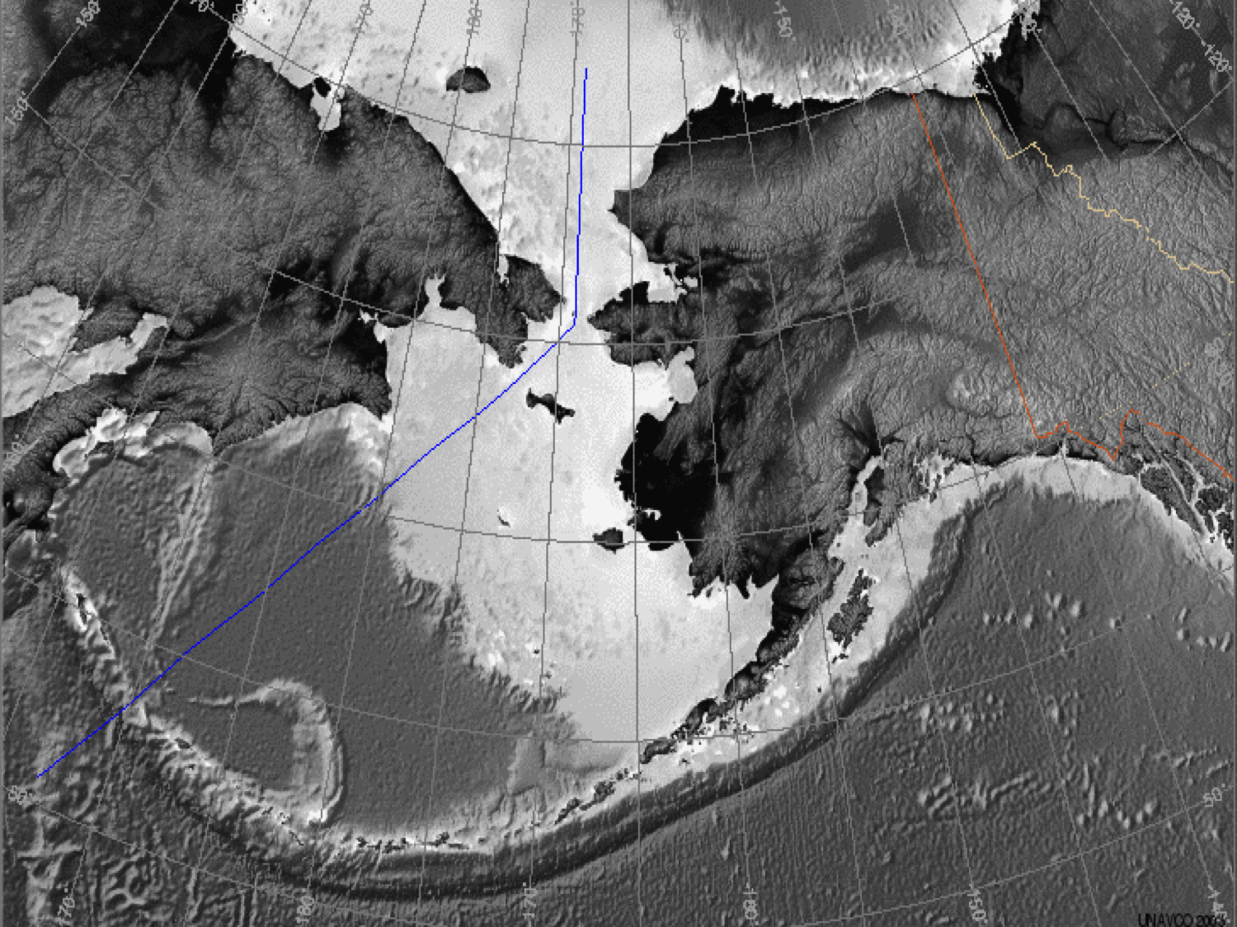
3. Discuss the questions relevant to your team’s data
Earthquake data:
How are earthquakes distributed? Where are there no earthquakes? Are they located near the edges of the continents, mid-continent, in the ocean?

If there is a pattern, how would you describe it? Are there multiple patterns?
At what depth(s) do the earthquakes occur? (hint: look at the legend)?

What other data would help you with your analysis?

Volcano Data
How are volcanoes distributed? Where are there no volcanoes? Are they located near the edges of the continents, mid-continent, in the ocean?

If there is a pattern, how would you describe it? Are there multiple patterns?

What other data would help you with your analysis?

4. Compare the Earthquake and Volcano Data
Get together with someone from the other data team and compare your findings. Sketch on your map the locations of the earthquakes and volcanoes from your partner’s map. Discuss these questions:

- What geographic features (mountains, plains, valleys, islands etc) are frequently found where there are only: Earthquakes? Volcanoes?

- In which regions do you find earthquakes and volcanoes near each other? Describe the geographic features of these regions.

- Summarize the relationships you discovered. Are the features you looked at (earthquakes and volcanoes) more commonly found together or separate?

- What explanation(s) can you provide for the observed relationships?

Part 3: How is Alaska moving over time? Analyzing GPS data

About velocity vectors

A vector is a special kind of arrow that shows the direction and speed of an object. In this case, GPS stations are anchored into rock or deep into soil so we can see how the whole area is moving. If the GPS stations are moving, then the ground is moving.
Each vector arrow originates at a GPS station, and points in the direction that the station is moving. Its length is proportional to the station’s speed (velocity). The longer the arrow, the faster the GPS and ground is moving.

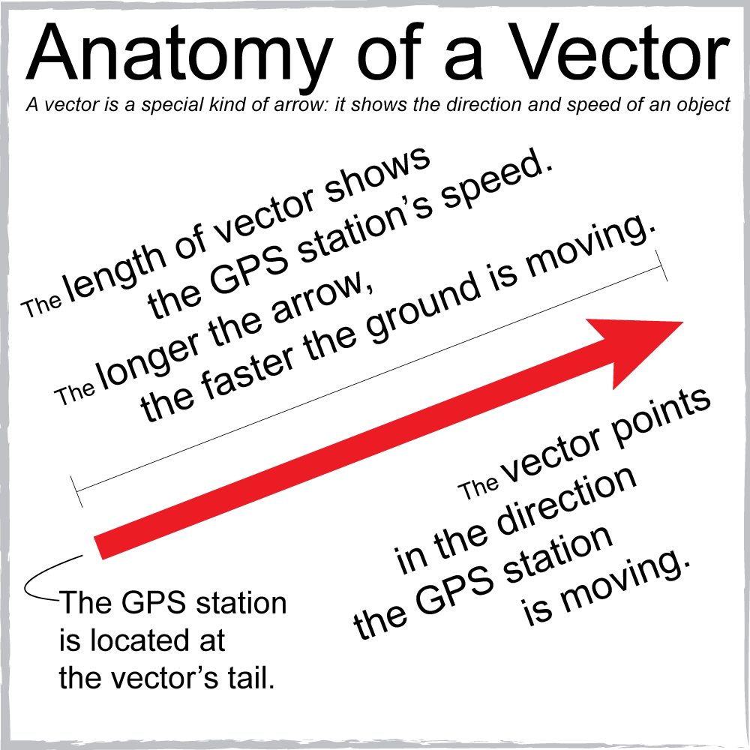
About reference frames
Every tectonic plate on Earth is in motion. Scientists compare the motion of one tectonic plate or region relative to another tectonic plate. In this activity, the vectors displayed on these maps are in the North American Reference Frame - the interior region of North America, such as central Canada and Kansas is not moving.
Reference frames allow scientists to more easily view the differences in motions on the North American tectonic plate and other adjoining plates, such as the Pacific plate. Sometimes you see surprising and subtle features. For instance, by using the North American reference frame, we can see that the very edge of the North American plate in California, Oregon, Washington, and Alaska is moving.

Open the UNAVCO GPS Velocity Viewer in a web browser.
- On UNAVCO’s website www.unavco.org., Click on Education Outreach, Interactive Data & Mapping Tools GPS Velocity Viewer

- Move the map to Alaska. Display all of the GPS stations and vectors, under How many markers displayed Show all

- Sketch some of the vector arrows on your map – Remember to show the scale as well.
  - Zoom in and out to see more details. Pay special attention to what direction the arrows are pointing (e.g. the direction the ground is moving and the lengths of the vector arrow (velocity).
  - Add and remove different data types (earthquakes, volcanoes, faults)

- Discuss these questions with your teammate and come to a consensus on the answers.
- What do you notice about the length of the vectors (the velocities) along the Aleutian Islands? How do the directions change? What landforms are found along the Aleutians?
- What patterns do you see in different regions of Alaska?
- How does the velocity and direction of the GPS stations change from the coast to inland? What other areas have differing velocities or velocities?
- What do you think is happening in these regions to cause these differences?

- How does the ground motion compare to the locations of earthquakes and volcanoes?

- Based on the data you have, sketch where locations of the plate boundaries. (Make a legend to describe the colors.)

- Display the plate boundaries using the Viewer - how close do these match the boundaries you drew? Were there any boundaries you didn’t draw? What additional information would you have needed for you to be able to draw the other boundaries accurately?

- How would you characterize the width of the plate boundaries on your map? How do they change width? Based on your data, which plate boundaries should be shown as a line or a broad zone? Why?

