Exploring plate motion and deformation in California with GPS
Cate Fox-Lent, UNAVCO master teacher; Andy Newman, Georgia Institute of Technology; Shelley Olds, UNAVCO; and revised by Nancy West.
Students explore the transform boundary between the North American and Pacific plates in California using measurements from research-grade Global Positioning Systems (GPS) stations. They learn about GPS, analyze data from stations on either side of the San Andreas fault zone, and then calculate the amount of slip that occurred during the 2004 Parkfield earthquake. As an extension, students can estimate the magnitude of the Parkfield earthquake.
Students will need a general understanding of plate to do this lesson. “Measuring plate motion with GPS” is also good background for this activity.
Topics: Plate tectonics, transform faults, earthquakes, ground deformation, GPS
Objectives: Students will be able to:
Model and describe the general set up of a GPS—how monuments receive signals from multiple satellites;  Interpret time series plots;  Represent time series data as velocity vectors, to scale, on a map;  Add vectors graphically to create a total horizontal velocity vector; | Discuss relative movement of the Pacific and North American plates in California, using GPS data;  Calculate the amount of slip along a fault using GPS time series data; and  Calculate the magnitude of an earthquake based on the slip on a fault (optional).
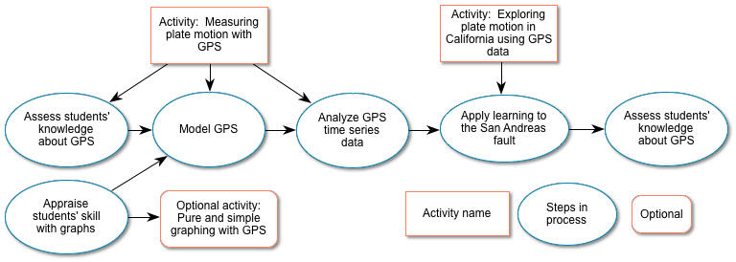
Lesson overview:

Next Generation Science Standards:
Performance Expectations:
MS-ESS2-2: Construct an explanation based on evidence for how geoscience processes have changed Earth’s surface at varying time and spatial scales.
MS-ESS3-2: Analyze and interpret data on natural hazards to forecast future catastrophic events and inform the development of technologies to mitigate their effects.
HS-ESS2-1: Develop a model to illustrate how Earth’s internal and surface processes operate at different spatial and temporal scales to form continental and ocean-floor features.
See Appendix A for related Science and Engineering Practices, Crosscutting Concepts, and Disciplinary Core Ideas from A Framework for K-12 Science Education. Also, Appendix A includes connections to Earth Science Literacy Principles.
Summary: In this activity, your students analyze scientific data to study the motion of the Pacific and North American tectonic plates. From GPS data, students learn that they can detect relative motion between the plates in the San Andreas fault zone--with and without earthquakes. To get to that discovery, they use physical models to understand the architecture of GPS, from satellites to sensitive stations on the ground. They learn to interpret time series data collected by stations (in the spreading regime of Iceland), to cast data as horizontal north-south and east-west vectors, and to add those vectors head-to-tail.
Students then apply their skills and understanding to data in the context of the strike-slip fault zone of a transform plate boundary. They interpret time series plots from an earthquake in Parkfield, CA to calculate resulting slip on the San Andreas fault and (optionally) the earthquake’s magnitude.
Grade Levels: 6 – 12
Teaching Time: Three class sessions (45 - 55 minutes)
Organization: This activity consists of four main parts, the first two coming from a companion activity.
- Modeling GPS stations (or “monuments”) and the satellite network that feeds time signals to the monuments. From “Measuring plate motions with GPS.”
- Making sense of GPS data--understanding time series data in order to develop total horizontal velocity vectors. Also from “Measuring plate motions with GPS.”
- Interpreting the vectors in the context of the strike-slip boundary between the Pacific and North American plates.
- Inferring an earthquake near Parkfield, CA from GPS time series data.

General Procedure: See following pages for specific suggestions and answers to questions.
- Review with your students (briefly) evidence for plate tectonics and the major kinds of tectonic boundaries. Divergent and transform boundaries appear in this lesson.
- Assess your students’ knowledge coming into these lessons. How much do they know about GPS, for instance?
- Work from the PowerPoint presentation “Measuring plate motion with GPS: Introducing GPS to study tectonic plates as they move, twist, and crumple,” as students do the activity.
- Have your students work from the lab sheets for this activity and support them with its PowerPoint presentation, “Exploring plate motion and deformation in California using GPS data.”
- Assess what your students have learned in this lesson.

Materials:
Student lab sheets--one copy per student or per group for “Measuring plate motion with GPS” and this activity, “Exploring plate motion in California with GPS data.”
Computers and a projector
Gumdrops, toothpicks, modeling clay, transparencies
3 ring stands, 3 objects (e.g. Double Bubble gum), string, and 1 gumdrop monument

Before you begin…
Students need a general understanding of plate tectonics for this lesson. Many excellent learning resources are available online covering evidence that support the theory of plate tectonics. Many of these resources take a global view of plate tectonics; this lesson explores how high-precision GPS can be used to measure regional plate movement and deformation.

Teaching tips and general background:
A variety of geologic phenomena including earthquakes, volcanic eruptions, and mountain building occur at plate boundaries, all of which cause the Earth’s surface, the crust, to deform. When deformation occurs, points on Earth’s surface change location (north-south, east-west, up-down). Precise GPS instruments can measure the change in position. Earth scientists use this data to record how much and how quickly Earth’s crust is moving due to plate tectonics and to better understand the underlying processes of the deformation.

When an earthquake occurs, the ground on either side of the fault moves instantaneously, sometimes causing strong shaking. GPS measurements enable scientists to map these displacements and determine how much slip has taken place along the fault and where slip occurred. Although we cannot feel it, the crust on either side of the fault continues to slip after the strong shaking is over, sometimes for several years. Scientists also record this motion with GPS.

Specific Procedures
Start with a brief review of the evidence for plate tectonics. This could include a brief discussion about multiple paths of evidence, such as shared fossil records across multiple continents, the pattern of earthquakes and volcanoes around the world, magnetic reversals in oceanic crust, and how the boundaries of the continents fit together like a puzzle.

Find out what your students already know about GPS. This will help you tailor instruction and will let students see how much they learn. Ask them, for example, how they use GPS and then to sketch or explain how a GPS works. How do they think geologists could use GPS?

Also, assess their skill and comfort with graphs. If they balk at making or interpreting graphs, consider detouring into “Pure and simple graphing of GPS data,” which teaches students to graph scientific data and to interpret graphs. Its first two parts act as a prequel to this, and its last part dovetails with this activity in teaching about velocity vectors.

Open the PowerPoint presentation “Measuring plate motion with GPS: Introducing GPS to study tectonic plates as they move, twist, and crumple.” At slide 8, hand your student lab sheets for that activity. Continue the lesson, moving among the presentation, models, and student lab sheets. (YouTube videos explain specific steps—they are designed for you, not for your students.)

Hand out lab sheets for this activity and open the PowerPoint presentation “Exploring plate motion and deformation in California using GPS data.” Work through slide 6 quickly—this will be review. Help your students as they analyze and interpret data, using the PowerPoint presentation to support them, especially in Part 2. Students should work in pairs. However, with confident and adept students, this activity could be done as homework.

The student lab sheets--with answers--follow. At the end of this section of student pages are suggestions for wrapping up the exercise, ideas for assessment, useful websites, and two appendixes.

Part 1: Analyze real time series data of two GPS stations
Work with a partner to study the data for two GPS monuments, BEMT and SBCC, to determine plate tectonic motion and to complete the questions.
If you have access to the Internet, follow the instructions below. Otherwise, fill in the table below using the time series plots on page 5.
- Start at www.unavco.org and click on the link for Data for Educators. (The direct link is: http://www.unavco.org/edu_outreach/data.html.)
- Move the map (click and drag on the map) until you can see California and then zoom to bring BEMT and SBCC into view. Hint: double click on the ocean near southern California multiple times to zoom in.
- Click on the green balloon with the station name (BEMT or SBCC) and click on the link for PBO Station Page to navigate to the Overview Page about the GPS station.
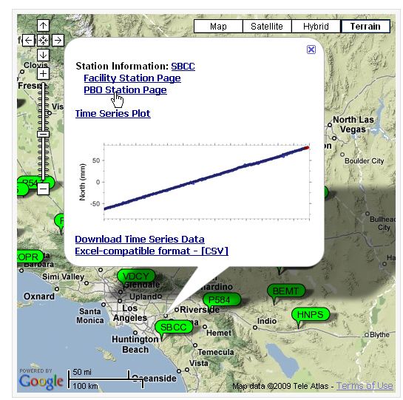
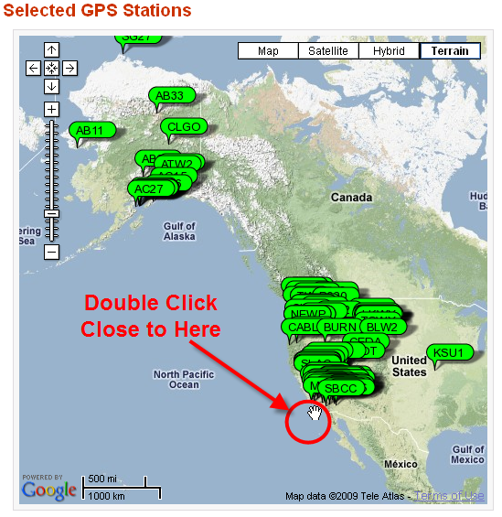

- Use the information provided on the Overview page. Notice that nearby GPS stations are also shown on the station area map.
SBCC  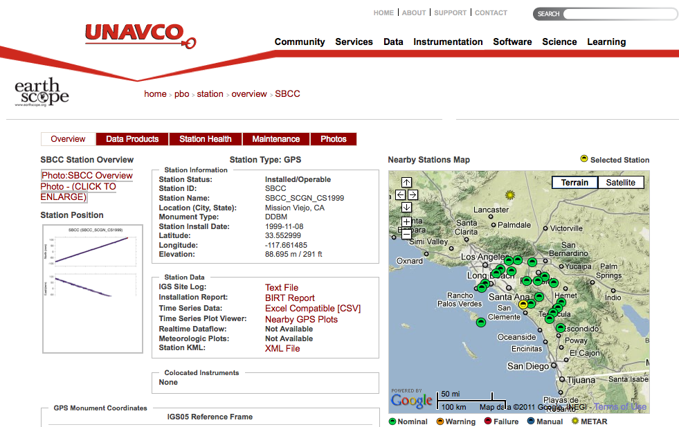 | BEMT  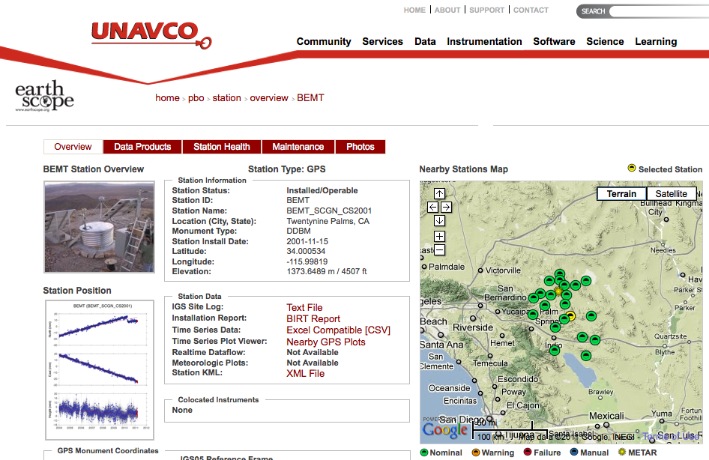
In which city and state is SBCC located?  Mission Viejo, CA  What are the latitude and longitude listed under SNARF Reference Frame (to 3 decimal places)?  33.553, -117.661 (this might vary slightly)  What is the elevation? 88.686 m | In which city and state is BEMT located?  Twentynine Palms, CA  What are the latitude and longitude listed under SNARF Reference Frame (to 3 decimal places)?  34.001, -115.998 (this might vary slightly)  What is the elevation? 1373.649 m

5. Click on the graph below Station Position. Study the plot entitled, “Most Recent Raw Data Times Series Plot”.

6. Calculate the speed of each GPS monument.
(The convention is to use a negative number for velocities to the south or west)
a. SBCC: How far (on average) has the station moved per year? (Calculate the speed over 5 years, and then divide by 5.)  b. SBCC North = Approx 27.3 mm/yr  Moving north or south? North  c. SBCC East = Approx. -26.1 mm/yr  Moving east or west? West  d. Study SBCC’s height (vertical) time series. Examine the trend line (the light red line going through the height data) then describe the motion vertically (up, down, stable):  Overall, the station is moving down.  e. When was SBCC at its highest elevation? How much has the station moved vertically since 2004?  January 2004; Overall, the elevation has dropped about a centimeter since 2004. | a. BEMT: How far (on average) has the station moved? (Calculate the speed over five years, and then divide by 5.)  b. BEMT North = Approx. 4.6 mm/yr  Moving north or south? North  What do you think happened at BEMT?  An earthquake in 2010 shifted the land slightly.  c. BEMT East = Approx. -4.0 mm/yr  Moving east or west? West  d. Study BEMT’s height (vertical) time series. Examine the trend line (the light red line going through the height data) then describe the motion vertically (up, down, stable):  Overall, down  e. When was BEMT at its highest elevation? How much has the station moved vertically since 2004?  January 2004. Overall, the elevation has dropped a few millimeters since 2004.
If you do not have Internet access, use the time series plots below. The dates on these plots will not match the newest plots.
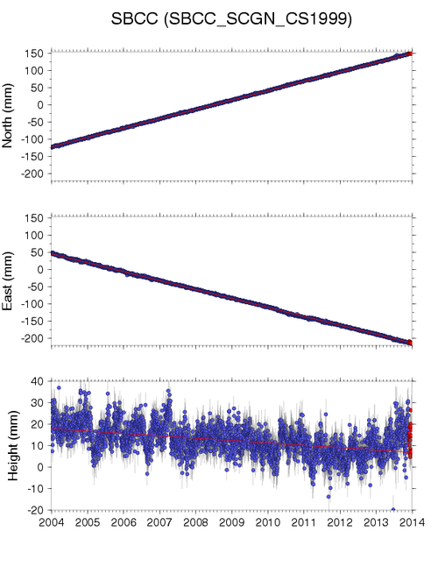 | 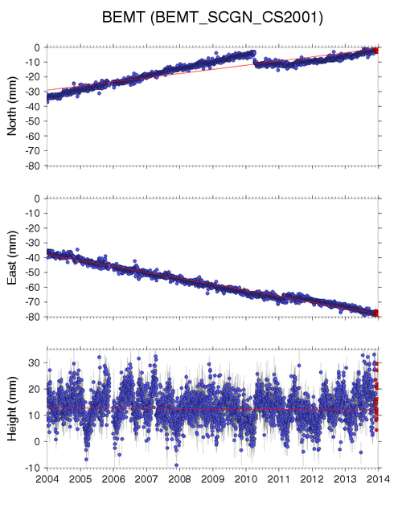

7. Plotting GPS motion on a map grid. On the map grids below:  - Draw a faint arrow to show the annual northward movement | 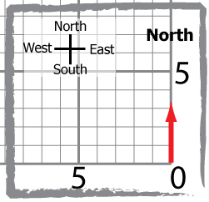
- From the end point of the north arrow, draw an arrow to show the annual eastward motion | 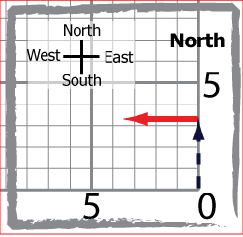
- Draw a diagonal arrow from (0,0) to the end point of the east arrow. This final arrow (vector) shows the overall annual direction and distance of motion of the GPS station and the land beneath it. | 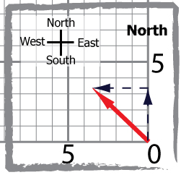
- Mark the length of the diagonal arrow—the total horizontal velocity vector—on a scrap of paper. Measure its length against an axis, where each square represents one millimeter (1 mm).

SBCC  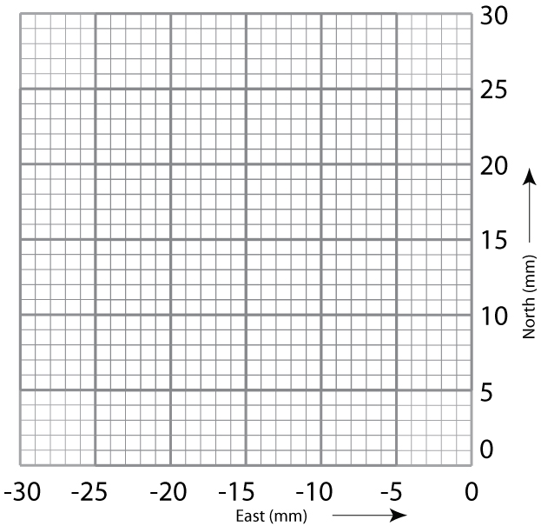  Approx. 38.8 mm/yr | BEMT  Approx. 7.76 mm/yr
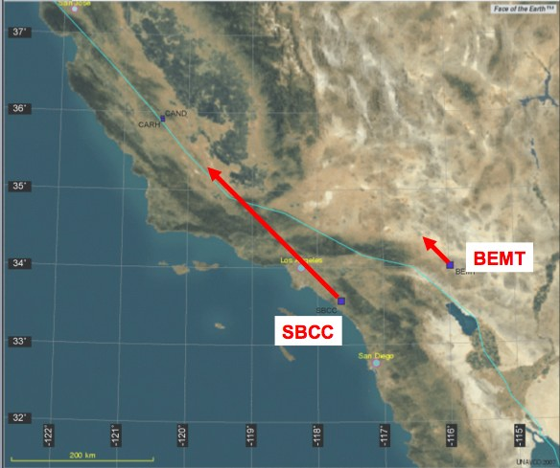
8. Plotting the GPS vectors on a map and analysis. Work with your partner:
- Plot the locations of the GPS stations on the map.
- Draw the vectors for BEMT and SBCC.
- Answer the following questions:

- Describe how the SBCC and BEMT vectors are different and how they are the same. Which station is moving faster?
SBCC and BEMT are moving in the same direction; SBCC is moving about five times faster.
- What would be some reasons for the differences in their rates?
Answers will vary. SBCC and BEMT are on different sides of the San Andreas fault (the light blue line). BEMT is close to the boundary between the Pacific and North American plates and, although on the North American plate, is being “dragged along”—indicating that the boundary is fault zone.
- Remember that the GPS monuments are affixed to the ground, if they are moving, then the ground must be moving.

- In 1000 years, how far has SBCC moved; how far has BEMT moved?
(Rounding to whole numbers) SBCC: 39 mm/yr *1000 years =39,000 millimeters = 39 meters
BEMT: 8 mm/yr * 1000 years = 8000 millimeters = 8 meters

- If the two GPS stations are moving in the same direction, how much farther will SBCC have moved in 1000 years compared to BEMT? Based on what you know about the San Andreas fault, how will this movement occur? All at once?
39 – 8 = 31 meters! Answers will vary and lead to a discussion about earthquakes.

Before turning to Part 2, study the time series plots for GPS monuments CAND and CARH.
What could have caused these two GPS stations to move like this?
An earthquake and post-seismic relaxation of the plate.

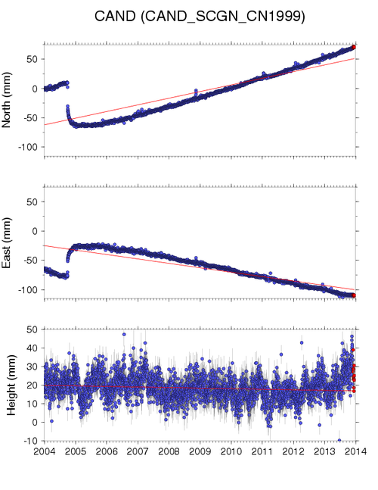
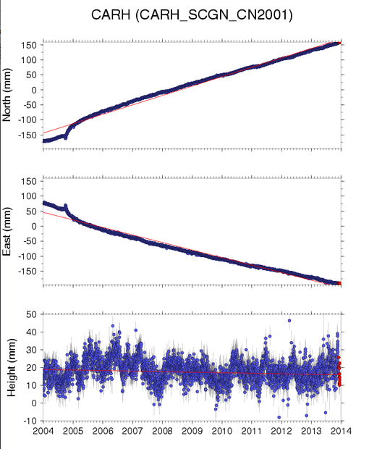

Part 2: Investigate deformation at two GPS stations in California
1. According to the position time series plots, when did the earthquake occur? Use the conversion chart on page 5 to provide the month and year.
Late September, 2004 (September 28, 2004)
2. Using the CAND time series plot, how much did the fault slip during the event?
~ 75 mm south and ~ 60 mm east, resulting in 96 mm combined slip
3. Describe how the CAND GPS station’s position changed during the earthquake.
The stations moved quickly to the southeast and then continued to move south and east for a number of weeks after the earthquake.
4. Describe how the CAND GPS station’s position changed after the earthquake.
CAND (and the surrounding crust) continued to move south and east for weeks after the earthquake and then slowly returned to original northwest movement.
5. Optional: Using the equation provided, which is a simplified estimate for the moment magnitude? What was the magnitude of the Parkfield earthquake based on the slip that you calculated?
M = log₁₀(D) + 6.32  0.9  In which M = magnitude  D = average slip in meters  [1000 mm = 1 meter] | M = log₁₀(.096) + 6.32  0.9  M = 5.9  (According to the USGS, the Parkfield earthquake was a magnitude 6.0 quake.)

Note: Moment magnitude is the most widely used method for calculating the size of an earthquake by seismologists, and is proportional to the energy released by the earthquake. A common misconception is that the Richter scale is still in use, but it has been replaced. The Richter scale was developed only for earthquakes in California within a specific range.
How well does magnitude match the measured magnitude (M = 6.0) of the earthquake?
Answers may vary. The calculation fits very well with the USGS measure magnitude.

More questions to consider
The Parkfield section of the San Andreas fault has not experienced a magnitude 6.0 (or greater) earthquake since the 2004 event, but the North American and Pacific plates continue to grind past each other.

1. Based on the data about the total slip due to the Parkfield earthquake at CAND and CAHR, and the fact that the plate is moving ~17mm/yr at Parkfield, how long should it take to build enough energy to generate an earthquake with a similar magnitude?
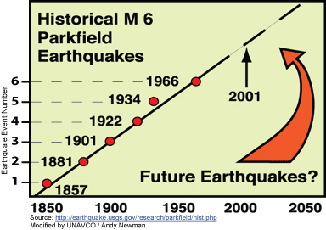
Answers may vary. ~ 96mm of slip during and after the Parkfield earthquake. 96mm / 17 mm per year = ~5.6 years. To learn where the figure of 17 mm/yr came from, see Appendix B.

2. Look at the diagram from the USGS illustrating when earthquakes with magnitudes similar to the 2004 events have occurred along the Parkfield section of the San Andreas fault. How often did these earthquakes occur?
~ every 20 years
3. Does your calculation from question 1 agree with the observed value from questions 2?
No, the calculated number is much lower than the observed one.
4. If you answered “no” to question 3, how could you explain the difference?
There could be many reasons: smaller earthquakes release some of the strain; there could be interaction with nearby faults, etc.

Extension Part 1: Explore more GPS locations near BEMT and SBCC
Teaching tips:
Your students’ lab sheets have larger versions of the time series plots shown below. They are large enough for students to draw best-fit lines through the data and find their slopes. To save time, slide 40 of the presentation shows North and East velocities for the stations from the trend lines (the red lines).
To transfer vectors accurately onto the map on the next page, protractors are helpful. Students can measure the angle between the total velocity vector and the horizontal on the graphs and replicate that angle on their maps. They can also measure the length of the total vector—or mark it on scratch paper to transfer it to the map.
Finally, this extension allows you to incorporate math skills. Students can find the length of the total velocity vector, which is the hypotenuse, with the Pythagorean theorem. Instead of drawing vectors head-to-tail, if your students are taking Geometry (or at the end of some Algebra 1 classes), they can determine the angle the vector makes with the x-axis by calculating its sine or cosine. They need to know the length of the hypotenuse to do this. Remember that the sine is the side opposite the angle divided by the hypotenuse. The cosine is the side adjacent to the angle divided by the hypotenuse. Or, students can use the tangent with just the North and East lengths.
For students:
If time permits, take a look at additional GPS stations near BEMT and SBCC, create velocity vectors for each station, and plot them on the map.
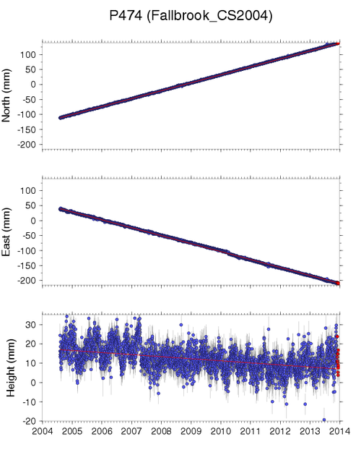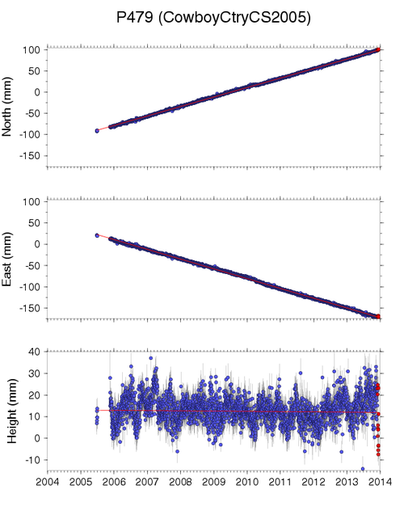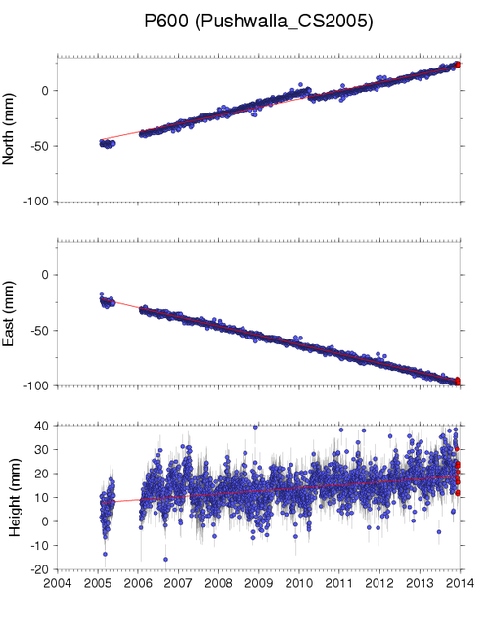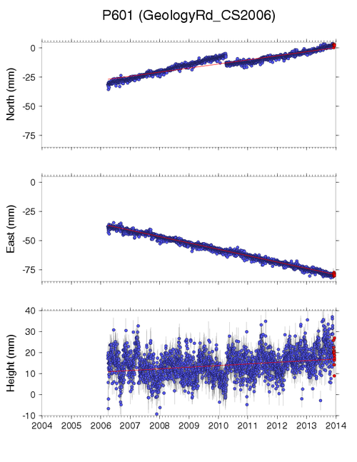
P474 P479 P600 P601
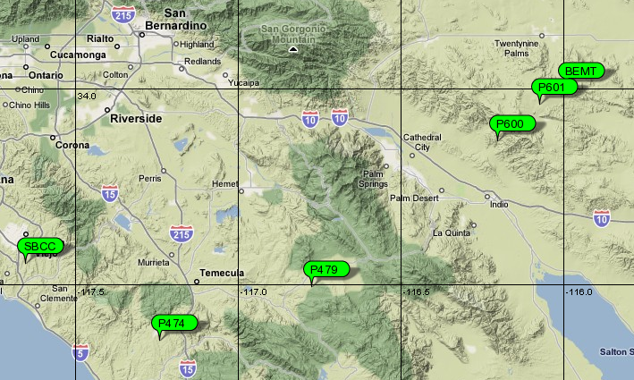

What do you notice about the resulting vectors of these GPS stations? They all point in general the same direction.

How do the velocities at each station change from west to east? They shorten, with a sharp decrease between P470 and P600.

Using these extra stations, where would you place the plate boundary--the San Andreas fault?
Between P470 and P600.
What other types of data might you explore to support your decision for this location?
Answers will vary but might include data from more stations to pin down the location of the fault and seismic data to see the fault defined by epicenters and intensity of shaking.

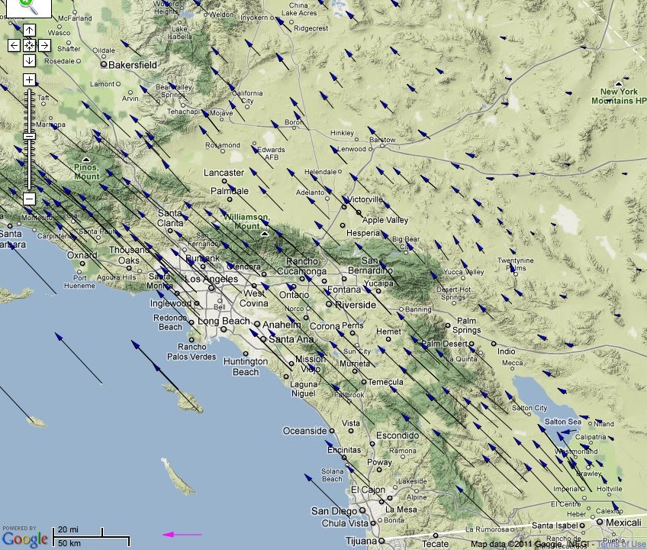
How do your vectors compare to the vectors in the map to the right?
The pattern of longer vectors to the west and short ones to the east is the same. They all point generally to the northwest.

Extension for Part 2: Explore more GPS locations near CAND and CARH
Explore the extent of movement (post-seismic relaxation) after the Parkfield earthquake by looking at additional GPS stations. Look at a few additional GPS stations near CAND and CARH, such as MNMC (located due north of CAND), MASW (located south of CARH), etc.

How to get the data:
One way to find these stations is to go to the overview map for the GPS station CAND on the Data for Educators’ page. (Search for “UNAVCO data educators.”) Zoom to CARH or CAND, click on the PBO Station Page link, and find the other stations on the Nearby Stations Map. To save time, the data is included in a table on slide 42 of the presentation.
What is the total slip for movement at these stations? Do they all show the Parkfield earthquake? Why not?
CRBT, LOWS, and MASW make a transect from west to east towards the fault, and all show slip. CRBT shows only about 15 mm of eastward slip during the event (including the general period of slip, not just during the earthquake September 28th). LOWS slipped about 30 mm northwest and MASW about 75 mm northwest. All are on the Pacific plate. MNMC slipped the opposite direction—about 65 mm to the southeast. It is on the North American plate.
Locate these stations on your map and label them with the 4-character ID (such as MNMC) and the maximum slip that occurred during and after the Parkfield event.
Now look at the intensity shake map from the Parkfield earthquake. You can also study a map made from more than 14,000 reports by citizens who felt the shaking in a program by the U.S. Geological Survey called “Did You Feel It?” (Search for “CISN ShakeMap 2004” and follow the link at the bottom to “Current Parkfield M6.0 ShakeMap.” Search for “DYFI archives” and then “Parkfield California September 2004.”)
What are the similarities and differences between the intensity of the shaking and the map you created?
Answers will vary. The intensity map shows strongest intensity along the fault (perhaps a little greater than VI), with intensity fading to IV about 30 km from the fault. Mountainous areas 10 – 15 km east of the epicenter also had an intensity of about IV. The map from the Did You Feel It site has similar intensities but covers a larger area. They show the same general pattern made by CRBT, LOWS, MASW, and so on.

Assessment: Ask students to summarize the activities they have done. Discuss the connection to plate tectonics and the increasing role GPS is playing in studying current tectonic events. This could be done in writing, as a Think-Pair-Share, in an interactive web project, or as a whole class brainstorming session. This discussion can act as summative assessment; of course you can also grade their lab sheets….
Resources:
"A Strong Earthquake Shakes Central California Fulfilling USGS' Parkfield Forecast," from the Southern California Earthquake Center. (Search for “SCEC Parkfield strong quake.”)
“The Parkfield, California, Earthquake Experiment,” from the U.S. Geological Survey’s Earthquake Hazards Program. (Search for “USGS Parkfield experiment.”) This site links to information about the tectonic setting of Parkfield and records of older earthquakes there.

Appendix A: Relevant excerpts from A Framework for K-12 Science Education as cited in the Next Generation Science Standards and Earth Science Literacy Principles
Science & Engineering Practices in the NGSS:
Developing and using models;
Analyzing and interpreting data;
Using mathematics and computational thinking; and
Constructing explanations (for science) and designing solutions (for engineering).
Crosscutting Concepts:
Patterns; scale, proportion and quantity; Scale, proportion, and quantity; Stability and change. Disciplinary Core Ideas:
ESS2.B: Plate Tectonics and Large-Scale System Interactions: Plate tectonics is the unifying theory that explains the past and current movements of the rocks at Earth’s surface and provides a framework for understanding its geologic history. Plate movements are responsible for most continental and ocean-floor features and for the distribution of most rocks and minerals within Earth’s crust. Maps of ancient land and water patterns, based on investigations of rocks and fossils, make clear how Earth’s plates have moved great distances, collided, and spread apart. [Grade 8]
ESS2.B: The radioactive decay of unstable isotopes continually generates heat energy within Earth’s crust and mantle, providing the primary source of heat that drives mantle convection. Plate tectonics can be viewed as the surface expression of mantle convection. [Grade 12]
ESS3.B: Natural Hazards: Mapping the history of natural hazards in a region, combined with an understanding of related geologic forces can help forecast the locations and likelihoods of future events. [Grade 8]
Earth Science Literacy Principles
Big Idea 1: Data and 1.1 Predict hazards.
Observations Lead to 1.3 Experiment and collect multiple kinds of evidence.
Understanding 1.4 Use indirect measurements.
1.5 Understand the past to forecast the future.
1.7 Advances in technology refine understanding.

Big Idea 2: Ancient Earth 2.7 Change can be gradual or catastrophic.

Big Idea 3: Earth as a System 3.6 Earth’s systems are dynamic.

Big Idea 4: Dynamic Earth 4.1 The geosphere changes.
4.3 Convection drives plate tectonics.
4.4 Tectonic plates move.
4.5 Geologic events happen at plate boundaries.

Big Idea 8: Natural Hazards 8.1 Earth processes can be dangerous.
8.4 Hazards can be sudden or gradual.
8.6 Earth scientists’ predictions are improving.
8.7 Humans’ actions can reduce risk.
8.8 Earth science literacy is vital to reducing risks.

Big Idea 9: Humans’ Impact 9.9 Earth science literacy promotes sound stewardship, policy, and cooperation.

Appendix B:

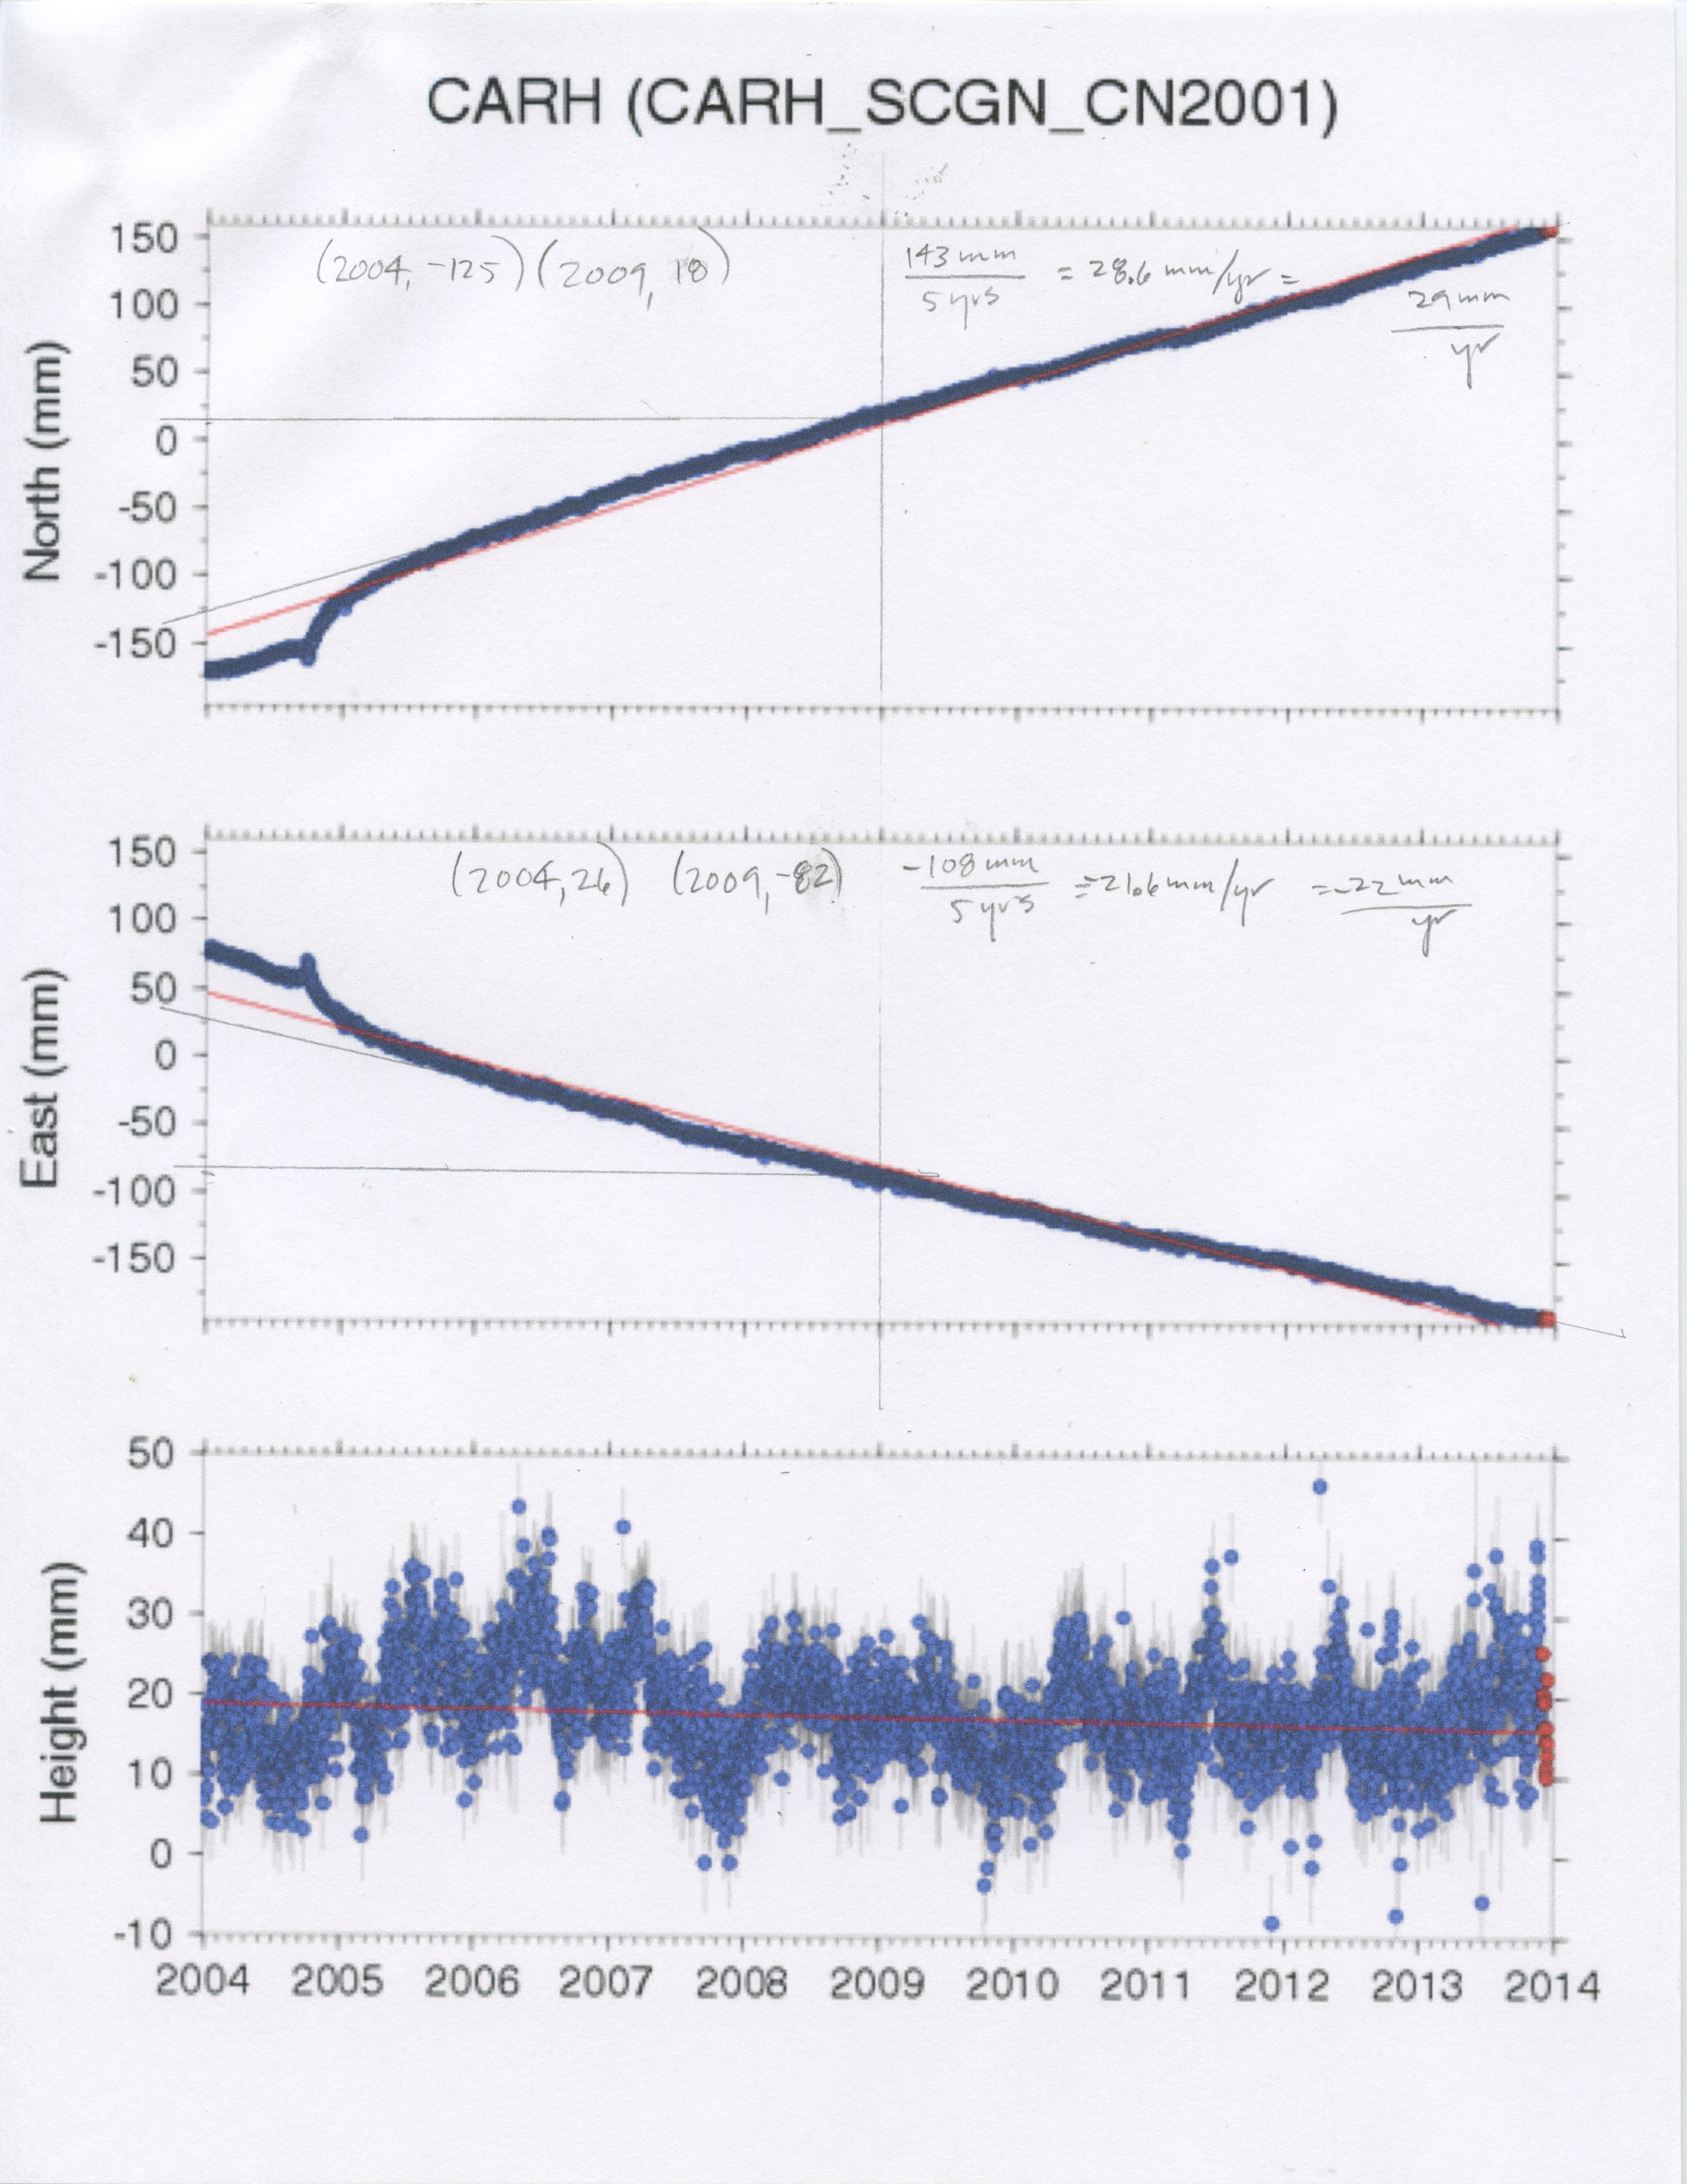
Stations CAND and CARH are moving in about the same direction, to the northwest. However, they are moving at different rates. The net result is that CARH is passing CAND--it is leaving CAND behind at about 17 mm/yr. This result comes from drawing a best-fit line through the post-earthquake data and calculating the slope, as seen in figures 1 and 2.
Figure 1. Finding the velocity of CARH from the slope of the penciled in line that fits the data as strain builds after the 2004 earthquake. The northward motion works out to about 29 mm/yr. The eastward motion is about ⁻22 mm/yr.

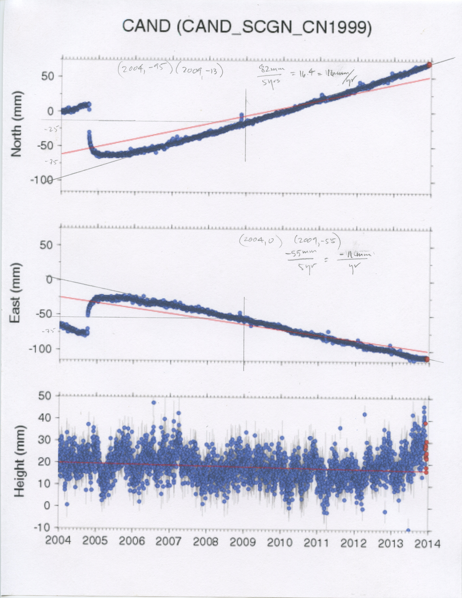
Figure 2. Determining the velocity of CAND. The northward motion works out to about 16 mm/yr. The eastward motion is about ⁻11 mm/yr.

In both cases, you can see that the hand-drawn line through the post-earthquake data has a different slope than the red trend-line calculated by a linear-regression applied to all the data. Rates of movement as strain builds along the fault are:

Station | North | East
CARH | 29 | -22
CAND | 16 | -11

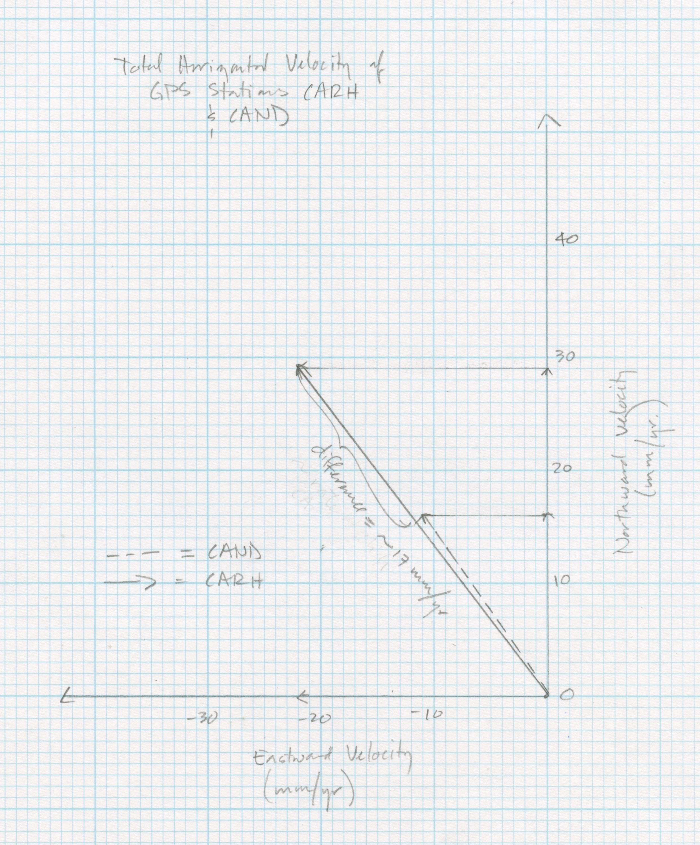
How do their velocities compare? When they are plotted on the same graph (Fig. 3), you can see that the stations have close to the same bearing, but that CARH is faster. The difference between the two speeds is about 17 mm/yr.
Figure 3. A comparison of velocity vectors for CARH and CAND. When CAND 's velocity vector is projected onto the vector for CARH, the difference is about 17 mm/yr.

