Explore Tectonic & Geologic Motions: Alaska
Student worksheet
Are the tectonic plates still moving? How do know? Let’s explore evidence of the plates moving using current GPS data to see how the land beneath your feet is moving, compressing, sliding, and stretching. In this activity, you will study the map on the Tectonics Motions of the Alaska poster to look for evidence of different types of crustal motion then consider the hazards and societal impact that might result due to these motions.
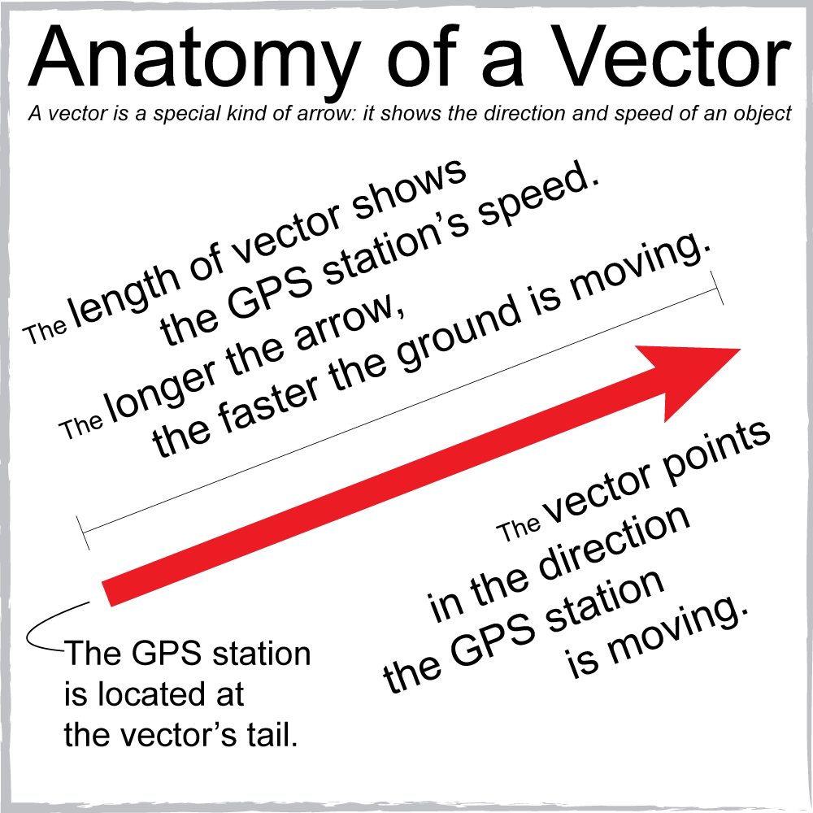
Explore the poster: Tectonic Motions of Alaska
- What do the red and yellow vectors on the map represent?
- What is the scale for the vectors? [Look at the bottom of the map] Using a ruler, measure the vector scale on the map:
- 10 mm/yr = _______ mm
- Draw the vector scale bar, representing 10 mm/yr here:
- What are the yellow lines on the map?
- Choose 2 vectors from the map, measure the length of each. This is the ground’s velocity at that GPS station.
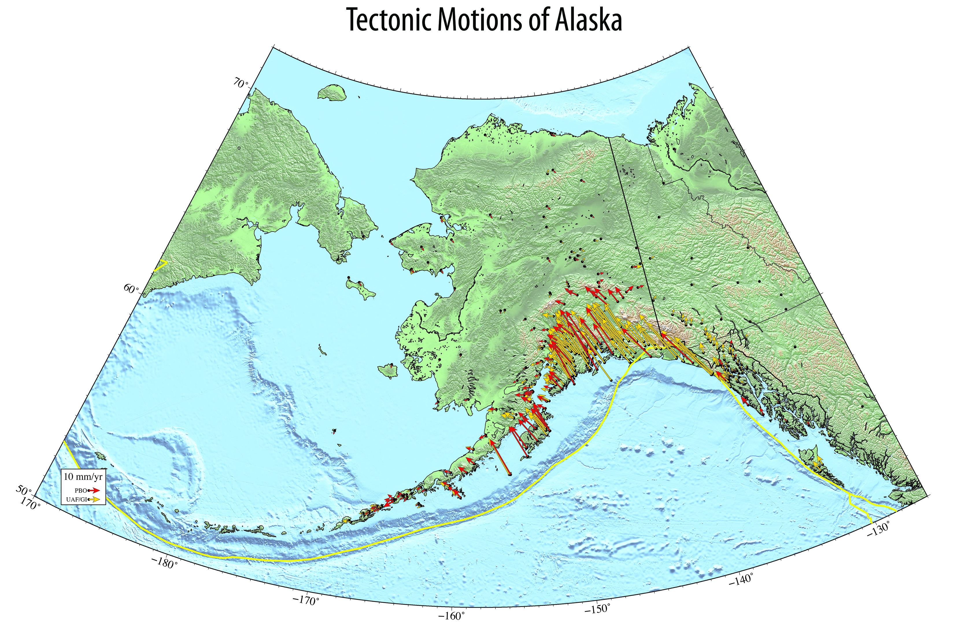
  - Using the vector scale bar, determine their velocities, and label their velocities & directions of motion on the map below.
- Describe the velocities & directions of 2 vectors + circle these vectors on the map where:
- Vectors point in similar direction but have very different lengths (speeds)
- Vectors are pointing different directions from each other
- Gradual changes in length of vector from the coast to inland.
- Across/ near a plate boundary (yellow lines on map)
- Look at the motions on the Aleutian island located at approximately longitude: -165°, latitude: 54°. What is the pattern of the vectors? What geological process could be going on here? Hint: take a look at a detailed map, such as the UNAVCO GPS Velocity Viewer (Google search for UNAVCO GPS Velocity Viewer)
- How is the ground changing shape over time (tens to hundreds of years) and where? Describe the resulting motion of the land in those areas if motion continues to move as it does today.
- What else might happen? What other data would be helpful to find out more about the regional tectonic picture? What types of plate boundaries could evolve over time (convergent, divergent, or transform)?

Societal impacts of plate motion
Identify two locations that you consider most likely to have earthquakes. Why did you choose these areas?

Look at this seismic hazard map of Alaska (Peak Ground Acceleration, 2% in 50 years.) How does the level of seismic hazard on the map compare to the areas you chose?
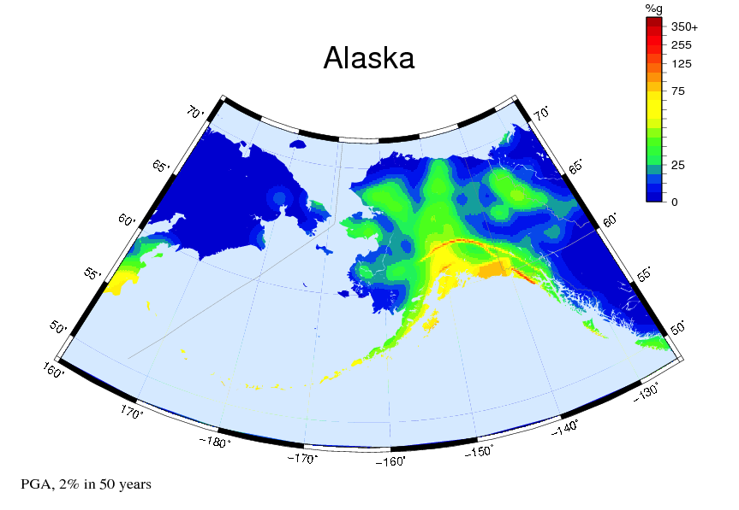

Defend your choices by describing the motions depicted on the map to support why you think these particular places would be more likely to have earthquakes.

Caption: Shaking is expressed as a percentage of gravity. Colors on this map show potential horizontal shaking in Alaska: less intense shaking is shown in shades of blue; more intense shaking shown as yellows and red.

The United States Geological Survey produces National Seismic Hazard Maps for the United States. This map shows peak ground motion that have a 2 percent change of being exceeded in a 50-year period.

Explore more using the online tool, the UNAVCO GPS Velocity Viewer: (Google search for UNAVCO GPS Velocity Viewer)

- Using just the GPS velocity vectors, can you predict the types of plate boundaries in different areas of the world? Zoom* in and out on the map to get different perspectives. (When zooming out to see the world, change the number of vectors displayed to 1 in 40 or 1 in 20.)

- Turn on and off the layers showing earthquakes and volcanoes. Try different GPS/GNSS data sources to change the reference frame or to show modeled data.

- Check your predictions by turning on the plate boundaries layer. What other types of data were useful for understanding the plate motions? How do they complement each other?
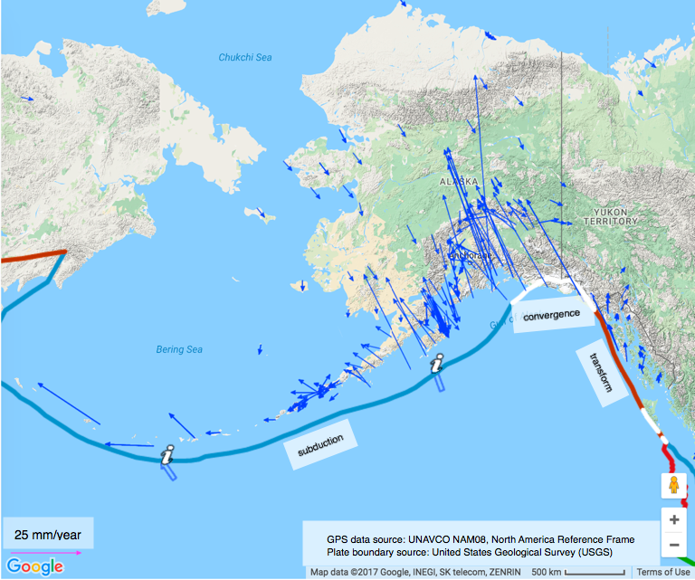
Caption: Map of Alaska using the UNAVCO Velocity Viewer. Ground motion vectors, in blue, are determined by high-precision GPS measurements from the Plate Boundary Observatory network. Plate boundaries published by USGS.

What’s a GPS vector? What are the arrows shown on the poster?

A vector is a special kind of arrow that shows the direction and speed of an object. In this case, GPS stations are anchored into rock or deep into soil so we can see how the whole area is moving. If the GPS stations are moving, then the ground is moving.
Each vector arrow originates at a GPS station, and points in the direction that the station is moving. Its length is proportional to the station’s speed (velocity). The longer the arrow, the faster the GPS and ground is moving.

Note about reference frames:
Every tectonic plate on Earth is in motion. Since every location on the Earth is moving, how do we know how fast a single place is moving? For plate motions, we think of one plate or region as fixed and not moving. We then compare the motions of other places to this fixed place. For example, in this activity, the interior region of North America, such as Kansas and Nebraska is fixed and not moving.
This reference frame, called the North American Reference Frame, shows the motion of the regions of the western United States compared to this fixed region. This allows scientists to view the differences in motions on the North American tectonic plate and other adjoining plates, such as the Pacific plate.

