Engaging your students: Solve the mystery of past earthquakes and tsunamis in Cascadia as a jigsaw: part of Detecting Cascadia’s changing shape with GPS
Nancy West and Shelley Olds

Activity overview
Topics: Plate tectonics, earthquakes, megathrust quakes, subduction crustal deformation, GPS, faulting, folding, and strain
Objectives: students will be able to:

Describe effects of great earthquakes arising from subduction;

Use data to inform decisions.
Education Standards supported: See Appendix A for Next Generation Science Standards, related Science and Engineering Practices, Crosscutting Concepts, and Disciplinary Core Ideas from A Framework for K-12 Science Education. Also, includes connections to Earth Science Literacy Principles.
Grade Levels: 6 – 12
Teaching Time: This activity could be a quick 10 minute engagement activity or used of homework.

Part 1. Engaging your students
Use suggested resources and activities to draw your students into these lessons with videos, images, or an activity with a smartphone or an iPad operating as a seismometer. Capture your students’ interest in Cascadian tectonics, and you’re on the way to a lively—in a good way—classroom. You only need to find the right bait.
We offer several possibilities: a story of discovery from vastly different clues, historical natural disasters, and intriguing applications of technology. Pick and choose among the activities and resources. Suggestions for quickly engaging students close this section.

Engage Option 1: A detective story—as a quick jigsaw activity or via media:
1. Sherlock Holmes could have led the team that pegged the last great earthquake in Cascadia to 9 p.m., Tuesday, January 26, 1700. Your students can have the experience of fitting four clues into a convincing story—of solving a mystery. As a jigsaw activity in which they form teams with “experts” about the clues, you can engage them in the history and future of Cascadia.
Appendix B provides the clues for the students. Summaries of the clues for you, the instructor, follow.
Give your students these clues (Appendix B) and see what they make of them: For ten minutes, give a quarter of your students a different clue to study. Then pull from these groups to make teams with diverse expertise. Ask teams to spend fifteen to twenty minutes reporting what each member has learned and discussing the clues. Can they think of an explanation that ties the pieces together?

Jigsaw A. The corpses. Dead red cedar forests stand in water along Washington and Oregon’s coast—they are “ghost forests.” When and why did they die?
Figure 1. Ghost forest in the Copalis River, WA. Atwater, 2005.

The trees’ deaths were dated two ways. Initially carbon-14 dating of the cellulose yielded death dates between 1695 and 1720. In the 1980s, scientists matched tree ring data from the dead trees against still living brethren (“witnesses”). But, death dates were too old because the tree ring samples came from battered trunks with missing bark. Finally, in 1996, when intriguing stories from Japan about a tsunami in 1700 emerged, scientists sought tree roots with the bark still attached. On eight samples of roots, seven trees died after the 1699 growing season, while one lingered into the next growing season.
Figure 2. Dating trees from their rings. Atwater, 2005.
For a virtual field trip to a ghost forest, visit the Teachers on the Leading Edge site and select the Southwest Washington Coast trip to Copalis Beach. Viewpoint 3 and 4 show ghost forests. You can spin 360 degrees and zoom in on examples of ghost trees. (Search for “TOLE virtual field.”)
Jigsaw B. Eye-witness accounts. Native people’s tales speak of earth shaking and flooding. Some can be loosely dated. For example, Chief Louis Nookmis, was interviewed in 1964, at age 84. “These are stories from my grandfather’s father about events that took place four generations before his time…over 200 years ago…the land shook…a big wave smashed into the beach.” Estimates for the time of the quake and tsunami are between 1640 and 1740. Beyond oral history tied to specific events, the cultural tradition of the Whale and Thunderbird battling tells metaphorically of catastrophic geological events. The tradition appears in stories, artifacts, and paintings on buildings.

Figure 3. Swai'xwe mask from British Columbia representing the shaking from an earthquake and the whirling of wind. Ludwin, et al., 2005.

Jigsaw C. Physical evidence. Coastal sediments have layers of sand and tidal muds lying over soil and vegetation. Some sites have charcoal, hearths, and woven fishing weirs at the soil horizon. Marshy soils and grasses usually lie above the tide or at the upper reaches of a tidal zone. Figure 6, though, shows them below sea level with beach sand covering them. (Marine microscopic organisms in the layer and its pattern of thinning inland indicate it is beach sand.) Muddy bay sediments lie above the sand. Examples of the sand deposits are found from northern Vancouver Island to northern California. In all cases, land must have dropped and been washed over by waves in order for the sand to be deposited. Similar sequences of sand sheets over soils were created by tsunamis after the 1960 Chilean and the 1964 Alaskan earthquakes.

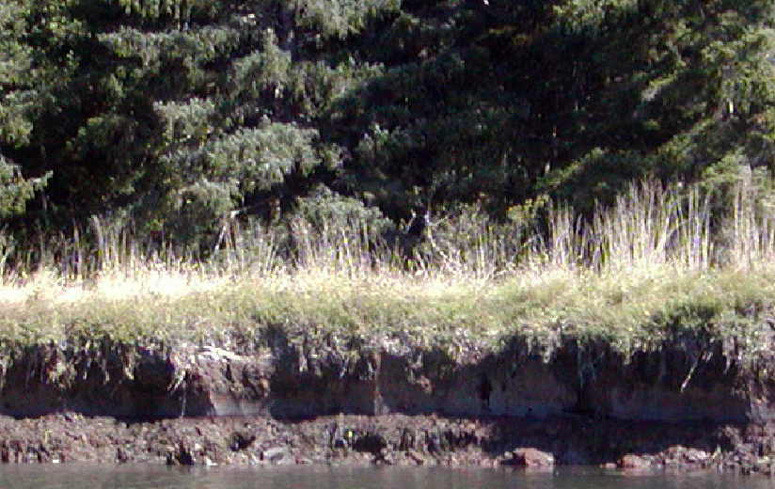
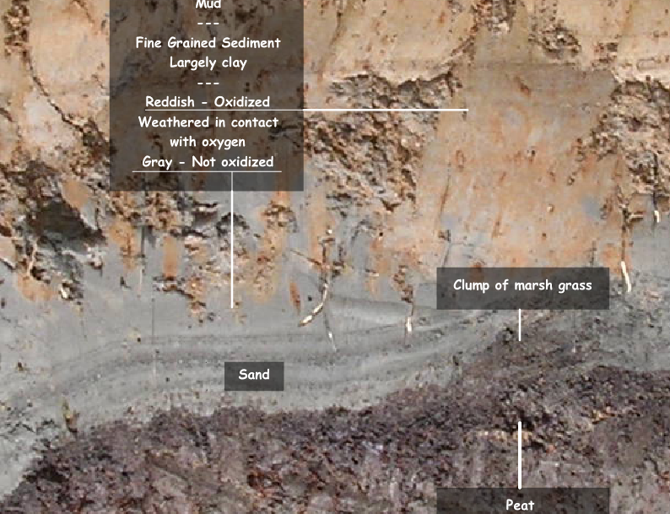
Figure 4. River bank deposits of tsunami sands lying above peaty marsh soils on the Niawiakum River, southwestern Washington. Inset shows the river bank. Granshaw, 2009.

Jigsaw D. Historical records. In Japan, close to 46,000 earthquakes were documented between 416 and 1872. While compiling earthquake records in the 1940’s, Musha Kinkichi, recognized that peculiar flooding occurred simultaneously in two spots. These two records were combined later with documents from several villages mentioning a tsunami or unusual flooding, “something like a high tide” that struck January 27, 1700. The village of Kuwagasaki lost 13 houses destroyed by waves and 20 by fire. Villagers headed to the hills, though, and no one was hurt (Fig. 7). The government stepped in with an emergency allotment of rice for 159 famished people and lumber to build temporary shelters. Elsewhere in coastal Japan, salt-evaporation kilns were damaged; a ship full of rice capsized; and rice paddies, villages, a government storehouse, and a castle’s moat were flooded. Because writers felt no preceding earthquake, they did not know what to make of this “orphan tsunami.”

Figure 7. A diary describing houses swept away by an "orphan tsunami," January, 1700. Atwater, 2005.

Discuss the mystery with your students. You can explain the story that was carefully pieced together by Brian Atwater and colleagues in 2005 of a massive earthquake (M ~ 9) along the Cascadia Subduction Zone (CSZ), triggering a tsunami. From historical and modern earthquake and tsunami records, scientists inferred the source, magnitude, and timing of this most recent Cascadian mega-thrust earthquake. Also, since geoscientists unraveled the mystery of ghost forests and orphan tsunamis, other geoscientists have cored sediments offshore Cascadia and extended and refined the history. In the last 10,000 years, 41 quakes magnitude 8 or greater have occurred.
2. As a shorter introduction, at the end of the jigsaw activity, or for absent students, consider playing a 7:48 piece on National Public Radio’s Morning Edition that featured Atwater. “Unearthing Proof of a Tsunami in the Pacific Northwest” assembles the clues and introduces emergency preparedness. However, it omits mention of Native peoples’ oral histories and traditions. (Search for “NPR tsunami proof.”)
3. The American Museum of Natural History tells the same story in "Ghosts of Tsunamis Past," an on-line article for non-scientists. (Search for “AMNH tsunamis.”)
Resources:
As background for you, watch Atwater explaining how scientists deciphered the 1700 earthquake. Seven YouTube videos cover a lecture Atwater gave as a Distinguished Lecturer for IRIS and the Seismological Society of America. (Search for “YouTube orphan tsunami Atwater.”)
Smithsonian.com covers the story in "Future Shocks." This four-page article is for non-scientists. Because it also discusses risks of movement on other Seattle area faults, which might or might not be tied to the CSZ, this article will be a good read for you but might confuse students. (Search for “Smithsonian future shocks.”)
Engage Option 2: The allure of danger
Earthquakes, some of which produce tsunamis, relieve crustal strain arising from subduction. You could show your students one of the videos that follow in a film fest, as homework in a flipped class, or one a day as a trailer while you wind down your previous unit. The following are vintage film clips or modern simulations of earthquakes and tsunamis. Videos come from the four largest earthquakes ever recorded: Chile in 1960 (M = 9.5), Alaska in 1964 (M = 9.2), Sumatra in 2004 (M = 9.1), and Japan in 2011 (M = 9.0). All spawned devastating tsunamis, and all were subduction zone megathrust earthquakes.
Resources:
A comprehensive video that shows shaking from the Tohoku, Japan 2011 earthquake and its ensuing tsunami. Footage includes the view from a Japanese Coast Guard ship and a view of a wave from the air. Simulations model the rise and fall of seismic waves through Japan as measured by GPS. If you show only one video, show this one from National Geographic’s Environmental News: Rare Video: Japan Tsunami. 3:34. (Search for “environmental news Japan tsunami.”)
Raw destruction from the Japanese tsunami, courtesy of BBC. The tsunami overturns fishing boats and drives one under a bridge while people film the spectacle from high balconies. 1:56. (Search for “BBC moment tsunami.”)
From NOAA, footage of the Japanese tsunami. “Tsunami Strike: Japan Part 1: Destruction.” 2:55. (Search for “tsunami strike destruction.”)
“Japan Earthquake: before and after” -- photos of many locations in Japan, from ABC News. Swipe your mouse over aerial photos to see the effects of the Tohoku earthquake and tsunami. This website is a simple and dramatic way to dig into details of images. (Search for “Japan quake before after photos ABC Australia.”)
Some students will be intrigued by vintage movies. A CBS News video, “Recalling the 1960 Chile Quake,” shows black and white video of the largest earthquake recorded--eleven minutes of shaking and a terrible tsunami. This was made after the 27 February, 2010 quake (M = 8.8). 1:50, plus an advertisement. (Search for “CBS recall Chile quake.”)
“Cataclysm: Volcano, Tidal Waves Devastate Pacific Area,” presents a Universal Studio newsreel from 27 May 1960 of the Chilean earthquake and tsunami. 1:44. (Search for “cataclysm newsreel.”)
A shocking 8 mm movie from a ship in Valdez, Alaska being slammed by shaking, burning, and flooding from the Good Friday, 1964, tsunami. “The Big Picture: Alaskan Earthquake,“ from the Department of Defense. 5:03. (Search for “Alaskan earthquake big picture.”)
Video linking Native American stories with modern research and modeling about tsunamis in Coos Bay and Cannon Beach, Oregon from Cascadia earthquakes. The video by Oregon Public Broadcasting includes clips about designing City Hall in Cannon Beach to shelter people from a tsunami. “Oregon Field Guide: Tsunami.” 10:02. (Search for “Oregon guide tsunami update.”)
AOL.on Education’s “The Great Sumatra-Andaman Earthquake Disaster.” This is a matter-of-fact video chronicling the tragic 2004 tsunami. This video focuses on the tsunami only; footage shows numerous examples of the waves and their effect on people and property. 4:17, with a 30 second advertisement. (Search for “AOL Sumatra earthquake 2004.”)
Engage Option 3: Fresh, high-test technology
The technology that scientists use to document and analyze Earth’s hiccups could engage some students. Ideas for three strands follow.
1. Earthquake early warning systems
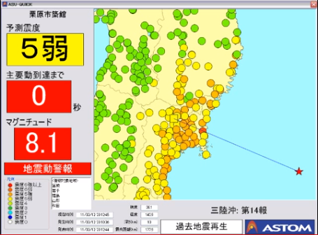
Predicting earthquakes is still in the future. We can, however, detect earthquakes and transmit warnings to people who live away from the epicenter. Japan, for instance, has a system that alerts people via cell-phones, TV, radio, and computers. In the 2011 Tohoku earthquake, citizens in Tokyo had 80 seconds to prepare for the shaking.
You can show your students the warning system in action with a video from TV coverage of the Japanese Parliament as it was interrupted by the early warning system. “Earthquake and Tsunami Alarm Systems of Japan March 11, 2011.” 3:41 (Search for “Japan earthquake tsunami alarm YouTube.”)
After showing the video, ask your students for their ideas about how the earthquake early warning system might work and then how they might devise one using GPS. They can then view the first 2:50 of “GPS and Earthquake Early Warning. "GPS and Earthquake Early Warning." 6:56 total. (Search for “UNAVCO educational resources” and scroll to the video.)
Resources:
“Earthquake early warning in action,” from the American Geophysical Union’s The Trembling Earth blog, explains that early shaking detected by seismometers triggers an alert with estimates of the probable intensity, how long until shaking begins, and magnitude. The signal is transmitted by electromagnetic waves that travel at the speed of light—300,000 km/sec--whereas seismic waves travel a few kilometers per second. Thus, a cell-phone call will reach someone before a P-wave does. (Search for “trembling early warning action Japan.”)
Figure 8. Japan's early warning system in action with the Tohoku quake. Elliott, 2011.
“The USGS and partners work to develop an earthquake early warning system for California” describes benefits of a system and how one is being tested in the ShakeAlert program. Examples of potential benefits are the ability to slow trains, open elevator doors, and halt medical procedures. (Search for “USGS partners warning.”)
Some high-resolution GPS stations deliver data in real-time. When they jump, signals can be processed in about two minutes and a warning sent out. A national program of federal agencies, universities, UNAVCO, and other institutions has created the Real-time Earthquake Analysis for Disaster (READI) Mitigation Network to employ GPS as an earthquake and tsunami warning system. Testing began in April 2012. NBC News.com describes the program in laymen’s language with “NASA tests GPS network to monitor earthquakes” in OurAmazingPlanet. NASA gives more detail with its news release, “NASA tests GPS monitoring system for big U.S. earthquakes.” (Search for “NBC READI NASA” and “NASA GPS earthquake news.”)
2. Simulating, modeling, or animating earthquakes and tsunamis
The power to show large-scale phenomena is one of the beauties of computers. Seeing simulations of Earth events could appeal to students with a penchant for modeling and simulation. An example is a simulation of seismic waves from the Tohoku quake rippling across the United States provided by the Incorporated Research Institutions for Seismology (IRIS). Red dots represent stations rising, blue dots show stations falling. The intensity of the color indicates how high the station rose or how low it fell. (Search for “USArray GMV Honshu.”)
Research GPS stations in Japan provided evidence of the great quake almost instantaneously. This model shows both horizontal and vertical jumps of the land. (Search for “grapenthin Sendai displacements.”)
Scientists use computers to model tsunamis as well. One example is a model of the tsunami generated by the 1960 Chilean earthquake, by Nobuo Shuto of Tohoku University, Japan. NOAA provides a color simulation of the same event. A third example, from the Pacific Tsunami Warning Center, gives another perspective. Students who are animated by computer applications could compare and contrast the three simulations. What makes a simulation effective? Why would you choose one style over another? Which conveys the most information? Which would be fastest (and least expensive) to design? (Search for “modeling 1960 Chile tsunami,” “NOAA Chile animation 1960,” and “PacificTWC Chile animation.”)
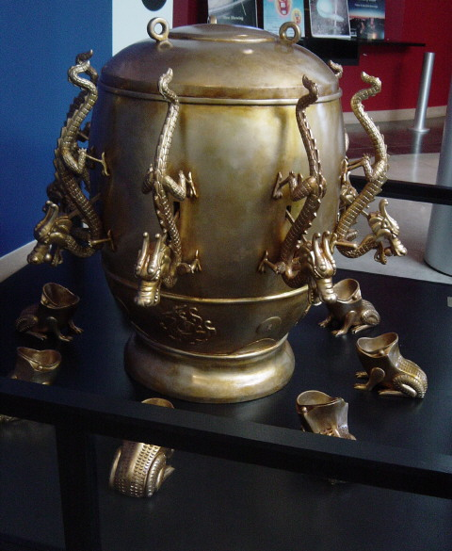
3. Playing with seismometers and citizen science.
Seismometers have evolved since a pendulum knocked a ball into a frog’s mouth (Fig. 9). With the right apps, smart phones and tablet computers can be seismometers. They contain accelerometers that detect motion along the three dimensions of space. If you have an iPhone on a desk with the seismometer app open AND an earthquake occurs, your phone will measure Earth’s motion.
Your students can experiment with these devices. They can lie on the floor with the device on their chest and watch their heart beat. Returning to geology, they can then place the device on a table, rap the tabletop and jostle each side. This will replicate the use of classic sets of three seismographs (Fig. 10) where each instrument measures motion in a single dimension. You will need an app such as iSeismometer or iSeismograph HD.
Figure 9 A replica of a Chinese seismometer from the first century A.D. Shizhao, 2004.
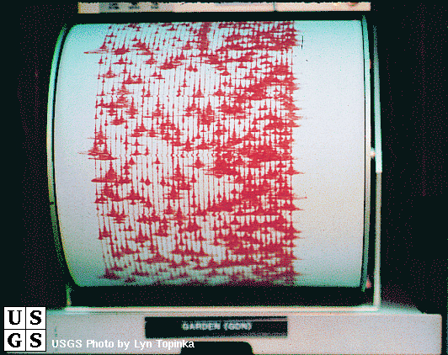
Researchers at the University of California, Berkeley, are working to turn smart phones into a network of seismometers to collect and automatically send shaking and location data to their server. With full development of their app, the information garnered can connect into an early warning system and Geographic Information System (GIS) to analyze soils, building design, proximity to faults, and shaking. All will be critical to hazard and risk analysis…and warning. BBC News explains in “Smartphones to be pocket seismometers” how researchers test apps with a shake table (Fig. 11) as well as their plans for a seismic citizen science project in the Bay Area. (Search for “BBC smartphone seismometer.”)
Figure 10. Old-school seismograph or seismometer. Topinka, date unknown.
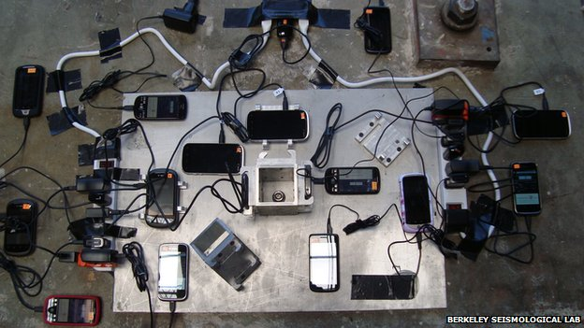

Figure 11. Smartphones being tested as seismometers on a shake table. Amos, 2012.

Engage Option 4: Streamlining this section
Choose among the options: the mystery of ghost forests and orphan tsunamis; drama and danger inherent to subduction zones; or modern technology to captivate your students. Culling the best to limit time spent might be the real challenge. To streamline this introductory engagement phase, choose one or two short videos that will interest your students—perhaps a comprehensive or quirky one. Suggestions are:
- “Unearthing Proof of a Tsunami in the Pacific Northwest.” 7:48. (Search for “NPR tsunami proof.”)
- National Geographic’s Environmental News: Rare Video: Japan Tsunami. 3:34. (Search for “environmental news tsunami.”)
- “Oregon Field Guide: Tsunami.” 10:02. (Search for “Oregon guide tsunami update.”)
- “Cataclysm: Volcano, Tidal Waves Devastate Pacific Area,” 1:44. (Search for “cataclysm Pacific tidal.”)
- And, play with a smart device—their coolness factor engages.

Appendix A: Relevant excerpts from A Framework for K-12 Science Education as cited in the Next Generation Science Standards and Earth Science Literacy Principles

Next Generation Science Standards:
Performance Expectations:
MS-ESS2-2: Construct an explanation based on evidence for how geoscience processes have changed Earth’s surface at varying time and spatial scales.
MS-ESS3-2: Analyze and interpret data on natural hazards to forecast future catastrophic events and inform the development of technologies to mitigate their effects.
HS-ESS1-5: Evaluate evidence of the past and current movements of continental and oceanic crust and the theory of plate tectonics to explain the ages of crustal rocks.
HS-ESS2-1: Develop a model to illustrate how Earth’s internal and surface processes operate at different spatial and temporal scales to form continental and ocean-floor features.
HS-ESS2-3: Develop a model based on evidence of Earth’s interior to describe the cycling of matter by thermal convection.
HS-ESS3-1: Construct an explanation based on evidence for how the availability of natural resources, occurrence of natural hazards, and changes in climate have influenced human activity.
HS-ETS1-3. Evaluate a solution to a complex real-world problem based on prioritized criteria and trade-offs that account for a range of constraints, including cost, safety, reliability, and aesthetics, as well as possible social, cultural, and environmental impacts.

1: Science & Engineering Practices in the NGSS:
4. Analyzing and interpreting data;
5. Using mathematics and computational thinking;
6. Constructing explanations (for science) and designing solutions (for engineering);
7. Engaging in argument from evidence; and
8. Obtaining, evaluating, and communicating information.

2: Crosscutting Concepts:
Patterns: HS-ESS1-5;
Cause and effect: HS-ESS3-1;
Scale, proportion, and quantity: MS-ESS2-2;
Energy and matter: HS-ESS2-3; and
Influence of science, engineering, and technology on society and the natural world: HS ETS1-3.

3: Disciplinary Core Ideas:
ESS1.C: The History of Planet Earth: Tectonic processes continually generate new ocean floor at ridges and destroy old floor at trenches. [Grade 12]
ESS2.B: Plate Tectonics and Large-Scale System Interactions: Plate tectonics is the unifying theory that explains the past and current movements of the rocks at Earth’s surface and provides a framework for understanding its geologic history. Plate movements are responsible for most continental and ocean-floor features and for the distribution of most rocks and minerals within Earth’s crust. Maps of ancient land and water patterns, based on investigations of rocks and fossils, make clear how Earth’s plates have moved great distances, collided, and spread apart. [Grade 8]
ESS3.B: Natural Hazards: Mapping the history of natural hazards in a region, combined with an understanding of related geologic forces can help forecast the locations and likelihoods of future events. [Grade 8]
ESS3.B: Natural Hazards: Natural hazards and other geologic events have shaped the course of human history; [they] have significantly altered the sizes of human populations and have driven human migrations. [Grade 12]
ETS1.B: Developing Possible Solutions: When evaluating solutions, it is important to take into account a range of constraints, including cost, safety, reliability, and aesthetics, and to consider social, cultural, and environmental impacts. [Grade 12]

Earth Science Literacy Principles
Big Idea 1: Data and 1.1 Predict hazards.
Observations Lead to 1.2 Many science disciplines come to bear on Understanding understanding Earth.
1.3 Collect multiple kinds of evidence.
1.4 Use indirect measurements.
1.5 Understand the past to forecast the future.
1.6 Improve data and observations to refine models.
1.7 New technology leads to breakthroughs.

Big Idea 2: Ancient Earth 2.1 Earth’s materials record its history.
2.7 Change can be gradual or catastrophic.

Big Idea 3: Earth as a System 3.2 Energy and matter cycle through Earth’s systems.
3.6 Earth’s systems are dynamic.

Big Idea 4: Dynamic Earth 4.1 The geosphere changes.
4.5 Geology happens at plate boundaries.
4.7 Landscapes evolve, reflecting tectonic processes.

Big Idea 5: Water 5.6 Water shapes landscapes.

Big Idea 7: Earth’s Resources 7.2 Geology determines population centers.

Big Idea 8: Natural Hazards 8.1 Earth processes can be dangerous.
8.2 Hazards shape human history.
8.4 Hazards can be sudden or gradual.
8.5 Local hazardous events can have global effects.
8.6 Earth scientists’ predictions are improving.
8.7 Humans’ actions can reduce risk.
8.8 Earth science literacy is vital to reducing risks.

Big Idea 9: Humans’ Impact 9.9 Earth science literacy promotes sound stewardship, policy, and cooperation.

Appendix B: Jigsaw pieces for Engage Option 1
Jigsaw Piece 1: Ghost Forests in Washington and Oregon

Figure 5. "Ghost forest" in the Copalis River, Washington. Atwater, et al., 2005.

The tree stumps you see in the photo have a story to tell. You could think of them as corpses in a mystery. They provide a clue that you will report to your classmates who are reading other clues. As a group you will try assemble the clues to solve the mystery, a real mystery. Only in 2005 did scientists and historians put together the pieces and figured out what these trees and other information imply. Your job is to explain these “ghost forests.”
The ghost forests are stands of dead western red cedar trees at the Washington coast. While the ones in the picture are in a tidal marsh of the Copalis River, there are other examples in Washington. Western red cedar trees cannot live knee-deep in salty water; the water killed them.
As a detective, what would you try to learn about these corpses?
Would you, for instance, like to know when they died? Scientists figured that out. They used two methods. In the 1980s, they used carbon-14 dating, a method used on objects that contain carbon, including plants, bones, teeth, and archeological objects. This method indicated that the trees died between 1695 and 1720.
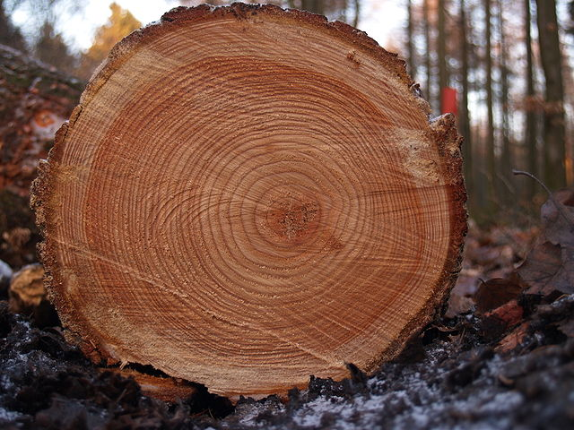
In the second method, researchers compared tree rings from slices of the ghost forest stumps and compared them to living trees in the same area. Fortunately cedar trees on land can live a long time. As trees grow, their diameters expand with alternating light and dark bands. Early in the growing season, new cells are light. Later in the year, they are dark. Especially good growing years yield relatively wide bands. The pattern of narrow and wide bands appears in trees across a region and can be matched from tree to tree.
Figure 6. Tree rings from a freshly cut tree. Arnoldius, 2006.
Here’s how it works. With a living tree, scientists work from the bark to the inside of the tree, looking at the pattern of light and dark bands. As they work inwards through the wood, they go back in time, one ring per year. As you can see in the figure below, you can think of the pattern as a bar code. Scientists match sections of tree ring patterns from ghost and living trees, count the rings on the living trees, and know when the ghost trees died.
Figure 7. Witness trees living above sea level used to date dead trees at or below sea level. Atwater, et al., 2005.
Originally, scientists worked from stumps that had been exposed to the weather for hundreds of years. Some outermost rings had obviously worn off. When they excavated tree roots with the bark still on them (in 1996), they knew they had the entire history of the trees. In seven of eight trees, scientists learned that the trees died after the growing season of 1699. The trees died in the winter of 1700. The eighth tree hung on into the 1700 growing season and then died.
You now know when the trees died. What about why they died? How could forests of trees that live on dry ground end up in salty water at high tide? You’ll discuss this with your teammates—they each have a different clue in this mystery.

Picture credits:
Figure 1. Atwater, Brian F.; Satoko, M.- R.; Kenji, S.; Yoshinobu, T.; Kazue, U.; and Yamaguchi, D.K. 2005. The Orphan Tsunami of 1700. U.S. Geological Survey Professional Paper 1707, p. 16.
Figure 2. Arnoldius. 2006. http://commons.wikimedia.org/wiki/File:Tree_rings.jpg Retrieved 3 October 2013 from Wikimedia Commons.
Figure 3. Atwater, Brian F.; Satoko, M.- R.; Kenji, S.; Yoshinobu, T.; Kazue, U.; and Yamaguchi, D.K. 2005. The Orphan Tsunami of 1700. U.S. Geological Survey Professional Paper 1707, p. 97.

Jigsaw Piece 2: Eye-Witness Accounts
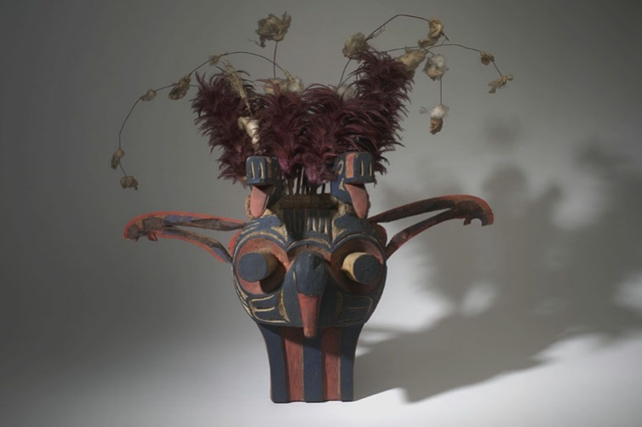

Figure 1. Mask from the Swai’xwe tribe, British Columbia. American Museum of Natural History.

If you danced wearing this mask, the feathers and other dangles on this mask from British Columbia would twitch and flutter along with you. Their motion represents what the artisans who made the mask knew to be their people’s history—a shaking earth and whirling atmosphere. The mask and picture below speak of cultural tradition based on tribal experiences.
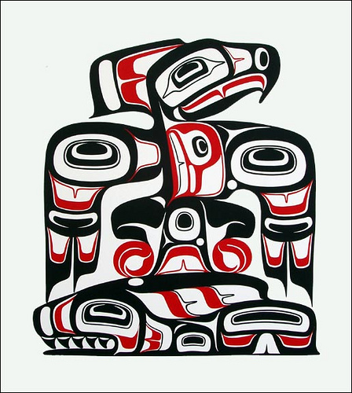
Native people in British Columbia, Washington, Oregon, and northern California have passed stories of massive flooding and ground shaking through generations. For example, Chief Louis Nookmis, was interviewed in 1964, at age 84. “These are stories from my grandfather’s father about events that took place four generations before his time…over 200 years ago…the land shook…a big wave smashed into the beach.” Estimates for the time of the event are between 1640 and 1740. (Ludwin, 2005, p. 142.)
Figure 2. Thunderbird and whale image. Pacific Northwest Seismic Network.
And, “They had practically no way or time to try to save themselves. I think it was at nighttime that the land shook. … I think a big wave smashed into the beach. The Pachena Bay people were lost. … But they who lived at Ma:lts’a:s, “House-up-Against-Hill” the wave did not reach because they were on high ground. … Because of that they came out alive. They did not drift out to sea with the others.” (Ludwin, 2005, p. 142, 143.)
The cultural tradition of battles between the Whale and the Thunderbird tells metaphorically of catastrophic geological events. The tradition appears in stories, artifacts, and paintings on buildings. The thunderbird grabs the whale from the ocean, flies towards his perch, and drops the whale on the ground. In other stories the whale pulls the thunderbird under—the victor and vanquished vary.
A medicine man of the Hoh tribe on the Olympic Peninsula of Washington said (in 1934), “My father also told me that following the killing of this destroyer [the thunderbird? whale?]…there was a great storm and hail and flashes of lightning in the darkened, blackened sky and a great and crashing “thunder-noise” everywhere. He further stated that there were also “a shaking, jumping up and trembling of the earth beneath, and a rolling up of the great waters.” (Ludwin, 2005, p. 144.)
These stories and legends are documented along the coast from Vancouver Island to northern California. However, native peoples from elsewhere do not share these tales.
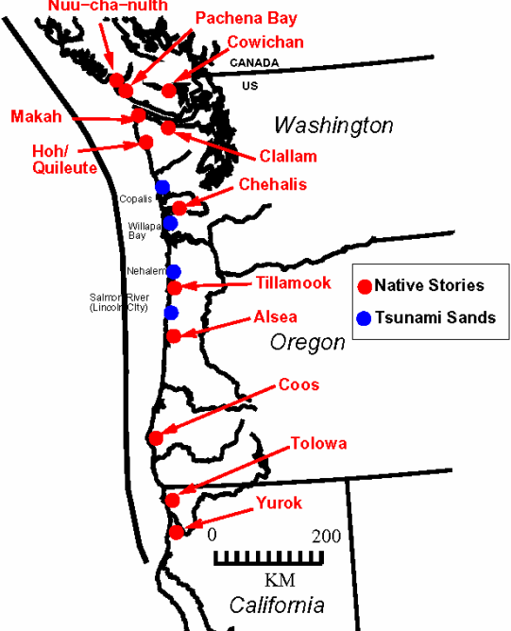

Figure 3. Places with an oral history of earthquakes or tsunamis. Ludwin, 2008.

Some stories refer to earthquake; others to floods, and as you have read, some refer to both. Your task is to pass along the oral history to your team. Let them know that people who lived along the Pacific Northwest coast report catastrophic geological events in their oral history, art, dance, and metaphors.

Picture credits:
Figure 1. Ludwin, Ruth S. 2008. “Pacific Northwest Earthquakes: Evidence in Native Myth and Tradition.” http://www.earthquakeconference.org/Presentations/Ludwin-PNW%20Earthquakes%20Native%20Myth%20and%20Tradition_%20NEC%2008.pdf Retrieved 11 October 2013.
Figure 2. Puget Sound Seismic Network. http://www.pnsn.org/outreach/native-american-stories/thunderbird-and-whale/thunderbird-and-whale-overview Retrieved 11 October 2013.
Figure 3. Ludwin, Ruth S. 2008. “Pacific Northwest Earthquakes: Evidence in Native Myth and Tradition.” http://www.earthquakeconference.org/Presentations/Ludwin-PNW%20Earthquakes%20Native%20Myth%20and%20Tradition_%20NEC%2008.pdf Retrieved 11 October 2013.

Jigsaw Piece 3: Physical Evidence
You will present physical evidence to your teammates in your effort to solve a mystery. Geologists noticed patterns of sediments when they dug along the coast of Washington and Oregon. Only in 2005, did they have enough insight into what caused the patterns to be comfortable publishing their story. Will your team come to the same conclusion?
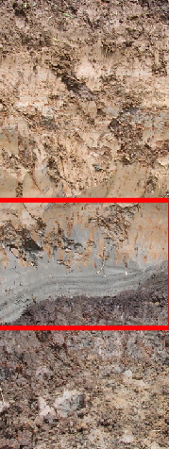
Here are examples of what geologists saw:
Figure 1. Sediments at the Niawiakum River, Washington. Granshaw, 2009.

Figure 2. Geologists dug into this mud and sand bank along the river to see the sediments in Figure 1. Granshaw, 2009.

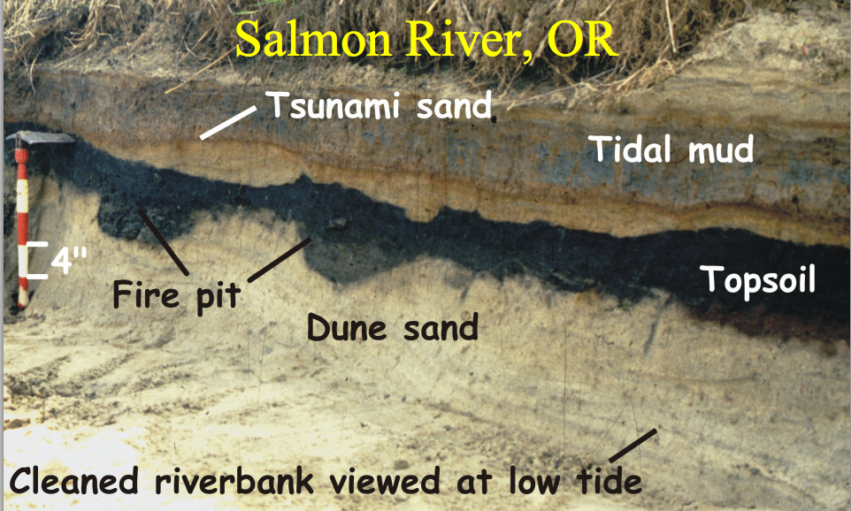
Farther south, this sequence lies along the Salmon River’s bank. Again, there is a dark zone (topsoil) with sand above it, and tidal mud on top. (Where tides sweep in and out, the water often deposits fine, gooey, stinky mud.) Native Americans cooked at this site.
These deposits of mud over sand over soil are found from northern Vancouver Island to northern California. What do they mean? In Chile (in 1960) and Alaska (1964), massive earthquakes occurred, triggering tsunamis that swept across the Pacific Ocean. Tsunamis from earthquakes also swept through Sumatra and Indonesia in 2004 and Japan in 2011.
Figure 3. A riverbank along the Salmon River, Oregon. Ludwin, 2008.

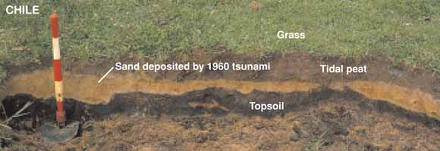
Figure 4 shows sediments from a bank in Chile. Notice the pattern? We know that the sand layer is from the 1960 tsunami. We know that in Chile that the earthquake dropped what had been dry land so that it was underwater and that a tsunami swept across it, depositing sand on top of the soil. Then, tides deposited silt and mud over the sand. We know this because Juan Vera and Maria Silva watched the tsunami cover their field.
Look again at the riverbanks from Washington and Oregon. What do you think they show? And, as a detective solving a mystery, how will you present your evidence?
Figure 8. Tsunami sand covering topsoil from a farm’s field. Near Rio Maullin, Chile. Photographer unknown.
Picture credits:
Figures 1 and 2. Granshaw, F. 2009. Teachers on the Leading Edge workshop. https://media.up.edu/Physics/TOLE/VFEs/a_TOTLE_VFE.swf Retrieved 4 October 2013.
Figure 3. Ludwin, Ruth S. 2008. “Pacific Northwest Earthquakes: Evidence in Native Myth and Tradition.” http://www.earthquakeconference.org/Presentations/Ludwin-PNW%20Earthquakes%20Native%20Myth%20and%20Tradition_%20NEC%2008.pdf Retrieved 11 October 2013.
Figure 4. Unknown. “May1960: Surviving a Tsunami—Lessons from Chile, Hawaii, and Japan.” National Weather Service’s Jetstream—Online School for Weather. http://www.srh.noaa.gov/jetstream/tsunami/survive.htm. Retrieved 15 October 2013.
Jigsaw Piece 4: Historical Records
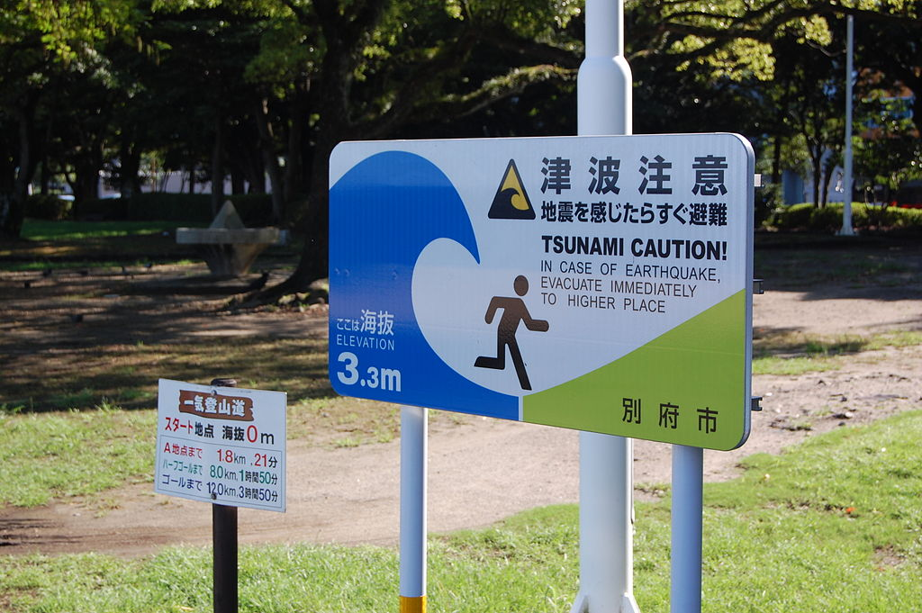
Japanese officials have documented earthquakes and tsunamis since 416 A.D. There were almost 46,000 earthquakes from 416 to 1872. Clearly, Japanese residents know earthquakes, and they know that tsunamis sometimes follow earthquakes. Do you remember the March 11, 2011 massive earthquake (magnitude 9.0) and terrifyingly sudden and deadly tsunami? The pair of events caught the attention of the world, just as a pair did in 2004 in Sumatra; 1964, in Alaska; and 1960 in Chile.
Figure 1. Japanese tsunami evacuation sign. Waterman, 2013.

One Japanese record look like this:
Figure 2. Record from Miyako Bay, Japan. Atwater, et al., 2005.
Read columns downwards, starting on the right side. What is the general gist of this diary entry? It’s an important clue to a mystery you and three classmates will try to solve. You each have very different clues. One has information about corpses, another has eye-witness reports, a third has physical evidence, and you bring history to the table.
The reference to the date of high water translates to January 27, 1700. The villages were all along the coast. Another record says:

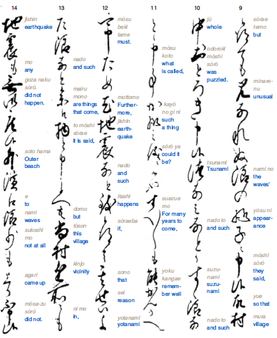

Figure 3. Report from the village of Miho of "something like a very high tide," coming as seven waves. Atwater, et al., 2005.

Reports of tsunamis on this date came from several villages in Japan. The government stepped in with an emergency allotment of rice for 159 famished people and lumber to build temporary shelters. Elsewhere, salt-evaporation kilns were damaged; a ship full of rice capsized; and rice paddies, villages, a government storehouse, and a castle’s moat were flooded. Because writers felt no preceding earthquake, they did not know what to make of this “orphan tsunami.”
We know that earthquakes (and sometimes landslides) cause tsunamis. When an earthquake jars the bottom of the sea along a fault, water is lifted—or dropped—and sets off as a wave that goes around the world. The wave doesn’t seem significant to a ship on the ocean, but it can grow to alarming heights as it hits shore.
As you have read, the Japanese villagers knew to seek high ground after earthquakes. But what if there orphan tsunami happens? How would someone know to climb to safety? Scientists and engineers have developed ocean buoys to detect the long-wavelength waves of tsunamis and can now warn people to leave low ground, now! Japanese road signs send people to safety (Fig. 1.) So do American road signs (Fig. 4).
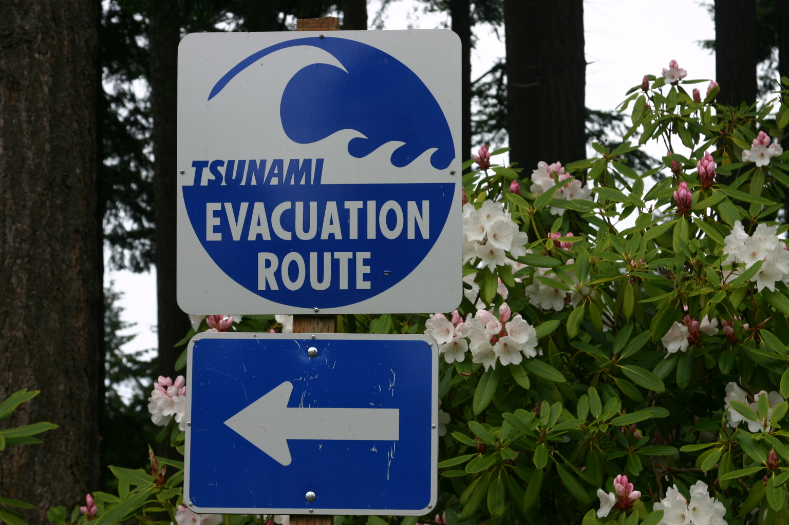
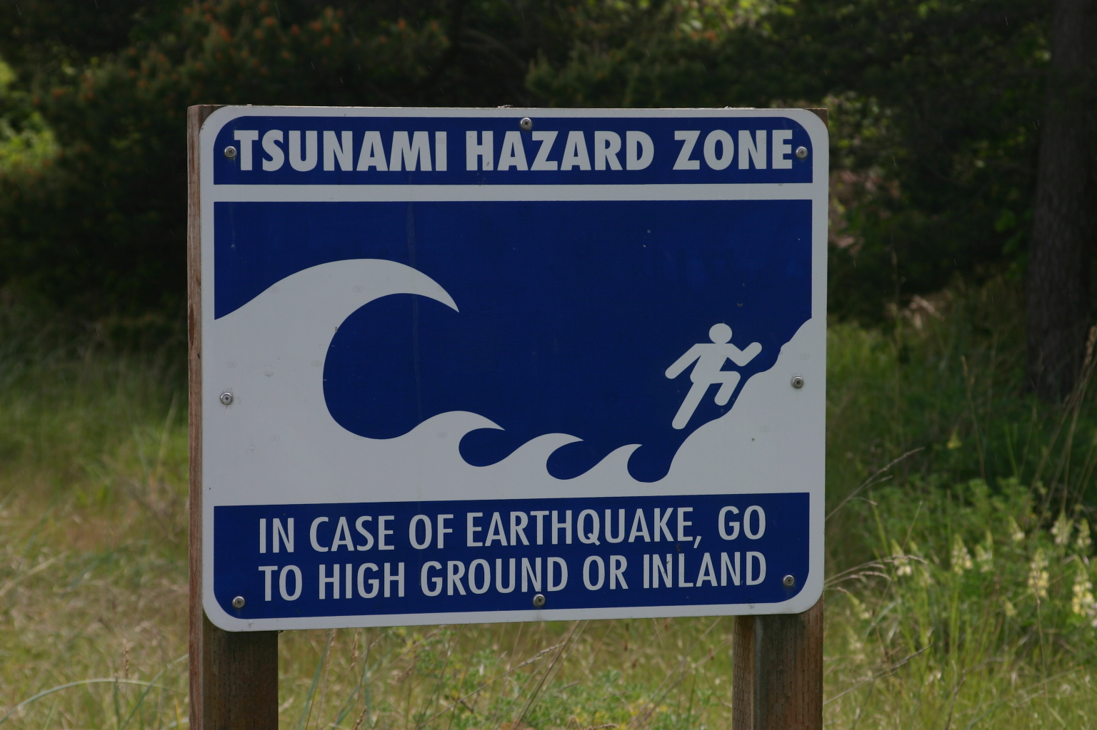
Figure 4. Tsunami warning signs from Fort Worden, Washington. West, 2013.

When you gather with your colleagues to discuss clues, what will you tell them about orphan tsunamis?

Picture credits:
Figure 1. Waterman, Elly. 2013. http://commons.wikimedia.org/wiki/File:Tsunami_waarschuwingsbord_in_Beppu_Japan.JPG via Wikimedia Commons. Retrieved 15 October 2013.
Figure 2. Atwater, Brian F.; Satoko, M.- R.; Kenji, S.; Yoshinobu, T.; Kazue, U.; and Yamaguchi, D.K. 2005. The Orphan Tsunami of 1700. U.S. Geological Survey Professional Paper 1707, p 52.
Figure 3. Atwater, Brian F.; Satoko, M.- R.; Kenji, S.; Yoshinobu, T.; Kazue, U.; and Yamaguchi, D.K. 2005. The Orphan Tsunami of 1700. U.S. Geological Survey Professional Paper 1707, p 78.
Figure 4. West, N. 2013.

Image sources for body of text
Figure 3. Atwater, B. 2005. The Orphan Tsunami of 1700. U.S. Geological Survey Professional Paper 1707, p. 16.
Figure 4. Atwater, B. 2005. The Orphan Tsunami of 1700. U.S. Geological Survey Professional Paper 1707, p. 97.
Figure 5. Ludwin, et al. 2005. “Dating the 1700 Cascadia Earthquake: Great Coastal Earthquakes in Native Stories.” Seismological Research Letters, v. 76, no. 2., pp. 143, figure 3.
Figure 6. Granshaw, F. 2009. Teachers on the Leading Edge workshop. https://media.up.edu/Physics/TOLE/VFEs/a_TOTLE_VFE.swf Retrieved 4 October 2013.
Figure 7. Atwater, B. 2005. The Orphan Tsunami of 1700. U.S. Geological Survey Professional Paper 1707, p. 52.
Figure 8. Elliott, Austin. April 11, 2011. “Earthquake early warning in action,” The Trembling Earth. AGU Blogosphere. http://blogs.agu.org/tremblingearth/2011/04/22/earthquake-early-warning-in-action/ Retrieved 25 September 2013.
Figure 9. Shizhao. 2004. http://en.wikipedia.org/wiki/File:EastHanSeismograph.JPG Retrieved 26 August 2013 from Wikimedia Commons.
Figure 10. Topinka, L. Date unknown. U.S. Geological Survey. Cascades Volcano Observatory. http://vulcan.wr.usgs.gov/Glossary/Seismicity/description_seismic_monitoring.html Retrieved 26 August 2013.
Figure 11. Berkeley Seismological Lab. 2012. In Amos, J. “Smartphones to be pocket seismometers.” BBC News: Science and Environment. http://www.bbc.co.uk/news/science-environment-20531304 Retrieved 26 August 2013.

Sources
Atwater, Brian F.; Satoko, M.- R.; Kenji, S.; Yoshinobu, T.; Kazue, U.; and Yamaguchi, D.K. 2005. The Orphan Tsunami of 1700. U.S. Geological Survey Professional Paper 1707, 133 pp.
Cascadia Region Earthquake Group. 2013. Cascadia Subduction Zone Earthquakes: A magnitude 9.0 earthquake scenario. 30 pp. http://www.crew.org/sites/default/files/cascadia_subduction_scenario_2013.pdf Retrieved 28 January 2014.
English, John and Lyles, R. 2012. “Discovering and Mapping Natrual Hazards with LiDAR.” LiDAR News eMagazine. Vol. 2, issue 2. http://www.lidarnews.com/PDF/LiDARMagazine_Smith_English-MappingNaturalHazards_Vol2No4.pdf Retrieved 31 August 2013.
Goldfinger, Chris; Nelson, C.H.; Morey, A.E.; Johnson, J.E.; Patton, J.R.; Karabanov, E.; Gutierrez-Pastor, J.; Eriksson, A.T.; Gracia, E.; Dunhill, G.; Enkin, R.J.; Dallimore, A.; and Vallier, T. 2012. Turbidite Event History—Methods and Implications for Holocene Paleoseismicity of the Cascadia Subduction Zone. U.G. Geological Survey Professional Paper 1661-F, 170 pp.
Ludwin, Ruth S.; Dennis, R.; Carver, D.; McMillan, A.D.; Losey, R.; Clague, J.; Jonientz-Trisler, C.; Bowechop, J.; Wray, J.; and James, K. 2005 “Dating the 1700 Cascadia Earthquake: Great Coastal Earthquakes in Native Stories.” Seismological Research Letters, v. 76, no. 2., pp 140-148.
Ludwin, Ruth S. 2008. “Pacific Northwest Earthquakes: Evidence in Native Myth and Tradition.” http://www.earthquakeconference.org/Presentations/Ludwin-PNW%20Earthquakes%20Native%20Myth%20and%20Tradition_%20NEC%2008.pdf Retrieved 11 October 2013.

Ludwin, et al.,2005. p 142.

