Determining strain graphically
Nancy West, Beth Pratt-Sitaula, and Shelley Olds, expanded from work by Vince Cronin, Baylor University and Anne Egger, Central Washington University.
We have ample evidence that Earth deforms—deformed rocks, earthquakes, and real-time data from GPS stations. In this activity, students explore the deformation graphically within an area bounded by a triangle of GPS stations. They do it graphically, using a map, velocity data garnered from GPS stations, and graph paper. The activity allows them to pull out the translation component of deformation and to see (literally) crustal distortion within the triangle of stations. The activity can culminate in students using a spreadsheet-based calculator to determine strain quantitatively.
The activity assumes that strain is homogeneous within the triangle. If a fault cuts through the area, then all bets are off, and you can have an interesting conversation with your students.

Instructor’s notes
Materials
Pencils, blue and red pens, graph paper (best if semi-transparent), rulers, drawing compasses, protractors, lab sheets for “Velocity maps” and “Determining strain graphically.” Students will also need access to the Internet for the strain calculator and for data, unless you provide data.

Preparation
We assume students have already learned about strain in rocks from activities in “Physical models” and concepts explained in “Strain—for students.” We also assume that you will want to supply GPS sites for them to explore strain, at least in the first run-through.
You will need to identify three GPS stations that will show something that fits into your content. Consider these sets:
*Strike-slip faulting on the San Andreas fault: P538, P539. P 541.
*Normal faulting along the Wasatch front: P116, P088, and COON.
*Compression, rotation, and episodic tremor and slip in the Cascadia subduction zone: NEAH, P401, and P403.
**Deformation along the Oregon Coast ranges: P395, P396, and P404.
*Used as examples in “GPS strain analysis examples,” with an explanation of how the tectonic setting influences the strain.
**Used as an example for retrieving data from GPS in “Finding location and velocity data for PBO GPS stations.”
Deformation in Oregon’s coastal ranges: CHZZ, P395, and P406. Picked arbitrarily to work the examples shown in Appendix A.
Decide whether students will retrieve the location and mean velocity data (and uncertainty), or whether you will. If you have a robust Internet connection, we suggest that students gather the data, and their lab sheets describe how to do this. “Finding location and velocity data for PBO GPS stations” can act as a reference; it provides a worked example. If your Internet service is dicey, consider providing either the relevant web pages on paper or the location and mean velocity data for them. (Search for “UNAVCO strain module materials.”)
Prepare a map with grids centered on the GPS sites (see “Velocity maps—Instructor notes.”) Paste it into “Velocity maps” and make a copy for each student. The exercise teaches students to add north-south and east-west vectors and to solve for the total horizontal velocity. They can solve for the velocity by measuring the length, using the Pythagorean Theorem, or both.
Plan your discussion about what the three vectors for total velocity mean collectively. If students worked with the stretchy tee-shirt (“Physical models”), you can remind them of that experience and even have them demonstrate with the tee-shirt what the vectors imply. You can also have them imagine the vectors representing three cars moving relative to each other.

Graphical analysis
Refer to the presentation "Using velocities from a triangle of GPS sites to investigate crustal strain" if you would like to bolster your own knowledge.
The students’ instructions lead them to determine deformation, including strain. They will calculate and show translation by finding the center (“centroid”) of a triangle of GPS sites and seeing how the centroid moved over time. They also explore strain within the triangle.
- Students create total horizontal velocity vectors by doing the activity “Velocity maps,” and they plot the vectors on their maps. (It can be a stand-alone exercise as well, or better yet, homework.) On graph paper stacked over their map, they mark the ends of their total horizontal velocity vectors, thereby making a new triangle showing deformation.
- By moving the center (centroid) of the deformed triangle so that it stacks directly above the center of the original triangle, they remove the translation component of deformation. Then by poking pinholes through the vertices of the deformed triangle into the map, they see the strain. If any internal stretching, compressing, rotation, and twisting have occurred, the pinholes don’t go through the original GPS locations.
- Students can enter location and velocity data into the strain calculator spreadsheet to quantify the strain. The spreadsheet calculates the length of the principal strain axes and the rotation. Students draw in the axes, using the azimuth for the orientation. "Explanation of Strain Calculator Output Data" expands on the meaning of the results.
- Although the calculator is a black box, many high school students have learned matrix algebra, and this shows them how it is used—in science, in a field that concerns itself with earthquakes and natural hazards. Advanced math students might enjoy looking at "Algorithm for computing infinitesimal strain rate between three non-colinear GPS stations, given their N-S and E-W velocities, with a worked example." This article explains the matrix algebra behind the calculator. And, students who enjoy computer programming might want to try writing the code in Matlab or Mathematica. They can check their results against the Excel version.

Making sense of the results
This activity morphs GPS time-series data into triangles that move and change shape in measureable ways. They are miniscule changes – millimeters spread across tens of kilometers. (Be sure to discuss the distances between stations; students might have determined it in “Velocity maps.”) However, when the changes occur over decades or centuries, strain builds to the point that the crust breaks. As an adjunct to this exercise, students can explore the recent earthquake history of the area they’re studying. (Search for “earthquake Google Earth”). They can also compare their results to faults younger than 1.6 million years old. These are listed in the USGS Earthquake Hazards program for Quaternary faults. (Search for “Quaternary faults Google Earth.”) How cool is this???!!!!

Appendix A
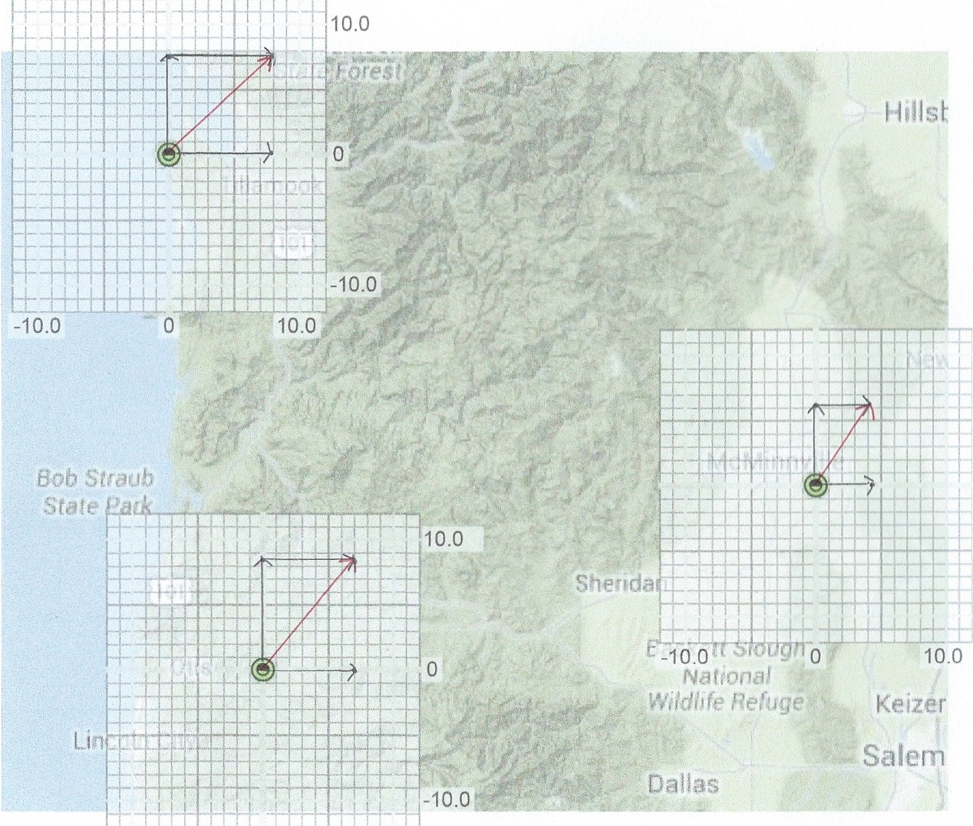
The following six figures show stages that students will reach when doing this activity.

Figure 1. The red vector is the total velocity vector drawn as the sum of the North and East velocity vectors.

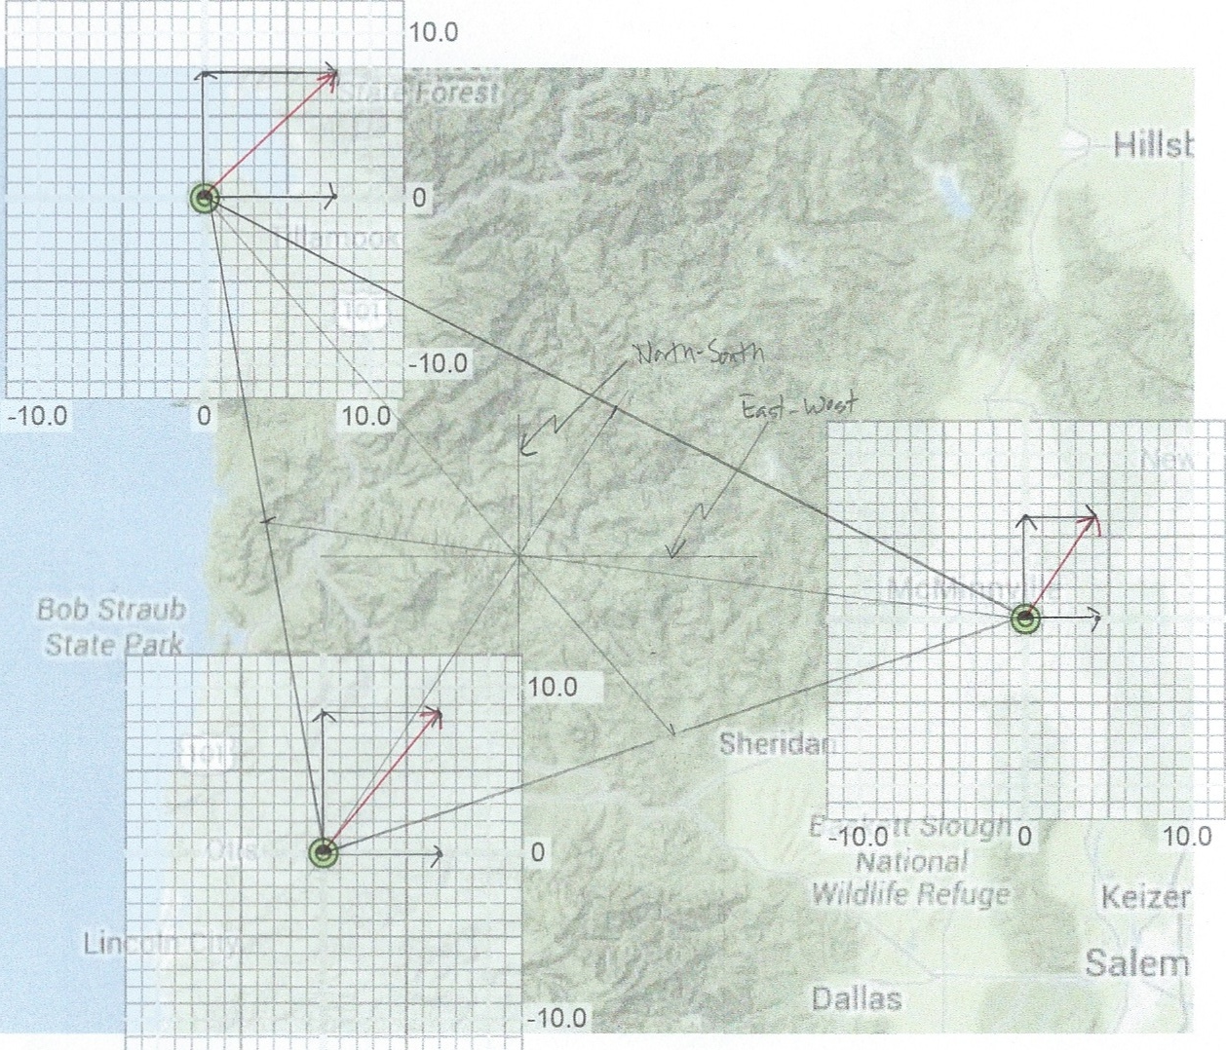

Figure 2. Triangle with centroid of the original GPS positions. East-west and north-south lines drawn through centroid.

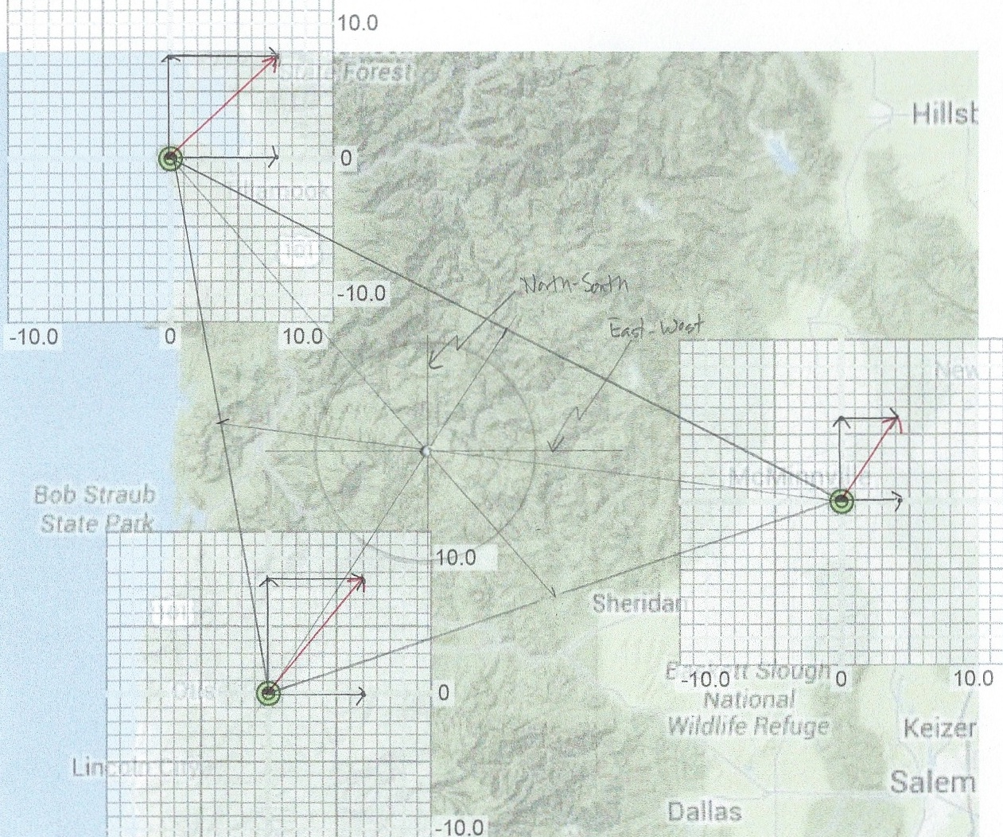

Figure 3. Circle drawn at centroid.

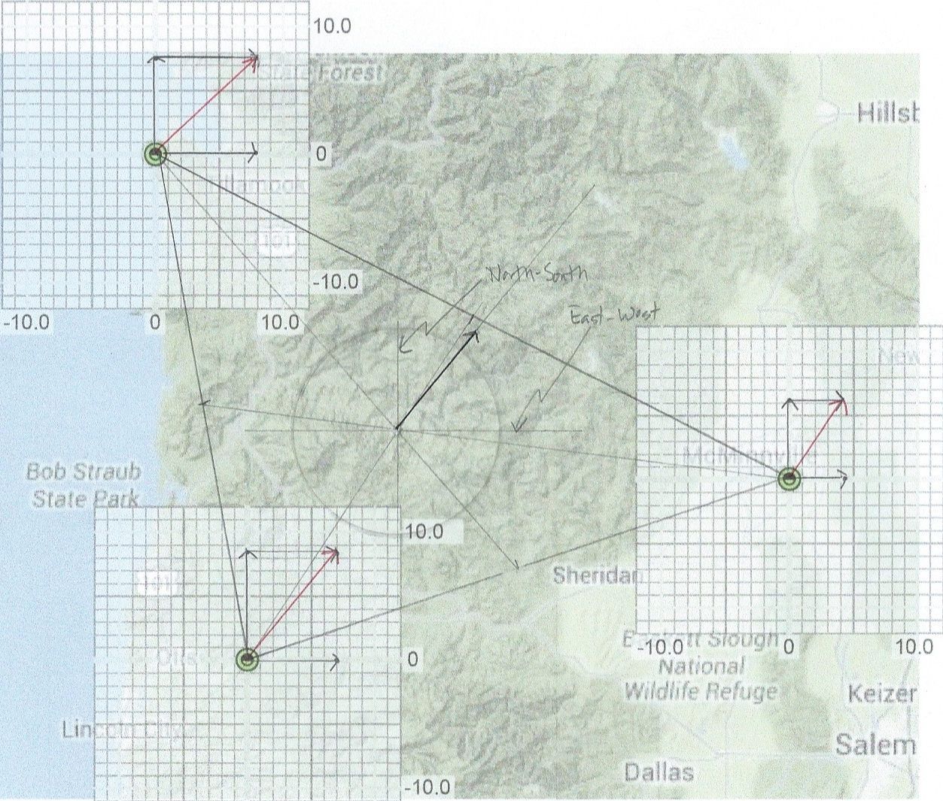

Figure 4. Vector for the translation of the centroid shown in black. This comes from drawing a triangle on graph paper with a vertex at the end of each velocity vector and finding the centroid of the deformed triangle. The deformed triangle’s centroid lies at the head of the black centroid vector

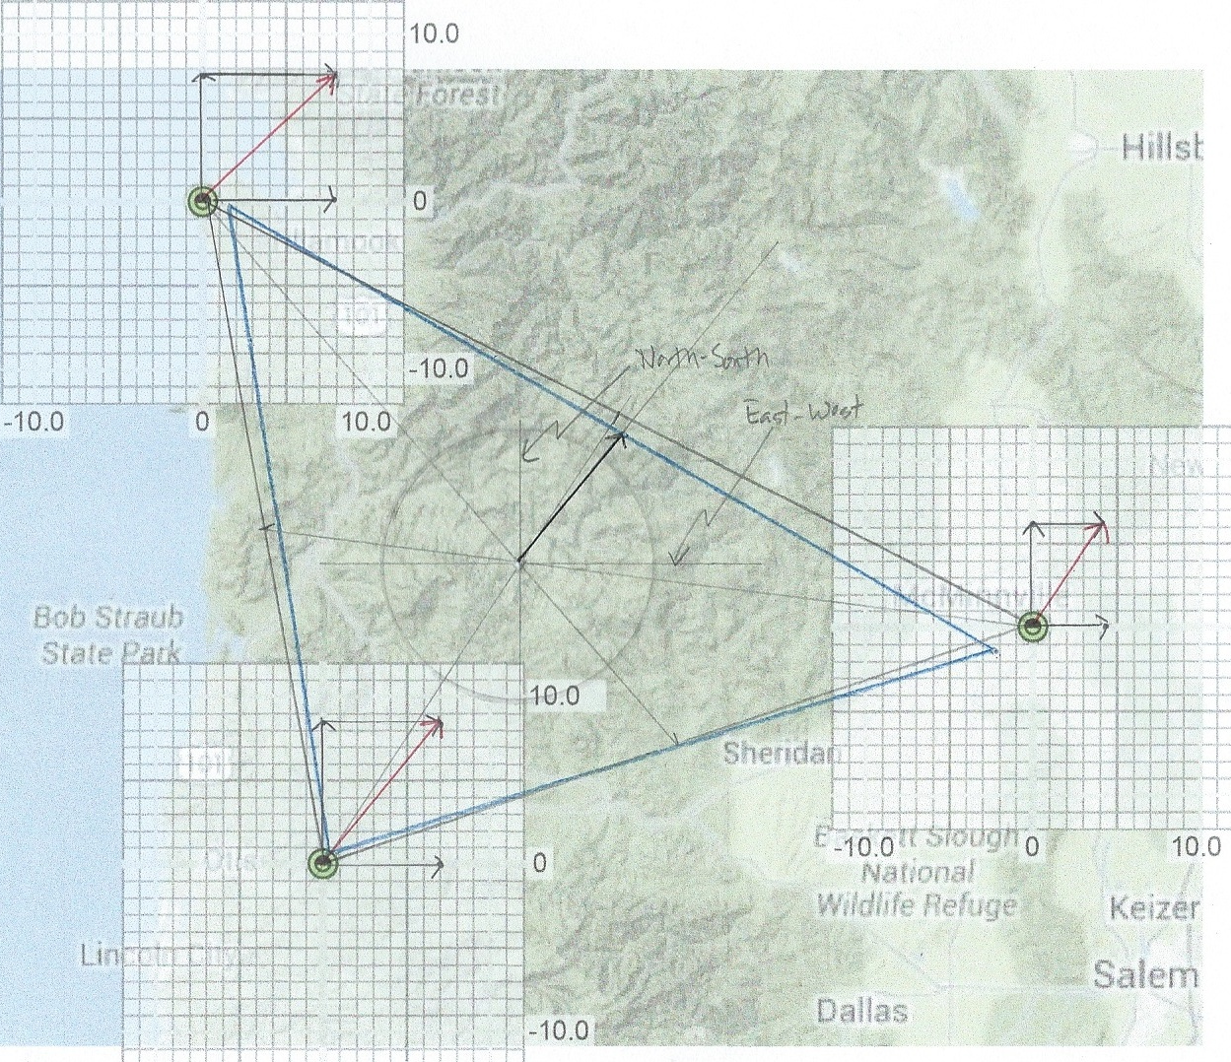

Figure 5. Blue triangle shows the strain only. The region has been rotated and distorted.

