Determining strain graphically
Nancy West, Beth Pratt-Sitaula, and Shelley Olds, expanded from work by Vince Cronin, Baylor University and Anne Egger, Central Washington University.
We know that Earth’s crust deforms because we
1) handle rocks that have changed shape. Linear features stretched, circular features became ovals, or symmetrical features became misshapen (Fig. 1);
2) record earthquakes daily and note offsets along faults (Fig. 2); and
3 )measure changes in position of GPS units fastened to the crust (Fig.3).

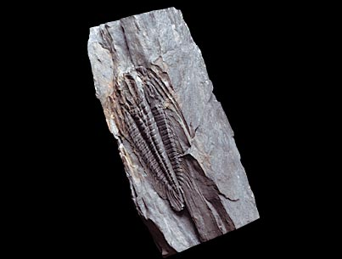
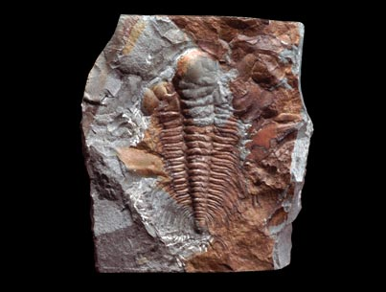

Figure 1b. Strained trilobite. Smithsonian, 2002.
Figure 1a. Trilobite. Smithsonian, 2002.

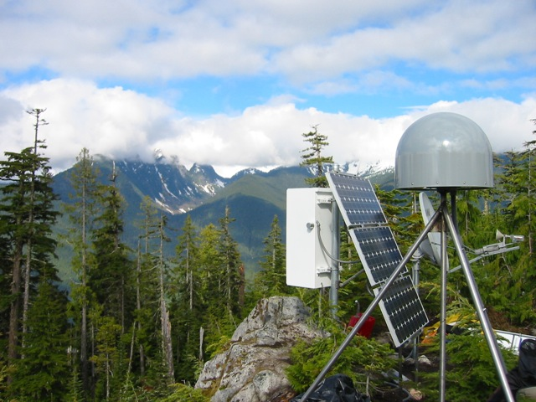
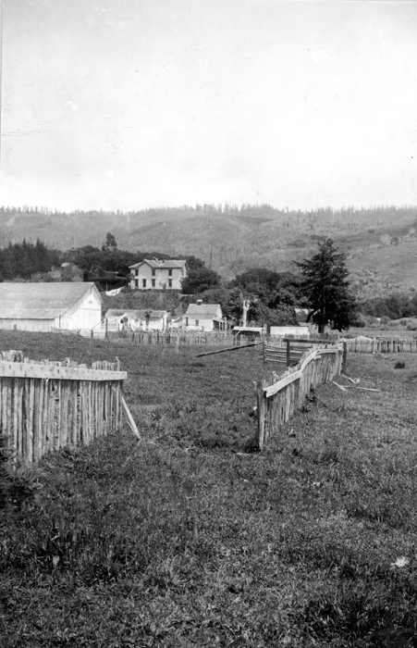

Figure 3. High-resolution GPS station (the dome), with solar charger and receiver. UNAVCO.

Figure 2. Offset in fence caused by the 1906 San Francisco earthquake. Total offset was 11 feet. Gilbert, 1906.

Recall that deformation arises from wholesale motion of a block of crust as well as its distortion--or strain. Data from a triangle of GPS stations allows us to analyze the deformation. This exercise uses real data from three real places to determine that deformation. By graphing triangles, you’ll be able to pull out the translation component accurately. You’ll also be able to judge roughly how the area has rotated and strained. However, by adding in the use of a spreadsheet-based calculator, you can also find the exact length of strain axes and exactly how much they have rotated. You will be able to describe exactly how Earth’s crust is deforming now—today.

Finding strain

Getting the data
You will need horizontal velocity data for three GPS sites. Your teacher might give this to you or you might retrieve it yourself. If you’re hunting for it, here’s what you do:
☐ Go to the Plate Boundary Observatory’s Station Finder. (Search for “PBO station finder.”) Above the map, enter the GPS station. Click on the icon.
☐ Click on the ID (the GPS station) on the first line. You’ll see a page like that in Figure 4.

Figure 4. Data for GPS station P538. It is the tiny yellow icon on the map.

In the lower left, where there’s a red loop in Figure 4, you’ll find the “SNARF Reference Frame.” “SNARF” stands for Stable North American Reference Frame. It is a group GPS sites in North America that don’t move; they act like an anchor against which other GPS stations push or pull.
☐ Copy the WGS 1984 latitude, longitude and elevation for the first site into the data sheet. Record all the digits and the sign. A positive latitude is in the northern hemisphere; a negative longitude is in the western hemisphere. Elevation is in meters.
☐ Click on the graphs labeled “Station Position.” (Fig. 5.) This shows you data about how the GPS station has moved in the last several years.

Figure 5. Station Position--"time series" data.
☐ On this graph, look at the horizontal axis. Write the span of time for which there is data on your data sheet.
☐ Look at the top graph, North. Is it increasing or decreasing over time? Does it have a positive or negative slope? In short, is the station moving farther north or south over time?
☐ Look at the middle graph, East. Is it increasing or decreasing over time? A positive slope means that the station is moving east.
☐ Scroll the cursor over the chart to see a gray box appear at the bottom. Click the right-hand arrow to gain access to “Cleaned” data. (Fig. 6.)
Figure 6. Cleaned data with the velocity and error calculated.

☐ From the cleaned data, record the velocity and error for all three parts of the chart on your data sheet.

☐ Repeat this for the other two GPS stations.

Analyzing the data
☐ First, you’ll make intuitive sense of the data by looking at the north and east velocities together. You’ll combine them and look at them on a map. Do this by completing the separate activity “Velocity maps.”

☐ Discuss your results with your group or entire class. What do you think the three vectors mean for the plot of land bounded by the three GPS stations?

Now you’ll analyze the data quantitatively. That means that you’ll figure out exactly—with numbers—how the land has been strained.

☐ Connect the GPS stations to make a triangle.
☐ Mark the middle of each side of the triangle. (Or, bisect each side.)

☐ Draw a very faint line from the midpoint of the side to the vertex opposite for each line. The three lines intersect in what’s called the “centroid” of the triangle. (Fig. 7.)

☐ At the centroid, draw an x-axis oriented E - W and a y-axis oriented N - S.
Figure 7. A triangle with lines connecting the midpoint of sides to the opposite vertex. Lines cross at the centroid.

☐ Also, use a compass or stencil to draw a circle inside the triangle with the center on the centroid.

☐ Lay a piece of graph paper over the map you have been working on. Make sure the edges of the pages line up, and N is at the top of the page. Temporarily tape the papers together.

☐ Looking through the graph paper to the map below, mark the ends of the arrows on the total velocity vectors. Connect the three points in a triangle.

☐ As before, find the centroid of this deformed triangle. Punch a hole with a pin through the centroid of the deformed triangle into the map below. Separate the papers.

☐ On the map, draw a new vector from its centroid to the pinhole. This vector shows the translation of the region over time. (Remember moving the tee-shirt without changing its shape?) The vector is the “translation vector.”

☐ Measure and record the length of the translation vector.

☐ Use a protractor or compass to measure the direction (“bearing” or “azimuth”) of the translation vector. Record this.

☐ Now, stack the centroid of the deformed triangle on top of the centroid of the undeformed triangle (on the map). Keep the x-axis parallel to the grid on the paper. By doing this, you are removing the translation component of the deformation.

☐ While the centroids are perfectly stacked up, poke pinholes in the vertices of the deformed triangle through the map. Separate the papers. To see the pinholes, hold the map up to the light.

☐ On the map, connect the three new pinholes into a triangle. This triangle shows the strain by itself—without any translation. It shows the change in size and shape of the crust in the region over time.

☐ How would you describe the type of deformation? Is there any rotation? Does it appear to be pure shear or simple shear? Discuss this with your classmates, and describe in a sentence or two on your graph paper what you see.

Think about how the circle you drew on the map deformed over the years that your data represents. The circle you drew on the map would become an ellipse on the graph paper. With some triplets of GPS station, you might even be able to sketch a strain ellipse and its major and minor axes. But, we can determine them exactly.

☐ Plug your data into the GPS Triangle Strain Calculator and let your computer use matrix algebra to determine strain axes and rotation quantitatively. (It is the same matrix algebra you might use a graphing calculator for in Algebra II or pre-Calculus.)

☐ On your graph paper, in the center of the triangle, plot the two strain axes that were just calculated for you. Use the azimuth to do this, and don’t worry about the absolute length of the lines. Show their lengths relative to each other, however, and label them.

☐ Turn in your map, your graph paper, and your data sheet, and congratulate yourself on working through a problem in crustal deformation.

Sources
Figure 1a. “Slate with undeformed trilobite fossil.” Smithsonian, National Museum of Natural History, Geogallery. Image 2002-1177. http://www.mnh.si.edu/earth/text/dynamicearth/6_0_0_GeoGallery/geogallery_specimen.cfm?SpecimenID=26&categoryID=4&categoryName=Rocks&browseType=group&groupID=8&groupName=Metamorphic Retrieved 25 February 2013.
Figure 1b. “Slate with deformed trilobite fossil.” Smithsonian, National Museum of Natural History, Geogallery. Image 2002-11799. http://www.mnh.si.edu/earth/text/dynamicearth/6_0_0_GeoGallery/geogallery_specimen.cfm?SpecimenID=103&categoryID=4&categoryName=Rocks&browseType=group&groupID=8&groupName=Metamorphic Retrieved 25 February 2013.
Figure 2. Gilbert, G.K. 1906. ID Gilber, G.K. 2845. http://libraryphoto.cr.usgs.gov/cgi-bin/show_picture.cgi?ID=ID.%20Gilbert,%20G.K.%202845 Retrieved 25 February 2013.
Figure 3. UNAVCO

Datasheet Name: ________________________
Time span of data: ___________________ Date data obtained: __________________
Geographic coordinates using WGS 1984 datum, (SNARF)
Site Latitude (decimal degrees) Longitude (decimal degrees)
____ ______________________ _______________________

____ ______________________ _______________________

____ ______________________ _______________________
GPS site velocities relative to SNARF, expressed in mm/year
Site N Velocity ± Uncert E Velocity ± Uncert Height Velocity ± Uncert
____ ___________ _________ ___________ _________ _________ _________
____ ___________ _________ ___________ _________ _________ _________
____ ___________ _________ ___________ _________ _________ _________

Length of translation vector: ____________ Azimuth of translation vector: ____________
Deformation data from Excel spreadsheet calculations
Azimuth Speed
Translation vector ________ ___________
Degrees/yr Direction
Rotation _________ ___________
Magnitude (nano-strain) Azimuth
Max horizontal (e1) ________ __________
Min horizontal (e2) ________ __________

