USERS MANUAL FOR

SUMMIT CAMP GPS SYSTEM

Version 4.0

May 2012





TABLE OF CONTENTS

I. OVERVIEW

II. SURVEYING BASICS

A. Differential Surveying
B. Initialization: A Key Concept
C. Kinematic Surveys
1. PPK Surveys
2. RTK Surveys

III. EQUIPMENT

A. Green House Base System
1. Base Receiver
2. RTK Base Radio
B. Roving System
1. Roving Receiver
2. Data Collector with Survey Controller Software
3. Bipod
4. Kinematic Backpack
5. Batteries

IV. PERFORMING A STATIC SURVEY

A. Verify Base Receiver Operation
B. Configure R7 receiver
C. Perform Static Occupation
D. Download Base and Roving GPS Datafiles and Perform Data QC

V. PERFORMING A PPK SURVEY

A. Verify Base Receiver Operation
B. Set up Roving System
C. Program Roving Receiver
D. Measure Points and/or Contours
E. Download Base and Roving GPS Datafiles and Perform Data QC
F. Using the Bipod versus the Backpack Antenna Mount

VI. PERFORMING AN RTK SURVEY

A. Program Roving Receiver
B. Turn on Base Radio
C. Measure Points and/or Contours
D. Navigating to a Point
E. Download Roving GPS Datafiles and Perform Data QC

VII. ADDITIONAL SYSTEM INFORMATION

A. Downloading Data from the NetR8 Base
B. Downloading Data from the TSC2 Data Collector
C. Downloading Data from the R7 Roving Receiver
D. Base Coordinates
E. Precise Point Positioning (PPP)
F. GISP2 Borehole Monument
G. Software on the Science Tech Computer
H. Quality Checking Data Using TBC Software

I. OVERVIEW

The Summit Camp GPS system was installed in April 2006. It is available for use by C2HM camp staff and visiting science groups. The system performs two main functions:

- Real-time and post-processed surveys for precision mapping and positioning

- Continuous GPS base station data recording for scientific purposes, including atmospheric research and ice motion studies.

This system provides post-processed and real-time centimeter-level positioning within the immediate camp area (~5 km). With proper surveying techniques, high accuracies can also be achieved within a ~100 km radius by using post-processing.

This document is intended to provide enough information for the Summit Camp Science Technicians to operate the system. Normal Science Technician support for the GPS includes real-time and/or post-processed surveys as requested, and basic troubleshooting and repair as needed. GPS training at the UNAVCO office in Boulder, Colorado is also available for incoming Science Technicians at CH2M request.

However, when surveys of long duration or high complexity are needed, the science group should contact UNAVCO in advance of the project for formal GPS training and/or UNAVCO field engineer support.

NOTE: Between June 30 and July 2 2009, the Green House building was moved approximately 80 meters from its former location. At this time, the GPS base station was renamed from SUMM to SMM1. Also, the RTK coordinates for the base station were updated. See Section VII for details.

A Summit Camp GPS webpage is maintained here, containing system specifications, inventory, and other useful technical information.

http://facility.unavco.org/project_support/polar/summit/summit.html

For technical support, send email to: support@unavco.org

For more information on the Global Positioning System and how it works, see the following online tutorials. The first tutorial below should also be present in the UNAVCO folder on the Summit FTP server.

http://www.javad.com/ As of 2012 a GPS tutorial (PDF) was still available here.

http://www.kowoma.de/en/gps/history.htm

http://gps.faa.gov/ As of 2012 a GPS tutorial was accessible from main page.
II. SURVEYING BASICS

A. Differential Surveying

For high precision GPS surveying, the differential technique is required. The simplest differential survey requires two receivers operating simultaneously: the stationary (“base”) system and the moving (“roving”) system. The differential technique takes advantage of the fact that many error sources which affect the accuracy of GPS positions are “common mode” between the base and roving receivers. If the two systems are located close enough to each other, it can be assumed that these errors affect the base and rover identically, and the errors can be cancelled such that the baseline distance between the two antennas to be calculated very accurately. As the systems move farther apart, more and more data must be taken to resolve this baseline, up to a practical maximum of ~100 km.

During surveying the base system, or more precisely the base antenna, is positioned at a precisely-known coordinate. Then the roving receiver collects data while its antenna is positioned at the point(s) of interest. To generate accurate coordinates for points surveyed by the roving system, the “baseline” distance between the base and roving antennas is calculated for each point, then added vectorially to the base coordinate. Thus the accuracy of coordinates measured by the roving system is obtained by a) very accurate knowledge of the base antenna coordinates and b) very precise baselines between the base and roving antennas.

An accurate base coordinate can be obtained in three ways. First, the base antenna can be positioned over a previously surveyed marker if such markers exist near the survey site. Second, if there is a GPS reference station operating nearby, a baseline can be generated from the reference station to your base station, thereby providing a good 3-D coordinate for your base. Finally if no markers or reference stations are within a reasonable distance of the survey area, your base coordinate can be generated by recording a long GPS data file (e.g. 24 hours) and then using sophisticated processing routines to arrive at an accurate “autonomous” base coordinate.

Once the base has been established, the precision of baselines between base and rover is achieved by good survey techniques. Such techniques include keeping the roving GPS antenna level and providing it with an unobstructed sky view. Power to the roving receiver must be maintained, along with a good “initialization”, as described below.

B. Initialization: A Key Concept

For several reasons, accurate baselines cannot be generated instantly. Satellite data must be collected simultaneously by both base and rover for a certain period of time before an accurate baseline can be unambiguously solved. This period of time is the “initialization” period, and varies depending on the baseline distance and the number of satellites in view. However, once an initialization is gained, that initialization applies to all points surveyed thereafter until either a) initialization is lost or b) the survey is ended. If initialization is lost, the points surveyed while the previous initialization was held are still valid. However, before surveying any more points, a new initialization must be gained. This new initialization will require as much time as the first initialization. Initialization can be lost in several ways, for example if the roving antenna’s view of the sky is obstructed by a building wall, if the antenna is tilted far away from level, if the antenna cable becomes detached, or if the roving (or base) receiver loses power.

C. Kinematic Surveying

At Summit Camp, it is anticipated that most usage of the GPS system will be “kinematic” surveying. As opposed to “static” surveying, where a GPS system is installed at one location for a long period of time (for example to measure motion of glaciers or tectonic plates), kinematic surveying essentially refers to mapping operations. A kinematic survey can involve both “topo points”, where the surveyor stops at specific points and measures their locations, and “continuous topo” segments, where the surveyor moves along a certain path and the receiver tracks the movement.

For example, if a new building was added to Summit Camp, the station layout drawing could be updated by surveying the four corners of the building (topo points) and then walking along the path of the building’s main power and/or water lines (continuous topo). Another example would be mounting the roving system on a snowmobile and driving along various transects to measure snow accumulation patterns around the station. There are two main types of kinematic surveys: post-processed kinematic (PPK) or real time kinematic (RTK).

1. PPK Surveys

With post-processed surveys, there is no communication between the base and roving receivers. GPS processing software is required to combine data from the base and roving receivers to obtain the results. Thus, baseline solutions for the surveyed points cannot be generated until after the survey is complete. The coordinates can then be exported for use in GIS, plotting, or drawing software. Two main advantages of a PPK survey over an RTK survey are:

- Longer baselines can be measured, up to 50-100 km from the base. RTK is limited to approximately 5 km baselines.

- There are fewer pieces of equipment to operate, since there is no radio link required between the base and roving receivers.

2. RTK Surveys

An RTK system allows the surveyor to obtain exact coordinate solutions as the survey is being conducted. This is accomplished using a radio link between the base and roving receivers. Here, the base receiver broadcasts a data stream which allows the roving system to calculate precise baselines in real time. Since the base station also broadcasts its own position, the baselines can be used to calculate the precise position of the roving system. Two main advantages of RTK surveys are:

- Instantaneous display of precise coordinates. This is particularly useful if the surveyor wishes to find an exact coordinate, such as a previously surveyed mark that has since been buried in snow. RTK can do this whereas PPK can not.

- An RTK system will tell the user when it is initialized. With a PPK system, you need to acquire a conservative amount of data to ensure your post-processing will yield a good initialization.

III. EQUIPMENT

A. Green House Base System

1. Base receiver

The base receiver is a Trimble NetR8, located in the green house. This receiver was installed on August 15 2011, replacing an older Trimble NetRS model. The base antenna is a Trimble Zephyr Geodetic, mounted on a threaded stud on the roof of the green house. A short run of LMR-400 coax cable connects receiver and antenna. A straight ethernet cable connects the receiver to the green house router. The receiver is powered by an 18VDC Friwo power supply through a “power/download” cable, which has coaxial power, 9-pin serial, and 7-pin LEMO connectors. When the LEMO connector is inserted take care to line up the red dots. It is surprisingly easy to push this connector in the wrong way, and you will break the pins if you do this.

The base receiver should always be on, since it continuously collects data even when there is no survey underway. This data has scientific applications and is downloaded daily by UNAVCO.

The NetR8 has HTML and FTP interfaces for programming and data retrieval. A read-only account exists for Summit Camp users to retrieve data through the local network. All programming and configuration are done remotely by UNAVCO, using a separate account.

The receiver has 4GB of internal memory operating in ring-buffer mode, and it is partitioned for recording high-rate and low-rate GPS data. The low rate data is recorded every 15 seconds, and a new low-rate data file is created at the start of each UTC day. Two high-rate data logging sessions are enabled, each recording to hour-long files. One session is recording 2Hz data and the other recording 5Hz data. The high and low rate data files should be adequate for every surveying task encountered by the Summit Science Technicians. If a different recording scheme is required, contact UNAVCO.

UNAVCO automatically downloads and archives the 15-second data once per day, however the high-rate files are not archived at UNAVCO and must be downloaded by the user within a certain time after completion of a survey. As of May 2012, about 40 days of 2Hz data and 16 days of 5Hz data are stored.

A base station inventory is maintained online at the address listed in Section I.

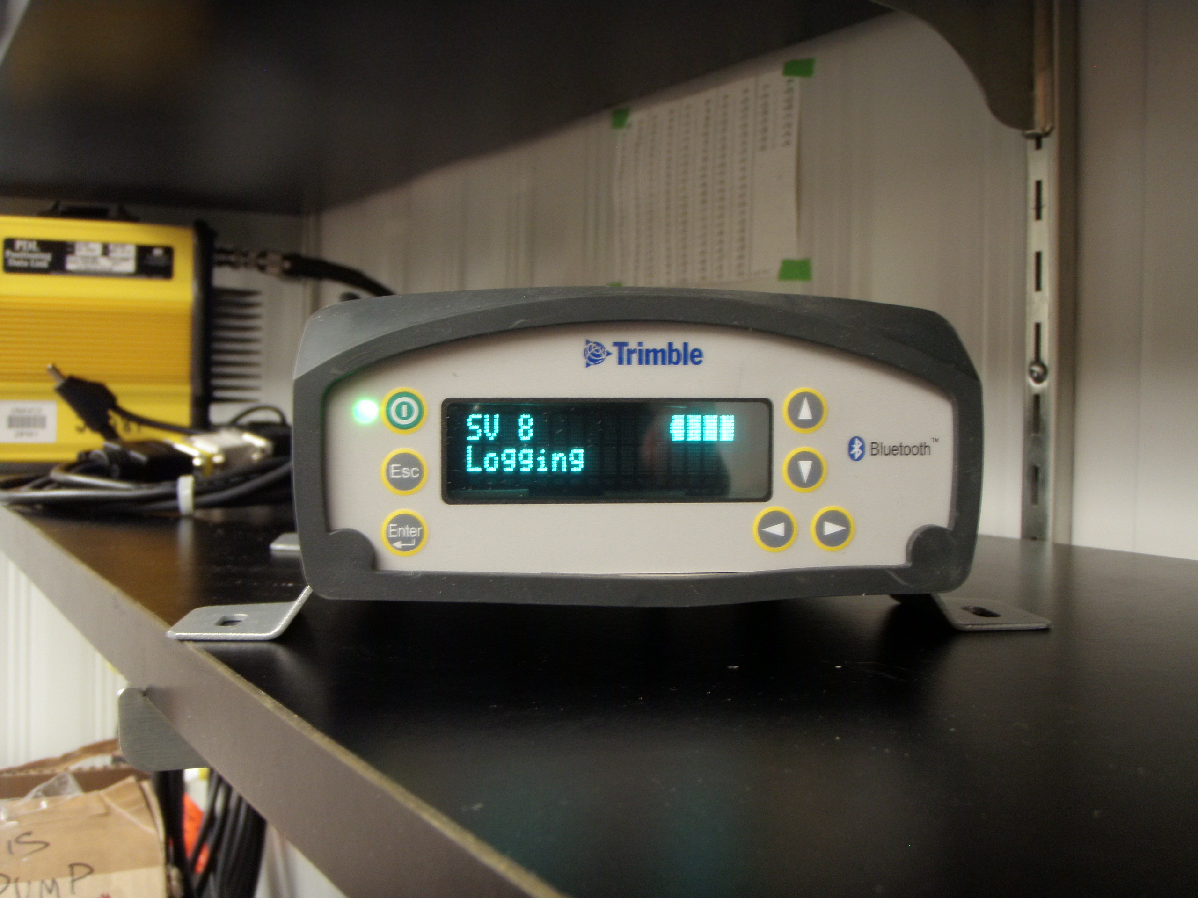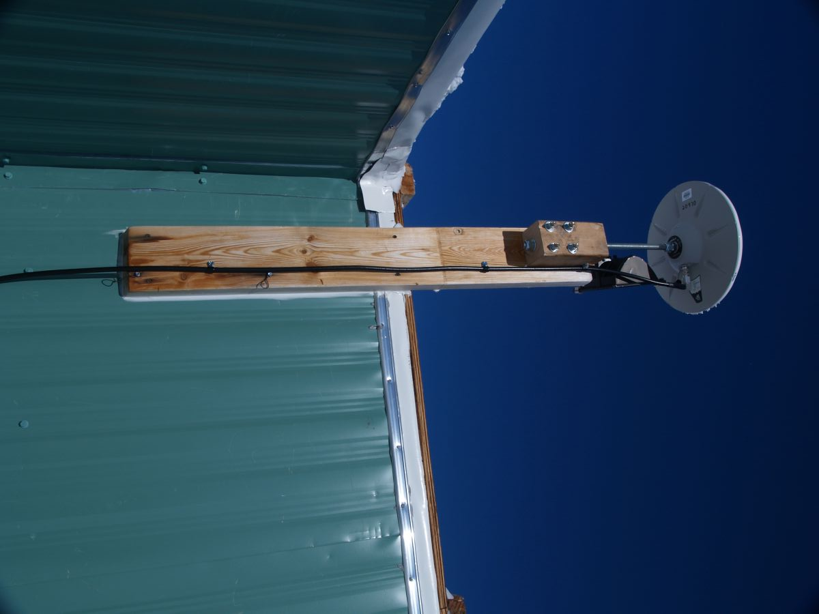

Figure 1a. Base GPS Receiver Figure 1b. Base GPS Antenna

2. RTK Base Radio

See Figure 2 for the RTK base equipment. A Trimble HPB-450 radio is attached to the power/download cable on port 2 of the base receiver. The radio cable goes from a 9-pin serial to a 5-pin LEMO connector, with a 2-pin power extension which connects to a 12VDC Phihong power supply. Please note the correct orientation of the 5-pin LEMO connector on the radio cable. When this connector is inserted take care to line up the red dots. It is surprisingly easy to push this connector in the wrong way, and you will break the pins if you do this.

This radio broadcasts via a whip antenna mounted on the Green House antenna mast. LMR-400 coax cable connects radio and antenna, with an N-type connector at the antenna and a BNC-TNC adapter at the radio. The radio broadcasts at a 2 Watt power level. The radio is capable of broadcasting at 35W, but the power level switch on the rear of the radio has been disabled to allow 2W operation only.

IMPORTANT: WHEN THE RADIO IS NOT BEING USED FOR AN RTK SURVEY, IT SHOULD BE TURNED OFF.

WARNING: DO NOT OPERATE THE RADIO IF SOMEONE IS CLIMBING ON THE ANTENNA MAST!

FCC regulations dictate that this radio must not be operated if a person is within 12” of the antenna.

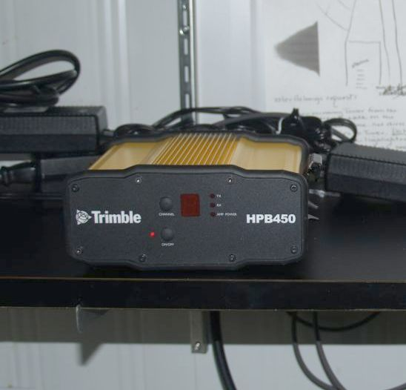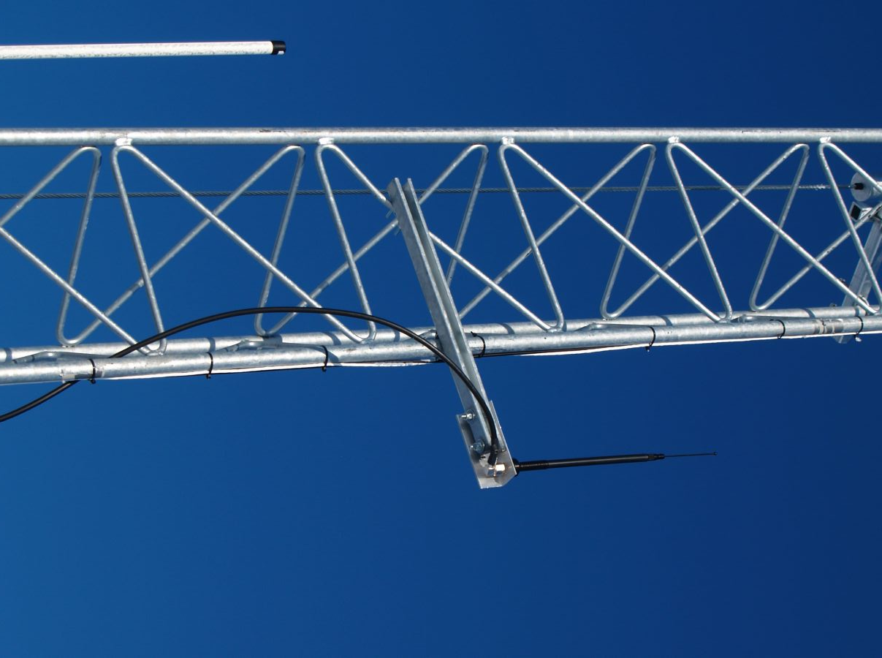

Figure 2a. RTK Radio Figure 2b. RTK Radio Antenna

B. Roving System

The roving system consists of the R7 roving receiver, Zephyr antenna, battery, TSC2 data collector, and cables. These can be transported inside the backpack for kinematic surveys or inside the large yellow Pelican case for static surveys. A 2 meter bipod is also provided, along with an antenna extension pole and a mounting bracket for the TSC2 data collector. All elements of the roving system, including the large yellow Pelican hard-shell case, should be stored in a single location. Also, the small yellow Pelican hard-shell case (containing spares and supplies) should be stored with the roving system.

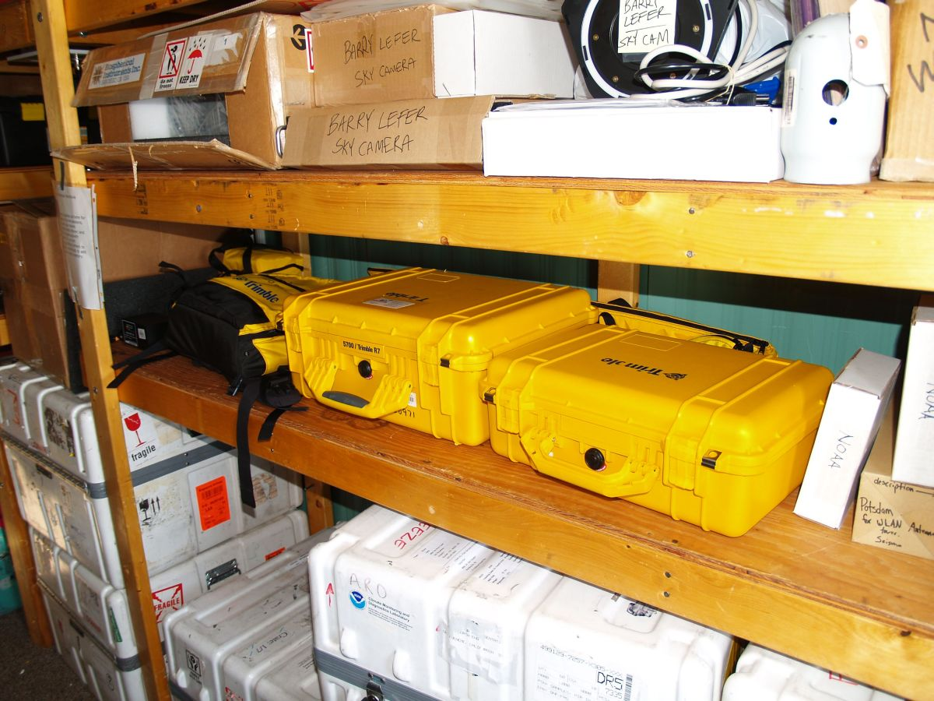

Figure 3. Storage of Roving System in Green House

1. Roving Receiver

The rover is a Trimble R7 with a built-in receive-only radio for RTK work. This receiver, along with the rest of the roving system, should be stored in the large Pelican case underneath the table below the base radio. An inventory of roving system components is maintained online at the address listed in Section I.

2. Data Collector with Survey Controller Software

The Trimble TSC2 data collector is used for kinematic work, both real-time and post-processed. This device is a Windows CE machine which runs the Trimble Survey Controller software. The data collector connects to the roving receiver and performs several functions:

- It communicates with the receiver and gives the user full control of receiver configuration, superceding any programs that may be stored in the receiver.

- It displays critical information about the current survey, including satellite
tracking data, battery power levels, receiver configuration, and points contained in the current survey job. In an RTK survey, it also displays radio information, real-time coordinates with calculated baseline precisions, and initialization information.

- It allows the user to give names to measured points and contours.

3. Bipod

A 2-meter bipod is available for higher-accuracy survey tasks. A built-in bubble level allows the antenna to be positioned vertically, directly above the point to be measured. It also has two telescoping feet to stabilize the antenna during the actual measurement of the point.

A 6-foot telescoping antenna extension pole is also provided, which can extend the antenna a further distance upward. This may be useful, for example, when surveying the corners of buildings. In this case, the surveyor needs to keep the antenna unobstructed by the walls of the building while at the same time getting as close to the building corner as possible.

Finally, two brackets are provided for use with the bipod. One bracket attaches the TSC2 data collector to the pole. The other bracket attaches the R7 receiver to the pole via metal clasps on the underside of the receiver.

4. Kinematic Backpack

This backpack can be used to house the receiver and the small battery during field surveys, leaving hands free to operate the Survey Controller (and bipod if used). Also, for lower accuracy surveys the roving antenna can be mounted on a 12” extension pole which attaches to the top of the backpack. This 12” pole should be stored in the backpack when not in use.

5. Batteries

Two external batteries are available for surveying: a small PowerSonic battery and a larger Interstate car battery. The Powersonic battery is charged with a Xenotronix battery charger while the Interstate battery uses the larger MeanWell charger. The small battery should last at least 12 hours in the cold when fully charged, and the larger battery should last at least 2 days.

Two small Trimble internal batteries are also provided, however they die quickly and are not suitable for surveying use. They can be used to power the receiver for short times such as during programming. They are charged by placing them in the R7 receiver and then hooking up the power/download cable (and 18V Friwo AC adapter) to Port 2 or Port 3.
IV. PERFORMING A STATIC SURVEY

A. Verify Base Receiver Operation

To ensure the NetR8 is operating correctly, it should be sufficient to look at the front panel. Press any button to illuminate the front panel. The top left should show “SV X” where X is the number of satellites being tracked, usually greater than 7. The lower left will alternate “Ref Stn” and “Logging”, indicating that data files are being written. The upper right will show a battery icon that should be fully illuminated, indicating the internal UPS battery is fully charged.

If the receiver is not tracking satellites the most likely problem is the cable and/or connectors between receiver and antenna. If the satellite tracking problem is not apparent, or if the receiver is displaying strange messages, contact UNAVCO.

B. Configure R7 Receiver

For static surveys, the R7 receiver must be configured directly since the TSC2 data collector is not used. For such surveys, it should be sufficient to simply load the default configuration file. You may elect to change the antenna information in the config file, but this is not critical since this can be changed during post-processing. The default configuration file for the Trimble R7 is located on the Green House PC, and is named

R7_24hr_15sec_Static.cfg

Programming the R7 correctly is critical for collecting the desired data. The process is not difficult, however a well understood sequence must be followed to ensure proper data collection. To program the R7 for static occupations, use the following steps:

1. Using a power/download cable, connect Port 2 on the R7 to the Green House PC (or any other computer with Trimble Configuration Toolbox loaded). The Keyspan USB-serial adapter can be used if the computer does not have a 9-pin serial port. Use the spare Friwo 18V AC adapter to power the R7 through the power/download cable.

The 7-pin LEMO connector on the power/download cable can easily be inserted the wrong way, causing breakage of the pins. The correct way to use this connector is:

a. Align the red dot on the plug with the red mark on the jack. This ensures that the key on the plug will slide into the slot on the jack.

b. Push firmly but do not force the connector. If resistance is felt, remove the connector and check for debris inside and/or crooked pins. Realign the connector and reinsert.

c. Give a slight tug on the cable itself to make sure the connector doesn’t pull out. If properly connected, a mechanism will lock the connector in place to prevent the cable from inadvertently detaching if the cable is pulled.

d. To remove the cable, pull the wire loop attached to the housing. This action retracts the two small “ears” and allows the cable to slide out.

2. Perform a hard reset of the R7 by holding down the power button for 45 seconds. After 15 seconds, the red satellite tracking LED will come on. After 30 seconds it will turn off. CAUTION: The hard reset will format the compact flash card and erase all data on the card! If there is any important data on the flash card, be sure to download it first. You can also remove the flash card before doing the hard reset.

3. Start the Trimble Configuration Toolbox program and “Open” the UNAVCO default configuration file, R7_24hr_15sec_Static.cfg (see above). This configuration file specifies 15-second data logging, and creates one new file each day. It is unlikely that any settings will need to be changed (other than the Antenna settings as described below), but if so, now is the time to do it.

4. There is only one roving antenna at Summit Camp, a Trimble Zephyr. If you want to change the antenna settings, select “Antenna” from the “Contents:” window. You can also modify the antenna height under the “Method” box. This height is almost always referenced to “Bottom of antenna mount”. For example, if you set up using the tripod and the bottom of the Zephyr is measured at 0.845m above the point of interest, enter “0.845m” and reference to “Bottom of antenna mount”. Again, neither antenna type nor antenna height are critical since you can modify these values during post- processing. Once you have changed the antenna height, click “Transmit”. You should get a window which says the file was successfully uploaded to the receiver.

IMPORTANT: Configuration Toolbox Bug. If you make any changes to the configuration file and want to save the modified file to your hard drive, be sure to “Transmit” the file to the receiver before “Saving” it. If you “Save” then “Transmit”, the receiver will NOT automatically log data (you do not want this!)

5. To verify that you have correctly loaded the configuration file, power cycle the receiver. From Configuration Toolbox, select “Communications” and then “Get File”. Select “power_up” from the file list and verify all settings are correct. If you have correctly loaded the UNAVCO default configuration file, the settings will be as follows:

i. File

Applied immediately: box checked
Stored in receiver: box checked
As auto power up file: circle checked
Reset to defaults before applying: box checked

ii. General

Elevation mask (deg): 5
PDOP mask: 20
Measurement rate: 1 Hz
RTK mode: Low latency

iii. Logging

Measurement logging rate: 15 secs
Position logging rate: 5 mins
Fast static timers: 4 SV: 20; 5 SV: 15; 6+ SV: 10
2nd Measurement logging rate: Off
2nd Position logging rate: Off
Enable automatic data logging: box checked
Enable automatic deletion: box not checked

iv. Antenna

Group: All
Type: Zephyr
Method: Bottom of antenna mount
Measured height (m): 0.000 (or your modified value).
True vertical height (m): This will be the Measured height plus 0.046 m for the Zephyr.
v. Static

Static mode: Static

vi. Time Activation

Time Activation Enabled: Yes
Date and Time: 1/1/2000 12:00:00 AM (UTC)
Repeat Interval: 24 Hours

6. Close Configuration Toolbox.

C. Perform Static Occupation

As of 2008, the GISP2 borehole is the only GPS monument in the vicinity of Summit Camp (see Section VII). Thus, an occupation of the GISP2 monument is used as an example for this section. In the future, more monuments may be installed, such as at the GRIP borehole or on the Big House. However any future monuments will also consist of 5/8” threaded studs, so occupation of such monuments would follow an identical procedure.

1. Before installing the R7 system on a monument, go outside and hook up the antenna to the receiver to verify that the receiver tracks satellites and automatically logs data when you turn it on. It may take a minute or two for the receiver to start logging data once it locks on to satellites. The meaning of the LED’s on the R7 is as follows:

 | Logging memory LED (yellow) | Satellite tracking LED (red) | Power LEDs (green=in use or yellow=standby)*
On | Data are being logged | Receiver in monitor mode | Healthy
Slow (1 sec) flash | Enough Fast Static data have been logged (per preset criteria) | Tracking four or more satellites | N/A
Fast flash | Warning-low memory | Tracking three or less satellites | Low power
Off | Not logging data | Not tracking any satellites | No power source present

2. After configuring and testing the R7 receiver, assemble the receiver, antenna, and antenna cable in the large yellow Pelican case. Bring a medium-sized crescent wrench for the nuts on the 5/8” monument threads. Also bring a piece of foam to stuff inside the threaded port on the side of the Pelican case. The cables enter the box through this port, so foam should be used to keep blowing snow from entering the case during the static occupation.

Bring a fully charged battery as well. For static occupations, the PowerSonic battery should last for 12 hours in the cold when fully charged. For longer occupations, use the Interstate battery in the yellow bag. This battery has its own charger, and should last about 2 days when fully charged.

3. At the GISP2 monument, do a quick inspection of the monument itself. Check if the wooden cap is loose or damaged. It should be tightly attached to the borehole casing with four hex-head pins. The 5/8” stud should have one or two hex nuts on it. If any problems are seen with the monument, contact UNAVCO.

If the monument is in good condition, screw the Zephyr antenna all the way onto the threaded stud. Use the crescent wrench to LIGHTLY tighten a hex nut against the bottom of the antenna. Attach the antenna cable to the antenna, run it into the Pelican case through the threaded port in the side of the case, and attach it to the receiver. If you are using the large Interstate battery, run the battery power cable in through the same port and plug it into either Port 2 or Port 3 on the receiver. If you are using the PowerSonic battery, it will fit the inside the Pelican case.

After running the cables, insert the foam into the cable port and turn on the receiver. Verify that the receiver tracks satellites and begins logging data. Close the Pelican case and secure it in the snow so the wind will not move it.

4. At the conclusion of the static occupation, first open the Pelican case and verify the receiver is still powered and is logging data. To turn it off, either press the power button for a few seconds or simply unplug the power cord.

D. Download Base and Roving GPS Datafiles and Perform Data QC

For any post-processed survey, it is necessary to download simultaneous GPS datafiles from both the roving and base receivers. After returning to Summit Camp, download the roving AND base data as soon as possible and save it in the appropriate directory on the Summit Camp FTP server. See Section VII for instructions on downloading data from the R7 roving receiver and the NetR8 base receiver.

For static surveys, it will be sufficient to download just one low-rate (15 second) file from the NetR8 base receiver on the day on when you did the survey (or from two days if your survey occurred during UT midnight). This low-rate data is downloaded and archived at UNAVCO, however it is good karma to save the base data files along with the roving data files.

IMPORTANT: Always create a text file with notes about the survey in each project’s directory on the FTP server. Include any notes which may be of interest to people processing this data in the future. In particular, note the antenna type, height, and reference point. Also note any interruptions in data collection or obstructions to the antenna’s sky view.

Once the base and roving data has been downloaded, QC this data using Trimble Business Center software. Instructions are in Section VII.

V. PERFORMING A PPK SURVEY

A Post-Processed Kinematic (PPK) survey is simpler to perform than a Real-Time Kinematic (RTK) survey, and should be the default survey method unless there is a specific need for precise real-time coordinates. The following procedure contains the steps necessary for a successful PPK survey.

A. Verify Base Receiver Operation

Verify proper base receiver operation as in Section IV A.

B. Set Up Roving System

For kinematic surveys, the roving receiver will usually be housed in the yellow Trimble backpack as shown in Figure 4. This photo shows the GPS antenna mounted on the 12” extension pole on top of the backpack, a configuration which is only suitable for lower-accuracy (~6” level) surveys, since the antenna is simply attached to the surveyor and its position is not tightly controlled. Keep in mind that the surveyed position is the position of the antenna minus whatever vertical offset is needed (more on this later). For higher accuracy surveys (centimeter level), use the bipod as described later in this document.

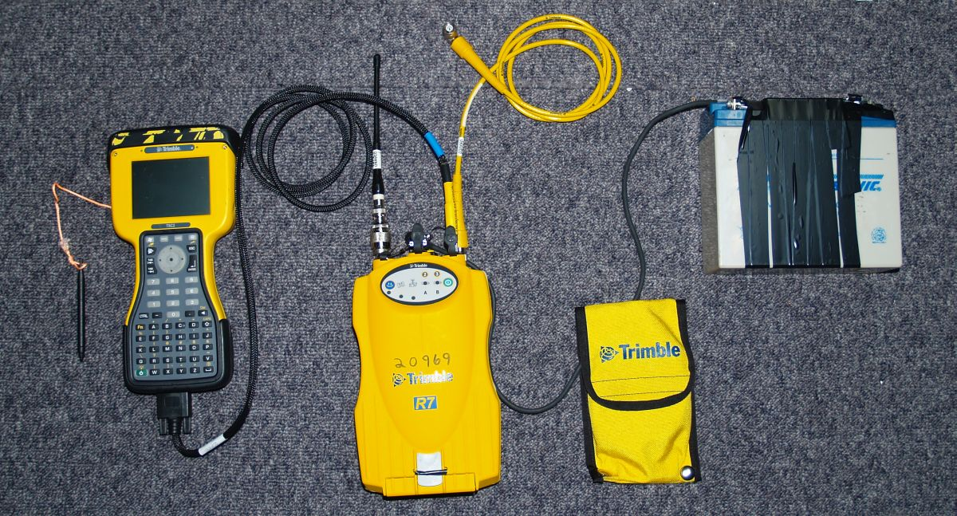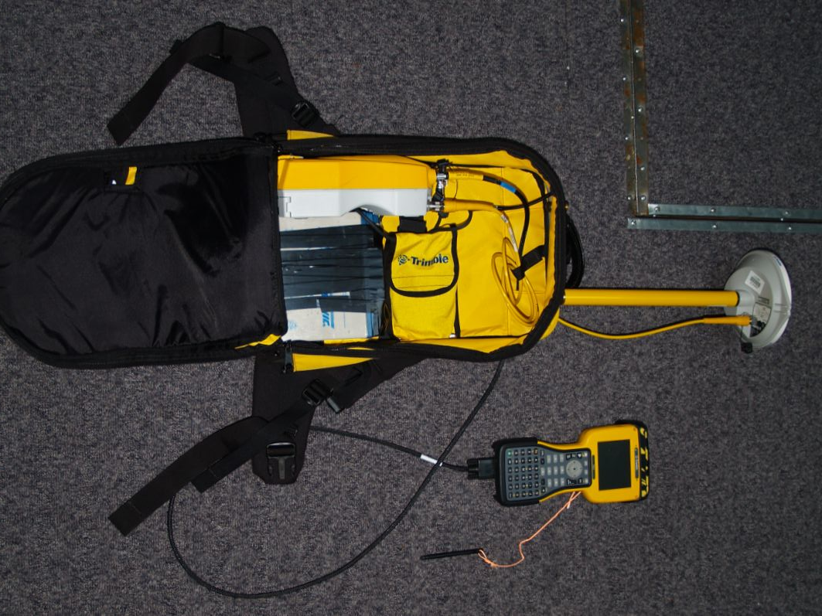

Figure 4a. Receiver, Controller, RTK antenna, Figure 4b. Roving system assembled
and battery connections (RTK antenna not inside backpack.
necessary for PPK surveys).

Assemble the backpack system via the following steps:

1. Make sure the PowerSonic battery is fully charged, using the Xenotronix battery charger. At full charge, the battery pack should operate the roving system for at least 12 hours in the cold.

2. Adjust the backpack straps to comfortably fit with your coat on.

3. Place the receiver and battery pack side by side as shown in Figure 4b. This figure shows the R7 receiver with the roving RTK antenna; this antenna is not necessary for PPK surveys.

4. Connect the straight TNC end of the antenna cable (either the 2 meter or 10 meter
cable) to the receiver and run this cable out of the backpack through one of the two feed-thrus on the top inside area of the backpack.

5. Connect the battery pack cable to either port 2 or port 3 on the receiver using the procedure below. The receiver may or may not turn on when power is connected. If the receiver does not power up, press the green power button on the front of the receiver. The 7-pin LEMO connector can easily be inserted the wrong way, causing breakage of the pins. The correct way to use this connector is:

a. Align the red dot on the plug with the red mark on the jack. This ensures that the key on the plug will slide into the slot on the jack.

b. Push firmly but do not force the connector. If resistance is felt, remove the connector and check for debris inside and/or crooked pins. Realign the connector and reinsert.

c. Give a slight tug on the cable itself to make sure the connector doesn’t pull out. If properly connected, a mechanism will lock the connector in place to prevent the cable from inadvertently detaching if the cable is pulled.

d. To remove the cable, pull the wire loop attached to the housing. This action retracts the two small “ears” and allows the cable to slide out.

6. Connect the TSC2 data collector to the receiver. Use the controller cable, which has a 7-pin LEMO connector on one end and a 9-pin serial cable on the other.
Run this cable out of the backpack through the same hole as the antenna cable.

Note that the controller cable is identical to the Trimble power/download cable, except is does not have the coax power pin. If the controller communication cable is lost or damaged, the power/download cable can be used in its place.

7. Plug the 9-pin serial end of the controller cable into the bottom of the TSC2 data collector. Tighten the two thumbscrews to ensure that this connector does not fall off during the survey.

8. Mount the GPS antenna. See Section V.F below for more info regarding backpack vs. bipod antenna mounting.

a. If mounting the antenna on the backpack, screw the antenna extension pole onto either stud on the top of the backpack. Screw the Zephyr antenna onto the top of this pole. Make sure the antenna is snug so that it does not come loose and rotate during the survey. Connect the 90 degree TNC end of the antenna cable to the antenna.

b. If mounting the antenna on the bipod, screw the two halves of the main (2-meter) bipod pole together tightly. Insert this pole into the clamp on the bipod legs and tighten the clamp. Make sure the conical points on the ends of all legs are tight.

Screw the Zephyr antenna onto the top of pole and attach the antenna cable. Make sure you have plenty of slack in this cable between the backpack and the antenna. For convenience, mount the TSC2 data collector to the bipod pole using the black plastic mounting bracket.

9. Make sure all cables are free from kinks and zip up the backpack.

C. Program Roving Receiver

The Survey Controller program has a myriad of functions, most of which are designed for construction-style job site surveys and do not apply to surveys around Summit Camp. The best advice for doing surveys is to keep it simple, and this includes programming the roving receiver. The following procedure contains the minimum steps for correctly setting up a PPK survey, and should suffice for most if not all PPK surveying tasks.

1. Make sure the TSC2 data collector battery is fully charged. The TSC2 only runs from this battery; it does not take power from the receiver’s battery. A Cincon 5VDC charger is stored in the small yellow Pelican case.

2. Turn on the TSC2 by pushing the green button. If the Survey Controller program is not already running, start it by touching “Start” then “Survey Controller” from the Windows CE menu. A screen with six selections will appear, along with a bar on the right hand side which contains receiver status information. The TSC2 has a touch screen which is operated by the stylus stored in the top of its casing. A pen or pencil will also work. You can always get back to this main screen by touching the “Menu” button on the right hand side of the display.

3. Now, create a new “Job”, or return to an existing job if you want to add more data to it. A Job refers to a set of data with something in common (such as work for a specific science project or work on a particular day), and can contain multiple RTK and/or PPK surveys performed over multiple days.

a. Touch “Files” then “New Job”. Type in the job name and touch “Enter”.

b. Under “Coord. sys.”, select “No Projection / No Datum”. A projection is a transformation of 3-D geodetic coordinates into a 2-D plane. You can choose a projection during the post-processing; there is no need to define this now. When the “Site Calibration” menu appears, hit “Store” to accept the default parameters.

c. There is no need to change any other parameter in this menu, except filling in the Description, Operator, or Notes text fields if you wish. These fields are accessed by touching the “1/2” box to scroll down to the next menu page. When you’re done, touch “Accept” to return to the main menu.

4. The next step is configuring the “Survey Style”. A survey style refers to the type of survey being conducted, in this case PPK. The PPK survey style has already been defined in the data collector, however you should verify that all these settings are correct before proceeding.

a. Touch “Configuration” then “Survey Styles” on the main screen, then touch “PPK”.

b. Under “Rover Options”, verify the following:

i. Survey Type: PP kinematic
ii. Logging interval: 5.0s is a common interval. However, if you are going to traverse continuous contours and want a higher logging rate to increase the spatial resolution, select 1.0s or 2.0s.
iii. Elevation mask: 10 degrees
iv. PDOP mask: 6.0
v. Logging device: Controller
vi. Auto file names: box checked
vii. Antenna Type: Zephyr
viii. Measured to: Bottom of antenna mount
ix. Antenna Height: Enter in the vertical distance between the ground and the bottom plane of the antenna. If you have the antenna mounted on the backpack, have another person measure this distance when you are standing straight with the backpack. You can enter in this vertical distance in inches or meters, for example a 1.92 meter distance could be entered in as “1.92m” or “75.59in”. If you have the antenna on the bipod, this distance will be “2.0m”. If you are using the bipod plus the antenna extension pole, the distance will be “3.829m” (i.e. 2 meters plus 6 feet).
x. Tracking Use L2e: Yes
xi. Tracking GPS L2C: box not checked
xii. Tracking GLONASS: box not checked

c. Touch “Accept” to return to the RTK Survey Style menu

d. Under “Topo Point”, verify the following:

i. Auto point step size: 1
This number is an increment for the last character of your point file name. For example, if you measure point “greenhouse1”, the data collector will assume the next point you want to measure is “greenhouse2”. This number can be negative as well, for example if you’re counting down as you survey the ATM line poles. The index also applies to letters, i.e. the data collector would assume the point after “skiway” would be “skiwaz”. Of course you can change these point names during the survey before you measure them.
ii. Auto store point: box checked
iii. Number of meas: 3
iv. Quality control: QC1
v. Occupation time: 0m15s
The combination of (iii) and (v) means that each “topo point” will require both a 15- second occupation and three observations (if you previously set using “Logging interval” to 5 seconds each).

e. Touch “Accept” to return to the PPK Survey Style menu. Touch “Store” and the “Escape” to save the settings and return to the main screen.

D. Measure Points and/or Contours

The receiver is now ready to begin the survey. Go outside and verify that the receiver is tracking satellites by watching the satellite display in the right-hand side status bar on the controller. At Summit, you ought to have between 7 and 12 satellites in view at all times. A bare minimum of 4 satellites is required to calculate a position, however, a practical minimum is 5. If 5 or more satellites are in view, proceed with the survey.

1. Touch “Survey”, then “PPK”, then “Start Survey”. The main screen will reappear, however at the bottom of the screen you will see “PPK:Float” and “PDOP:2.4” (or some number like that). The meanings of these two fields are described below.

a. “PPK:Float” is the data collector telling you that you have not acquired enough data yet to gain an initialization. However, because the roving receiver does not communicate with the base in PPK mode, the data collector actually has no way of knowing exactly how long it would take to become initialized. Instead, there are built-in timers (which can be changed) that simply count down a set amount of time depending on the number of satellites in view. The default is 15 minutes for 5 satellites and 8 minutes for 6 or more satellites. So if you have 9 satellites, the initialization timer will require 8 minutes of continuous satellite observations. At this point the data collector will tell you “Initialization has been gained” and the bottom line will switch to “PPK:Fixed”.

These built-in timers are handy, but a much better rule of thumb is the following:

i. For baselines of 10 km or less, always collect at least 10 minutes of data to ensure initialization.

ii. For baselines over 10 km, add 1 minute for each additional kilometer, i.e. 28 minutes for a 28 km baseline.

During the initialization period, you do not have to keep the antenna still. The Trimble receivers have an “On The Fly” initialization feature which allows you to move during the initialization period. However, you MUST ALWAYS keep the antenna level and unobstructed when you are doing a survey. Tipping the antenna over or obstructing its sky view can cause breaks in satellite tracking, therefore preventing initialization or causing a loss of initialization once gained. The data collector will probably tell you if you make a mistake and lose lock on satellites. If this happens, you simply need to wait until initialization is regained before continuing your survey. You can still measure points during this re-initialization period, however these points will only be accurate if you wait long enough for the re-initialization to occur.

b. The PDOP number at the bottom of the screen is a dimensionless, scaled measure of how “good” the spatial distribution of the available satellites is. The more spread out the satellites are through the sky view, the better your positioning. A high PDOP means that the geometry is poor. The “PDOP mask” you set in the PPK Survey Style configuration is a threshold above which the system will not record data. You will get an error message if the PDOP exceeds this value. A common source of high PDOP is a partial obstruction of the antenna’s sky view.

2. You are now ready to survey topo points (instructions below) or contours (see Step 3). To measure individual “topo points”, touch “Survey” then “Measure Points”. A new screen will appear.

a. Before measuring a point, verify the following:

i. Point name: type in point name here and touch “Enter”
ii. Method: Topo point
iii. Antenna height: verify this is what you previously entered
during PPK Survey Style configuration
iv. Measured to: Bottom of antenna mount
v. Code: This is another text field where you can
enter in a further descriptor of the point to be measured.

b. Whether using the backpack antenna mount or the bipod for measuring points, position the antenna directly above the desired point (or as close as you can get). Then, touch “Measure”. During the next 15 seconds, keep the antenna as straight as possible (to keep the antenna level), and as still as possible. The less the antenna moves during the 15 second measurement period, the less error you have introduced into the coordinate. The “Time so far” timer will count up to 15 seconds, and the “Epochs remaining” will count down to zero.

c. At the end of 15 seconds, the data collector will say “Observation Stored” and will increment the point name to the next assumed value. Proceed to the next point and repeat Step 2.

3. To record a continuous path, go back to the main screen by touching “Escape”, then touch “Survey” and “Continuous Topo”. A new screen appears.

a. Before traversing a contour, verify the following:

i. Method: Fixed time
ii. Antenna Height: verify this is what you previously entered
during PPK Survey Style configuration
iii. Measured to: Bottom of antenna mount
iv. Time interval: 0m5s (or whatever you entered under “Logging interval” in the PPK survey Style).
If you want more rapid measurements than every 5 seconds, you must end the survey by touching “Escape”, “Survey”, “End Survey”, then “No” when asked to power down the receiver. Then, go back to “Configuration”, “Survey Styles”, “PPK” and change the “Rover Options”, “Logging Interval” to the desired sample rate. Then, restart the survey and trace your desired contour (making sure you collect enough data to initialize again!).
v. Code: This is another text field where you can
enter in a further descriptor of the point to be measured.
vi. Start point name: Type in a point name which describes the
contour to be traversed, for example “cleanairboundary1”. Then once you start the measurement the system will record points every 5 seconds (or whatever) called “cleanairboundary2”, “cleanairboundary3” and so forth until you end the continuous segment.

b. Touch “Start” and begin traversing your path. Once you are done, touch “End”.

4. Once you have finished surveying your topo points and/or continuous segments, go back to the main screen and touch “Survey” then “End Survey”. Touch “Yes” when asked to power down the receiver and then disconnect the cable from the data collector.

E. Download Base and Roving GPS Datafiles and Perform Data QC

For any post-processed survey, it is necessary to download simultaneous GPS data files from both the roving and base receivers. After returning to Summit Camp, download the roving AND base data as soon as possible and copy it to the appropriate directory on the Summit Camp FTP server. See Section VII for instructions on downloading data from the TSC2 and the NetR8 base receiver. For kinematic surveys, it is critical to download the correct base data files in a timely manner.

Simultaneous base and roving data are necessary for post-processing. This does not mean
just base and roving files that cover the same time period, it means every roving
measurement MUST have a corresponding base measurement! For most kinematic
surveying the sample rate will be a moderate sample rate, usually in the 2Hz to 5 second
range. In this case the 2Hz high-rate base data will be sufficient, since it contains data
points which exactly overlap the roving data points.

IMPORTANT: It is critical to download the high-rate base data files, since only ~40 days weeks of 2Hz data are stored on the base receiver. The high-rate data is not archived at UNAVCO and eventually it will be gone forever.

NOTE: Always create a text file with notes about the survey in each project’s directory on the FTP server. Include any notes which may be of interest to people processing this data in the future. In particular, note the antenna type, height, and reference point. This is particularly important for kinematic surveys, where the antenna is usually a good distance above the actual point being measured! Also note any interruptions in data collection or obstructions to the antenna’s sky view.

Once the base and roving data has been downloaded, quality check this data using Trimble Business Center software. See Section VII.

F. Using the Bipod versus the Backpack Antenna Mount

Mounting the antenna to the backpack using the 12” extension pole is a convenient means of performing surveys, especially those requiring significant walking. However, this is an inherently inaccurate method of surveying since it is difficult to position the antenna directly above the desired measurement point, and even more difficult to keep it completely stationary (and level) during the 15-second measurement period. If accuracies of 6”-12” are acceptable, the backpack is probably the way to go. Likewise, mounting the antenna on the back of a snowmobile would be ideal for measuring the change in snow surface elevation over a long transect, but it would be difficult to precisely measure the coordinates of a single point.

For higher precision, use the bipod. To survey a point with the bipod, place the point of the center pole directly on top of the point to be measured. Then, extend the two legs out and down, using the pushbuttons on the top of each leg to telescope the legs in and out. Adjust the legs so that the bubble level is centered. This will ensure the antenna is directly above the measurement point, and thus the only offset between the bottom of the antenna and the measurement point will be the 2.0 meter length of the survey pole. Set the bipod to ensure the antenna does not move during the 15-second measurement. Also, when using the bipod it is convenient to mount the TSC2 data collector to the bipod pole using the black plastic bracket.

VI. PERFORMING AN RTK SURVEY

The setup for a Real-Time Kinematic (RTK) survey is similar to a Post-Processed Kinematic (PPK) survey. For an RTK survey, first follow steps in Sections V.A through V.C.2 above (i.e. everything up to but not including creating the new “Job”). Also you must also connect the rubber-coated RF antenna to the “Radio” jack on the R7 receiver. Then, proceed as follows.

NOTE: The base receiver changed position by ~80 meters in July 2009 when the Green House was moved. The coordinate used for the RTK broadcast was updated at this time. See Section VII for details.

A. Program Roving Receiver

The Survey Controller program has a myriad of functions, most of which are designed for construction-style job site surveys and do not apply to surveys around Summit Camp. The best advice for doing surveys is to keep it simple, and this includes programming the roving receiver. The following procedure contains the minimum steps for correctly setting up an RTK survey, and should suffice for most if not all RTK surveying tasks.

1. Make sure the TSC2 data collector battery is fully charged. The TSC2 only runs from this battery; it does not take power from the receiver’s battery. A Cincon 5VDC charger is stored in the small yellow Pelican case.

2. Turn on the TSC2 by pushing the green button. If the Survey Controller program is not already running, start it by touching “Start” then “Survey Controller” from the Windows CE menu. A screen with six selections will appear, along with a bar on the right hand side which contains receiver status information. The TSC2 has a touch screen which is operated by the stylus stored in the top of its casing. A pen or pencil will also work. You can always get back to this main screen by touching the “Menu” button on the right hand side of the display.

3. Now, create a new “Job”, or return to an existing job if you want to add more data to it. A Job refers to a set of data with something in common (such as work for a specific science project or work on a particular day), and can contain multiple RTK and/or PPK surveys performed over multiple days.

a. Touch “Files” then “New Job”. Type in the job name and touch “Enter”.

b. Under “Coord. sys.”, select a projection. A projection is a transformation
of 3-D geodetic coordinates into a 2-D plane. Enabling a projection allows
you to navigate to precise points in RTK mode. A widely used system is
the Universal Transverse Mercator projection, or UTM. Summit Camp is
in UTM zone 24 North. The “Units (Dist.)” should be meters.

c. There is no need to change any other parameter in this menu, except filling in the Description, Operator, or Notes text fields if you wish. These fields are accessed by touching the “1/2” box to scroll down to the next menu page. When you’re done, touch “Accept”.

4. The next step is configuring the “Survey Style”. A survey style refers to the type of survey being conducted, in this case RTK. The RTK survey style has already been defined in the data collector, however you should verify that all these settings are correct before proceeding.

a. Touch “Configuration” then “Survey Styles” on the main screen, then touch “RTK”.

b. Under “Rover Options”, verify the following:

i. Survey Type: RTK
ii. Broadcast format: CMR+
iii. Use station index: 0
iv. Prompt station index: box not checked
v. Satellite differential: Off
vi. Ignore health: N/A
vii. Elevation mask: 10 degrees
viii. PDOP mask: 6.0
ix. Antenna type: Zephyr
x. Measured to: Bottom of antenna mount
xi. Antenna height: Enter in the vertical distance between the ground and the bottom plane of the antenna. If you have the antenna mounted on the backpack, have another person measure this distance when you are standing straight with the backpack. You can enter in this vertical distance in inches or meters, for example a 1.92 meter distance could be entered in as “1.92m” or “75.59in”. If you have the antenna on the bipod, this distance will be “2.0m”. If you are using the bipod plus the antenna extension pole, the distance will be “3.829m” (i.e. 2 meters plus 6 feet).
xii. Serial number: not necessary
xiii. Tracking Use L2e: Yes
xiv. Tracking L2C: box not checked
xv. Tracking GLONASS: box not checked

c. Touch “Accept” to return to the RTK Survey Style menu

d. Under “Rover radio”, check the following:

i. Type: Trimble internal
ii. Method: Trimble 450/900

e. In the same “Rover radio” screen, touch “Connect” to access the receiver’s internal radio. It may not connect, but if it does, verify:

i. Frequency: 460.0000 MHz
ii. Base radio mode: TT450s at 9600 bps

f. Touch “Accept” to return to the RTK Survey Style menu

g. Under “Topo Point”, check the following:

i. Auto point step size: 1
ii. Auto store point: box checked
iii. Number of measurements: 15
Notice that the number of measurements here is 15, as opposed to 3 in the PPK survey style. This is because the RTK broadcasts are made at a rate of 1 per second by the base radio. Thus, 15 measurements are taken during the 15 second occupation.
iv. Precision/Auto tolerance: box checked
v. Quality control: QC1
vi. Occupation time: 0m15s

h. Touch “Accept” to return to the RTK Survey Style menu. Touch “Store” to save the settings and then touch “Escape” to return to the main screen.

B. Turn on Base Radio

Check that the Trimble HPB-450 radio is plugged into the 12 VDC Phihong power supply and that cables are securely attached from radio to port 2 of the NetR8 receiver. Push the power button on the radio. The radio should power up, briefly display the broadcast channel number, and then the Tx light should start blinking once per second.

The radio should be set to broadcast on channel 2 (460.0000 MHz), since it has been found that channels 1 and 3 can cause interference with channels 2, 3, and 5 on the Summit Camp VHF hand-held radio network. Push the Channel button once to see the current channel, then if necessary press it again several times to scroll through the available channels until the channel 2 is reached. The roving receiver is programmed with three frequencies: 450.0000 MHz (channel 1), 460.0000 MHz (channel 2), and 470.0000 MHz (channel 3). The channel of the roving radio must match that of the base radio.

C. Measure Points and/or Contours

The receiver is now ready to begin the survey. Procedurally, surveying points and contours in an RTK survey is similar to a PPK survey. First, go outside and verify that the receiver is tracking satellites by watching the satellite display in the right-hand side status bar. At Summit, you ought to have between 7 and 12 satellites in view at all times. A bare minimum of 4 satellites is required to calculate a position, however, a practical minimum is 5. If 5 or more satellites are in view, proceed with the survey.

Also, verify that the receiver’s radio is receiving the RTK broadcasts from the base radio. A small icon should be present in the upper right hand corner of the display which looks like a box with an antenna. The R7 receiver itself also has a radio LED, which should blink GREEN approximately once per second. If a good number of satellites are being tracked and there is a solid radio link, then:

1. Touch “Survey”, then “RTK”, the “Start Survey”. The main screen will reappear, however at the bottom of the screen you will see “RTK:Float”, “H:1.9m”, and “V3.2m” (or some numbers like these). The meanings of these three fields are described below.

a. “RTK:Float” is the data collector telling you that you have not acquired enough data to initialize the survey. With RTK, the data collector will process the data received from the base and roving receivers and tell you when the initialization has been gained, unlike the PPK system where a timer simply counts down a conservative amount of time which should yield an initialization during post-processing. The amount of time it takes to get initialized varies with baseline length. Around the immediate Summit Camp area, it should take one minute or so. Farther away, up to the ~5 km limit for RTK, it might take 5 minutes. Once initialization has been gained, the data collector will tell you so and the bottom of the screen will change to “RTK:Fixed”. An additional “RMS” field will appear as well, which is an approximate value of the overall precision of the baseline.

b. The H:, V:, and RMS: fields give the user information about the horizontal, vertical, and overall precision of the baseline solution between the base and the rover. Before initialization, the “RTK:Float” field is accompanied by H: and V: precisions of a few meters or so. Thus, until this $25,000 differential GPS system has gathered enough data to precisely calculate the baseline between base and rover, the coordinates measured by the roving receiver are no better than a $200 hand-held Garmin GPS unit! After initialization, you will see these values decrease drastically, to a few centimeters or so. In general, GPS accuracies are twice as good in the horizontal plane than the vertical, since there are satellites available for all 360 degrees around the horizontal plane but the earth blocks out 180 degrees of the vertical plane.

2. You are now ready to survey points (instructions below) or contours (see Step 3). To measure individual “topo points”, touch “Survey” then “Measure Points”. A new screen will appear.

a. Before measuring a point, verify the following:

i. Point name: type in point name here and touch “Enter”
ii. Method: Topo point
iii. Antenna height: verify this is what you previously entered
during RTK Survey Style configuration
iv. Measured to: Bottom of antenna mount
v. Code: This is another text field where you can
enter in a further descriptor of the point to be measured.

b. Whether using the backpack antenna mount or the bipod for measuring points, position the antenna directly above the desired point (or as close as you can get). Touch “Measure”. During the next 15 seconds, keep the antenna as straight as possible (to keep the antenna level), and as still as possible. The less the antenna moves during the 15 second measurement period, the less error you have introduced into the coordinate. The “Time so far” timer will count up to 15 seconds, and the “Epochs remaining” will count down to zero.

c. At the end of 15 seconds, the data collector will say “Observation Stored” and will increment the point name to the next assumed value. Proceed to the next point and repeat Step 2.

3. To record a continuous path, go back to the main screen by touching “Escape”, then touch “Survey” and “Continuous Topo”. A new screen appears.

a. Before traversing a contour, verify the following:

i. Method: Fixed time
ii. Antenna Height: verify this is what you previously entered
during RTK Survey Style configuration
iii. Measured to: Bottom of antenna mount
iv. Time interval: 0m1s
Since RTK broadcasts at once per second, you can set the time interval between points to any multiple of 1 second you want. Select a convenient value based on your rate of travel that will yield data points at a good spatial resolution.
v. Code: This is another text field where you can
enter in a further descriptor of the point to be measured.
vi. Start point name: Type in a point name which describes the
contour to be traversed, for example “cleanairboundary1”. Then once you start the measurement the system will record points every 5 seconds (or whatever) called “cleanairboundary2”, “cleanairboundary3” and so forth until you end the continuous segment.

b. Touch “Start” and begin traversing your path. Once you are done, touch “End”.

4. Once you have finished surveying your topo points and/or continuous segments, go back to the main screen and touch “Survey” then “End Survey”. Touch “Yes” when asked to power down the receiver and then disconnect the cable from the data collector.

D. Navigating to a Point

A primary advantage of the RTK system is the ability to navigate to a precise point. This function is similar to the navigation function of a hand-held GPS receiver, but with much higher accuracy. You can either navigate back to a point you just measured in the current survey, or navigate to coordinates that you entered into the data collector prior to the survey.

1. Entering a coordinate into the data collector prior to a survey

To load coordinates into the data collector, touch “Key in” from the main screen, then “Points”. By touching the “Options” button, you can choose to enter “Grid” coordinates (projected coordinates, i.e. northing, easting, elevation) or WGS-84 coordinates (geodetic coordinates, i.e. latitude, longitude, height). For geodetic coordinates, you can enter longitude/latitude in the form ddd mm ss.ssss N/S (or E/W), where ddd is degrees, mm is minutes, and ss.ssss is decimal seconds. Alternatively, you can enter them in straight decimal degrees: ddd.ddddddddd N/S (or E/W). Heights are entered in meters. These points will become part of the current job.

It is beyond the scope of this document to describe the intricacies of different projections and geodetic coordinate systems, however there is one key point to keep in mind when trying to locate a point that you typed in. Any geodetic coordinate you enter must be in the ITRF-00 datum, not WGS-84 as shown on the data collector menu. This is because of the way the Summit Camp base station coordinates were derived. The Summit base coordinate is in ITRF-00; thus all baselines calculated from a survey will end up in ITRF-00 unless you specifically perform a datum transformation. If you have latitude, longitude, height values in another datum (such as WGS-84 or NAD-83), you might well navigate to a point that is a good distance away from the point you were seeking. But if you are trying to locate a point that was measured during a previous survey with this RTK system, that point was almost certainly calculated in ITRF-00, so you can simply enter it in.

2. Navigating to a Point

Once you key in a point, it becomes part of the current job along with all the other points you have surveyed during the job. To navigate to any point, touch “Instrument” from the main screen, then “Navigate to Point”. The “Find a Point” screen will appear. Now:

a. Touch the arrow to the right of the “Point name” box and choose “List”.

b. Select the desired point and then verify the settings:

i. Navigate: To the point
ii. Antenna Height: verify this is what you previously entered
during PPK Survey Style configuration
iii. Measured to: Bottom of antenna mount
iv. Code: N/A unless you typed in a code when this point was entered or surveyed

c. Touch “Start”. A screen will appear which tells you how far you need to go in each direction to reach the point. An arrow also appears which indicates the direction of the desired point. When you get close enough the display shifts from “coarse” to “fine” mode. Here, the point will appear as a bullseye and the arrow will shift to a crosshair.

E. Download Roving GPS Datafiles and Perform Data QC

When you return to Summit Camp, download the data as soon as possible and copy it to the appropriate directory on the Summit Camp FTP server. With RTK surveys it only necessary to download roving data, since the base data has already been used to solve for precision coordinates. See Section VII.

NOTE: Always create a text file with notes about the survey in each project’s directory on the FTP server. Include any notes which may be of interest to people processing this data in the future. In particular, note the antenna type, height, and reference point. This is particularly important for kinematic surveys, where the antenna is usually a good distance above the actual point being measured! Also note any interruptions in data collection or obstructions to the antenna’s sky view.

Once the roving data has been downloaded, you can open and view it using Trimble Business Center software. The data has already been processed by the RTK system, but TBC can be used to view and export RTK data sets.
VII. ADDITIONAL SYSTEM INFORMATION

A. Downloading data from the NetR8 base

Data can be downloaded from the base station from any computer on the Summit local network. First, open a web browser and connect to:

http://rtkgps.summitcamp.org/ or
http://192.168.1.34 or
http://www.summitcamp.org:34080/
The username and password for Summit users are:
Username: smm1
Password: gps
Users can also log in by clicking the Security tab on the left-hand menu. This menu also allows you to see how many satellites the receiver is tracking, what data files are being logged, and other configuration information. However, you can only download data using the Summit user account and cannot change any of these parameters. Configuration changes are done remotely by UNAVCO using a separate account; contact UNAVCO for any changes or requests.
To download data, next click on the Data Logging tab, then Data Files. Click on the Internal directory then navigate to the directory where the desired files are stored. When you locate the file(s) you want, click on the filename to download. Note that you cannot download any files that are currently being written to. The NetR8 is configured to log files in the following locations:
24-hour 15-second datafiles
/Internal/YYYYMM/24hr15sc/SMM1YYYYMMDD0000A.T01
60-minute 2-Hz datafiles
/Internal/YYYYMM/DD/1hr2hz/SMM1YYYYMMDDHH00B.T01
60-minute 5-Hz datafiles
/Internal/YYYYMM/DD/1hr5hz/SMM1YYYYMMDDHH00C.T01
Each of these file types is allocated a certain portion of the NetR8 memory. When this section of memory is full, the oldest files are deleted. The NetR8 stores approximately 800 days of 15-second data, 40 days of 2Hz data, and 16 days of 5Hz data.
All GPS base and roving data files, survey notes, and TBC files should be stored in the relevant project directory on the Summit Camp FTP server.

B. Downloading Data from the TSC2 Data Collector

Upon completion of a PPK or RTK survey, download files from the controller according to the following steps. Two programs are needed to download data from the TSC2: Microsoft ActiveSync and Trimble Data Transfer. Both programs are installed on the Science Tech computer in the Green House, and it is assumed that this computer will be used for data downloading.

1. Turn on the TSC2 and use the flat-to-square connector USB cable in the yellow Pelican case to attach the data collector to the computer

2. When you hook up the TSC2, ActiveSync should start up and read “Connected”. Don’t set up a “partnership”, just close that window if it appears. Also, you may get a MS Outlook error message along the way. If ActiveSync doesn’t start up
automatically, try starting it. If it doesn’t automatically say “Connected”, try turning the TSC2 on and off, and disconnecting/reconnecting the USB cable. Eventually it will work.

3. Open Trimble Data Transfer from the Start menu. Shortcuts for ActiveSync, Trimble Data Transfer, and other GPS utilities are also stored in the UNAVCO folder on the Desktop.

4. If the top right-hand display doesn’t automatically say “Connected”, select “Survey Controller on ActiveSync” from the “Device” window at the top left. Click the Green button to connect, and the top right display should tell you that you are connected.

5. Click “Add” and then select the Job file you want to download. In this window you can also browse to select the directory to which the files will be downloaded.

6. Once the Job file is selected, click “Transfer All”. You should see a “Receiving” window appear, followed by a “Converting” window with little gears turning. The “Converting” window indicates the compressed .T00 files are being uncompressed to .dat files. A “Transfer Completed” window will then appear, signaling the download is finished.

All GPS base and roving data files, survey notes, and TBC files should be stored in the relevant project directory on the Summit Camp FTP server.

C. Downloading Data from the R7 Roving Receiver

Although “static” surveys will be rare at Summit Camp, occasions will occur when this is necessary, such as periodic occupation of the GISP2 borehole. In this case, the TSC2 data collector will not be used. Rather, data will be stored directly on the compact flash card on the R7. There are two ways to download such data from the R7: directly from the compact flash card, and through the receiver via the power/download cable. Reading directly from the flash card is the faster method.

To download files from the compact flash card:

1. Open the door at the base of the R7 and remove the compact flash card.

2. Insert the flash card into a suitable reader. There is a PCMCIA flash card reader in the yellow Pelican case for use with laptops. Otherwise, an external USB-compact flash reader will be required (not supplied).

3. The compact flash card will appear as a separate drive under “My Computer”, probably E:\ or F:\. Select the desired files and copy to the computer.

4. When copying straight from compact flash, you are copying the compressed .T00 (or .T01) files. Before loading these into Trimble Business Center for processing, they must be uncompressed. On a computer with Trimble Data Transfer utility installed, right-click on the filename and select “Convert to DAT”.

To download files through the receiver, the Trimble Data Transfer utility is needed. This program is installed on the Science Tech computer in the Green House, and it is assumed that this computer will be used for data downloading.

1. Carefully connect LEMO end of the power/download cable to port 2 on the R7. Connect the coaxial power connector to the Trimble 18 VDC power supply. Connect the 9-pin serial end to the computer. Turn on the R7.

A Keyspan USB-serial adapter is provided in the yellow Pelican case for computers that don’t have 9-pin serial COM ports. Most XP machines should recognize it automatically, however the Keyspan USB driver is saved on the Science Tech computer and can be loaded onto other computers as needed if the computer doesn’t automatically recognize the Keyspan adapter. When using the Keyspan adapter, the connection will most likely appear as serial port COM3.

2. Open Trimble Data Transfer from the Start menu.

3. If the top right-hand display doesn’t automatically say “Connected”, select “Trimble R7 on COM3” from the “Device” window at the top left. Click the Green button. The top right display should tell you that you are connected.

4. Click “Add” and then select the files you want to download. In this window you can also browse to select the directory to which the files will be downloaded.

5. Once your files are selected, click “Transfer All”. You should see a “Receiving” window appear, then a “Converting” window with little gears turning. The “Converting” window indicates the compressed .T00 files are being uncompressed to .dat files. A “Transfer Completed” window will then appear, when the download is finished.

All GPS data files, survey notes, and TBC files should be stored in the relevant project directory on the Summit Camp FTP server.

D. Base Coordinates

Since the GPS base station moves along with the ice sheet, the base coordinate must be handled on a survey-by-survey basis.

For example, when processing ice motion data or snow elevation / accumulation data, the motion of the base station must be taken into account. However, for local-area surveys such as camp maps and snow drifting, it is more usually more important to use a single, constant base coordinate so these surveys are based on the same reference point in camp. This coordinate is the RTK base coordinate, programmed into the NetR8 and broadcast in the RTK data stream. Also, it is sufficient to use the RTK coordinate as the base coordinate for quality checking survey data.

The RTK coordinates of the base station SUMM as of July 2 2009 are:

Latitude: 72° 34' 46.50309" N ITRF-00
Longitude: 38° 27' 33.06611" W ITRF-00
Ellipsoidal Height: 3260.293 m ITRF-00

These coordinates refer to the center of the bottom plane of the Zephyr Geodetic antenna; thus during postprocessing, define these coordinates as “0.0 m” to “bottom of antenna mount”. Although these coordinates should appear in TBC for any file from the base receiver, always verify the base coordinate when doing postprocessing.

Between June 30 and July 2 2009, the Green House was moved approximately 80 meters from its former location. At this time, the base station RTK coordinate was updated to reflect its current position. This new coordinate was generated in a manner to keep consistency with previous RTK surveys. Therefore, any RTK surveys performed after that date should overlap with previous surveys, i.e. you should still be able to navigate to the any point that was previously marked using RTK during an older survey. Also at this time, the base station was renamed from SUMM to SMM1, in keeping with GPS station protocol.

For reference, the coordinates of the base station SUMM between June 16 2006 and July 2 2009 were:

Latitude: 72º 34’ 45.07299” ITRF-00
Longitude: 38º 27’ 25.92000” ITRF-00
Ellipsoidal Height: 3255.909 m ITRF-00

E. Precise Point Positioning (PPP)

It is beyond the scope of this document to describe the intricacies involved with processing ice motion and snow elevation / accumulation data. However since there are no fixed GPS monuments or base stations in the vicinity of Summit Camp, the Precise Point Positioning (PPP) technique is useful to obtain precise absolute coordinates. Other occasions may also arise where absolute coordinates are needed, so it is noted here that instructions for PPP processing are online at:

http://facility.unavco.org/project_support/polar/support/PPP.pdf

There is also a copy of this document in the UNAVCO folder on the Summit FTP server. For further information contact UNAVCO.

F. GISP2 Borehole Monument

Since the Green House will inevitably shift and settle, the position of the SMM1 base antenna will change over time. Since there is no bedrock at Summit Camp on which to install a stable base monument, the GISP2 borehole was fitted with an antenna mount as shown in Figure 5. Since the casing is more-or-less anchored to the ice, this monument is used as a reference point.

NOTE: A series of measurements was performed in 2006-07 using the GISP2 borehole as an auxiliary monument. In part because of these measurements, it was later determined that the borehole casing has been damaged due to differential ice motion. Because of this, the utility of the GISP2 borehole as a GPS reference point is diminished.

However, the GISP2 monument may still be useful, for example as a reference point for tie surveys when the GPS base station is moved along with the periodic Green House relocations. Here, a 1-hour static occupation before and after the Green House move, while the base station is running, will be necessary.

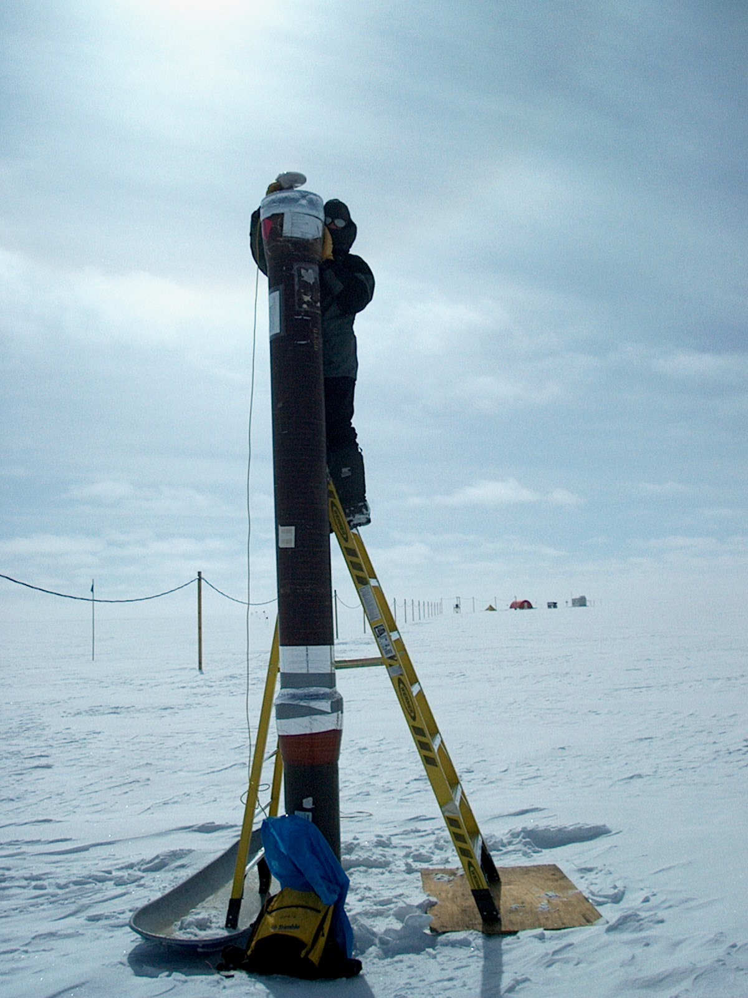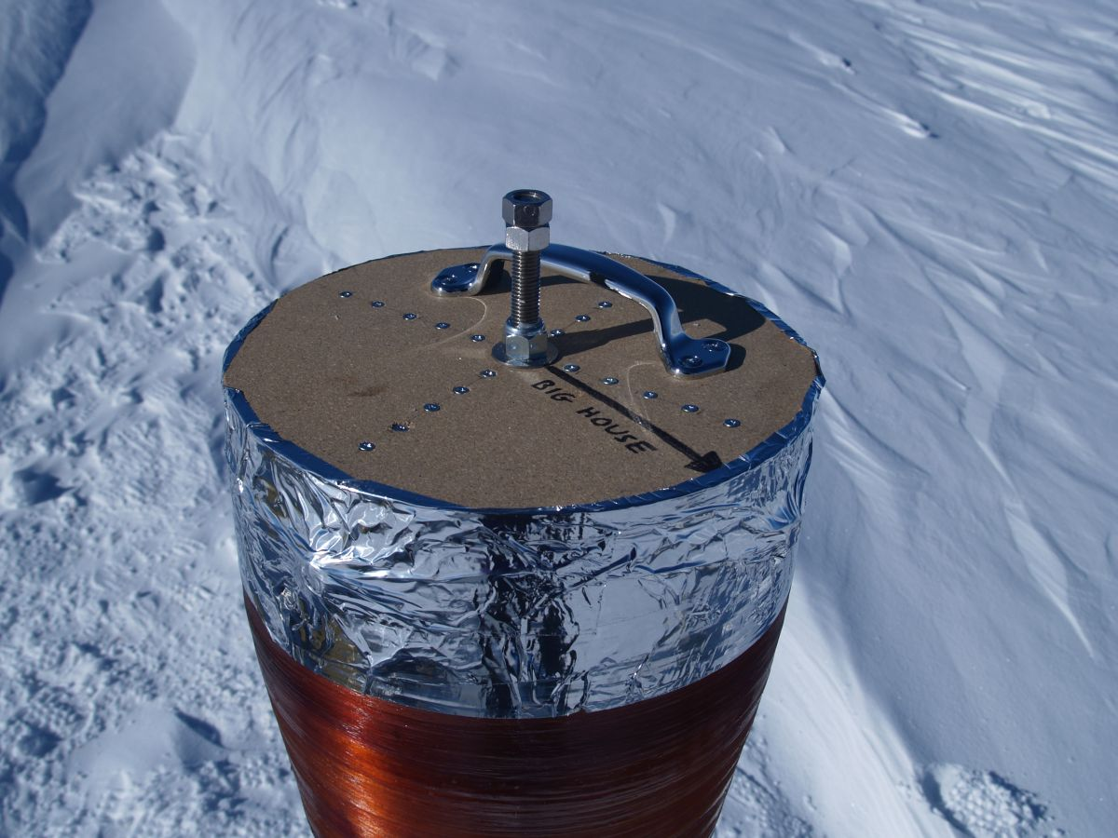

Figure 5. GISP2 borehole (June 2006) with GPS monument.

G. Software on the Science Tech computer

The Science Tech computer in the Green House has all software necessary for operating the GPS system at Summit Camp. Following is a list of software programs and their purposes. Installation CDs for almost all programs are in the UNAVCO spares Pelican case. Also, there may be certain installation files on the Science Tech computer in the C:\Program Files\ folder where the programs are installed, or in the UNAVCO folder on the Summit FTP server. The installation files for Trimble Data Transfer Utility and Microsoft ActiveSync are available from www.trimble.com and www.microsoft.com respectively.

1. Trimble Business Center. This program is used for postprocessing PPK and static survey data as well as viewing RTK survey data. This software should be used by surveyors to quality check data soon after collection; see Section H below.

A detailed how-to manual for this software is outside the scope of this document, however the software itself contains a useful Help menu. When possible, users intending to do on-site processing of GPS data should schedule training ahead of time at the UNAVCO office or their home institution. Contact UNAVCO for more information.

2. Trimble Data Transfer utility. This program is used to download data from the TSC2 data collector and from the R7 roving receiver.

3. Trimble Configuration Toolbox. Used for configuring the R7 roving receiver for static surveys.

4. Trimble GPS Configurator. Similar to Configuration Toolbox, but with more advanced programming features.

5. WinFlash. Used for advanced programming of the R7 receiver, including radio frequencies.

6. PDLConf. Used for programming the HBP-450 base radio.

7. Microsoft ActiveSync. Used to connect to the TSC2 data collector for downloading data with Trimble Data Transfer utility.

8. Keyspan USB-serial adapter drivers.

H. Quality Checking Data Using Trimble Business Center Software

Final data processing to generate research-quality coordinates is the responsibility of the science group that requested the survey. However a quick quality check should be performed by the Science Techs soon after the survey in order to verify that high quality data was collected. For processing differential GPS data, Trimble Business Center (TBC) software is installed on the Science Tech computer at Summit. An installation CD is in the UNAVCO spares case.

Instructions for using TBC are provided in a separate document, available at Summit, titled “How to Quality Check GPS Data Using Trimble Business Center”. This document is also online at the website listed in Section I.

Note that TBC cannot be used without a license. UNAVCO maintains a license server with several licenses that can be checked out by remote users. Therefore, in order to use TBC the computer at Summit must be online.

