Measuring Plate Motion with GPS
Student worksheet
Roger Groom, Cate Fox-Lent, and Shelley Olds, UNAVCO. Revised by Nancy West and Kathleen Alexander.
Under our feet is a dynamic, ever-changing Earth. Pressure builds. Time passes. Earth’s outer shell is rearranged. Sooner or later – a sudden shift releases the pent-up pressure. Earthquake! Scientists monitor Earth’s movement in advance of an earthquake so we can be more prepared.
Global Positioning System (GPS) is used to study how Earth’s tectonic plates move and deform. GPS monuments are cemented into the ground to measure how the underlying plate moves in three directions (north-south, east-west, and up-down). While GPS units in a car measure movement in miles per hour, high-precision GPS units used for scientific studies measure tectonic plate movement as slow as a few millimeters in a year. Even those few millimeters can be important--slowly moving crust can build up energy, leading to an earthquake.

Part 1: How does GPS work to pinpoint a location on Earth?
5. Sketch a diagram of the locating position demonstration, labeling the components: satellites (and the number needed to pinpoint a location), distance (time), and GPS/Earth.

6. What is the ground station’s purpose?

7. Sketch a diagram to show the parts of the gumdrop GPS and components of a GPS station:

Pinpointing location with GPS:
- What can we do with geodesy?

- What do the pieces of bubblegum represent? How far above the Earth would they actually be?

- What does each length of string represent?

- How many satellites are needed to pinpoint the location of a spot on Earth? Why?

Procedure for using gumdrops to model a GPS monument:
- Insert three toothpicks diagonally into the gumdrop (the GPS antenna). The toothpicks will act as the legs or braces to hold the monument steady.
- Insert a slightly shorter toothpick sticking straight down from the middle of the gumdrop. The tip of this toothpick should be just barely above the surface. This will be the “place marker.”
- Put very small pieces of clay on the bottom of the legs (not the place marker) and affix the GPS to the transparency. The clay acts as cement to hold the GPS monument in place. In reality, the legs are concreted deep into the ground. When the ground moves, the GPS also moves.
- Set aside this model for now. Answer questions 6-7.

Part 2: What can GPS tell us about Iceland?
Introduction: Measuring GPS Movement with Time Series Plots:
Time series plots show the position of a monument as time passes. There are three directional components: north-south, east-west, and up-down movement (We are not using the vertical motion in this exercise).

As a reference to help read time series plots, sketch what graphs look like for each direction vs. time in the box below. Use your model to envision a monument moving purely north through time. What would its graph look like? (See below for this example.)
Sketch of a GPS moving north Sketch the graph for a GPS moving south
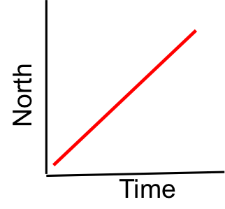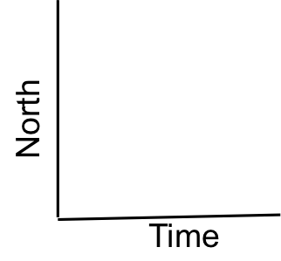
Sketch the graph for a GPS moving east Sketch the graph for a GPS moving west
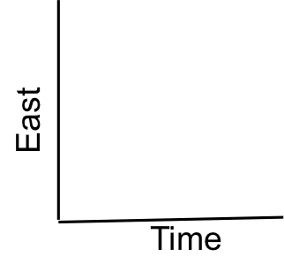

Exploring Iceland’s GPS data and maps:
By analyzing multiple GPS time series plots you can determine the directions and rates of regional deformation. As the ground moves, these GPS stations move with it. Look at the data from GPS monuments REYK and HOFN, from Iceland.

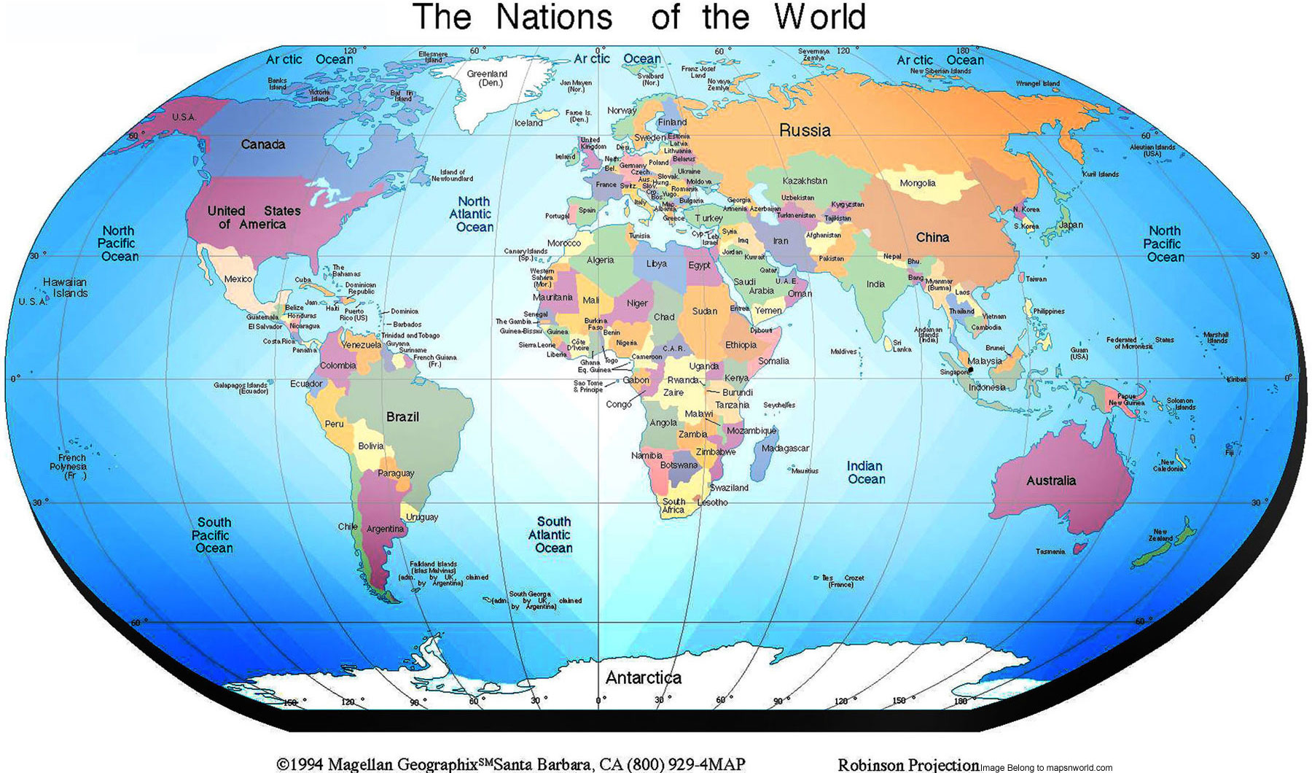
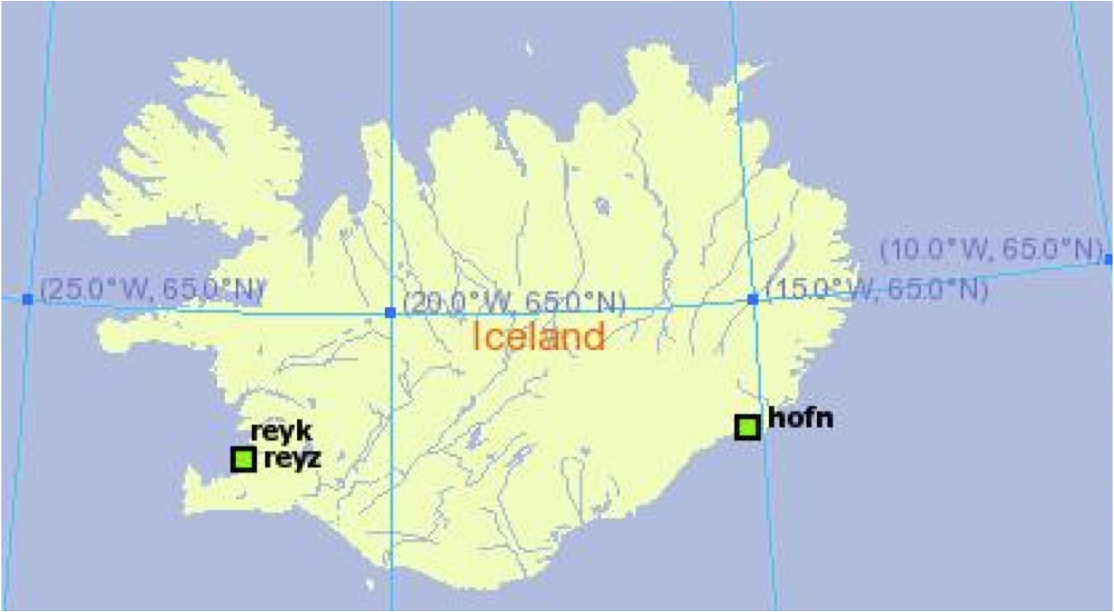

Use the data from GPS Monuments REYK and HOFN to answer the questions below.
GPS Monument REYK | GPS Monument HOFN
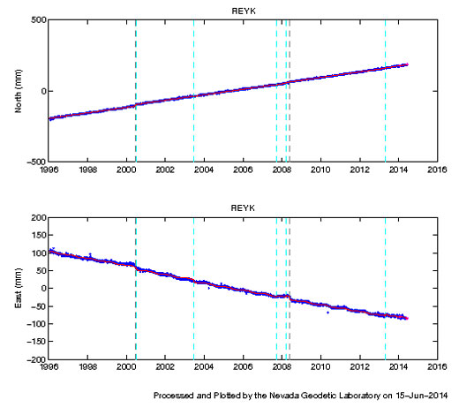  North  East | 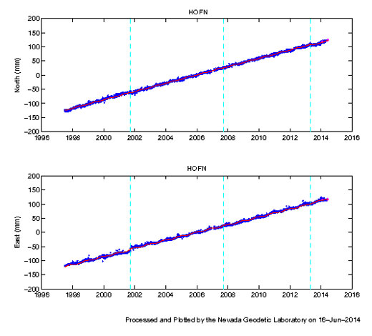

- Think, simulate the movement of each GPS using the data and the map with your gumdrop GPS models, then discuss with your neighbor: what general directions are monuments REYK and HOFN moving? How did you determine this?

REYK is moving __________ HOFN is moving ______________
- Are the two monuments moving towards each other, away from each other, or in the same direction?

- On these time series plots, the trend lines have already been drawn for you. What are the units of measurement for these time series?

X-axis uses _______________ and y-axis uses _______________________

Calculating velocities of the GPS stations:

On the next two pages are larger copies of the time series plots for HOFN and REYK. Complete the tables under the data to calculate annual motions in north-south and east-west directions for REYK and HOFN.

HOFN time series plot 1997 – 2014 (North and East plots)

HOFN North plot:  Over 10 years, how far did HOFN move? | _______ millimeters (mm) in 10 yrs
Each year, this station is moving: | ________ mm/year to the (north or south) (circle one).
HOFN East plot:  Over 10 years, how far did HOFN move? | _________ mm over 10 years.
Each year, this station is moving | _______ mm/year to the (east or west).
HOFN: Do you findings agree with your previous answer about the general motion of HOFN?

REYK time series plot 1997 – 2014 (North and East plots)
(Movements to the south and east are written as negative numbers).
REYK North plot:  Over 10 years, how far did REYK move? | ______ millimeters (mm) in 10 years
Each year, this station is moving: | ______ mm/year to the (north or south). (circle one)
REYK East plot:  Over 10 years, how far did REYK move? | ________ mm over 10 years.
Each year, this station is moving… | _______ mm/year to the (east or west).
REYK: Do you findings agree with your previous answer about the general motion of HOFN?

Displaying Horizontal Velocities on a Map
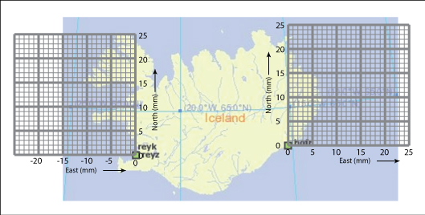
HOFN
North: ___ mm/yr
East: ___ mm/yr
REYK
North: ___ mm/yr
East: ___ mm/yr
We know the velocity each monument is moving in the north-south direction and in the east-west direction. Now we are going to add these together to show the total horizontal motion.
- Copy your answers from the previous pages for REYK and HOFN onto the blanks at the bottom of the map of Iceland. Remember that directions to the south and west are written as negative values. REYK is on the west side of Iceland; HOFN is on the east side of Iceland.
Drawing vectors to show velocity:
What is a vector?  A vector is a special type of arrow that shows velocity and direction of motion. We can draw a vector to show the north motion and another vector to show the east (or west) motion. By adding them together we can show the total horizontal motion!  - The vector’s tail is the starting location of the GPS monument.  - The direction the vector points is the direction the GPS station is moving.  - The length of the vector represents the velocity the GPS monument and the land beneath it is moving. |  |  | 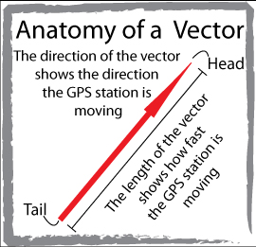
Adding vectors: Step 1.  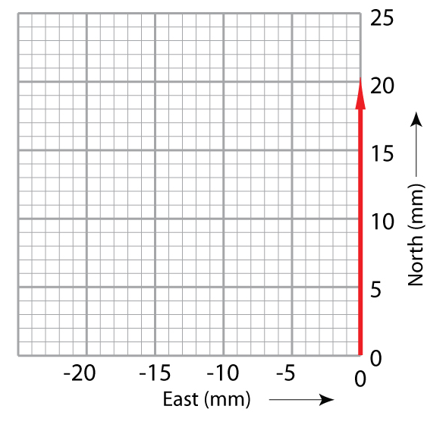  Start at the origin (0,0) draw a light arrow along the north axis the length equal to the north velocity (e.g. one block is 1 mm/yr.) | Step 2.  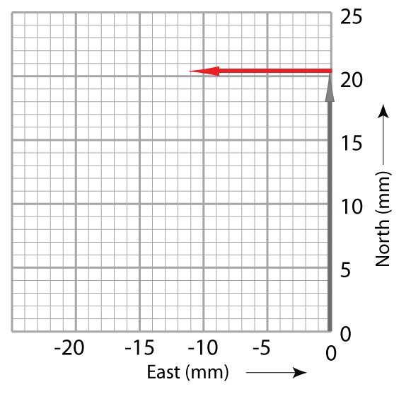  Draw the east vector from the end of the north vector’s arrowhead.  (A vector moving west is drawn to the west.) | Step 3.  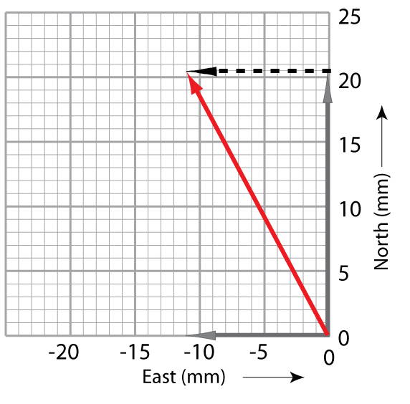  Draw a diagonal arrow from (0,0) to the arrowhead of the east vector.  This new vector is the sum of the north and east vectors.
- Following the steps above, use the graph paper on the map near REYK to add the North and East velocities together to find the total horizontal velocity for REYK on previous page.
- Using the same procedure, draw the total horizontal motion vector for HOFN.
- Use your gumdrop models to simulate this motion by moving your model along each vector, starting at the tail and moving the model toward the head. Does this match the movements you had simulated the beginning of Part 2?
Interpreting the data and maps:
Work with a partner to answer these questions.
1. Describe how the resulting vectors of the two GPS monuments REYK and HOFN are different and how they are similar.

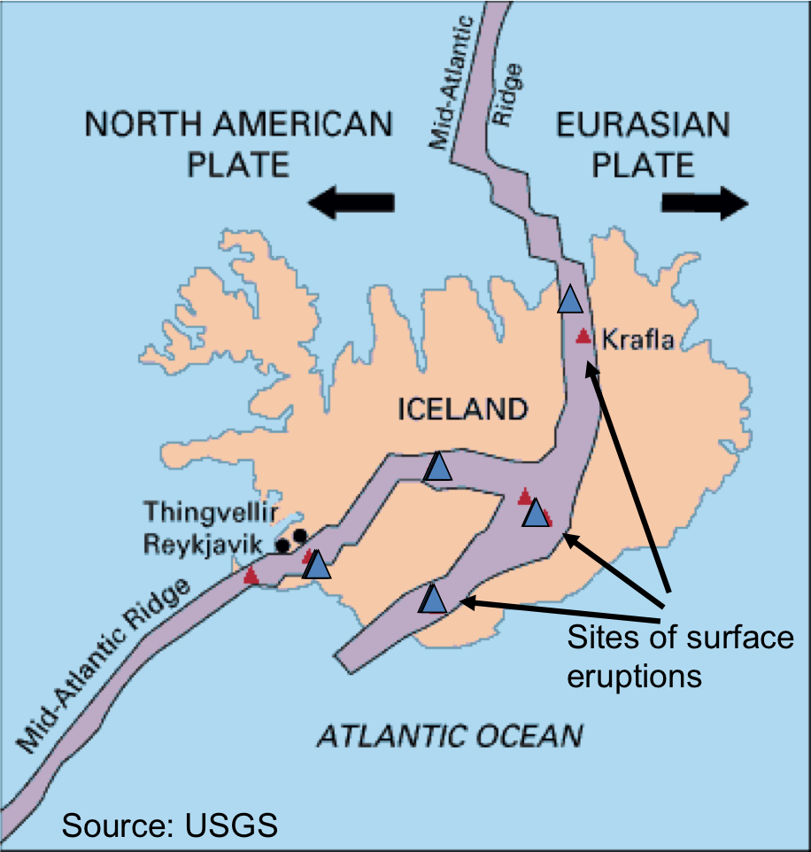
2. Remember that the monuments are fastened to the ground. If they are moving, then the ground must be moving. If you flew in a plane over Iceland, 1000 years from now, how far apart will the monuments be in the east – west direction? (Hint, go back to the East graphs)

3. Give one possible explanation for the way the ground is moving in Iceland. What’s filling in the gap that is forming?

4. The map shows the location of recent lava eruptions in Iceland. On your map with vectors, sketch in the Mid-Atlantic Ridge. In what way does this support or conflict with your explanation?

5. What kind of tectonic boundary is this?

Bonus: Where else in the world do we see seafloor spreading? Where in the past have we seen seafloor spreading? If your teacher directs you to use computers, use the UNAVCO Velocity Viewer to explore the world to find this answer.

Calculate the magnitude of the annual motion vectors for REYK and HOFN. You can use a ruler and the graph paper to create a scale or you can use the Pythagorean theorem. (That is, take the square root of [(north velocity)² + (east velocity)² ].)

There are a few gaps in the data for some of the stations. Given what you know now about how GPS data is collected and their location in Iceland, give two possible causes for the gaps.

Extension – Explore plate motions using GPS data on the UNAVCO Velocity Map tool:
Good job! Now you can look at scientific GPS time series plots and figure out the direction our Earth’s tectonic plates are moving! Go explore using the UNAVCO GPS Velocity Viewer: (Google search for UNAVCO GPS Velocity Viewer)
http://www.unavco.org/software/visualization/GPS-Velocity-Viewer/GPS-Velocity-Viewer.html
Key features of the Velocity Viewer are:
- High precision GPS from the Plate Boundary Observatory (PBO) and other networks;
- Web-based free platform;
- Data-sets: near-real time (PBO); historical (GSRM);
- Plate motion is relative to a reference frame; and
- Changing the reference frame changes the perspective of plate motion.

- Where else in the world do we see seafloor spreading? Sketch a few vectors that indicate plate(s) spreading (a divergent boundary).

- Find areas with high rates of motion - where are these areas? Where are areas that have high rates velocities near low velocities? What could this mean long term?

- In regions where plate motions are relatively slow, how would you change the size of the vectors?? What do you observe? How does the purple vector (which represents 25 mm/yr in length) change?

- Look at the same part of the world and change the data sources to show different reference frames. Try some of the data sources labeled modeled at the bottom of the list. What do you observe? Can you predict the types of plate boundaries in different areas of the world? Check your predictions… turn on the plate boundaries layer and other layers – how do they complement each other?

Part 3: Apply your knowledge
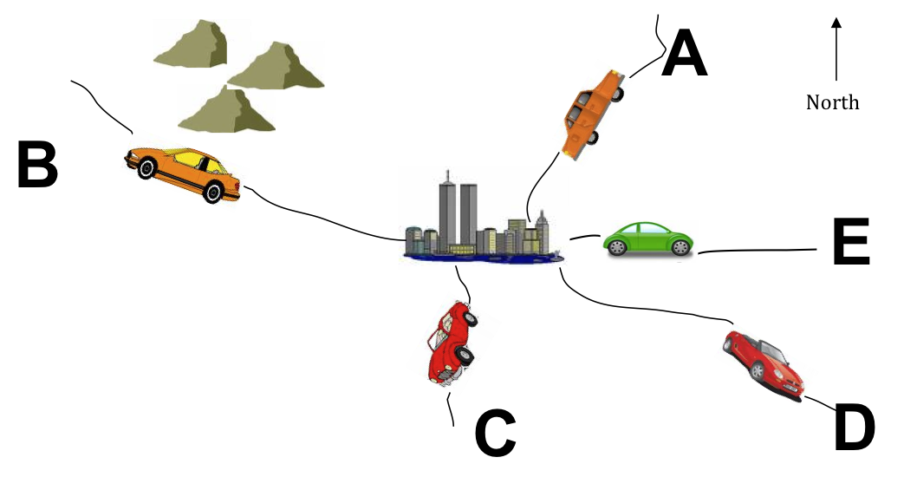
Which car matches the graphs?
- Look at the North and East pair of graphed data below and describe the direction the car would be moving and identify the letter of the car (on the map) that most closely matches the direction shown by the graphs. The first example has been done for you.
 |  | Direction | Car letter
i. | 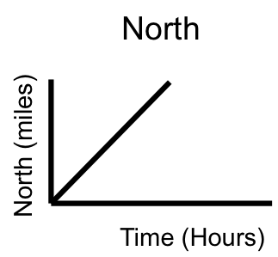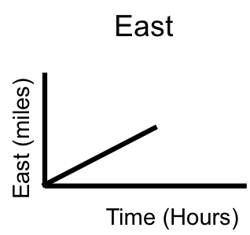 | north-northeast | Car A
ii. | 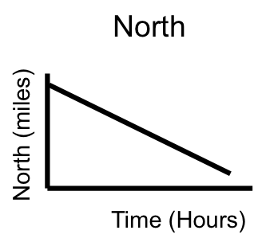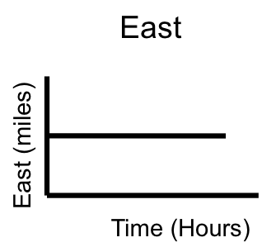 | Direction:  _______ | Car:  _______
iii. | 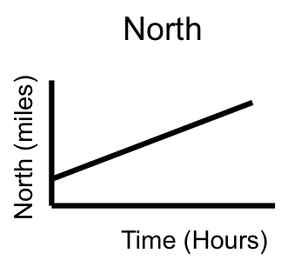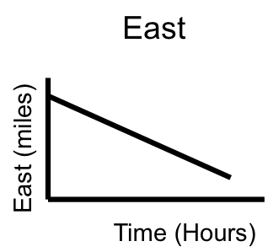 | Direction:  ______ | Car:  _______

For the two cars remaining, identify the car letter and direction it is moving, and draw the north and east graphs that match each car’s direction.
iv. Car letter _______  is moving _________ | 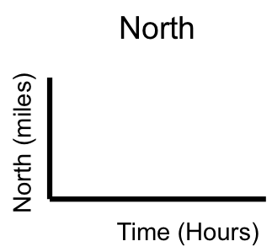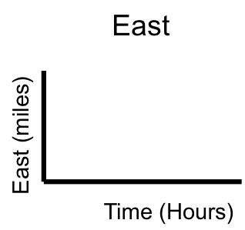
v. Car letter _______
is moving _________

