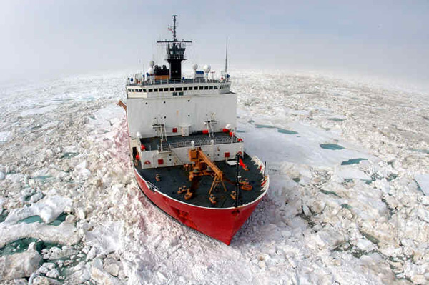
Getting to know you…
This activity is designed to introduce the participants and instructors to one another, to investigate some facts about plate tectonics, GPS, and earthquakes and how they have affected people in the group.
Directions: Mingle with your course participants, obtain her/his initials & answer.
I have stood on a major fault  Name of fault:  Initials: | I have experience with a tsunami  When / where?  Initials: | I know how plate move motion can be directly measured  How?  Initials:
I have seen a ghost forest  Where?  Initials: | I know about oral history of Cascadia  Location?  Initials: | I have used data in my teaching  Type of data?  Initials:
I have used a GPS unit or GPS data in my teaching  I use it for…  Initials: | I have felt an earthquake  When? Did you observe any damage?  Initials: | I have lived on more than one tectonic plate  Which Plates?  Initials:

