# Map Packet

Earthquakes of Western United States

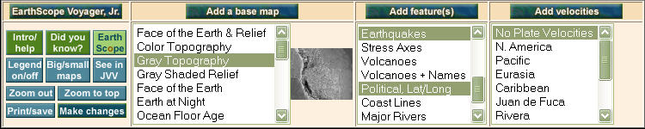

# eq_greyTopo_mapVolcanoes of Western United States

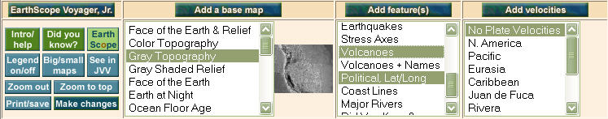

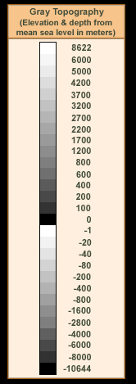

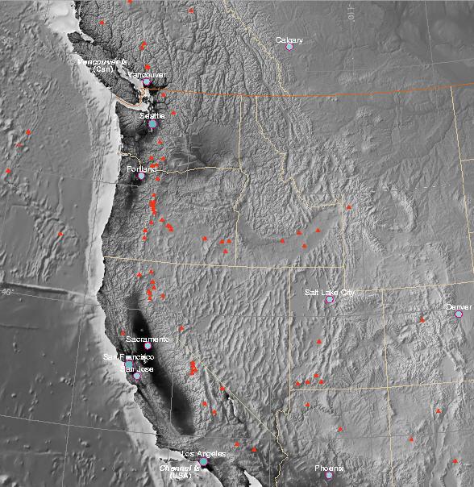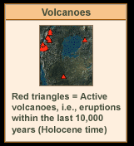

# Plate Velocity Vectors: Pacific Northwest, United States

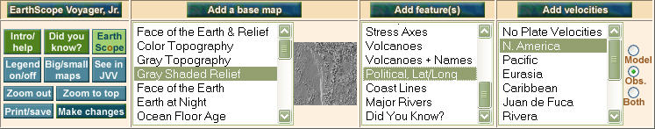

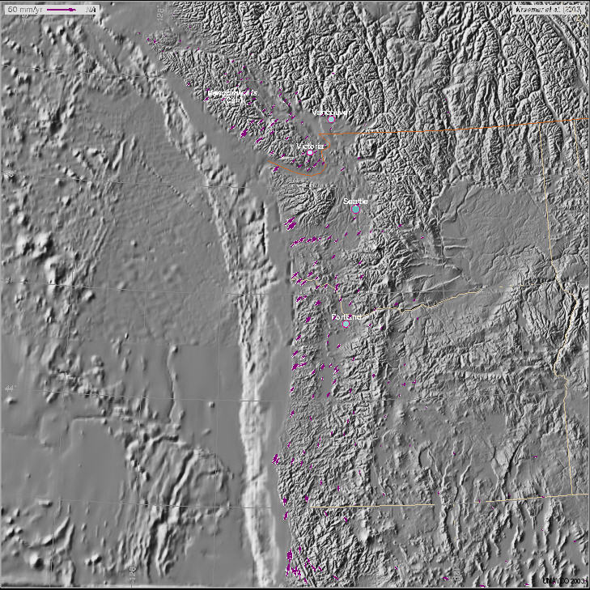

# Plate Velocity Vectors: California, United States

# SoCal_N_AmVectors_grShaded_mapSoCal_N_AmVectors_grShadedPlate Boundaries of Western United States

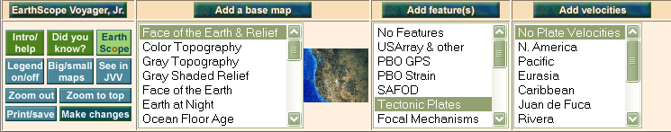

# Extra Blank Map of the Western U.S.

# greyTopo_map