Introduction to Graphing of GPS Data *Student Worksheet*

Roger Groom, Cate Fox-Lent and Shelley Olds. Revised by Nancy W. West and Kathleen Alexander

Introduction:

*You might have used a Global Positioning System (a “GPS”) to steer yourself towards a destination on foot or in a car. Scientists use GPS for that too—and for measuring how a given spot on Earth moves over time. These high-precision GPS stations are anchored to the ground with concrete so that, as Earth’s crust moves or deforms, the station moves, too. The stations, or “monuments,” detect crustal movement as small as a few millimeters a year. That’s tiny – even small motions can tell us a lot about Earth.*

*Scientists use graphs to show the creeping of GPS monuments over time. This exercise leads you to make some of these graphs and then to make sense of them. You’ll begin with simple data and then you’ll use data from real GPS stations in the western United States.*

# http://www.unavco.org/highlights/2007/gnet-1.jpg

# Abel Brown from the Ohio State University awaiting pick-up after installing GPS station TIMM on Timmiariit Island in southeast Greenland.

# Part 1: Determine the Direction of Movement of a bicycle through a city

First, let’s look at the route a bicycle could take through a city.

1. Look at the simple map of a small city below. Each street is shown as a line. In the space provided, sketch on the map and write down the directions for the route that you would give to Jose to ride to the building.

Your Directions – (What direction? How many blocks? …): _____________________________________________________ ______________________________________________________________________________________________________________________________________________________________ After the class discussion, how would you improve your directions? ____________________________________________________

_

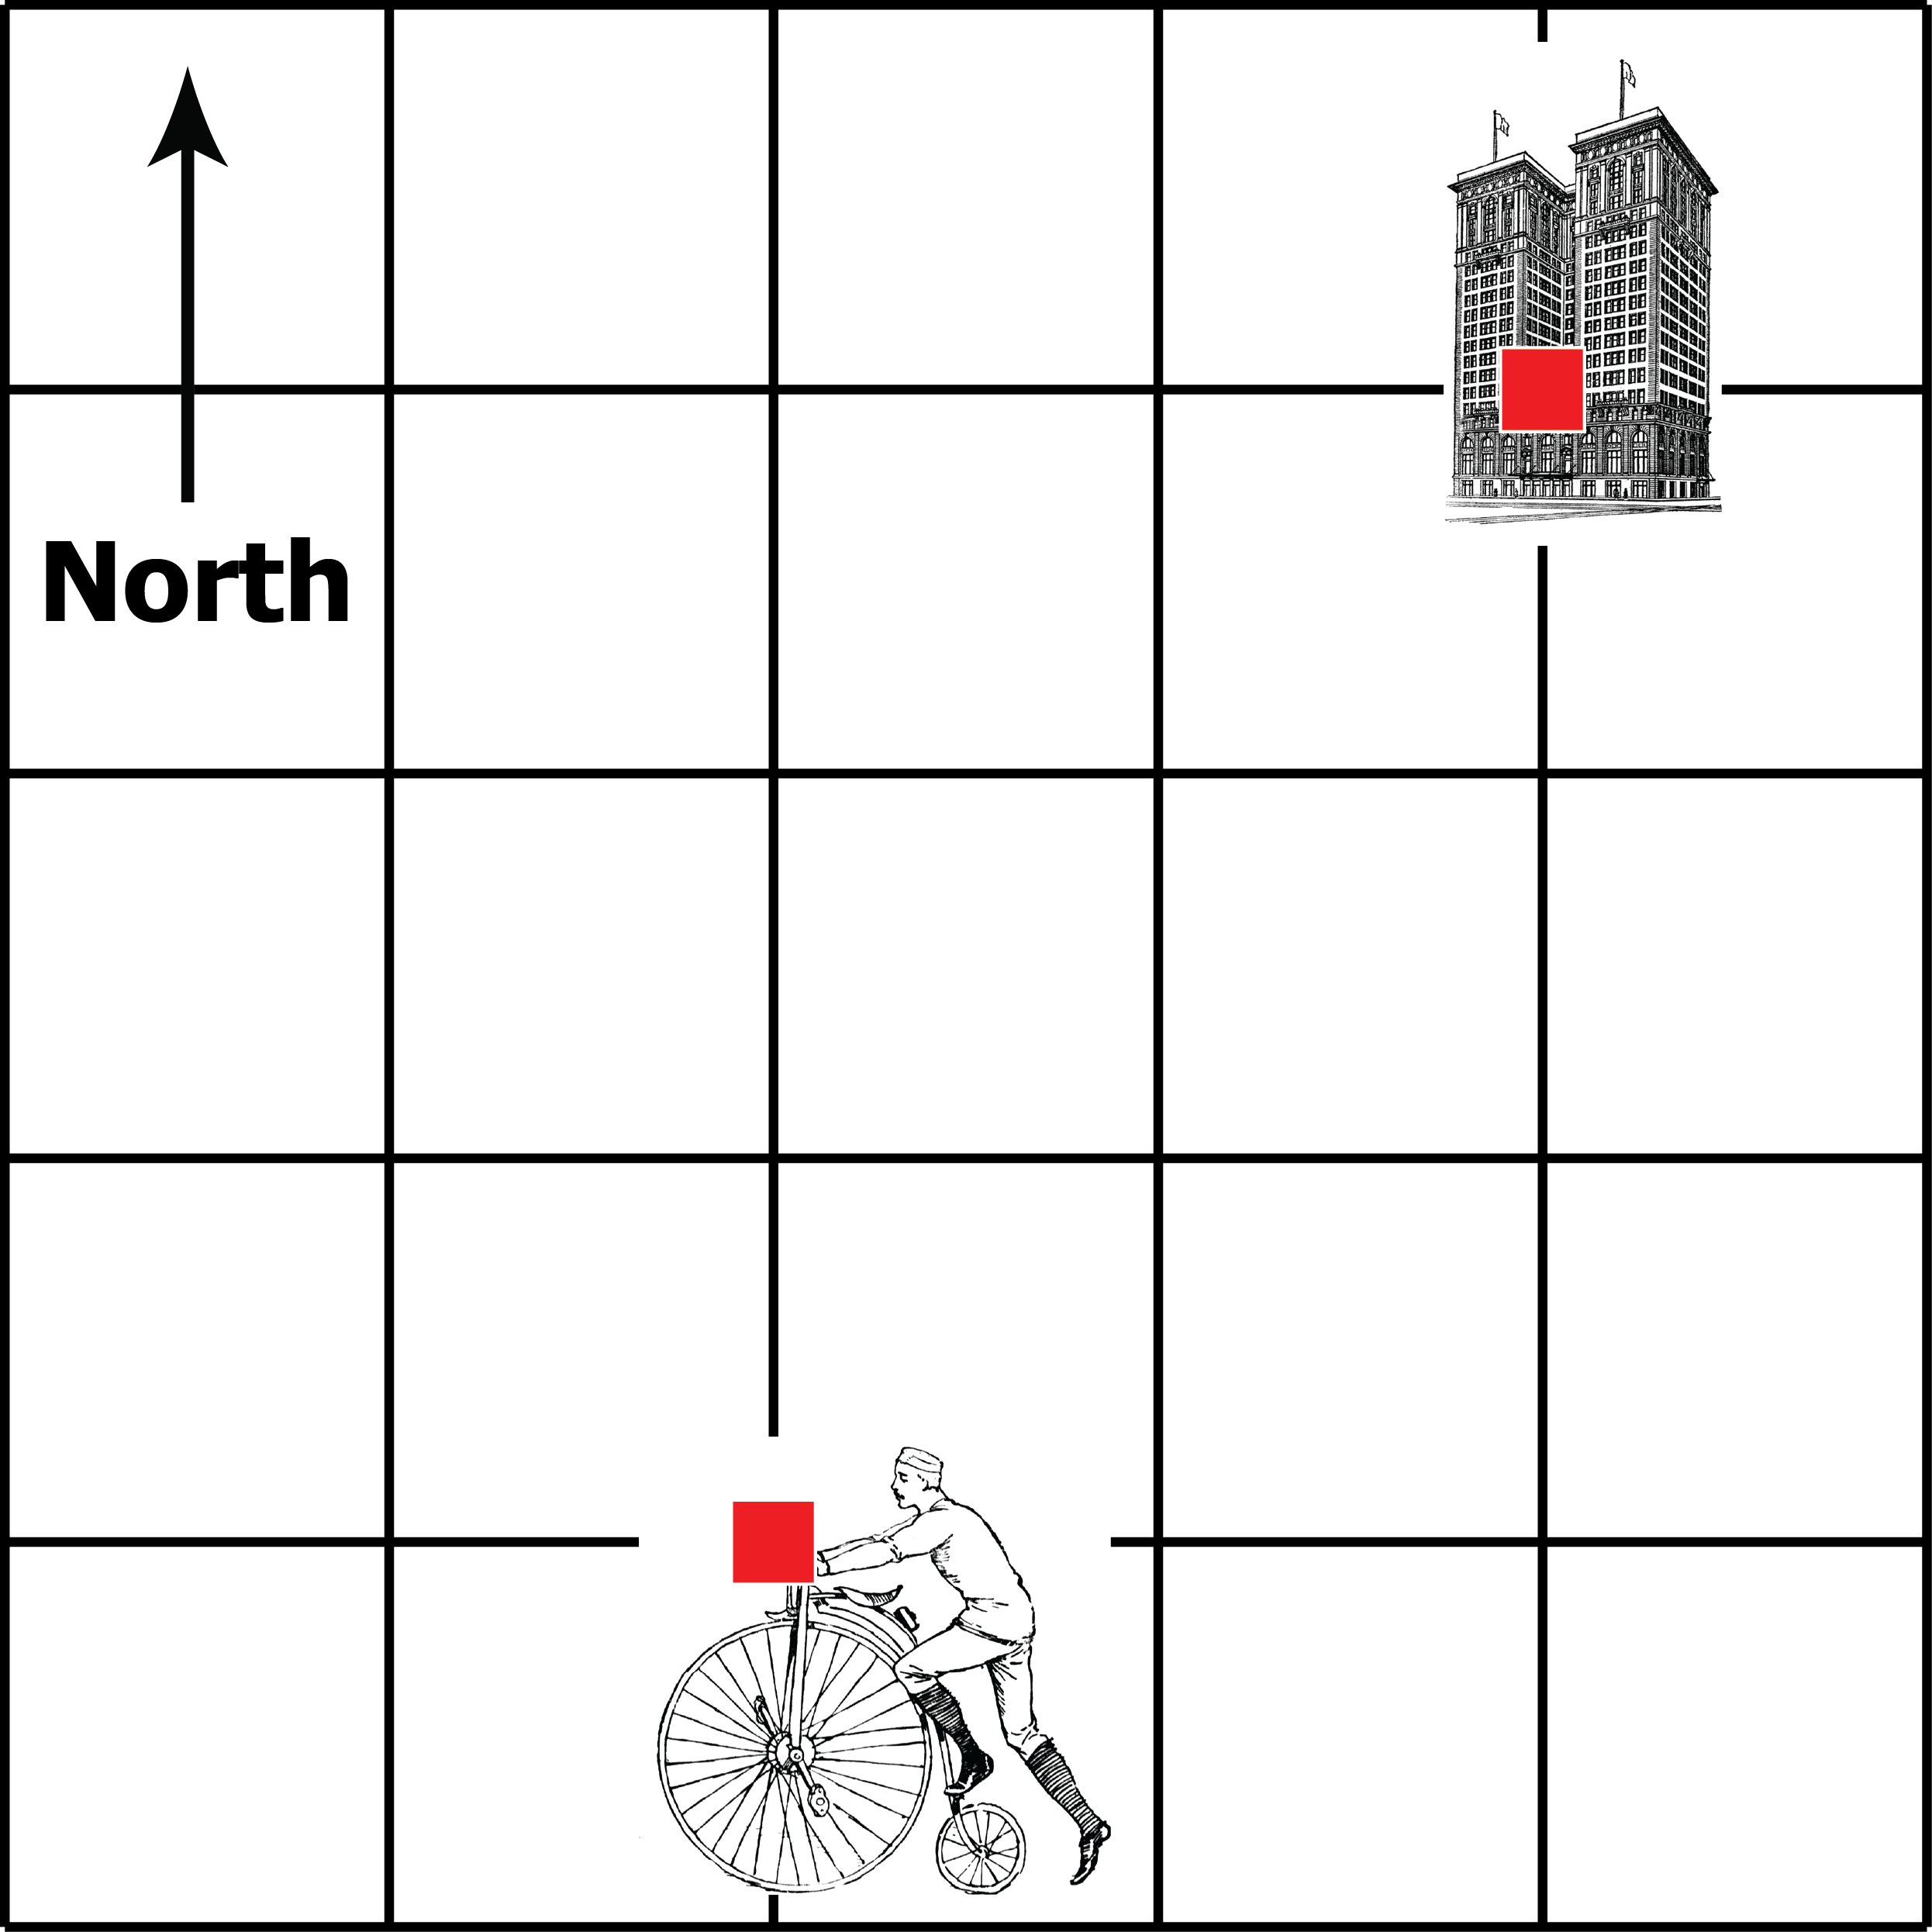

1. This is Jose’s route shown in a data table – each row shows Jose’s position after each minute. The data shows the position (total number of blocks) Jose moved north and east from his starting point after each minute. The first column shows Time in minutes.

|  |  |  |
| --- | --- | --- |
| Time (minutes) | North  (blocks) | East  (blocks) |
| 0 | 0 | 0 |
| 1 | 0 | 0.5 |
| 2 | 1 | 1 |
| 3 | 2 | 1.5 |
| 4 | 3 | 2 |

We will make two different graphs. The NORTH column shows the position of the bike after each minute. Place a dot on the graph below marking each minute. The location of the bike for minutes one and two have been plotted for you.



The line on the North vs Time graph was moving in the positive direction. What direction would a bike be going if the numbers decreased from 3 to 1?

*Your answer:* _________________________________________________

Now make a graph showing how far EAST the bike had moved after each minute.



On the second graph you made, the numbers for the East direction got bigger over time. What direction would a bike be going if the numbers got smaller over time?

*Your answer:* ______________________________

Now let’s plot the North and East together on a map to figure out where the route of this bike. Plot the location of the bike (north and east) at minute 1, minute 2, minute 3, and minute 4 on the map starting at 0,0 on the map:

North



East

Draw an arrow starting from the dot for the first minute to the final dot at 4 minutes. According to your map, what direction is the bike moving? *Your answer: _______*___________

# Part 2: Determine the Direction of Movement using Fictitious GPS Data

In Part 1, we made two types of graphs of the movement of a bicycle through a city. The type we made of a graph of the movement of the bike (measured in city blocks) vs time. The other type of graph used a coordinate system to map out the bicycle’s movement using North vs East.

Now we’ll take a look at some GPS data. Similar to the GPS in a car, a high-precision GPS collects data as coordinates such as latitude, longitude, and elevation with a time stamp. Scientists convert the data into three directions: north, east, vertical, plus the time each data point is collected.

The data in the table on the next page shows how far fictitious GPS monument A moved each year. The first column shows the time, in years. The other two columns show how far the monument moved in the north-south and east-west directions, in millimeters. You will make graphs to display and understand this data.

## GPS Monument A

|  |  |  |
| --- | --- | --- |
| **Year** | **North**  **(mm)** | **East**  **(mm)** |
| 2000 | 0 | 0 |
| 2001 | 1 | 1 |
| 2002 | 2 | 2 |
| 2003 | 3 | 3 |
| 2004 | 4 | 4 |
| 2005 | 5 | 5 |

1. Make a North vs. Time graph for GPS Monument A by placing a dot on the grid below marking each year. On your graph, each block represents 1 millimeter (mm). The locations of the monument for the years 2000 and 2001 have been plotted for you.
   1. What direction is GPS Monument A moving as time passes? North or south?

*Your answer: __________________*

* 1. Explain how you know this. ___________________
  2. What direction would the monument move if the North position *decreased* from 5 to 0 from year 2000 to 2005?

*Your answer (north or south):* ____________________

1. Make an East vs. Time graph showing how GPS monument A moved every year. 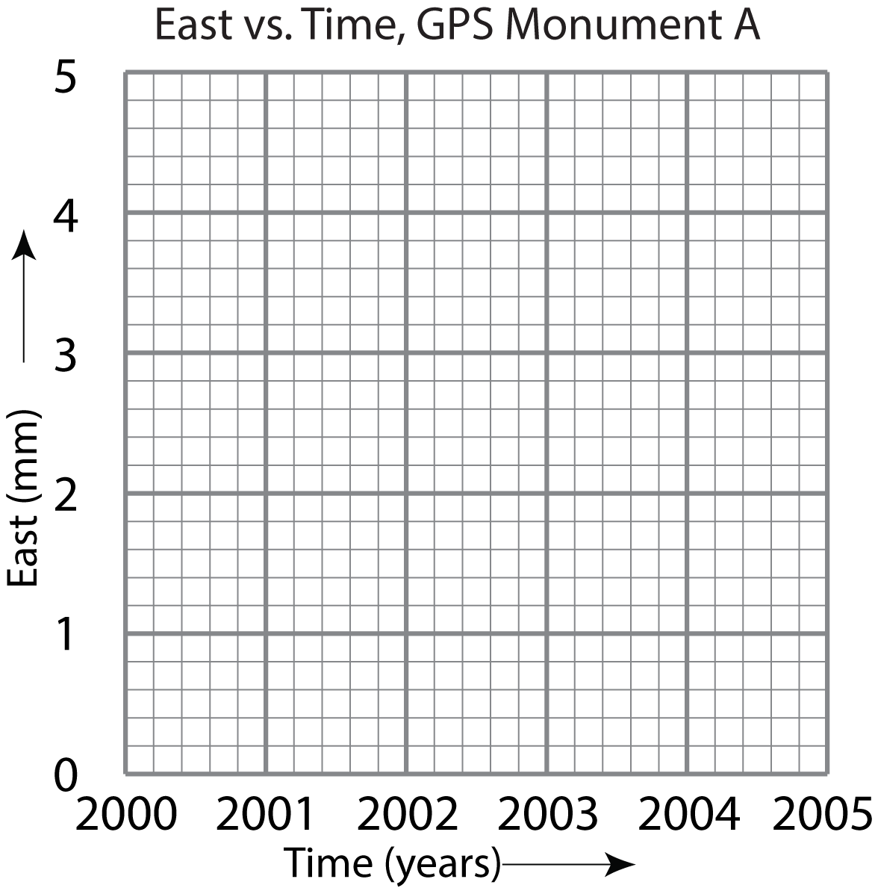
2. What direction is GPS monument A moving? East or west?

*Your answer: _________________*

1. What direction would the monument move if the East positions *decreased* from 5 mm to 0 mm from years 2000 to 2005?

*Your answer (east or west):*

______________

## GPS Monument B

You’ve learned that when a monument moves north or east, the numbers increase. And, in the case of monument A, all of the values are positive. That is not always the case. Look at the data for monument B next.

1. Focus first on the North data:

|  |  |  |
| --- | --- | --- |
| **Year** | **North**  **(mm)** | **East**  **(mm)** |
| 2000 | -5 | 0 |
| 2001 | -4 | -2 |
| 2002 | -3 | -4 |
| 2003 | -2 | -6 |
| 2004 | -1 | -8 |
| 2005 | 0 | -10 |

a. Is North data for monument B increasing or decreasing?

*Your answer:* _________________

b. Is GPS Monument B moving north or south?

*Your answer:* ______________

Graph North vs. Time.

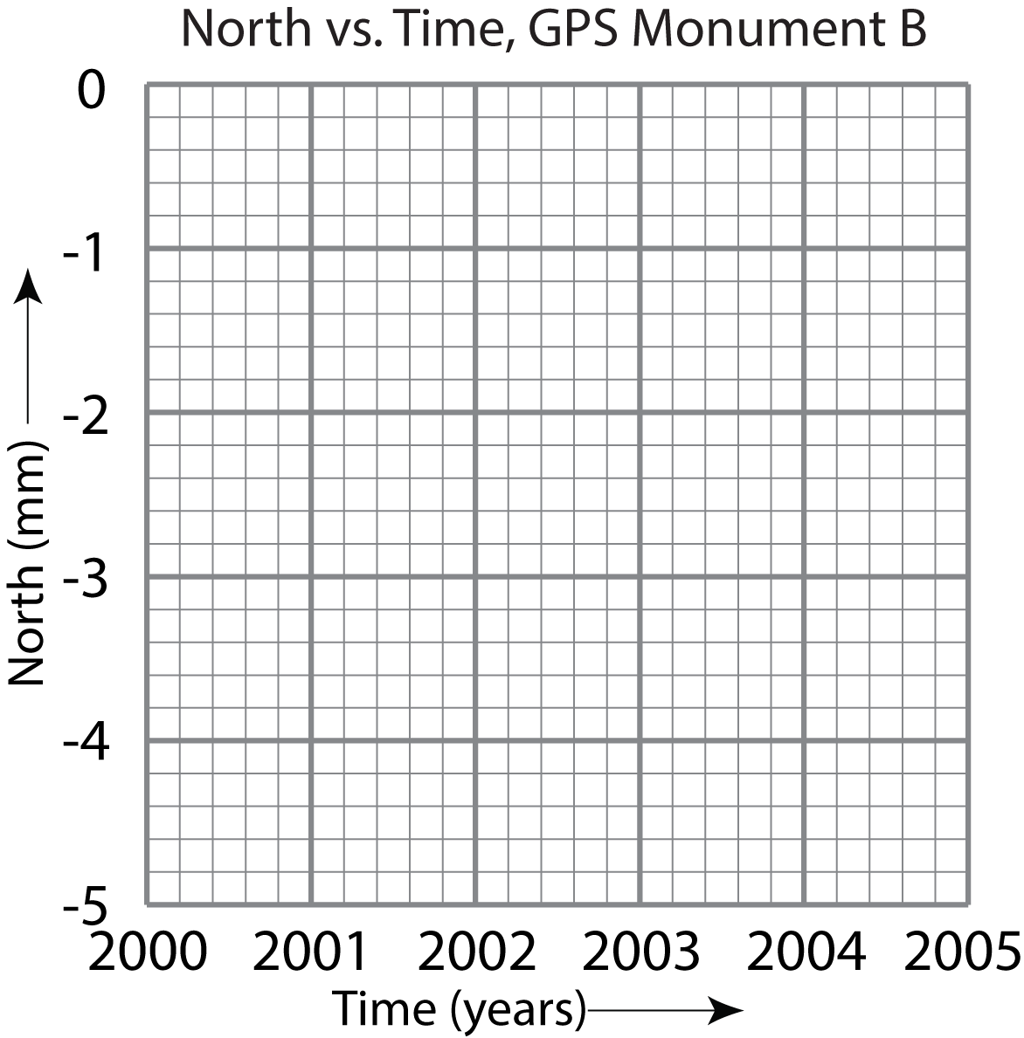

2. Now, focus on the East data of Monument B:

a. Are the values for monument B becoming more positive or negative?

*Your answer:* _________________

Is GPS monument B moving east or west?

*Your answer:* __________________

Graph East vs. Time in both of these two grids.

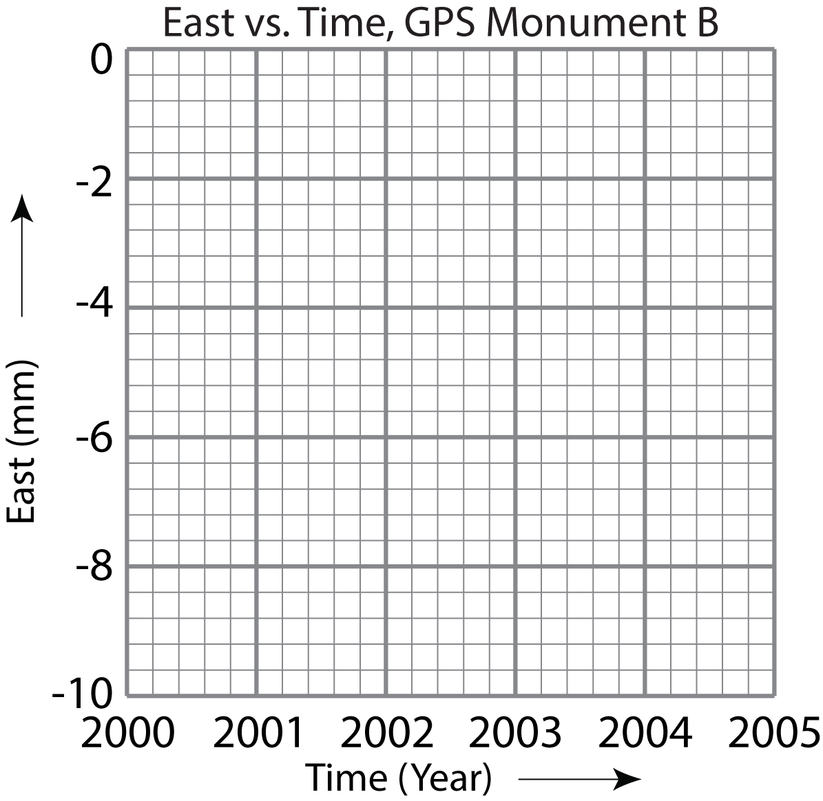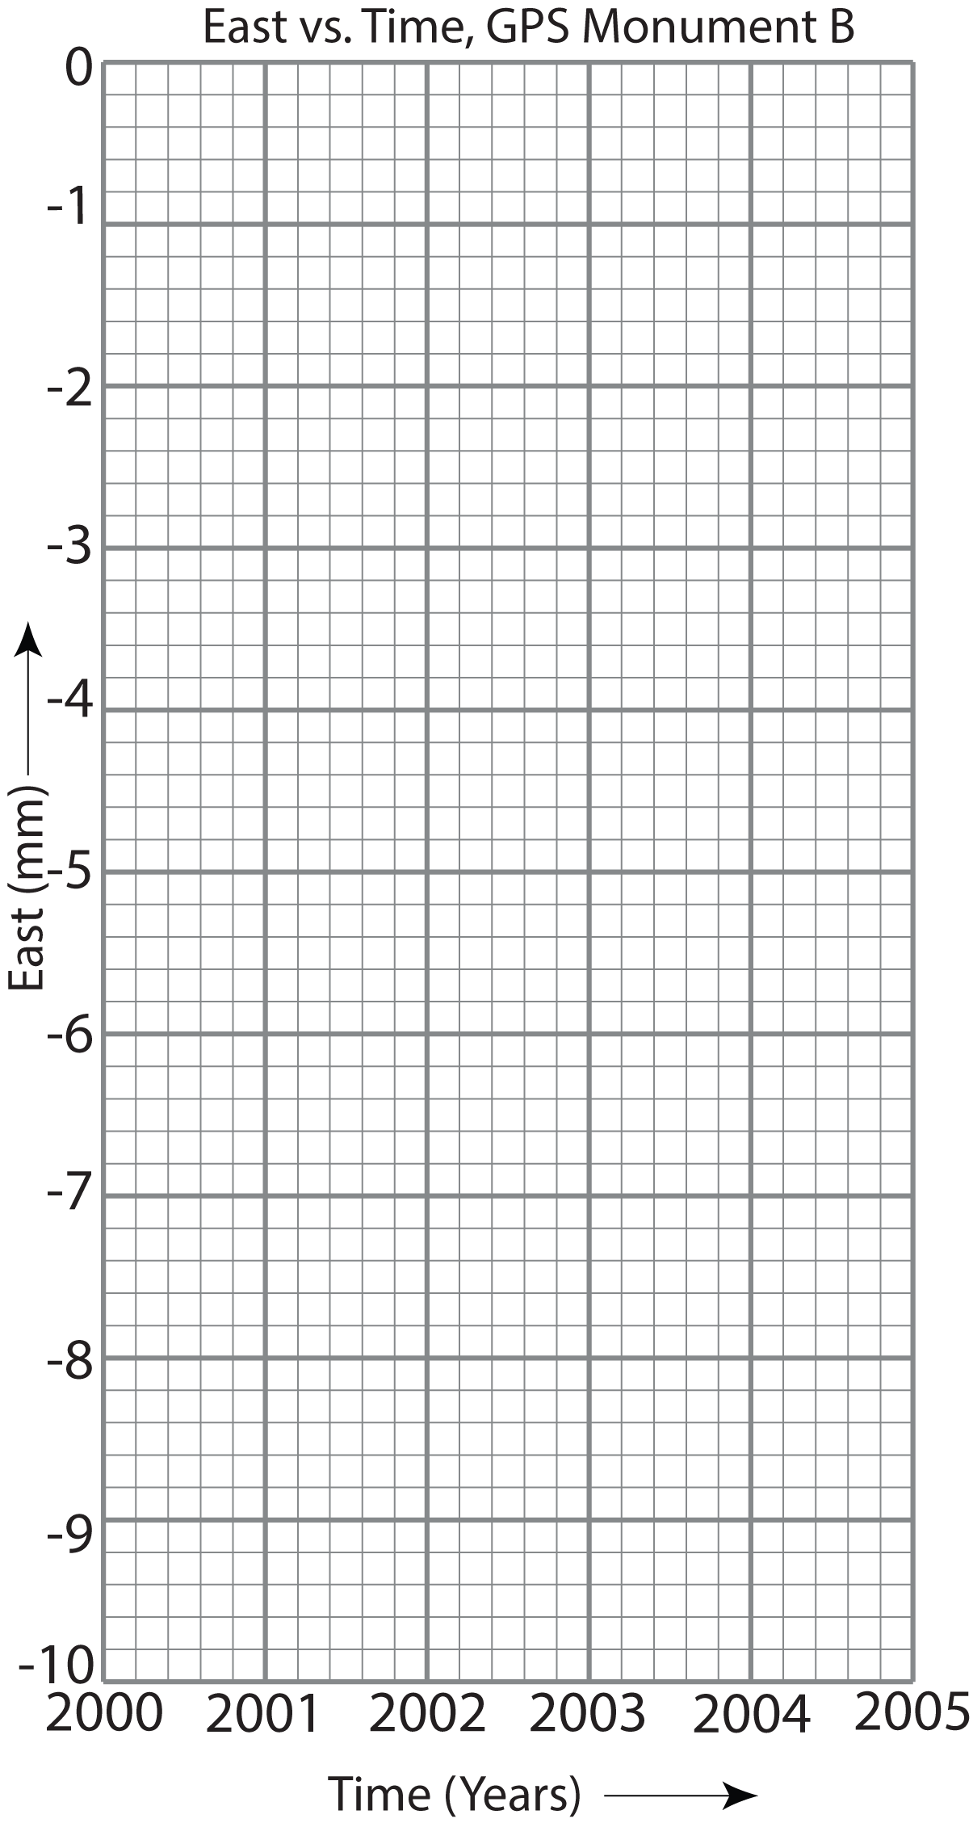c. What is the effect of changing the scale on the grids?

*Your answer: _________________________*

______________________________

d. Compare the North vs. Time to the East vs. Time graphs. What are some of your observations? (Use the long version of East vs. Time because each block outlined with darker ink represents 1 mm of motion in both graphs.) *Your answer: _______________*

e. Summarize in words and/or drawings what trends in data tell you about the north-south movement of a GPS monument. For example, “When the values increase over time in the North data, it means that … but when they decrease, it means that….”

*Your answer: ___________________*______________________________

f. And the east-west movement:

*Your answer: ___________________*_____________________________

Note: Independent vs. Dependent Variables:

Graphs are usually set up so that the horizontal (x) axis is for values independent of our control. For example, when time is one of the things you graph, you plot it on the *x*-axis -- time marches along no matter what. Time is therefore the ________________ variable. The *y*-axis is for the component that changes depending on time. This is called the ________________ variable. (A review of independent vs dependent variables is available on [MathBench Visualization – A graphing primer](http://mathbench.umd.edu/modules/visualization_graph/page02.htm).)

# Part 3: Determine the direction of movement of real GPS monuments

Introduction

In the western U.S., positions measured by research GPS stations often have negative values, and they typically have decimal places. That makes graphing by hand more challenging, but still doable. Do the best you can by rounding numbers, estimating between grid lines, and remembering that it is the trend you see in the numbers and graphs that counts.

## Example 1) GPS Station P430, western Washington



|  |  |  |
| --- | --- | --- |
| **Date** | **North**  **(mm)** | **East**  **(mm)** |
| 2008 | -35.5 | -53.8 |
| 2009 | -29.9 | -46.3 |
| 2010 | -22.9 | -39.8 |
| 2011 | -17.8 | -35.0 |
| 2012 | -12.8 | -29.2 |
|  |  |  |

Figure : Location of GPS station P430

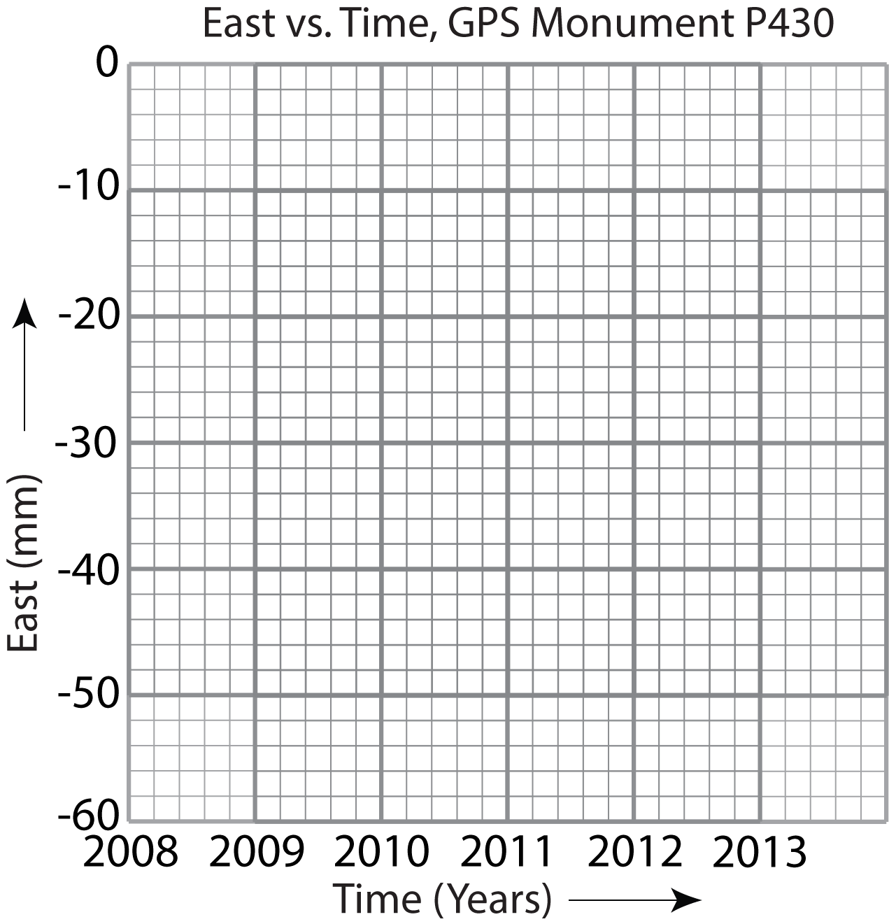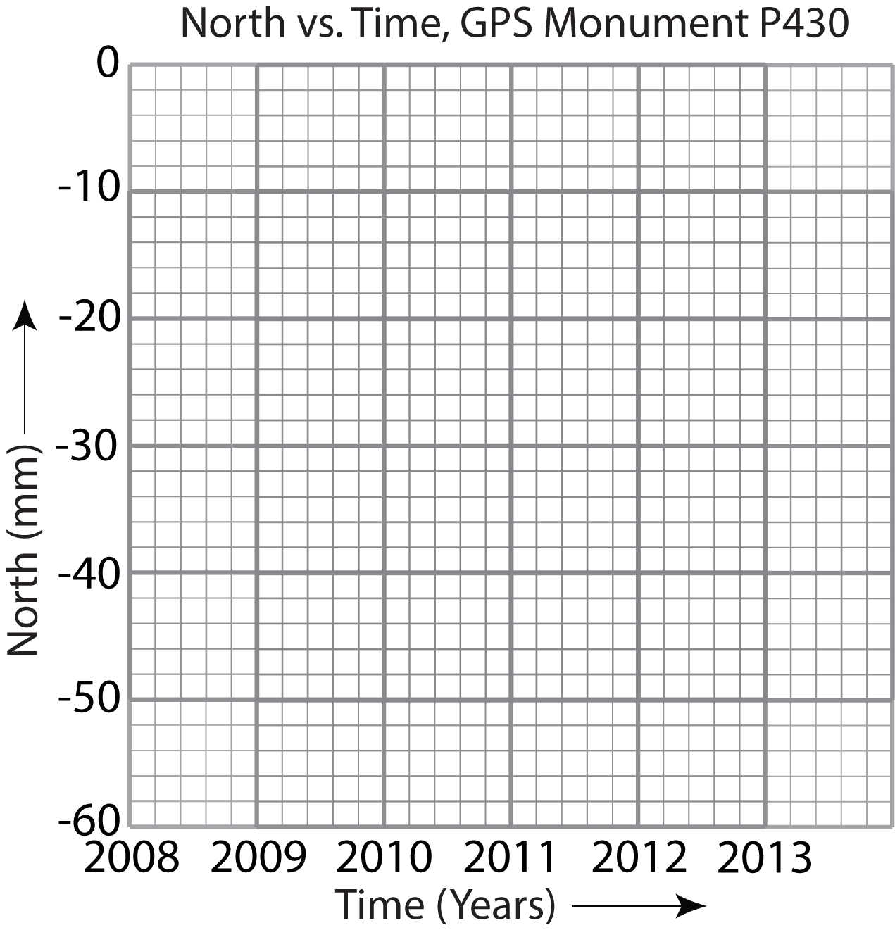1. On the grids below, graph North vs. Time and East vs. Time. On the vertical axis, the *y*-axis, each heavy line equals 10 mm. Each light line is 2 mm. A number like -22.9 will be about halfway between -22 and -24. Values like -46.3 plot a little below -46..

a. Is station P430 moving north or south? *Your answer:* __________________

b. And east or west? *Your answer:* __________________

Notice that the scale is different than on previous graphs because the spread in data is larger. For the North vs. Time graph, there is a spread of about 23 mm (from -12.8 to -35.5); for East vs. Time, it is about 25 mm (-29.2 to -53.8). The scaling accommodates the range of data.

|  |  |  |
| --- | --- | --- |
| **Date** | **North**  **(mm)** | **East**  **(mm)** |
| 2008 | -52.0 | -37.4 |
| 2009 | -12.9 | --60.5 |
| 2010 | 22.1 | -76.1 |
| 2011 | 54.9 | -95.1 |
| 2012 | 86.5 | -114.5 |
|  |  |  |

## Example 2) GPS Station P157, northern California



Figure : Location of GPS station P157

1. Graph North vs. Time on a piece of graph paper.

a. For these graphs, you’ll have to decide how to scale each axes.

Here’s how: Time will go on the horizontal (x) axis. Place years evenly across the axis from the minimum year to the maximum year, on heavy lines—if your graph paper has them.

As before, North positions will go on the vertical (y) axis. (The positions vary over time; their value depends on when they were made.) The North data ranges from -52.0 to 86.5. How big a spread is that? (To make life easier, round -52.0 down to -50 and round 86.5 up to 90 or even 100.) Write numbers in even intervals: every 10 or every 20, for instance--for each heavy line on the graph paper.

b. Place the data on the graph, one dot per year. You will need to estimate where to spot the data points between lines. (This is what pencils and erasers were invented for….)

2. Now, graph East vs. Time.

a. Choose a scale for both axes. Do you see any reason to change the *x*-axis?

For the *y*-axis, data ranges from -37.4 to -114.5. If your scaling starts at 0 and goes lower than -114.5, choose a round number to end your scale. Think about what a convenient interval would be. Write those numbers at the dark lines on the graph paper. Again, estimate where to put each point between grid lines.

b. To be complete, draw a small circle around each plotted points on each graph for P157. It’s called “protecting the point,” like a moat around a castle. You’ll see why soon. Also, label both axes, and add a title at the top.

c. Is station P157 moving north or south? *Your answer:* __________________

d. East or west? *Your answer:* __________________

e. How do the rates of the north-south motion compare to the rate of east-west motion? Before you answer, think about how the scale of the *y*-axis could trick you.

## Example 3) GPS Station P058, northern California

Unlike data for monuments P430 and P157 that were average positions for the year, data for P058 is the monument’s position on specific dates.

|  |  |  |  |
| --- | --- | --- | --- |
| **Date** | **North**  **(mm)** | **East**  **(mm)** | **Vertical**  **(mm)** |
| 1/1/08 | -40.9 | -51.1 | 26.5 |
| 7/1/08 | -31.0 | -50.4 | 29.1 |
| 1/1/09 | -25.8 | -51.3 | 40.4 |
| 7/1/09 | -17.4 | -48.6 | 28.3 |
| 1/1/10 | -10.7 | -47.2 | 21.2 |
| 7/1/10 | -3.0 | -44.3 | 27.2 |
| 1/1/11 | 5.7 | -42.1 | 16.5 |
| 7/1/11 | 13.8 | -41.3 | 19.9 |
| 1/1/12 | 21.9 | -43.0 | 28.1 |
| 7/1/12 | 30.4 | -39.7 | 21.0 |
| 1/1/13 | 38.5 | -38.7 | 10.4 |
|  |  |  |  |

Figure : Location of GPS station P058

1. For P058, make a North vs. Time graph and an East vs. Time graph on graph paper. You’ll have to work out the scaling on this, as you did before. Protect your points with circles, label axes, and title the graph.

a. In what direction is the station moving? Your answer: __________________

b. For all of the P058 graphs, position a ruler so that it goes through the heart of the data (it may slant). Eyeball the line so that it best represents the trend of the points. Lightly draw a line along the edge of the ruler. If the “best-fit” line crosses a circle, break it at the edge of the circle and pick it up again on the other side. That way, the exact data point will still be visible.

c. How does its rate of motion compare to that of P157?

d. Now, graph the vertical data on graph paper. Until now, you haven’t looked at vertical data. How does its graph compare to the other graphs?

|  |  |  |
| --- | --- | --- |
| **Year** | **North**  **(mm)** | **East**  **(mm)** |
| 2000 | 0 | 0 |
| 2001 | 1 | 1 |
| 2002 | 2 | 2 |
| 2003 | 3 | 3 |
| 2004 | 4 | 4 |
| 2005 | 5 | 5 |

There are statistical ways calculators or computers draw that line. The process is called “regressing a line” or “linear regression.” The device calculates the equation for the best-fit line (in the slope-intercept form y = mx + b) and draws this line for you. A best-fit line is often called a trend line when there is enough data.

# Part 4: Plotting North vs. East using authentic GPS data

## Using fictitious data: GPS Monument A

These plots have a different purpose from the Direction vs. Time graphs you’ve been making. You make them the same way (you did this in Part 1). You can think of this plot as a map. The grid is like lines of latitude and longitude.

You will graph North positions on the vertical (y-axis) and East positions on the horizontal (x-axis). When both axes have the same scales, you are creating a stylized map-like graph, with north at the top. We’ll start with simple, fictitious data again.

1. Plot the North and East positions together on the map grid. Note that north is on the y-axis and East is on the x-axis. The positions for years 2000 and 2001 have been plotted.

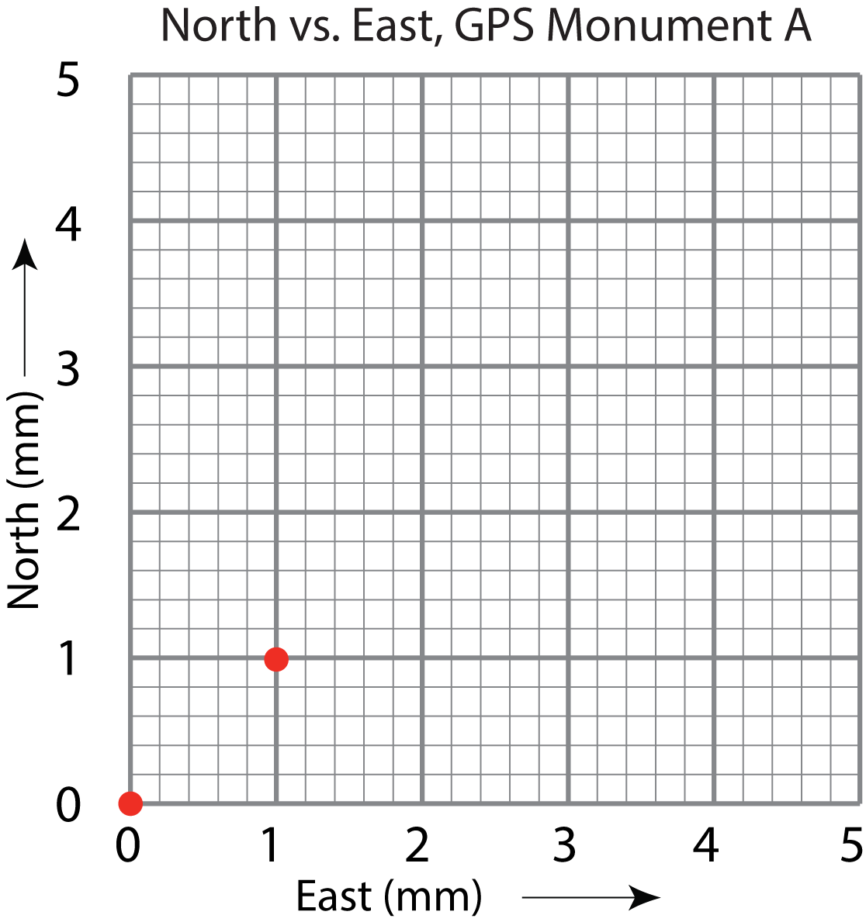

a. Plot the locations of the GPS monument for years 2002 through 2005.

b. Draw an arrow with the tail at the first point and the arrowhead at the last data point.

c. According to your map grid, what direction is your GPS monument moving?

Your answer: _______________________

What does this mean?

Your arrow shows the direction the monument moved, and its length shows how far it moved over 5 years. This is a special type of arrow called a vector. If you were to measure the length of the arrow with a ruler, you would know how far it moved in five years. You could then calculate how far it moved in one year in mm/yr. Distance over time is velocity. Velocity vectors from GPS stations in the EarthScope Plate Boundary Observatory and other networks can be observed online at UNAVCO’s Velocity Viewer. (Search for “UNAVCO Velocity Viewer.”)

Measure the length of your vector to determine how far Monument A moved in 5 years.

_____________mm

On average, how fast has GPS Monument A been moving (what is its average velocity)?

___________mm/yr

Real data: GPS Station P430, western Washington

You plotted this data in Part 3, making two graphs: north position vs time and east position vs time. In this example, you will plot North vs East on graph paper. A sample grid to help you set up the graph is provided below the map.



|  |  |  |
| --- | --- | --- |
| **Date** | **North**  **(mm)** | **East**  **(mm)** |
| 2008 | -35.5 | -53.8 |
| 2009 | -29.9 | -46.3 |
| 2010 | -22.9 | -39.8 |
| 2011 | -17.8 | -35.0 |
| 2012 | -12.8 | -29.2 |
|  |  |  |

Figure : Location of GPS station P430

1. For these plots to be useful as maps, remember that *the scales must be the same on both the x- and y-axes.*
2. Plot the data North vs East.
3. Draw the best-fit line on your graph.
4. What direction is the monument moving?

* If you have a protractor, measure the vector’s direction, clockwise from north.
* 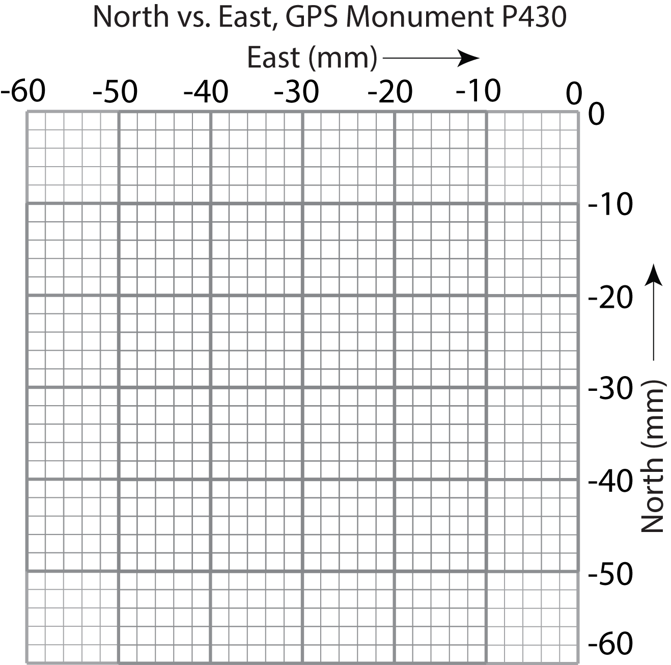If you have a directional compass, a smartphone or a tablet with a compass app, line up the long edge of the paper with north, and tape it down. Then rotate your compass or electronic device to line up with the vector.

Your answer: __________________

The direction the GPS station is moving is called its “bearing” or “azimuth.”

1. Over how many years was the data collected? Your answer: ___________________
2. How far has it moved in this time period? (How long is its arrow?) Your answer: ___________________
3. What is its velocity, where speed equals distance/time? Your answer: ___________________

For more practice, graph North vs. East from Part 3 and answer these questions.

1. GPS station # and location:
2. Plot the data North vs East.
3. Draw the best-fit line on your graph.
4. Measure the Azimuth. What direction is the monument moving? *Your answer:* ___________________
5. Over how many years was the data collected? *Your answer:* ___________________
6. How far has it moved in this time period? (How long is its arrow?) *Your answer:* ___________________
7. What is its velocity, where speed equals distance/time? Your answer: ___________________

Explore More

For some GPS stations, time series graphs (e.g. North vs. Time) are easy to download from online, and they include a best-fit trend line drawn on them. Sometimes there are multiple trend lines if there are changes in the station’s movement, such as after an earthquake.

You can find the time series graphs by turning on the ‘Station Information’ option on the [UNAVCO Velocity Viewer](http://facility.unavco.org/data/maps/GPSVelocityViewer/GPSVelocityViewer.html). (Search for “UNAVCO Viewer.”)