Taking the pulse of Yellowstone’s “breathing“ volcano: Problem-Based Learning in America’s first national park
Denise Thompson. Revised by Nancy West and Shelley Olds.
Yellowstone National Park has an aura of magic. When it’s mentioned, people’s faces light up. Who doesn’t treasure a memory of Yellowstone or dream of going there? In this activity you experience its sublime geology, flora, and fauna virtually as you solve a problem: you will use layers of earth science and cultural data to place a research station within the park, somewhere where it will be safe from volcanism, seismicity, and crustal deformation.

Objectives
With classmates, you will:
- identify a good spot to build a scientific research station in Yellowstone National Park;
- interpret historical and real-time scientific data about volcanic activity in the park;
- analyze the data to detect regions of high and low risk for volcanic hazards;
- define criteria for determining when the research station must be evacuated; and
- communicate your findings.

The Problem for you and your classmates to solve:
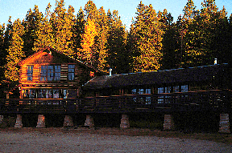
Congratulations! You are a private consultant, and you have just been awarded a $250,000 contract. A research group has preliminary approval to create a research station within Yellowstone National Park. The station is for scientists to live and work as they do research on geological features, flora and fauna, and weather and climate. They will stay at the station for as long as several months. Therefore, the station—or camp--will have
Figure 1. University of Colorado--Boulder Mountain Research Station. Photographer and date unknown.
- bedrooms or bunkrooms for about 20 people;
- two laboratories, one for geologists and one for biologists to prepare and examine specimens;
- a kitchen;
- a dining room;
- a living room big enough for all 20 people to relax at the end of the day’s work;
- covered porches;
- and a garage to store snowmobiles.
Because the park is already in recreation heaven, there will be no need to build recreational facilities like a movie theater. The station needs to be located near an existing road but not visible from the main roads. Assume that the station will cover five to ten acres. How big is ten acres? An acre is about the size of a football field without the end zones. On the map at the end of these instructions, 10 acres would be a square about 0.2 mm on a side. If you made a dot with the sharpest pencil you could find, that dot would be larger than the field station’s area.

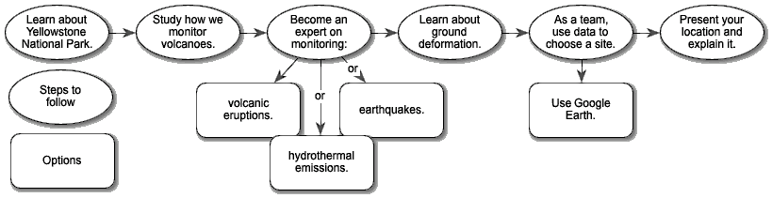
Quick Overview of How You Will Tackle the Problem

First, you will decide where the camp should be. Plan for it to exist for at least a century, without disturbing animals or altering the astounding geological features that draw visitors.
To do this, you will learn about Yellowstone National Park and its geological setting—in volcanic calderas. All of you will learn about how we monitor volcanoes, using the 1980 eruption of Mount St. Helens as an example. Then you’ll become an expert about volcanic eruptions, hydrothermal activity (and gas emissions), or earthquakes. Finally, all of you will learn about how the ground deforms.
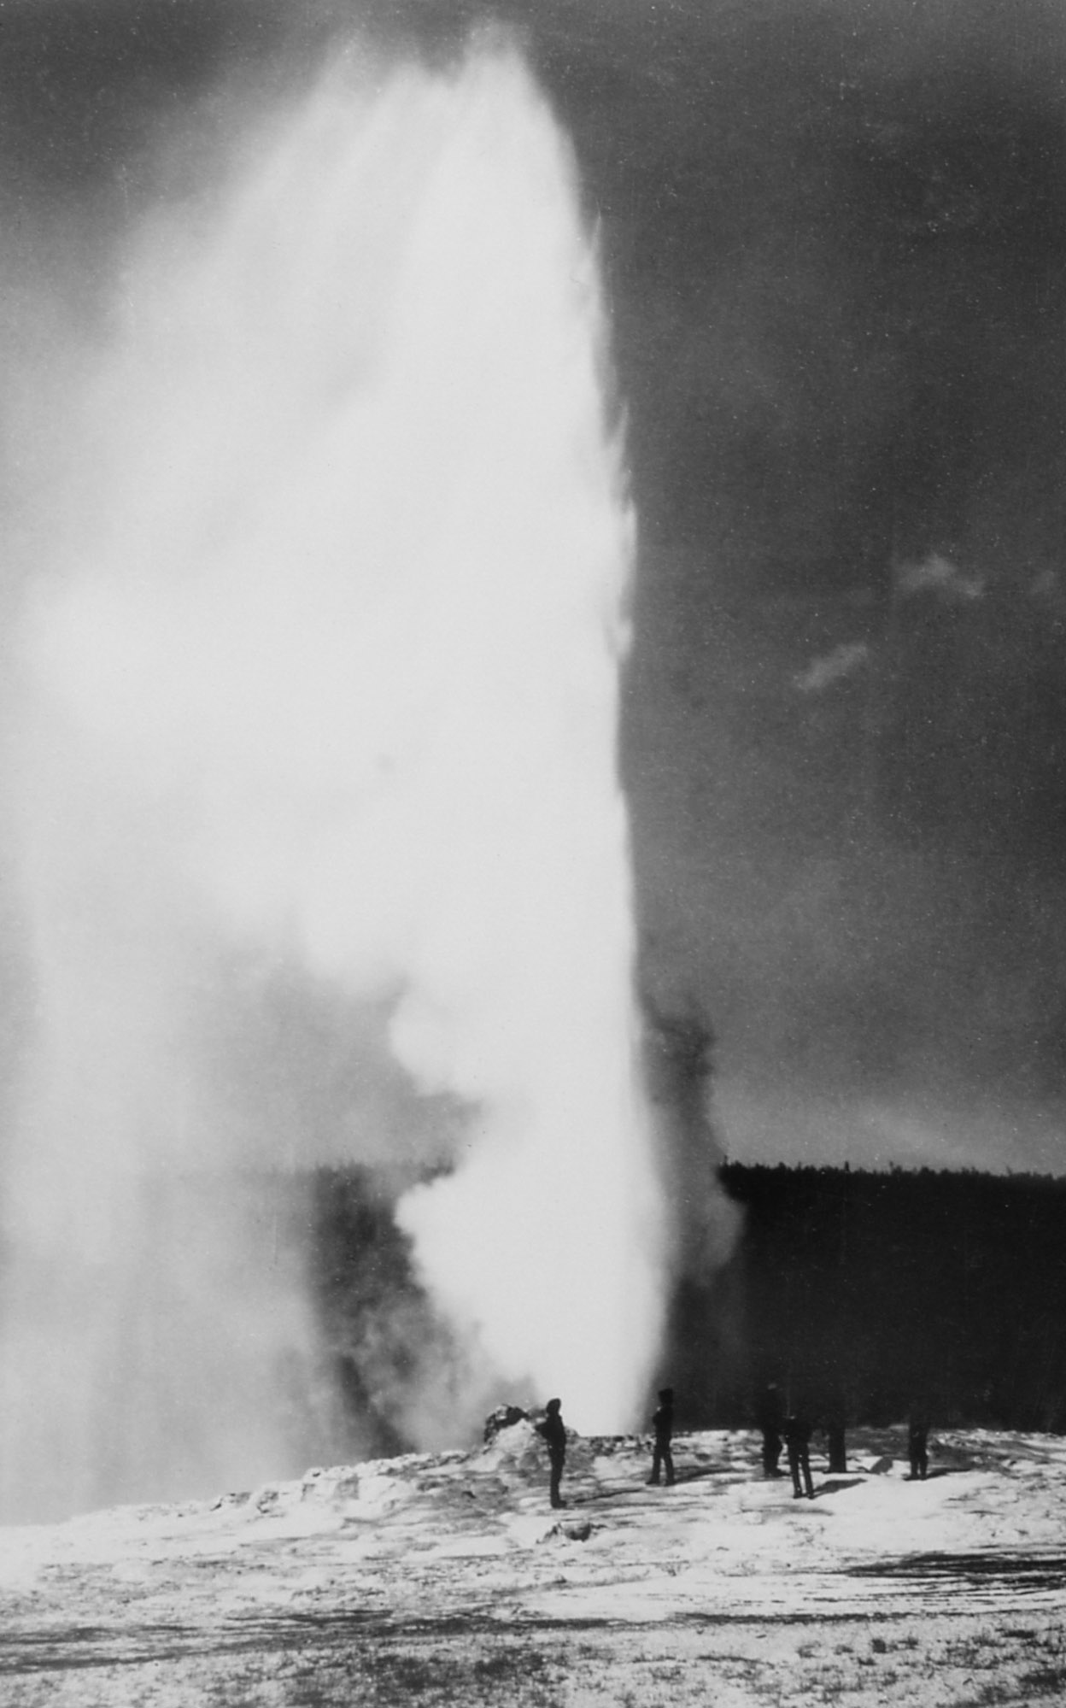
With that knowledge, an expert from each group -- volcanoes, hydrothermal activity, and earthquakes—will join to form a team of three people who combine their expertise to locate the site for the camp. You will use Google Earth or paper maps to analyze your data to find the perfect site.
Figure 2. "First" Picture of Old Faithful Eruption. William Henry Jackson, 1872.
You will propose a location and explain why it is the best site within the park.
Also, you will develop guidelines to establish when the risk of an eruption is too high for scientists to stay at the camp. They must evacuate—according to your guidelines, or your “Safety Protocol.”

A. Introduction: Monitoring Volcanic Activity
In your team of three, or as a whole class, review the presentation, “The Science of Prediction: Monitoring Volcanic Activity.” This presentation shows you how scientists monitor volcanoes. You will see the kinds of measurements scientists made before Mount St. Helens erupted and are making now at volcano observatories in the United States. Yellowstone National Park hosts the Yellowstone Volcano Observatory.
Make a drawing that illustrates the different signs of volcanic activity and the scientific tools to monitor each type.

B. Learn about the Yellowstone Supervolcano: Analyzing eruptive history, seismic, or hydrothermal data
Individually, you will become knowledgeable about Yellowstone’s volcanic history, its earthquakes (“seismicity”) or hydrothermal activity and volcanic gases. Each of the topics has a presentation.

Materials
1. Google Earth and instructions or
2. A map of Yellowstone NP (see last page of this handout: Yellowstone National Park Base Map); colored pencils or transparency pens; and transparency sheets
3. Graph paper or Excel/spreadsheet program
4. One interactive presentation for each group, “Taking the Pulse of Yellowstone’s “Breathing” Caldera – Eruptive History, Seismic Activity, or Hydrothermal Activity: on a computer or a printout.
5. Yellowstone GPS data set (Excel file or print version in the slides)
6. (optional) Real-time data (access to Internet or print copies)

Procedure
1. Get together with classmates who are learning the same topic to become an expert on that topic. Based on your teacher’s instructions, open your presentation,
Taking the Pulse of Yellowstone’s “Breathing” Caldera—Eruptive History; or
Taking the Pulse of Yellowstone’s “Breathing” Caldera—Seismic Activity; or
Taking the Pulse of Yellowstone’s “Breathing” Caldera—Hydrothermal Activity.
These presentations describe the current and historical monitoring data at Yellowstone NP. Some slides will ask you to follow links to websites.
2. Record your data as you follow along with the presentation, on the Yellowstone National Park Base Map on the last page of this document.
- If you’re using paper maps and transparencies, you’ll want to draw on your map locations of important information by hand. This might be where big earthquakes occurred, hydrothermal vents, past lava flows, for instance. If you’ll be using Google Earth to analyze your data, then also use the slides about Google Earth.
- Make a key for your map similar to those you see on several of the slides. Consider making a draft copy of the map and then dress it up for a final clean copy.
3. Discuss the relevant questions to your team’s topic

Volcanic eruption history data
How often does the Yellowstone hot spot create a new caldera?
What types of volcanic eruptions are associated with Yellowstone?
How are these volcanic eruptions dangerous?
Where are the areas most prone to hazardous eruptions?
In your professional opinion, is there an immediate (next 100 years or so) danger related to volcanic eruptions at Yellowstone?

Hydrothermal & volcanic gases activity data
In what way is hydrothermal activity dangerous?
What gases are monitored at Yellowstone? In what way are these gases dangerous?
Where are the areas that are most dangerous due to hydrothermal activity or gases that would keep you from building a research station?
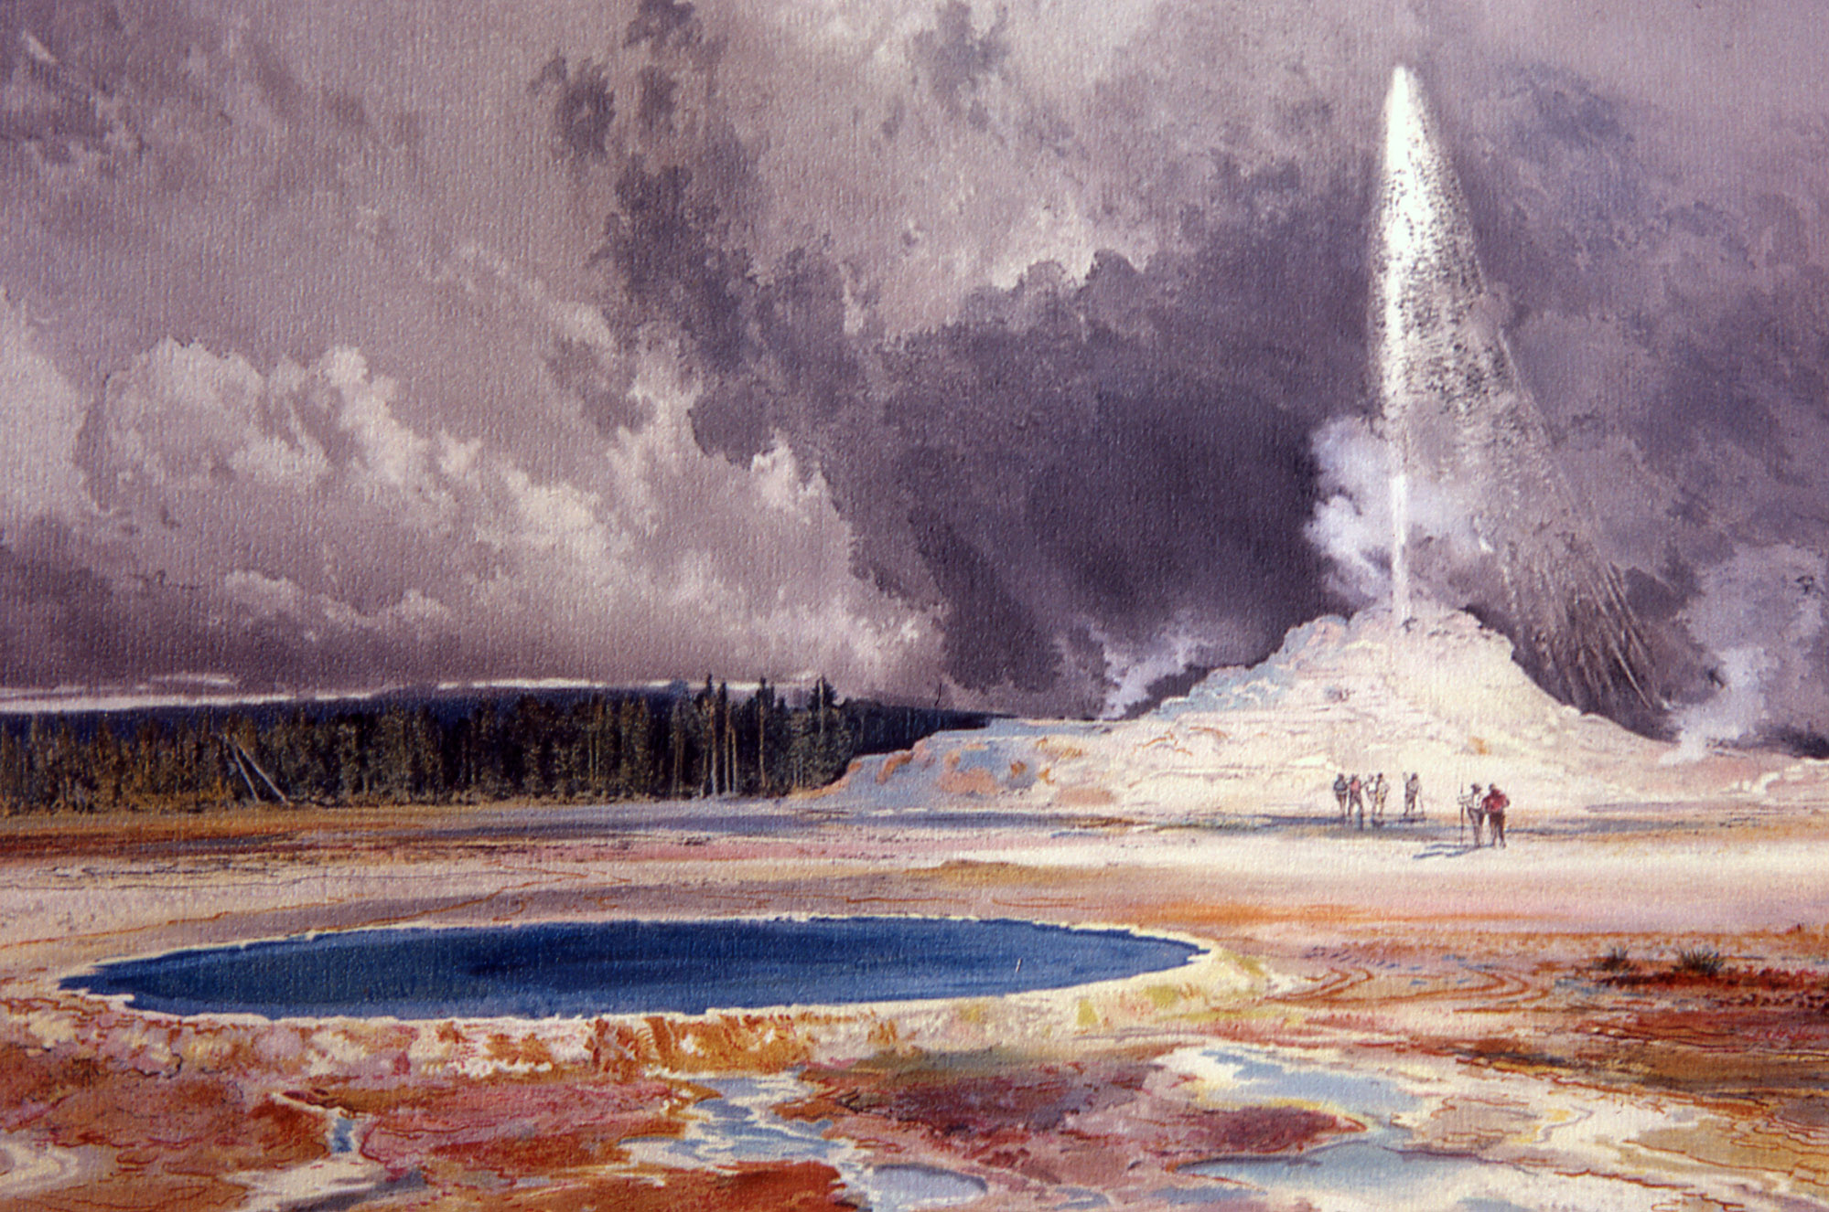
In your professional opinion, is there an immediate (next 100 years or so) danger related to hydrothermal activity or the release of volcanic gases at Yellowstone
Figure 3. Castle Geyser, Upper Geyser Basin. Thomas Moran, undated.

Seismic (earthquake) activity data
How are earthquakes dangerous? How many modern day large (greater than magnitude 5) earthquakes have occurred at Yellowstone?
What is the most common magnitude of earthquakes recorded at Yellowstone?
Does the pattern of earthquakes at Yellowstone suggest movement of magma? (Remember the pattern at Mount St Helens.)
Where would earthquakes most likely affect a research station?
In your professional opinion, is there an immediate (next 100 years or so) danger related to earthquakes at Yellowstone?
C. How is Yellowstone inflating and / or deflating over time? Analyzing GPS data
As a team, you will explore how areas of Yellowstone have changed elevation throughout time. You will analyze how the land’s elevation has changed in two different areas of Yellowstone and graph the deformation data from four GPS locations.
You might also be graphing data from the “Deformation data--optional” data set, a larger set provided by your teacher. And, you might be exploring ground deformation data with Google Earth.

1. Now return to your original team and learn about GPS and ground deformation. You’ll do this by working through the interactive presentation,
“Taking the Pulse of Yellowstone’s ‘Breathing’ Caldera—Ground Deformation.”
2. Record your data as you follow along with the presentation, on the Yellowstone National Park Base Map on the last page of this document.
- Using the map on the slide, Measuring Elevation Changes: the Leveling Line, as a guide, draw a line between Lake Butte and Mount Washburn on your paper map. This will be like a leveling line. Mark four points on your map where scientists survey at Lake Butte, Mount Washburn, Le Hardy Rapids, and B11 1923.
- Where is this line compared to the caldera? Discuss this as a group.
- Analyze the graph on the slide, Measuring Elevation Changes: Analyzing the Leveling Data, discuss the elevation changes over time. As a group, discuss these questions—and, if your teacher asks you to, write down your responses.
  - What does the horizontal axis show? The vertical axis?
  - What do positive numbers on the vertical axis mean? What about negative ones?
  - When was the area rising? When was it falling?
- Using the map on the slide, Measuring Elevation Changes: using GPS Data, as a guide,
- Draw the locations of GPS stations OFW2, HVWY, LKWY, and WLWY, the station ID labels, and a line that connects OFW2 & WLWY on your map.
- Before going to the next slide, what elevation changes might you expect to see based on the locations of the GPS stations, the caldera boundary, and the older leveling data?
- Analyze the graphs on the slide, Measuring Elevation Changes: Analyze Data from Four GPS Stations:
  - Discuss these questions as a group.
  - What does the horizontal axis show? The vertical axis? How do the vertical axes change between the stations?
  - When was the area rising? When was it falling? When did it peak? How much? Describe the timing of the inflation and deflation of the ground at the GPS stations compared to each other.
  - Where is this line compared to the caldera?
- If your teacher asks you to, you’ll make a graph similar to the leveling data graph. A sample graph with data plotted for three dates from OFW2 is shown on the slide, Measuring Elevation Changes: Graphing the GPS Data.
- Discuss the questions as a group:
- How are the trends similar and different in the GPS data compared to the leveling data?
- Can you assume this trend is true for all of Yellowstone?
- Study the data available in the remaining slides; clicking on the interactive elements to explore the data. Discuss these summary questions about Yellowstone’s ground deformation.

Ground deformation: How is Yellowstone inflating and / or deflating over time?
In what way could ground deformation be dangerous?
What patterns do you observe in the data?
Why might the GPS data be different from the leveling data? (Think about how and when each is measured.)
Does uplift or subsidence affect some areas more than others? Would this affect where you might put your research station?
In your professional opinion, is there an immediate (next 100 years or so) danger related to ground deformation at Yellowstone?
Data
Your data will be your labeled maps or Google Earth files and graphs you have created.
Analysis
Now you get to assemble what you’ve learned and decide where you propose building a research station. Refer to your maps or use Google Earth to look at the data for each of the science topics you explored with your other groups: eruption history, seismic activity, hydrothermal activity, and ground deformation.
Discuss with your teammates questions you answered earlier for each science topic in the previous sections.
D. Conclusions Making a Decision: Selecting a Site for the Research Station
Read the problem on the first page again. Using the data on your paper maps or Google Earth maps, and the information you’ve discussed in your group, come to an agreement as a group for the best place to build a five to ten acre research station. Keep in mind the practical considerations and safety issues.
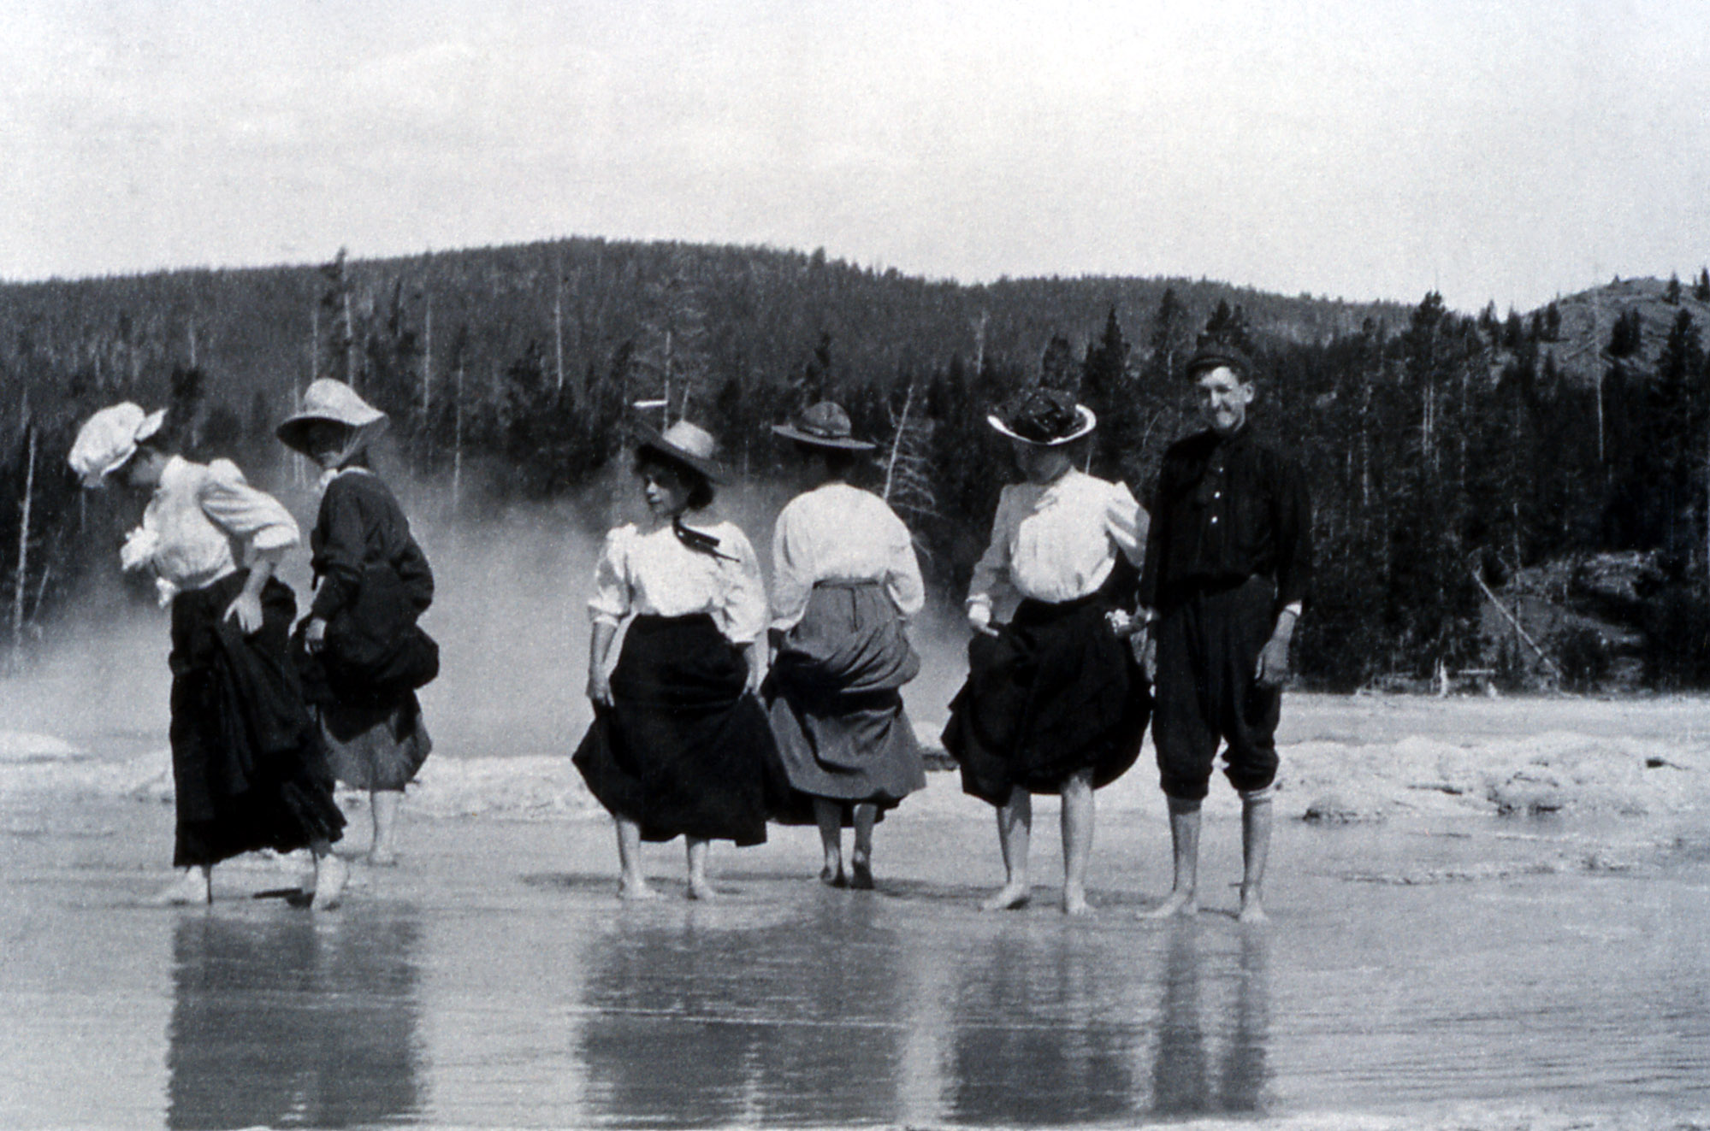
E. Prepare Your Recommendations
How you do this depends on what your teacher assigns. For instance, you might make an oral presentation or write a paper or glossy brochure, or some combination of those. No matter what your assigned format is, you will want to:
- Restate the problem—remind the research group of what they are paying you to do.
- Summarize your data—they don’t have expertise or time. That’s why they hired you. Explain to them what data you collected and what it means.
- Make your recommendations—be specific as to where you think it is appropriate for research station to be.
Figure 4. Tourists Wading in Great Fountain. Artist
unknown, 1908.
- Support your recommendations—explain why the spot you recommend is the best spot. Use specific details from your data. You should also describe any further data collection that you recommend.
- Make your case in a conclusion by emphasizing the important points.
- Persuade your classmates that yours is the best site for the research station.
Create guidelines for evacuation: Also, if you’ve been asked to do this, draft guidelines that will be used to decide if and when scientists (and tourists nearby) must be evacuated in order to keep them safe. How many guidelines and what kind of data you use is up to you. Consider saying something like, “If an earthquake swarm occurs and lasts for x months, then….” Or, if geysers in a geyser basin begin erupting unusually, then....” Or, “If heat values seen on LandSat images exceed x, then….” (The last refers to data visible on Google Earth.)
Image Sources
Figure 1. University of Colorado Mountain Research Station’ Wildrose Dining Hall. Photo. Photographer unknown. Date unknown. http://www.colorado.edu/mrs/setting-facilities Retrieved 26 March 2012.
Figure 2. William Henry Jackson. “First” Picture of Old Faithful Eruption. Photograph. 1872. Yellowstone Digital Slide File k# 64,176. http://www.nps.gov/features/yell/slidefile/history/jacksonphotos/Page-2.htm Retrieved 24 March 2012.
Figure 3. Moran, Thomas. Castle Geyser, Upper Geyser Basin. Watercolor. No Date. Yellowstone Digital Slide File. http://www.nps.gov/features/yell/slidefile/history/moranandotherart/Page-1.htm Retrieved 24 March 2012.
Figure 4. Artist unknown. Tourists Wading in Great Fountain. Photograph. 1908. Yellowstone Digital Slide File. http://www.nps.gov/features/yell/slidefile/history/1872_1918/visitoractivities/Page.htm Retrieved 25 March 2012.
Yellowstone National Park Base Map

