Measuring Plate Motion with GPS
Roger Groom, Cate Fox-Lent, and Shelley Olds, UNAVCO. Revised by Nancy West and Kathleen Alexander.

Topics: Earth processes, Earth structure, Mathematics, Engineering and technology, Plate tectonics, deformation, earthquakes, interpreting data, identifying patterns, graphing skills, constructing explanations
Grade Levels: 6 – 12
Time: 1hr 20min (1 or 2 class periods)
Summary:
In this activity, students analyze scientific data to study the motion of tectonic plates and conclude that the Mid-Atlantic Ridge is rifting Iceland. Through physical modeling and discussion, students develop an understanding of the architecture of GPS—from satellites to research quality stations on the ground. Students learn to interpret time series data collected by the stations, cast it as horizontal north-south and east-west vectors, and add those vectors graphically. Students then interpret their total horizontal vectors from Iceland in the context of a divergent plate boundary. Finally, students extend their understanding of GPS data with an abstraction using cars and maps and explore GPS vectors in the context of global plate tectonics.
Lesson Objectives: Students will be able to:
- Describe how a Global Positioning System (GPS) works in general terms and why a GPS monument needs at least three satellites to determine its position.
- Illustrate GPS data as velocity vectors on a map.
- Add vectors graphically to produce total horizontal velocity vectors.
- Analyze the graphical representation of vectors and infer that Iceland and the Mid-Atlantic Ridge are moving away from each other (rifting).
- Apply knowledge of vectors to the interpretation of car motion and global GPS data.
- (extension) Explore and describe tectonic plate motions via velocity vectors using UNAVCO’s Velocity Viewer.
Next Generation Science Standards (NGSS):
Performance Expectation | Students who demonstrate understanding can:
MS-ESS2-2 | Construct an explanation based on evidence for how geoscience processes have changed Earth’s surface at varying time and spatial scales.
MS-ESS3-2 | Analyze and interpret data on natural hazards to forecast future catastrophic events and inform the development of technologies to mitigate their effects.
HS-ESS2-1 | Develop a model to illustrate how Earth’s internal and surface processes operate at different spatial and temporal scales to form continental and ocean-floor features
See Appendix A for alignment to Common Core State Standards for Mathematics (CCSSM) and the Science and Engineering Practices, Crosscutting Concepts, and Disciplinary Core Ideas from A Framework for K-12 Science Education.
Universal Design for Instruction (UDI):
Universal Design for Instruction principles have been incorporated in this lesson in order to accommodate for differences in strengths, challenges, and abilities among students. Specifically, multiple, accessible instructional methods (visual, auditory & kinesthetic), group work that values different skills and roles, multiple methods of assessment, and frequent transitions provides rich support for learning and reduces barriers to the curriculum.
Lesson Overview:
- Activation of prior knowledge related to GPS is followed by a PowerPoint presentation: Measuring plate motion with GPS: Introducing GPS to study tectonic plates as they move, twist, and crumple.
- The teacher and students cooperatively create and work with model GPS monument and the satellite network that feeds time signals to the monuments.
- Students analyze and interpret GPS data, using time series plots in order to develop total horizontal velocity vectors of plate motion in Iceland.
- Extension: using the Velocity Viewer, students explore a map interface and interpret GPS velocity vector data around the world to identify other divergent zones and other plate motions.
- As a summative activity, students apply knowledge in an abstraction using cars and maps and explore GPS vectors in the context of global plate tectonics in the UNAVCO Velocity Viewer.

Materials:
- Student lab worksheets—one copy per student, pair, or group
- Computer and a projector (instructor), computers (students for extension)
- Gumdrops
- Toothpicks
- Modeling clay
- Transparencies (cut into 4 squares each)
- 3 ring stands (or student volunteers)
- 3 satellite representations (e.g. Double Bubble gum)
- String
- 1 gumdrop monument (created from toothpicks, gumdrop, and modeling clay)

Before you begin…
Students need a general understanding of plate tectonics for this lesson. Many excellent learning resources are available online covering evidence that support the theory of plate tectonics. Many of these resources take a global view of plate tectonics; this lesson explores how high-precision GPS can be used to measure regional plate movement and deformation.

Teaching tips and general background:
A variety of geologic phenomena including earthquakes, volcanic eruptions, and mountain building occur at plate boundaries, all of which cause the Earth’s surface, the crust, to deform. When deformation occurs, points on Earth’s surface change location (north-south, east-west, up-down). Precise GPS instruments can measure the change in position. Earth scientists use this data to record how much and how quickly Earth’s crust is moving due to plate tectonics and to better understand the underlying processes of the deformation.

Before starting the lesson, review these videos on how to demonstrate how GPS works:
  - In addition to following the steps below, watch this video (http://bit.ly/HowGPSworks-demo) on YouTube to inform your instruction. The first segment demonstrates how to build a monument while the second half suggests ways to demonstrate how a GPS monument gathers location information. This video is meant to inform the instruction of teachers, not to be shown to students.
  - A second video (http://bit.ly/GPSdemo-part3) on YouTube provides background for teachers about time series plots. (On YouTube search for “GPS gumdrop activity 3-5.”) .
Key points for the demonstration
- Satellites are in orbit above Earth’s surface at an altitude of 20,200 km (12,600 mi)
- Each satellite sends a signal many times a second and ‘talks’ to the GPS; the GPS calculates the how long it takes for the signal to reach the GPS and then calculates the distance between them.
  - The string represents the distance between the satellite and a monument after this distance is calculated.
- The GPS needs 3 satellites to find its position on Earth.
  - With one satellite, the GPS could be anywhere on the surface of a sphere with a radius equal to the distance between the GPS and the satellite.
  - With two satellites, the monument could be anywhere on the circle of the two intersecting spheres.
  - With three satellites, the GPS could be at one of the two points where three spheres intersect. The Earth is the fourth sphere (the satellites know where the Earth is).
  - Since time is part of the calculation to find a position, a 4th satellite provides even more precision in location to correct position errors caused by in clocks on the satellite and GPS.
- These measurements are being made while satellites are moving at 2 kilometers/second!
- Review this video for teaching: NASA’s Brief History of Geodesy (http://bit.ly/nasawhatisgeodesy).

Part 1: How does GPS work to pinpoint a location on Earth?
Activation of Prior Knowledge:
- Assess students’ level of prior knowledge by facilitating a preliminary discussion of GPS technology. Some questions to launch a discussion may include:
  - What is GPS technology?
  - What does GPS stand for?
  - How does GPS technology work?
  - What is GPS technology used for?
  - Who uses GPS technology?
Procedure (Pinpoint location with GPS):
- In advance, mark locations of ring stands such that all three strings meet in one location
- Launch the PowerPoint presentation, Measuring plate motion with GPS: Introducing GPS to study tectonic plates as they move, twist, and crumple.
- Show the video, NASA’s Brief History of Geodesy (http://bit.ly/nasawhatisgeodesy ),
  - Engage the class in a brief discussion about geodesy and uses of GPS.
  - Ask a volunteer to provide an explanation of Geodesy and remind your students that Geodesy is the study of the Earth’s size, shape, orientation, gravitational field, and variations of these with time.
  - Pose the question, “How can GPS data be used in the field of Geodesy and geology?” before advancing to the next slide.
- At the “GPS Basics” slide, stop and model how satellites pinpoint the location of a GPS station. For the demonstration you will need 3 ring stands (or 3 volunteers), 3 ‘satellites’ (e.g. Double Bubble gum) to place at the top of the stand to represent satellites, 3 lengths of string of different lengths (all longer than the height of the stand), and 1 gumdrop monument.
- Ask volunteers to distribute the student worksheet.
  - Differentiation: Arrange students in either pairs or groups of three for this activity, pairing students with different strengths and challenges together. Consider assigning group roles to facilitate active participation in all students. Group roles may include: Scribe, Group Leader, Artist, Discussion Director, etc.
- Explain
  - Satellites are flying above Earth’s surface at an altitude of 20,200 km (12,600 mi); the ring stands represent that altitude. The bubble gum represents the satellites.
  - The pieces of the GPS “gumdrop” monument:
    - The gumdrop is the GPS antenna;
    - Each toothpick is a leg of the monument – the legs are cemented up to 30 feet into the ground.
    - The putty is the cement holding the GPS monument in place.
    - The “place marker of the monument is the slightly shorter toothpick sticking straight down from the middle of the gumdrop so that the tip of this toothpick is barely above the surface.

  - Gumdrop ‘GPS’ monument and the satellites relationship
    - The satellite ‘talks’ (broadcasts) to the GPS its satellite name and current position in space; the GPS receiver calculates how long it takes for the signal to reach the GPS and then calculates the distance between them. Measuring the distance is called trilateration.
    - The string represents the distance between the satellite and a monument after this distance is calculated. This calculation is happening every second, sometimes 10 times a second!
- Demonstrate how the location of the GPS becomes more pinpointed with one, then two, then three satellites.
  - One satellite (GPS could be anywhere on the surface of the sphere with the satellite in the center).
    - Ask a student to move one string (held tautly) in all directions to indicate that the distance (approximately 20,000 km) is known, but the direction isn’t. The GPS could be anywhere on the surface of the sphere with the satellite (at least where the satellite had been at that moment since it is moving) at its center.
  - Two satellites (GPS could be anywhere on the circle of the two intersecting spheres):
    - Ask another student to hold the string taut and move the 2nd string in the shape of the sphere. Then move the 1st and 2nd strings together, so that the strings stay taut and ask what shape is made by this movement (a circle). Emphasize again that the only known entity is the distance between the monument and satellite.
  - Three satellites (The GPS could be at one of the two points where three spheres intersect.)
    - Ask a third student to move the 3rd string along with 1st and 2nd strings to show where all three strings intersect.
    - The Earth is the fourth sphere (the satellites know where the Earth is).
  - A 4th satellite provides even more location precision by correcting the tiny errors in the clocks on the satellite and GPS.
- Place the gumdrop GPS monument where the three strings intersect.
- Remind students that the GPS measures the time it takes for the signal to go from the Satellite to the GPS monument then calculates the distance - this happens while satellites are moving at 2 kilometers/second!
- Ask your students to complete the questions 1 - 5 in Part 1 of the worksheet.

Worksheet questions 1 – 5
- When all students have completed all 5 questions, summarize core concepts and assess levels of comprehension by posing the following questions to the class:
- What can we do with geodesy?
[The video, A Brief history of Geodesy, provides many good examples. Finding locations, navigation, laying out railroads and streets, etc.]
- What do the pieces of bubblegum represent? How far above the Earth would they actually be?
[The tops of the stands represent where the satellites are. They all are at the same height above the Earth. The bubble gum represents the satellites. The satellites are approximately 20,000 km above the surface of the Earth.]
- What does each length of string represent?
[The string represents the distance between monuments and satellites.]
- How many satellites are needed to pinpoint the location of a spot on the Earth? Why?
[At least three satellites are needed to pinpoint the location of the monument on the surface of the earth (the intersection of 3 spheres is 2 points; the Earth acts as the 4th sphere. In reality, more than three are used. A 4th satellite is used to fixed position errors caused by differences in clocks on the satellite and GPS.]

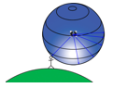
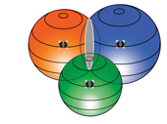
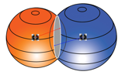
one GPS satellite: two GPS satellites: three GPS satellites:

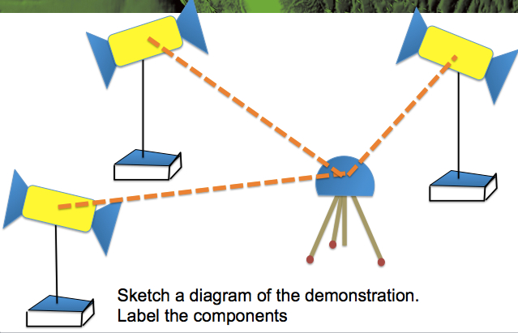
- Sketch a diagram of the locating position demonstration, labeling the components: satellites (and the number needed to pinpoint a location), distance (time), and GPS/Earth.
[Students should draw the setup with three stands, strings, and the gumdrop monument. They may also wish to draw the intersecting spheres]

Build a model of a GPS monument:
- If you would like your students to work in pairs or small groups, arrange students into teams at this time.
- Ask volunteers to distribute materials. Each team will need 2 gumdrops, 8 toothpicks, modeling clay, and two ¼ squares of a transparency in order to make 2 stations. Allow students time to construct 2 GPS stations.
- Differentiation: This would be a great opportunity to allow more energetic students to get out of their seats and walk around!
- With the “Modeling GPS” slide displayed, allow students to sketch a diagram of a GPS station. Walk among students and assess levels of understanding, asking questions and providing clarification where necessary.

Worksheet question 6 - 7.
- What is the ground station’s purpose?
Ground stations, (called the Control Segment), monitor satellite location & health, correct orbits & time synchronization

- Sketch a diagram to show the parts of the gumdrop GPS and components of a GPS station:

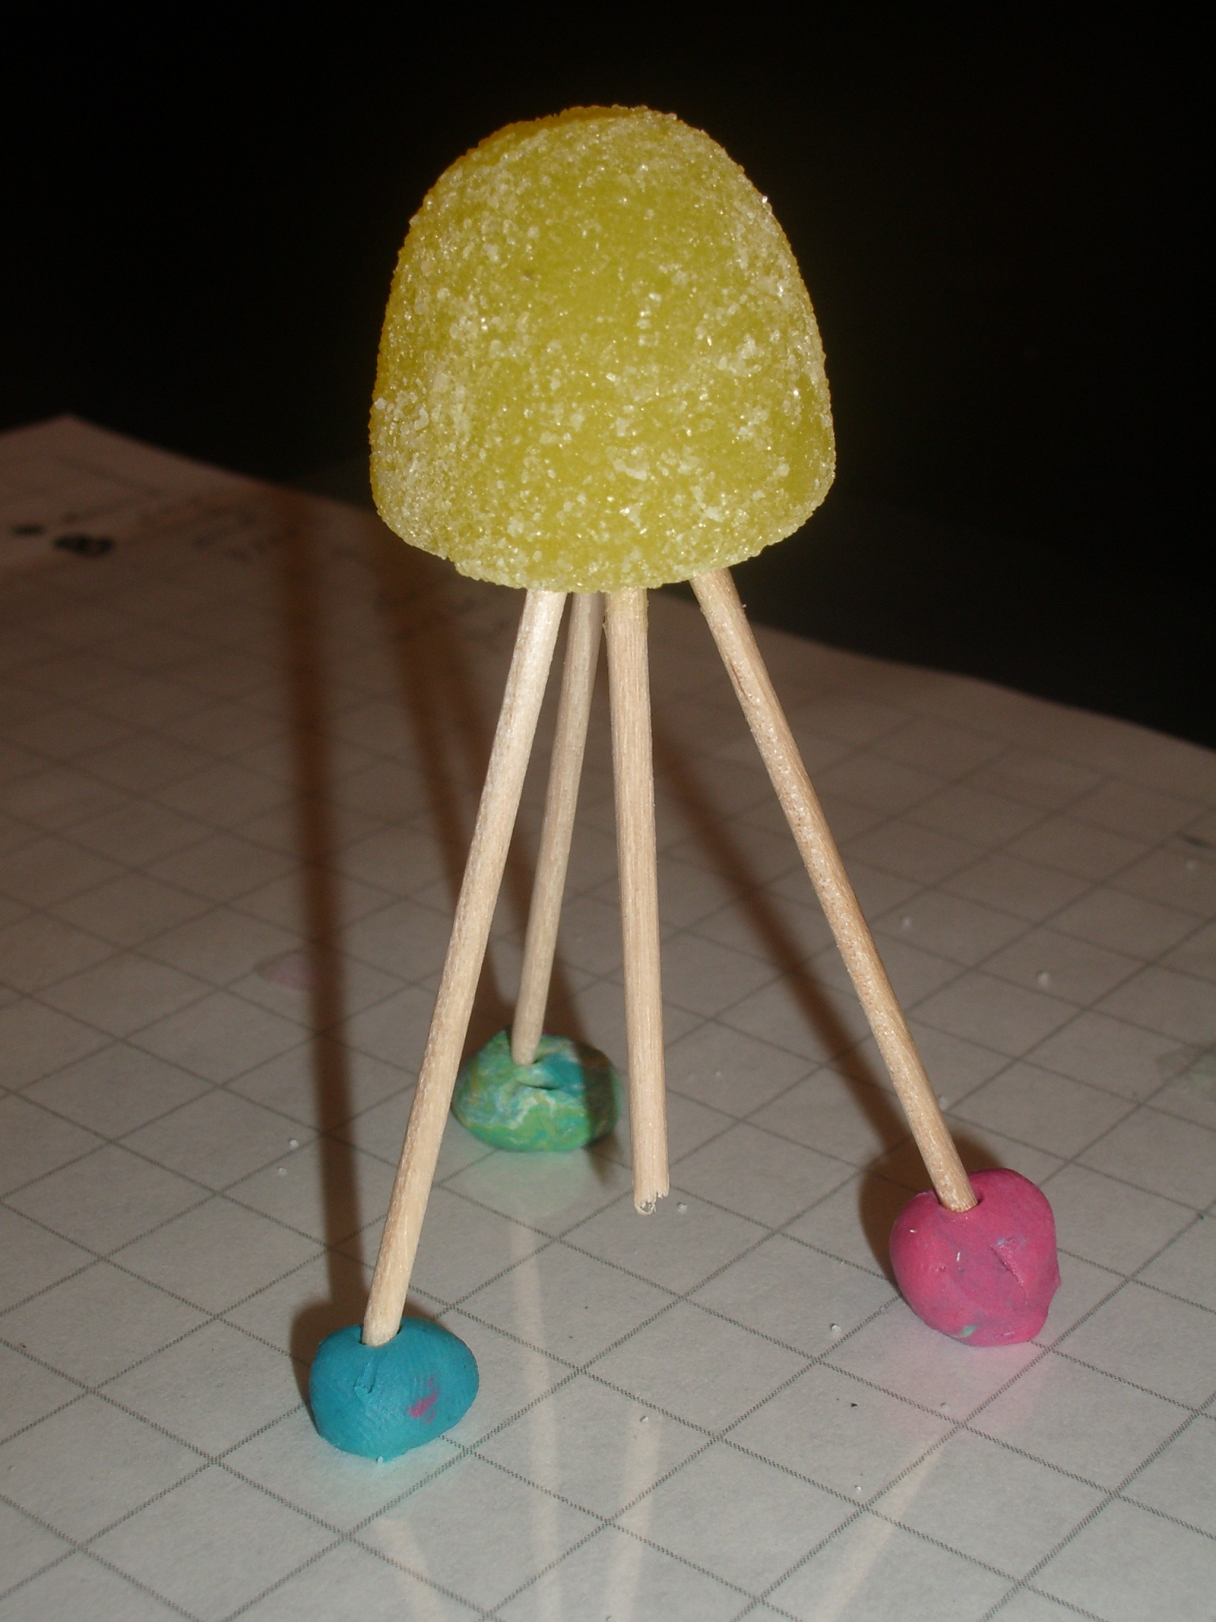
    - The gumdrop is the GPS antenna;
    - Each toothpick is a tripod leg of the monument – the legs are cemented up to 10 feet into the ground.
    - The putty is the cement holding the GPS monument in place.
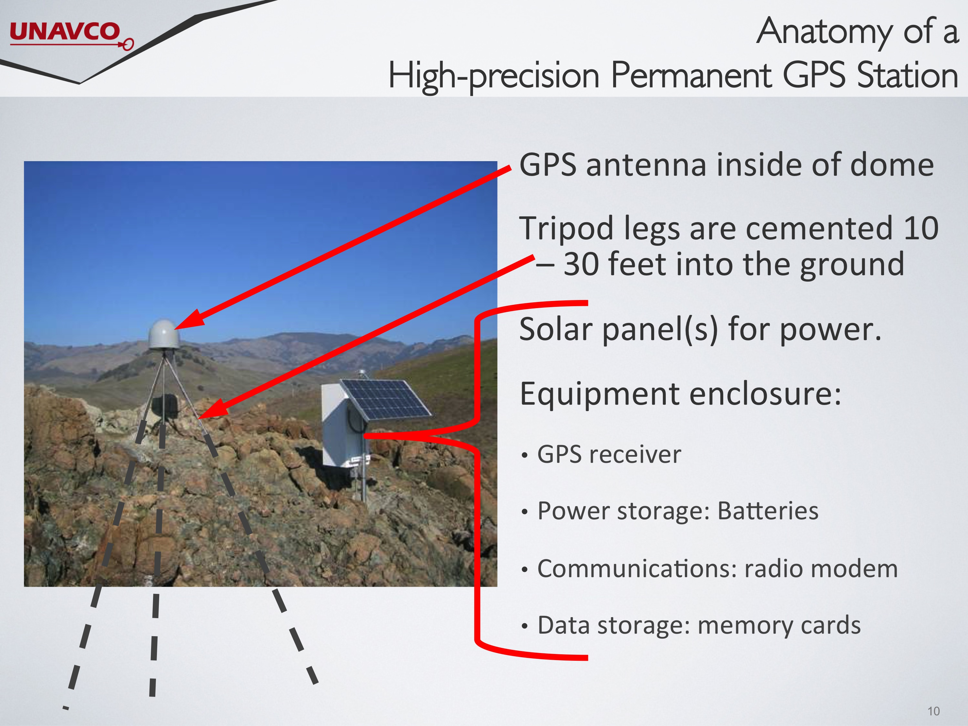
- GPS antenna inside the dome
- GPS antenna inside of dome
- Tripod legs are cemented 10 – 30 feet into the ground
- Solar panel(s) for power.
- Equipment enclosure:
- GPS receiver
- Power storage: Batteries
- Communications: radio modem
- Data storage: memory cards

Ask several students to share their answer to question 5 - 7 with the class.
Closure/Assessment of Part I (Pinpoint location with GPS and Build a model of a GPS monument):
- When all students have completed their diagrams summarize core concepts and assess levels of comprehension by posing the questions on the worksheet to the class.
*Student worksheets with anticipated answers can be viewed in Appendix B
- Ask several students to share their diagrams of the GPS locating position demonstration (question 5) and components of a GPS station with the class.

Part 2: What can GPS tell us about Iceland?
Introduction: Measuring GPS Movement with Time Series Plots:

- Display the “Measuring GPS Movement…” slide. Inform students that they are viewing data collected from a single GPS station. Explain that the data from the GPS stations in the Plate Boundary Observatory operated by UNAVCO (which is one of the EarthScope projects) is freely available to the public. Each GPS station has a data file which contains the daily change in position.
- Ask students to flip to page 2 of their student worksheets.
- Display the “GPS Time Series Plots” slide. Explain to your students that time series plots show the position of a monument as time passes. There are three components: north-south, east-west, and up-down movement. We are not using the vertical motion in this exercise.
- A second video (http://bit.ly/GPSdemo-part3) on YouTube provides background for teachers about time series plots. (On YouTube search for “GPS gumdrop activity 3-5.”)
- [optional - Currently the next 4 slides are hidden in the Powerpoint] Walk through the slides to help students learn how to read the time series plots. Discuss the slides as your students fill in the box on their worksheets as a reference.
- On the “Time Series Plots” slide, discuss the relationship between time series plots and direction with your students, asking questions to assess for comprehension.
- On the “Gaps in Data” slide, discuss the gaps that may occur in data with your students.

Worksheet:
Time series plots show the position of a monument as time passes. There are three directional components: north-south, east-west, and up-down movement (We are not using the vertical motion in this exercise).

As a reference to help read time series plots, sketch what graphs look like for each direction vs. time in the box below. Use your model to envision a monument moving purely north through time. What would its graph look like? (See below for this example.)

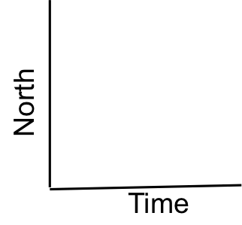
Sketch of a GPS moving north Sketch the graph for a GPS moving south
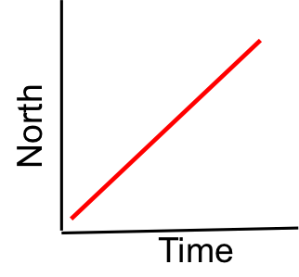
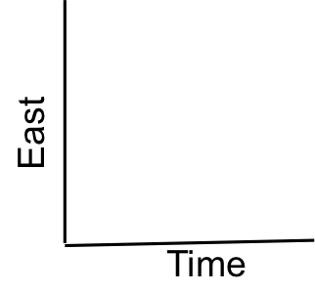
Sketch the graph for a GPS moving east Sketch the graph for a GPS moving west

Bonus – what does the graph for a GPS monument not moving east or west look like?

Closure (Measuring GPS Movement…):
- Use a think-pair-share model to revisit core concepts covered in the lesson before proceeding. Some questions to consider posing may be:
  - How are satellites used to locate the position of a GPS station? (see the answer sheet, questions 3 and 4)
  - Why is it necessary to have at least 3 satellites to pinpoint the exact location of a GPS station? [The intersection of three spheres are 2 points; the Earth acts as the 4th sphere. A 4th satellite is used to fix position errors caused by differences in clocks on the satellite and GPS.]
  - What is the GPS station measuring? [The GPS is measuring the movement of the land beneath the GPS]
  - What is a time series plot? What does it show? How can a time series plot be used to show the direction of movement? [The plot shows motion in three directions: North-South, East-West, and Up-Down of the GPS and the ground beneath it]
  - [optional] Show the last two slides (hidden) in Part 1 about the movement of GPS stations to reinforce that the GPS stations are measuring the movement of tectonic plates.

*If you are splitting this lesson across two periods, this may be an adequate point to conclude day one.

Exploring Iceland’s GPS data and maps:
Activation of Prior Knowledge:

If you are splitting this lesson across two class periods, consider beginning day 2 by revisiting questions posed at the conclusion of day 1.
- As a quick pre-assessment, you may also wish to ask your students, “How can GPS data be used to study the Earth?”
Procedure:
- Orient the students by showing the slide with the world map and perhaps having students use a large wall map or globe to find Iceland.
- Display the “Iceland’s GPS data: REYK and HOFN” slide. Explain to students that they will be analyzing data collected from two GPS stations on Iceland, REYK (in the town of Reykjavik) and HOFN (in the town of Hofn) to see how the tectonic plates underlying the monuments are moving.
- Show students the next slide that shows both the plots for both GPS stations. Allow students to complete questions 1-3 on their worksheets either independently or in pairs.
- Display the “Units on time series plots” slide and discuss the answers for 1 – 3.

Worksheet:
By analyzing multiple GPS time series plots you can determine the directions and rates of regional deformation. As the ground moves, these GPS stations move with it. Look at the data from GPS monuments REYK and HOFN, from Iceland.

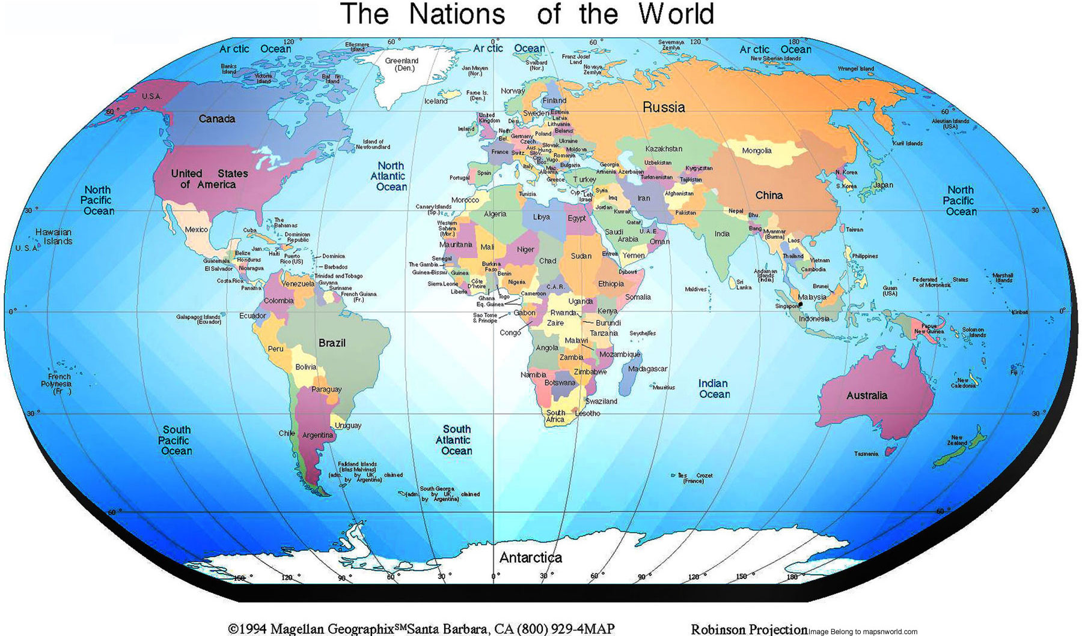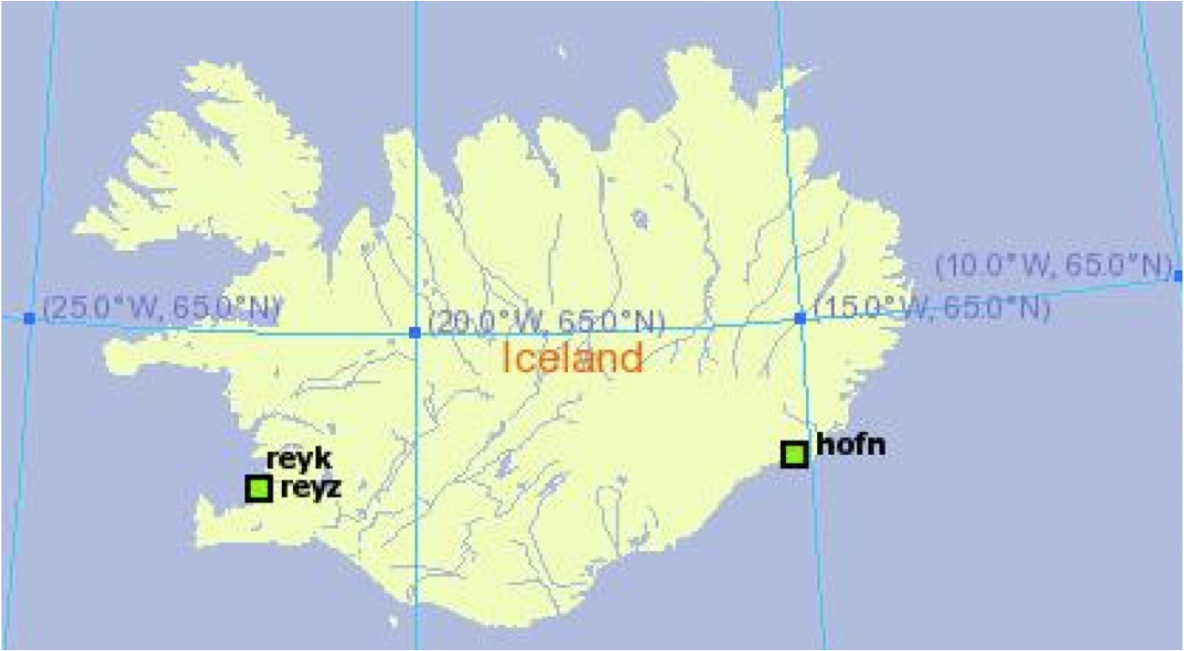
Use the data from GPS Monuments REYK and HOFN to answer the questions below.
GPS Monument REYK | GPS Monument HOFN
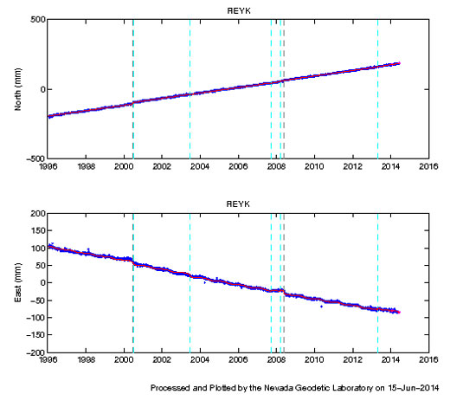  East  North | 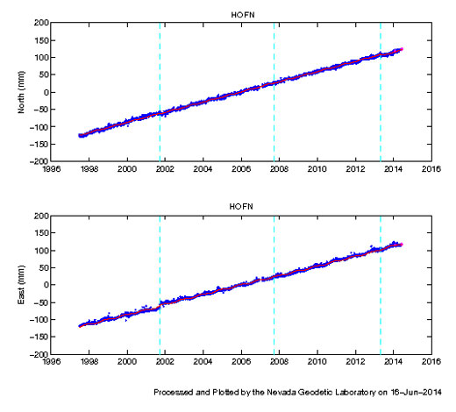

- Think, simulate the movement of each GPS using the data and the map, then discuss with your neighbor: what general directions are monuments REYK and HOFN moving? How did you determine this?
REYK is moving northwest HOFN is moving northeast.
- Are the two monuments moving towards each other, away from each other, or in the same direction? ? away from each other
- On these time series plots, the trend lines have already been drawn for you. What are the units of measurement for these time series?
X-axis uses___ time in years_________ and y-axis uses___millimeters__

Calculating velocities of the GPS stations:
Procedure
- (optional) Work through the North component of HOFN together.
- Have students complete the remaining questions for the East component of the HOFN time series plot on their worksheets and “GPS Monument REYK” questions. Students may work independently, in pairs, or with the think-pair-share model. Check for understanding by going through their answers for the velocities for HOFN and REYK. (optional, walk through the slides that are hidden)

Worksheet: On the next two pages are larger copies of the time series plots for HOFN and REYK. Complete the tables under the data to calculate annual motions in north-south and east-west directions for REYK and HOFN.

HOFN time series plot 1997 – 2014 (North and East plots)
(look at a student worksheet for full size plots)
HOFN North plot:  Over 10 years, how far did HOFN move? | __148___ millimeters (mm) in 10 yrs
Each year, this station is moving: | ___14.8__ mm/year to the (north or south)
HOFN East plot:  Over 10 years, how far did HOFN move? | __131___ mm over 10 years.
Each year, this station is moving | __13.1__ mm/year to the (east or west).
HOFN: Do you findings agree with your previous answer about the general motion of HOFN?
…. Students should answer yes, to the Northeast
REYK time series plot 1997 – 2014 (North and East plots)

REYK North plot: Over 10 years, how far did REYK move? | _204_millimeters (mm) in 10 yrs
Each year, this station is moving: | ____20.4_ mm/year to the (north or south).
REYK East plot: Over 10 years, how far did the station move? | __-108__ mm over 10 years.
Each year, this station is moving… | ___-10.8__ mm/year to the (east or west).
REYK: Do you findings agree with your previous answer about the general motion of HOFN?
…. Students should answer yes, to the Northwest
Displaying Velocities on a Map:
Procedure
- Display the slide, “Displaying velocities on a map: There must be an easier way to show this! Prompt students to copy their answers for REYK and HOFN onto the map – making sure they have copied correctly.
- Display the slide, “Are REYK and HOFN moving…” and have students simulate the movement of REYK and HOFN with their models. Monitor understanding either by walking around the classroom, asking students to show you the motion of the GPS stations with their models, or allow students to share their responses with the class.
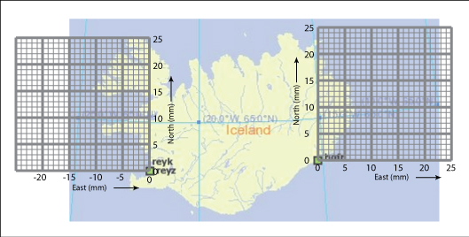
Worksheet
HOFN
North: 14.8 mm/yr
East: 13.1 mm/yr

REYK
North: 20.4 mm/yr
East: -10.8 mm/yr

We know the velocity each monument is moving in the north-south direction and in the east-west direction. Now we are going to add these together to show the total horizontal motion.
- Copy your answers from the previous pages for REYK and HOFN onto the blanks at the bottom of the map of Iceland. Remember that directions to the south and west are written as negative values. REYK is on the west side of Iceland; HOFN is on the east side of Iceland.

Drawing vectors to show velocity:
Procedure
- Ask your students, “If you were geologists, how would you represent this information so that it could be easily interpreted by others?”
- Display the “Mapping plate movement” slide and explain how vectors can be used to show the velocity of motion.
- Explain that they will be making a map like this one, zoomed into Iceland.
- Ask students to look at the steps for creating a vector in their packets and display the “What is a vector?” slide. (The map of Iceland and graphs included in the lab worksheets may be used for graphing. However, you may also wish to distribute extra graph paper at this time for students to create a “rough copy” as they practice drawing vectors.)
- Differentiation: If you do choose to provide students with extra graph paper, this would be a great opportunity to allow more energetic students to get out of their seats and walk around!
- Explain that all vectors have magnitude and direction. With GPS monuments, the magnitude is the speed at which it moves. The direction is the direction the GPS moves, or its azimuth.
  - Vector’s tail = starting location of the GPS monument.
  - Direction the vector points = direction the GPS station is moving.
  - Length of the vector = how fast the GPS station is moving.
  - See the What is a vector in the Student Worksheet
- Continue through the PowerPoint as students draw the vectors on the map on their worksheets and illustrate vectors on their graph paper. Monitor students as they simulate the motion of both GPS stations with their models.
- With the “Mapping Vectors” slide displayed, tell students that after collecting and displaying data, it is now time to analyze and synthesize data in order to draw scientific conclusions. Allow students time to work through the “Interpreting the data and maps” section of their worksheets with a partner. Pace among students as they work, providing clarification and support where necessary.
- Differentiation: Display an online timer on the board for 10-15 minutes to keep students on task.
- Differentiation: Students who finish early may continue on to the bonus questions.
Worksheet:
An easier way to display the velocity of a GPS monument is by drawing a vector on the map. Follow the steps below to add the north-south and east-west velocity vectors for REYK and HOFN. Draw the vectors on the grids on the map above.
What is a vector?  A vector is a special type of arrow that shows velocity and direction of motion. We can draw a vector to show the north motion and another vector to show the east (or west) motion. By adding them together we can show the total horizontal motion!  - The vector’s tail is the starting location of the GPS monument.  - The direction the vector points is the direction the GPS station is moving.  - The length of the vector represents the velocity the GPS monument and the land beneath it is moving. |  |  | 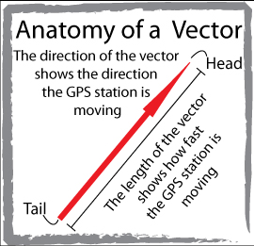
Adding vectors: Step 1.  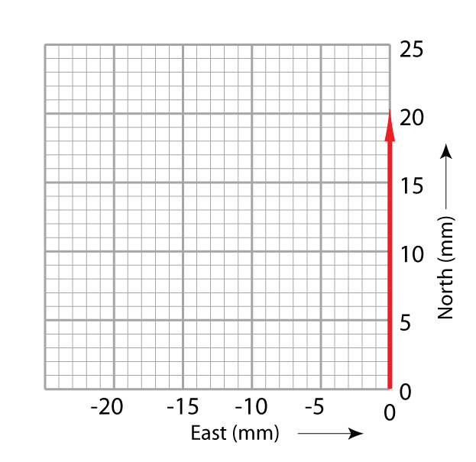  Start at the origin (0,0) draw a light arrow along the north axis the length equal to the north velocity (e.g. one block is 1 mm/yr.) | Step 2.  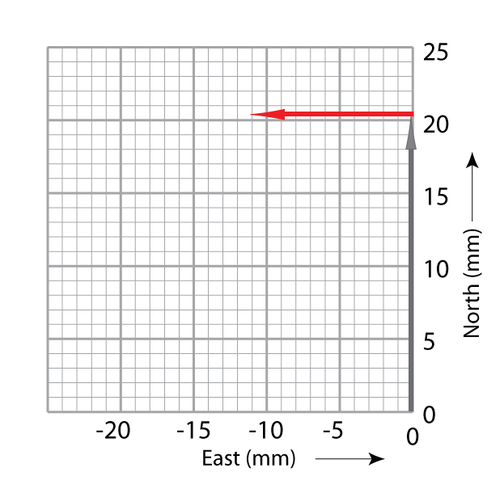  Draw the east vector from the end of the north vector’s arrowhead.  (A vector moving west is drawn to the west.) | Step 3.  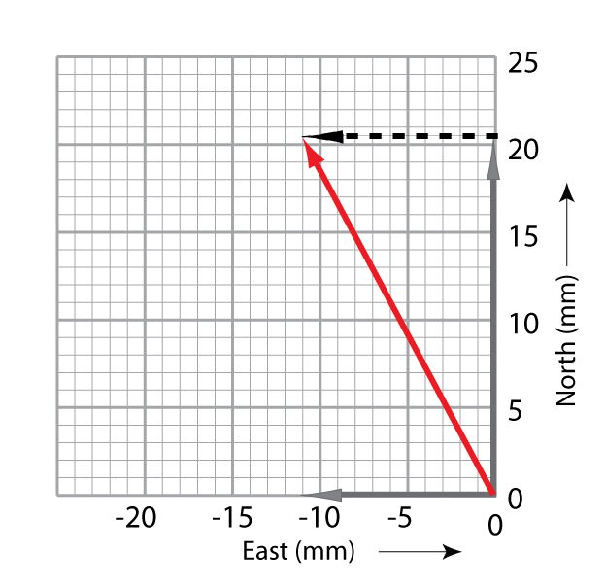  Draw a diagonal arrow from (0,0) to the arrowhead of the east vector.  This new vector is the sum of the north and east vectors.
- Following the steps above, use the graph paper on the map near REYK to add the North and East velocities together to find the total horizontal velocity for REYK on previous page.
- Using the same procedure, draw the total horizontal motion vector for HOFN.
Solution:
HOFN
North: 14.8 mm/yr
East: 13.1 mm/yr
REYK
North: 20.4 mm/yr
East: -10.8 mm/yr
- Use your gumdrop models to simulate this motion by moving your model along each vector, starting at the tail and moving the model toward the head. Does this match the movements you had simulated the beginning of Part 2?
[students use their gumdrop GPS models to illustrate the stations moving away from each other (to the northwest and northeast)
Closure: Interpreting the data and maps
- When all students have completed questions, review all answers as a class by calling on volunteers to share what they have concluded.
- At the slide, Looking at the world view of motion, explain that these vectors show the movements of the different tectonic plates from the perspective of someone not sitting on Earth, but looking down from space. Extra credit – if you were sitting at HOFN for a very long time, how would REYK be moving? (You would subtract the movement of HOFN from REYK – the easier way is to go back to the North and East vectors,
Subtract REYK north (20.4 mm/yr ) - HOFN north (14.8 mm/yr) = 5.2 mm/yr North
REYK east (-10.8 mm/yr) - HOFN East (13.1) = - 23.9 mm/yr East
Then add the two vectors together.
- Display the next slide and ask, “What is happening to Iceland?” Show slides and explain rifting, fissure openings, and the Mid-Atlantic ridge as you display the next 3 slides.
Worksheet
Work with a partner to answer these questions.
- Describe how the resulting vectors of the two GPS monuments are different and how they are the same. [The vector for REYK is longer (thus moving faster). The two vectors are moving away from each other in the E-W direction, but both are moving north.]
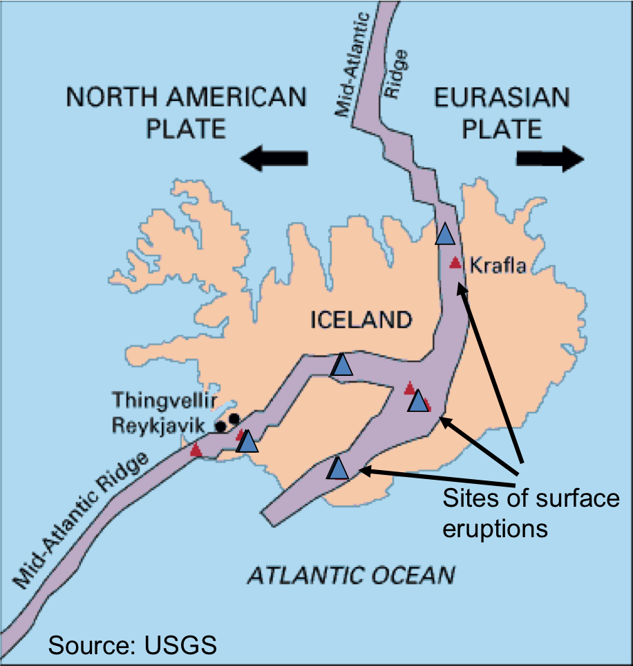
- Remember that the monuments are fastened to the ground. If they are moving, then the ground must be moving. If you flew in a plane over Iceland, 1000 years from now, how far apart will the monuments be in the east – west direction? (Hint, go back to the East graphs) [You wouldn’t even see the tectonic motion.
REYK is moving west @ 10.8 mm/yr
HOFN is moving east @ 13. 1 mm/yr
Add these together to get total separation per year = 10.8 + 13.1 = 23.9 (round up to 24 mm/ yr). Over 1000 years = 24 mm * 1000 = 24,000 mm. Ask the students to convert to meters, reminding them that 1000 mm = 1 meter. 24 meters!]
- Give one possible explanation for the way the ground is moving in Iceland. What’s filling in the gap that is forming?
[Some students might say that a valley or hole is opening up in the ground. Others might say that the earth is breaking apart, etc. The North American tectonic plate and the European plate are moving apart in this location, and in fact, all along the Mid-Atlantic Ridge. Magma fills in the gap turning into lava.]
- The map shows the location of recent lava eruptions in Iceland. On your map with vectors, sketch in the Mid-Atlantic Ridge. In what way does this support or conflict with your explanation? [When tectonic plates move apart, they stretch the crust of the earth, making it thinner. This allows magma from the mantle to break through the crust in an eruption.]
- What kind of tectonic boundary is this?

Bonus:
Where else in the world do we see seafloor spreading? Where in the past have we seen it? (Have students use the UNAVCO Velocity Viewer to explore the world to find this answer.) [Divergent Boundary. Answers will vary. Some other examples are East Africa, the middle of the Atlantic Ocean, off the coast of the Pacific Northwest (between Juan de Fuca and the Pacific Plate), the Rio Grande Rift, and around Antarctica are possible answers. In the past, we have seen rifting along the Eastern seaboard and the Rhine River valley.]
Calculate the magnitude of the annual motion vectors for REYK and HOFN. You can use a ruler and the graph paper to create a scale or you can use the Pythagorean theorem. (That is, take the square root of [(north velocity)² + (east velocity)² ].)
[REYK: 23.1 mm/yr to the northwest. HOFN: 19.8 mm/yr to the northeast.]
There are a few gaps in the data for some of the stations. Given what you know now about how GPS data is collected and their location in Iceland, give two possible causes for the gaps.
[REYK is in Iceland. Possible causes for missing data are that the equipment iced up, batteries died, or the station was destroyed by wildlife, weather, or a volcanic eruption. In this case, when the station went down, about five years passed before an engineer could get to the site to fix it.]

Show the slides on East Africa and discuss the vectors showing the motions of Africa and East Africa. Have the students study the vectors. The reference frame is Africa fixed. What do you notice about East Africa? How are the motions similar and different from Iceland?

[The vectors in East Africa point mostly to the east or northeast, while the vectors on the mainland Africa either are very short or pointing west. East Africa, from this perspective, is moving away from Africa creating a rift. This is similar to the motions seen in Iceland. Students could explore more…]

Extension – Explore plate motions using GPS data on the UNAVCO Velocity Map tool:

Introduction:
- Tell students that they will now have the opportunity to look at scientific GPS vectors plots and figure out the direction our Earth’s tectonic plates are moving!
- Ask students, “What do you predict you will observe on a global vector map?

Procedure:
- Transition students onto computers, ask that they bring their lab sheets, and direct them to the UNAVCO Velocity Viewer (The link is under the map. Or, search for “UNAVCO velocity.”).
- Go over the key features of the Velocity Viewer:
- High precision GPS with an observatory of multiple GPS stations;
- Web-based free platform;
- Data-sets: near-real time (PBO) and recent (GSRM);
- Plate motion is relative to a reference frame; (read about reference frames ( url) and
- Changing the reference frame changes the perspective of plate motion.
- Students should have the freedom to explore during this activity! Tell students to experiment with the tool using the questions on their lab sheets to guide their exploration. As the students work through the extension activity, pace among student in order to ask questions, clarify misunderstandings, and assess for understanding.

Worksheet
Good job! Now you can look at scientific GPS time series plots and figure out the direction our Earth’s tectonic plates are moving! Go explore using the UNAVCO GPS Velocity Viewer: (Google search for UNAVCO GPS Velocity Viewer)
http://www.unavco.org/software/visualization/GPS-Velocity-Viewer/GPS-Velocity-Viewer.html
Key features of the Velocity Viewer are:
- High precision GPS from the Plate Boundary Observatory (PBO) and other networks;
- Web-based free platform;
- Data-sets: near-real time (PBO); historical (GSRM);
- Plate motion is relative to a reference frame; and
- Changing the reference frame changes the perspective of plate motion.

- Where else in the world do we see seafloor spreading? Sketch a few vectors that indicate plate(s) spreading (a divergent boundary) [Answers will vary. Some other examples are East Africa, the middle of the Atlantic Ocean, off the coast of the Pacific Northwest (between Juan de Fuca and the Pacific Plate), the Rio Grande Rift, and around Antarctica are possible answers. In the past, we have seen rifting along the Eastern seaboard and the Rhine River valley.]

- Find areas with high rates of motion - where are these areas? Where are areas that have high rates velocities near low velocities? What could this mean long term? [Answers will vary depending on the reference frame (data source). Guide students to look at North America region using the North American reference from (NAM08) and a world reference frame (IGS08). Areas with the highest rates of motion will have the longest vectors! See if your students are able to make this connection independently. If not, pose questions to help students arrive at this conclusion (e.g. If a plate is moving quickly, will it’s motion be represented by a relatively long or short vector?
In NAM08, some places with high rates of motion are California, coast of the Pacific Northwest, Alaska.
In IGS08 – lots of places, the Himalayas, near Japan, near Turkey, near Sumatra, etc.]
- In regions where plate motions are relatively slow, how would you change the size of the vectors?? What do you observe? How does the purple vector (which represents 25 mm/yr in length) change?
[To the right of the map, the “Velocity vector size scaling” option controls the size of the vectors. Change the Vector Length (scaling) then remember to click on Draw Map. The length of the vector ‘grows’ – and the purple vector also grows proportionally.]
- Look at the same part of the world and change the data sources to show different reference frames. Try some of the data sources labeled modeled at the bottom of the list. What do you observe? Can you predict the types of plate boundaries in different areas of the world? Check your predictions… turn on the plate boundaries layer and other layers – how do they complement each other?
[Answers will vary. Through careful observation of the vectors, plate boundaries are mostly likely found where the vectors either change speed quickly or are in different directions from each other.]

Part 3: Apply your knowledge
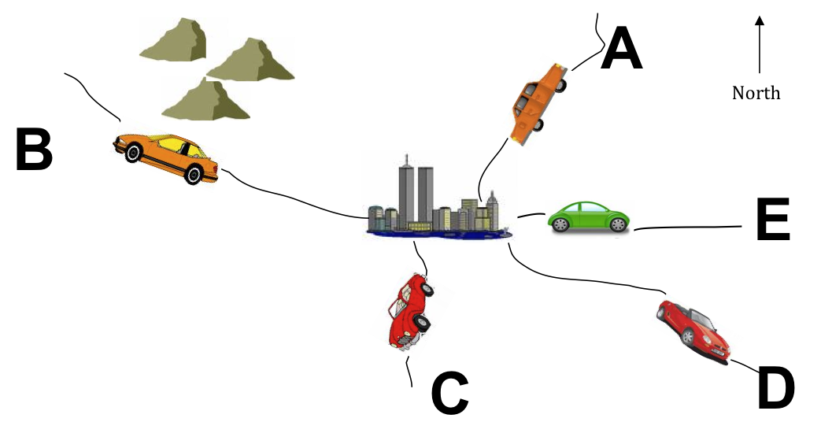
Introduction:
- Display the slide titled, “Part 3: Applying knowledge” and have students turn to the corresponding section in their lab worksheets.
- Ask your students, “How else might vectors be used by humans?” Explain that, while knowledge of vectors and time-series plots can be applied to the field of geology, there are additional practical applications of these processes (transportation, animal migration, movement of thunderstorms and tornadoes).
- This part can be done as a summative evaluation of student understanding of reading time series plots and the corresponding movement of an object.

Procedure:
- Proceed through the next 5 slides as students follow along in their lab worksheets.

Worksheet:

Which car matches the graphs?
- Look at the sets of graphed data below and describe the direction each set of graphs indicates.
- Identify the letter of the car (on the map) that most closely matches the direction shown in the graphs. The first example has been done for you. Refer to the previous pages for help.
 |  | Direction | Car letter
i. | 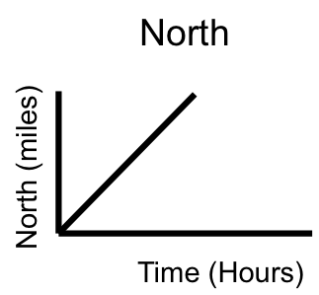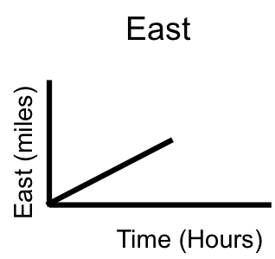 | north-northeast | Car A
ii. | 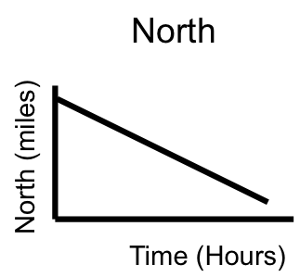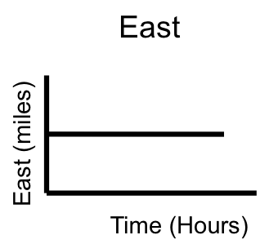 | Direction:  _south_ | Car:  _C_
iii. | 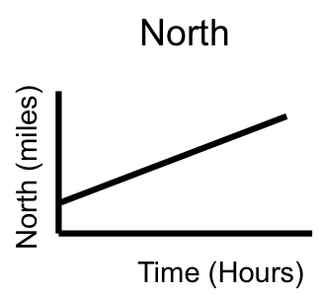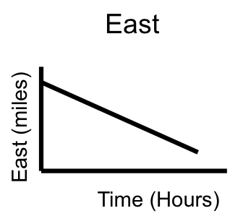 | Direction:  _northwest_ | Car:  _B_

For the two cars remaining, identify the car letter and direction it is moving, and draw the north and east graphs that match each car’s direction.
iv. Car letter __D_ is moving _southeast_ | 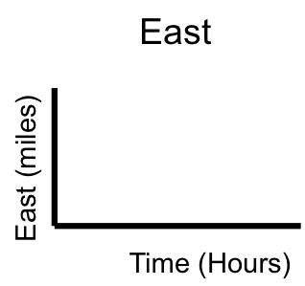  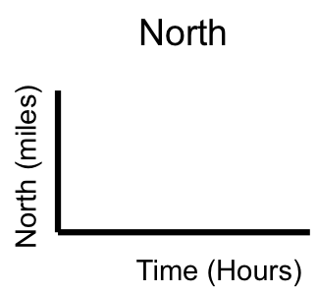
v. Car letter ___E___ is moving _east___

Conclusion (Apply your knowledge):
- Hold a final classroom discussion in order to summarize acquired knowledge. Some questions to ask may include:
  - How does a GPS system work?
  - How many satellites are needed to pinpoint a GPS location? Why?
  - What is a time-series plot? How are they used?
  - What are velocity vectors? How are they used?
  - As geologists, what have we been able to conclude by analyzing GPS data?
- What are additional applications of time-series plots and velocity vectors?

Conclusion (Extension):
- Hold a final, open-ended discussion where students share what they discovered using the UNAVCO Velocity Viewer. See Student Worksheet for questions.

Appendix A: Relevant excerpts from A Framework for K-12 Science Education as cited in the Next Generation Science Standards
Common Core State Standards for Mathematics (CCSSM):
Performance Expectation | Students who demonstrate understanding can:
Ratios and Proportional Relationships 6.RP.3 | Use ratio and rate reasoning to solve real-world and mathematical problems, e.g., by reasoning about tables of equivalent ratios, tape diagrams, double number line diagrams, or equations.
Statistics and Probability 6.SP.4 | Display numerical data in plots on a number line, including dot plots, histograms, and box plots.
Statistics and Probability 8.SP.1 | Construct and interpret scatter plots for bivariate measurement data to investigate patterns of association between two quantities. Describe patterns such as clustering, outliers, positive or negative association, linear association, and nonlinear association.
Statistics and Probability 8.SP.2 | Know that straight lines are widely used to model relationships between two quantitative variables. For scatter plots that suggest a linear association, informally fit a straight line, and informally assess the model fit by judging the closeness of the data points to the line.
Interpreting Categorical and Quantitative Data. S-ID | Represent data with plots on the real number line (dot plots, histograms, and box plots).
Understand and apply the Pythagorean Theorem. 8.G.7 | Understand and apply the Pythagorean theorem to determine unknown side lengths in right triangles in real-world and mathematical problems in two and three dimensions.

3D Alignment:
Science and Engineering Practices | Disciplinary Core Ideas | Crosscutting Concepts
Analyzing and Interpreting Data:  Analyze and interpret data to provide evidence for phenomena.  Developing and using models;  Using mathematics and computational thinking  Constructing explanations (for science) and designing solutions (for engineering) | ESS2.A: Earth's Materials and Systems:  The planet's systems interact over scales that range from microscopic to global in size, and they operate over fractions of a second to billions of years. These interactions have shaped Earth's history and will determine its future. [grade 8]  ESS3.B: Natural Hazards  Mapping the history of natural hazards in a region, combined with an understanding of related geologic forces, can help forecast the locations and likelihoods of future events. [grade 8]  PS2.A: Forces and Motions: All positions of objects and the directions of forces and motions must be described in an arbitrarily chosen reference frame and arbitrarily chosen units of size. In order to share information with other people, these choices must also be shared. [grade 8]  ESS3.B: Natural Hazards: Natural hazards and other geologic events have shaped the course of human history; [they] have significantly altered the sizes of human populations and have driven human migrations. [grade 12] | Scale Proportion and Quantity:  Time, space, and energy phenomena can be observed at various scaled using models to study systems that are too large or too small.  Patterns:  Graphs, charts, and images can be used to identify patterns in data.  Stability and Change:  Stability might be disturbed either by sudden events or gradual changes that accumulate over time

