Exploring plate motion and deformation in California with GPS
Student worksheet
Cate Fox-Lent, UNAVCO master teacher; Andy Newman, Georgia Institute of Technology; Shelley Olds, UNAVCO; and revised by Nancy West.
What’s happening in California? Earthquakes are shifting the landscape, faults are bending the countryside, and the land is creeping and shaking. But, where? In this activity you will work with GPS data downloaded directly from the UNAVCO website to explore plate motion and deformation in California. By analyzing multiple GPS time series plots you can determine the directions and rates of regional deformation. Remember, the GPS stations are permanently concreted to the ground, so if a GPS monument is moving, the Earth’s tectonic plate below it is moving or deforming. Let’s look at the GPS data from California.

Part 1: Analyze real time series data of two GPS stations
Work with a partner to study the data for two GPS monuments, BEMT and SBCC to determine plate tectonic motion and to complete the questions.
If you have access to the Internet, follow the instructions below. Otherwise, fill in the table below using the time series plots on page 3.
- Start at www.unavco.org and click on the link for Data for Educators. (The direct link is: http://www.unavco.org/edu_outreach/data.html.)
- Move the map (click and drag on the map) until you can see California and then zoom to bring BEMT and SBCC into view. Hint: double click on the ocean near southern California multiple times to zoom in.
- Click on the green balloon with the station name (BEMT or SBCC) and click on the link for PBO Station Page to navigate to the Overview Page about the GPS station.
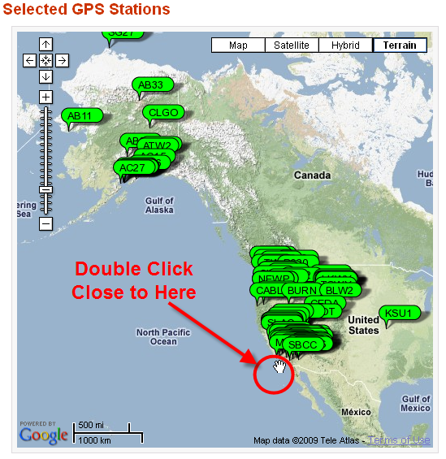
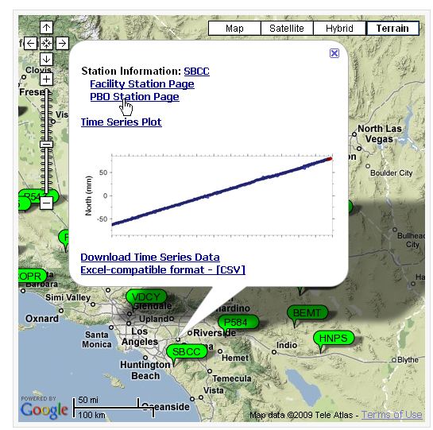
4. Use the information provided on the Overview page. Notice that nearby GPS stations are also shown on the station area map.
SBCC  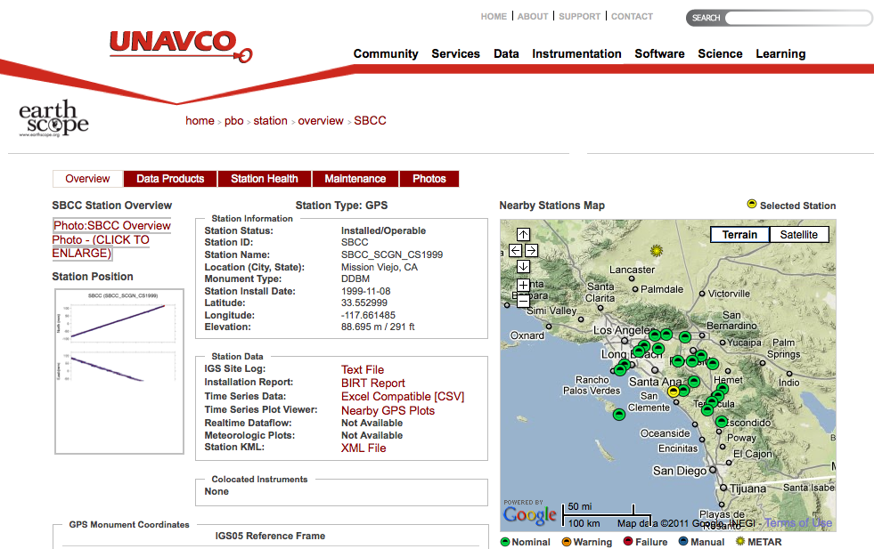 | BEMT  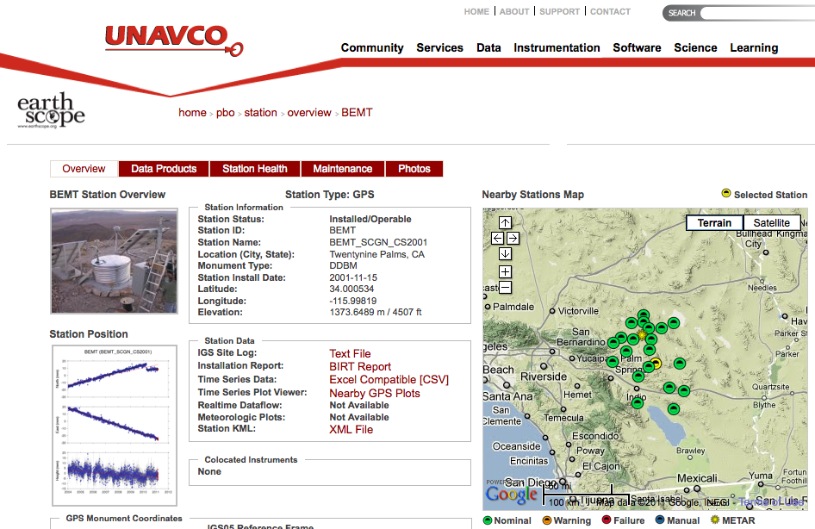
In which city and state is SBCC located?  What are the latitude and longitude listed under SNARF Reference Frame (to 3 decimal places)?  What is the elevation? | In which city and state is BEMT located?  What are the latitude and longitude listed under SNARF Reference Frame (to 3 decimal places)?  What is the elevation?

5. Click on the graph below Station Position. Study the plot entitled, “Most Recent Raw Data Times Series Plot.”

6. Calculate the speed of each GPS monument.
(The convention is to use a negative number for velocities to the south or west.)
a. SBCC: How far (on average) has the station moved per year? (Calculate the speed over five years, and then divide by 5.)  b. SBCC North = __________ mm/year  Moving north or south?  c. SBCC East = __________ mm/year  Moving east or west?  d. Study SBCC’s height (vertical) time series. Examine the trend line (the light red line going through the height data) then describe the motion vertically (up, down, stable):  ___________________________  e. When was SBCC at its highest elevation? How much has the station moved vertically since 2004? | a. BEMT: How far (on average) has the station moved? (Calculate the speed over five years, and then divide by 5.)  b. BEMT North = __________ mm/year  Moving north or south?  What do you think happened at BEMT?  c. BEMT East = __________ mm/year  Moving east or west?  d. Study BEMT’s height (vertical) time series. Examine the trend line (the light red line going through the height data) then describe the motion vertically (up, down, stable):  ___________________________  e. When was BEMT at its highest elevation? How much has the station moved vertically since 2004?
If you do not have Internet access, use the time series plots below. The dates on these plots will not match the newest plots.
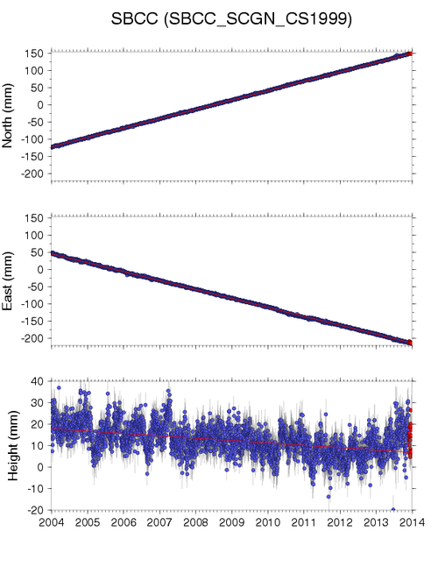 | 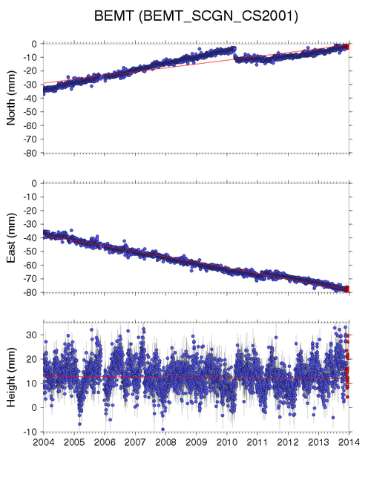

7. Plotting GPS motion on a map grid. On the map grids below:  - Draw a faint arrow to show the annual northward movement. | 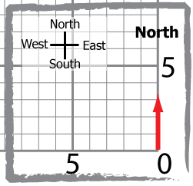
- From the end point of the north arrow, draw an arrow to show the annual eastward movement. | 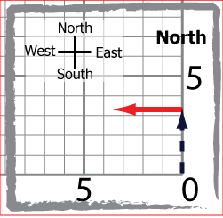
- Draw a diagonal arrow from (0,0) to the end point of the east arrow. This final arrow (vector) shows the overall annual direction and distance of motion of the GPS station and the land beneath it. | 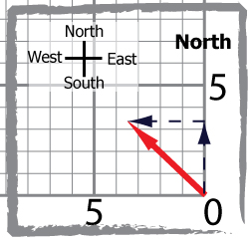
- Mark the length of the diagonal arrow—the total horizontal velocity vector—on a scrap of paper. Measure its length against an axis, where each square represents one millimeter (1 mm).

SBCC map grid  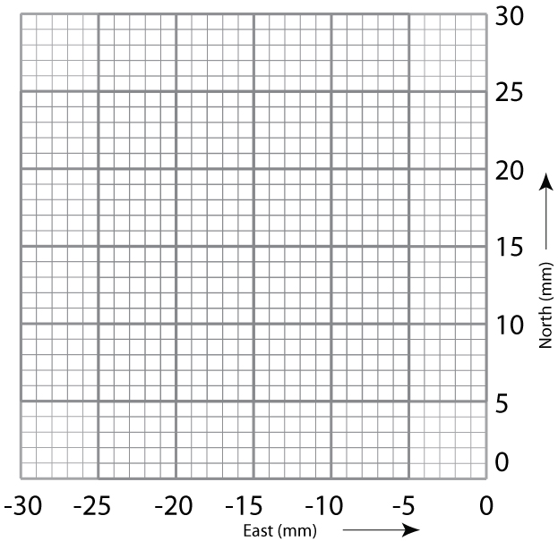 | BEMT map grid

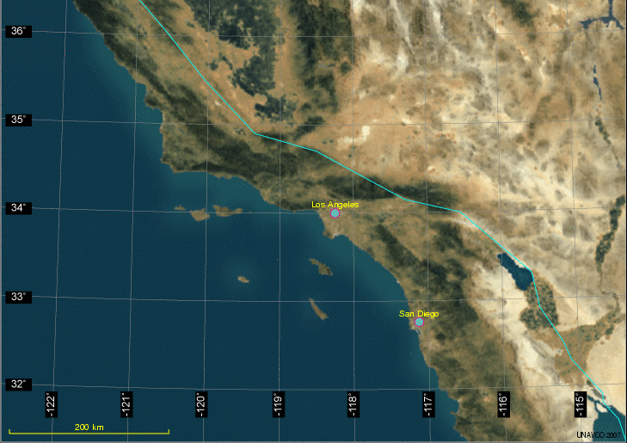
8. Plotting the GPS vectors on a map and analysis. Work with your partner:
- Plot the locations of the GPS stations on the map.
- Draw the vectors for BEMT and SBCC.
- Answer the following questions:

- Describe how the SBCC and BEMT vectors are different and how they are the same. Which station is moving faster?

- What would be some reasons for the differences in their rates?

- Remember that the GPS monuments are affixed to the ground. If they are moving, then the ground must be moving.

- In 1000 years, how far has SBCC moved; how far has BEMT moved?

- If the two GPS stations are moving in the same direction, how much farther will SBCC have moved in 1000 years compared to BEMT? Based on what you know about the San Andreas fault, how will this movement occur? All at once?

Before turning to Part 2, study the time series plots for GPS monuments CAND and CARH.
What could have caused these two GPS stations to move like this?
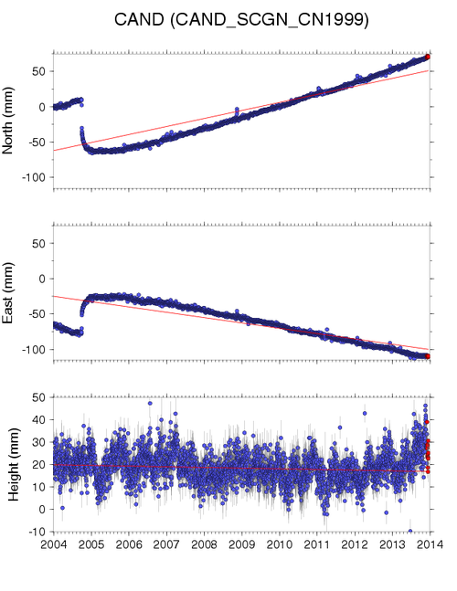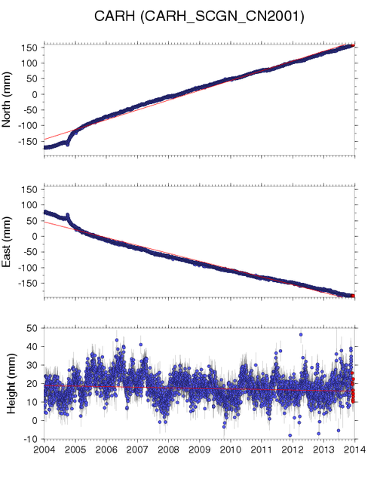

Part 2: Investigate deformation at two GPS stations in California
1. According to the position time series plots, when did an earthquake occur? Use the conversion chart on page 3 to provide the month and year.

2. Using the CAND time series plot, how much did the fault slip during the event?

3. Describe how the CAND GPS station’s position changed during the earthquake.

4. Describe how the CAND GPS station’s position changed after the earthquake.

5. Optional: Using the equation provided, and the slip you calculated, what was the magnitude of the Parkfield earthquake?

M = log₁₀(D) + 6.32
0.9
In which M = magnitude
D = average slip in meters

[1000 mm = 1 meter]

How well does the magnitude match the measured magnitude (M = 6.0) of the earthquake?

More questions to consider
The Parkfield section of the San Andreas fault has not experienced a magnitude 6.0 (or greater) earthquake since the 2004 event, but the North American and Pacific plates continue to grind past each other.

1. Based on the data about the total slip due to the Parkfield earthquake at CAND and CAHR, and the fact that the Pacific plate is moving ~17mm/yr past the North American plate at Parkfield, how long should it take to build enough energy to generate an earthquake with a similar magnitude?
2. Look at the diagram from the USGS (next page) illustrating when earthquakes with magnitudes similar to the 2004 events have occurred along the Parkfield section of the San Andreas fault. How often did these earthquakes occur?
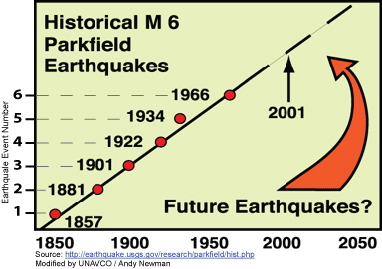
3. Does your calculation from question 1 agree with the observed value from question 2?

4. If you answered “no” to question 3, how could you explain the difference?

Extension for Part 1: Explore more GPS locations near BEMT and SBCC
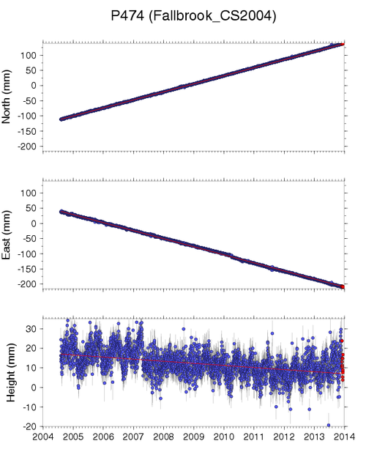
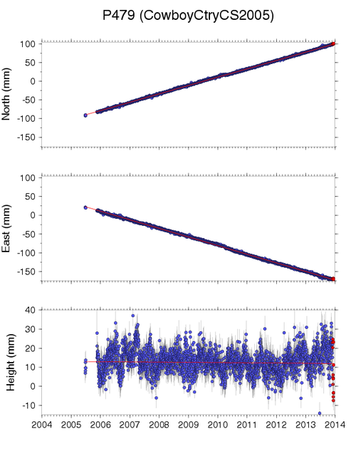
If time permits, take a look at additional GPS stations near BEMT and SBCC, create velocity vectors for each station, and plot them on the map on page 10.
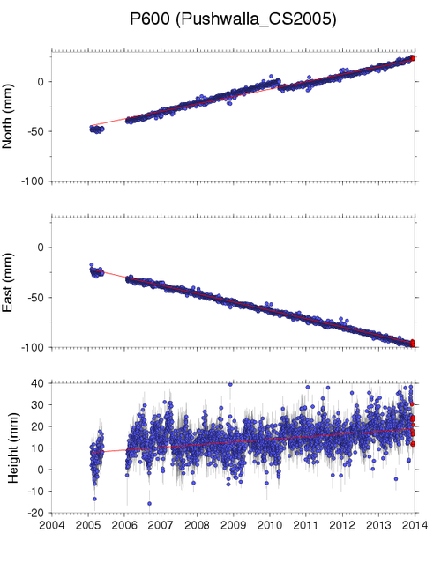
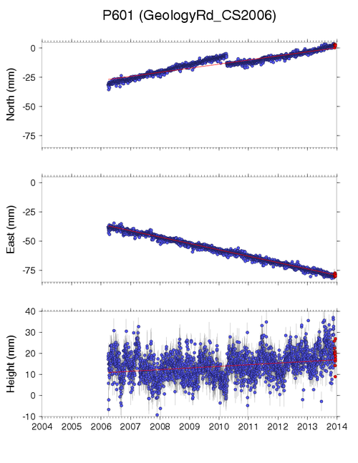
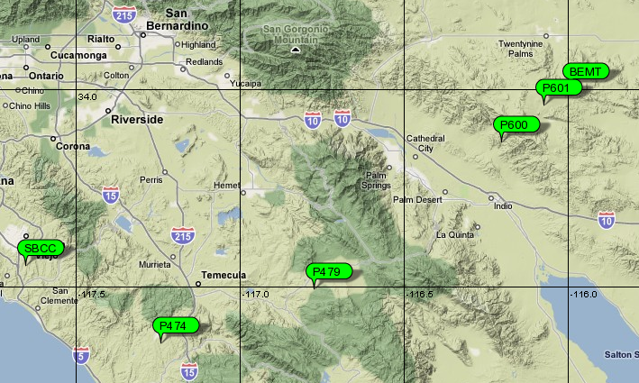
What do you notice about the resulting vectors of these GPS stations?

How do the velocities at each station change from west to east?

Using these extra stations, show on your map where you would place the plate boundary--the San Andreas fault?

What other types of data might you explore to support your decision for this location?

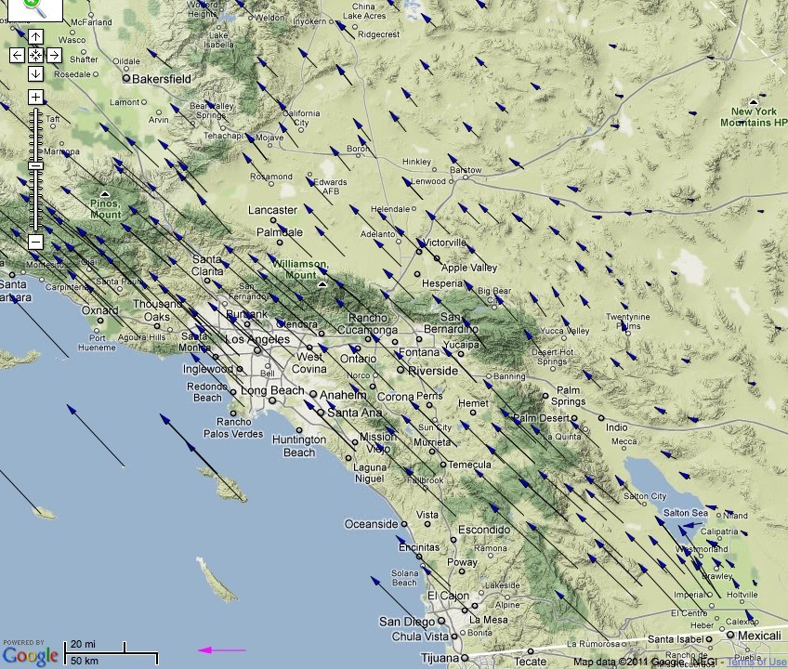
How do your vectors compare to the vectors in this map?

Extension for Part 2: Explore more GPS locations near CAND and CARH
Explore the extent of movement (post-seismic relaxation) after the Parkfield earthquake by looking at additional GPS stations. Look at a few additional GPS stations near CAND and CARH, such as MNMC (located due north of CAND), MASW (located south of CARH), etc.
Explore the extent of movement (post-seismic relaxation) after the Parkfield earthquake by looking at additional GPS stations. Look at a few additional GPS stations near CAND and CARH, such as MNMC (located due north of CAND), MASW (located south of CARH), etc.

How to get the data:
One way to find these stations is to go to the overview map for the GPS station CAND on the Data for Educators’ page. (Search for “UNAVCO data educators.”) Zoom to CARH or CAND, click on the PBO Station Page link, and find the other stations on the Nearby Stations Map.

What is the total slip for movement at these stations? Do they all show the Parkfield earthquake? Why not?

Locate these stations on your map and label them with the 4-character ID (such as MNMC) and the maximum slip that occurred during and after the Parkfield event.

Now look at the intensity shake map from the Parkfield earthquake. You can also study a map made from more than 14,000 reports by citizens who felt the shaking in a program by the U.S. Geological Survey called “Did You Feel It?” (Search for “CISN ShakeMap 2004” and follow the link at the bottom to “Current Parkfield M6.0 ShakeMap.” Search for “DYFI archives” and then “Parkfield California September 2004.”)

What are the similarities and differences between the intensity of the shaking and the map you created?

