Explore Tectonic Motions of the World
Student worksheet
Are the tectonic plates still moving? How do know? Let’s explore evidence of the plates moving using current GPS data to see how the land beneath your feet is moving, compressing, sliding, and stretching. Study the maps and look for evidence of different types of crustal motion, then consider the hazards and societal impact that might result due to these motions.

Circle on the map areas where
- Vectors point in similar direction but have very different lengths (speeds)
- Vectors are pointing different directions from each other
- Gradual changes in length of vector from the coast to inland.

Table 2 GPS data | Site 1 | Site 2 | Site 3 | Site 4 | Site 5
Location
Reference Frame 1 name
Describe the vectors:

Directions & Lengths

(note: magenta scale vector = 25mm/year)
Reference frame 2 name
Describe the vectors:

Directions & Lengths
Sketch the plate boundary on the blank maps.
Describe the boundary type here:
Similar regions
(land and ocean)
Where might earthquakes occur in this region?

Site 1

Blank map:

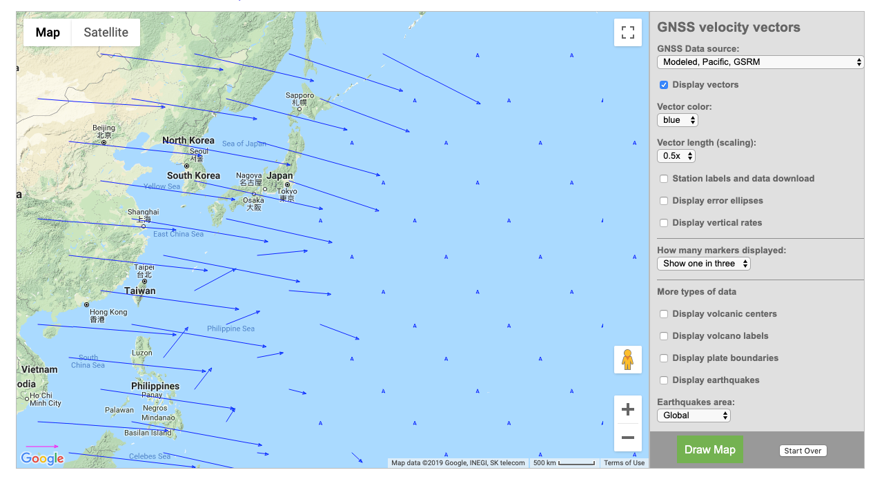

Reference
Frame 1:
(Modeled, Pacific)

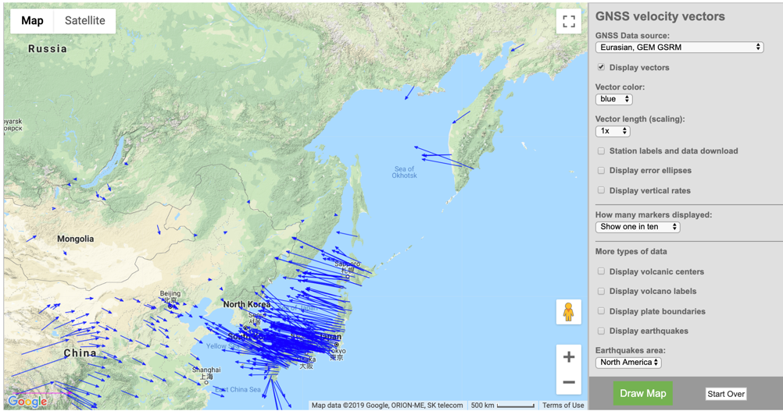

Reference
Frame 2:
(Eurasian)

(note vector scale)

Site 2

Blank map:

Reference
Frame 1:

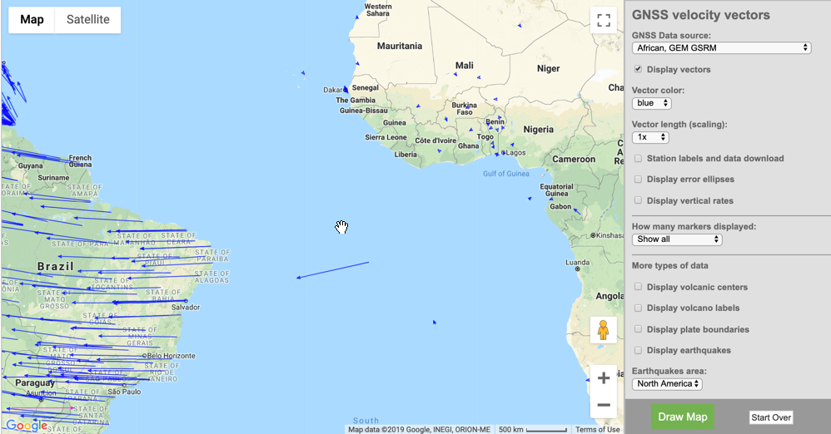

Reference
Frame 2:

Site 3

Blank map:

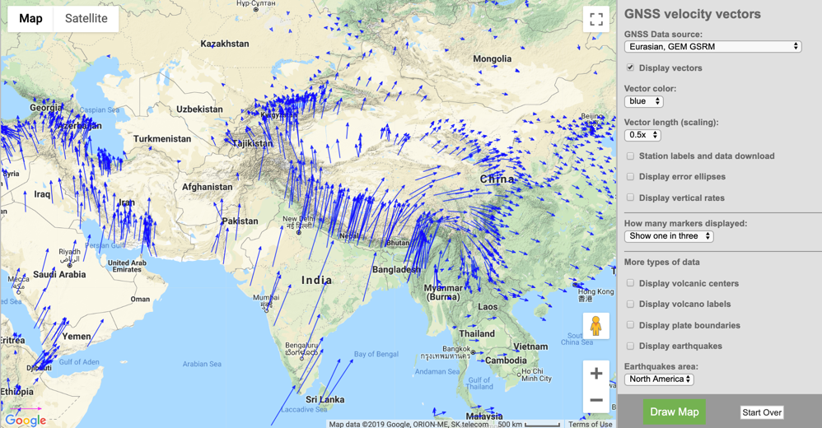

Reference
Frame 1:

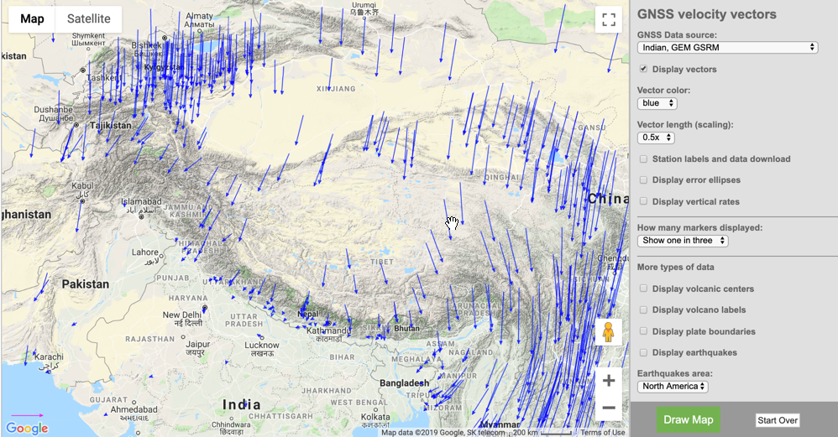

Reference
Frame 2:

Site 4

Blank map:

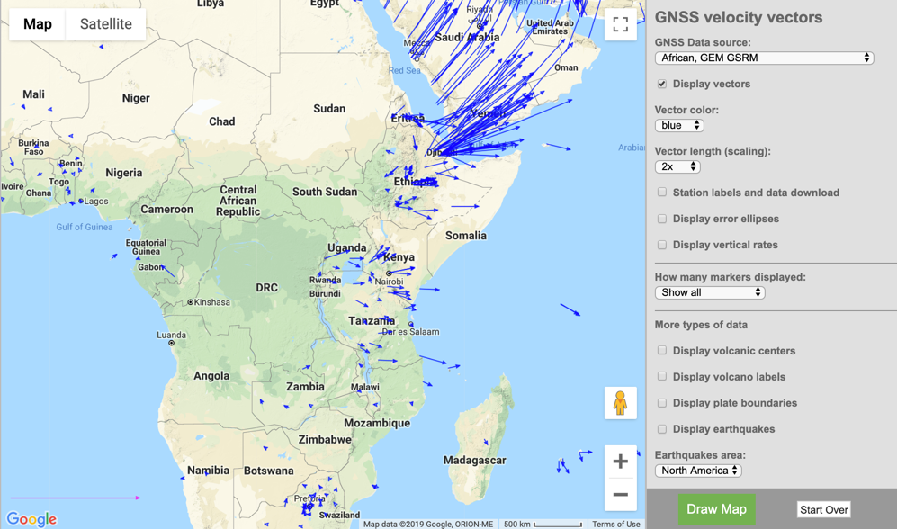

Reference
Frame 1:

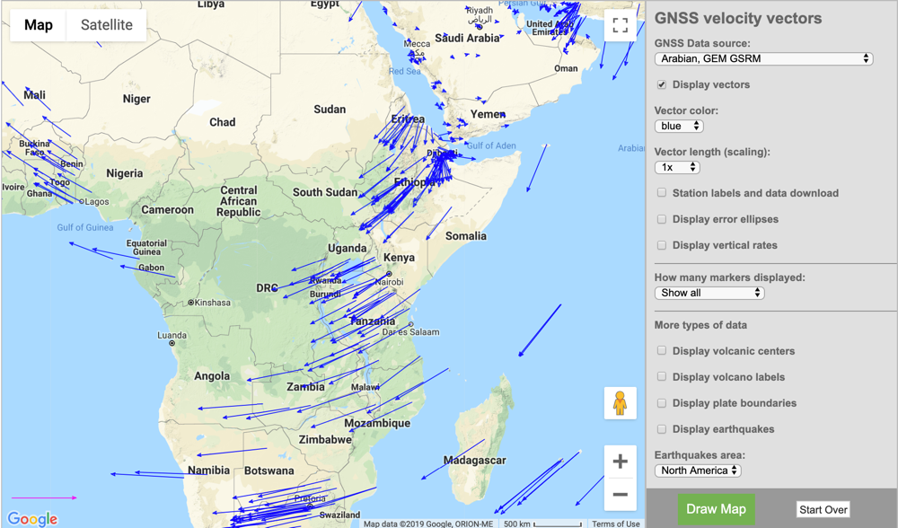

Reference
Frame 2:

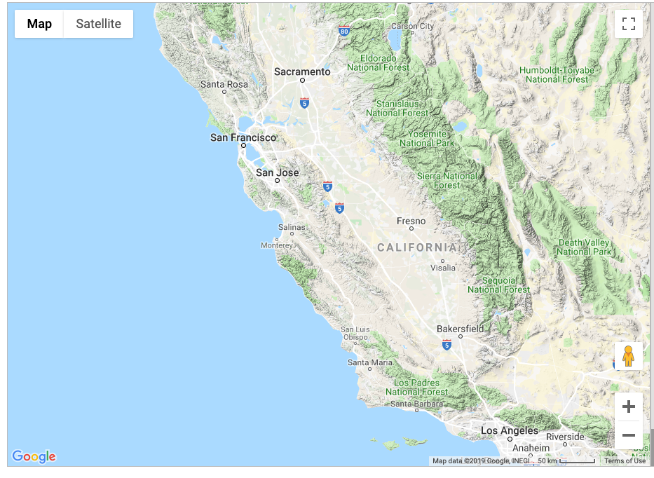
Site 5

Blank map:

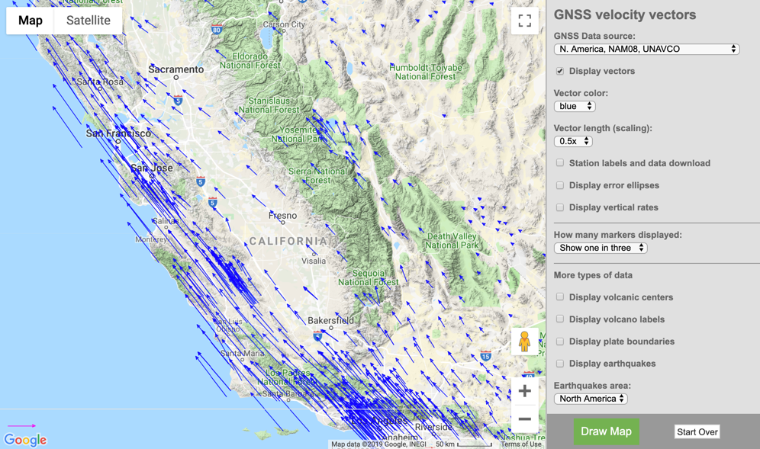

Reference
Frame 1:

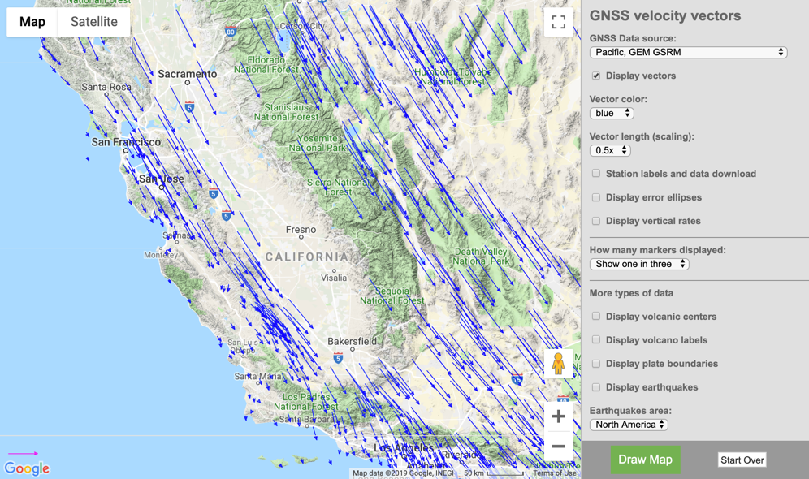

Reference
Frame 2:

