Velocity maps
Nancy West, Beth Pratt-Sitaula, and Shelley Olds, expanded from work by Vince Cronin, Baylor University.
In this activity, students manipulate velocity vectors that they pulled from GPS time series data. Their immediate goal is to determine the total horizontal velocity for each station. This activity is an early step in the activity “Determining strain graphically.”

Instructor’s notes
Students will need to have N-S and E-W velocity vectors associated with the three PBO GPS sites in hand for this exercise. You can provide it, or they can seek it out themselves. Students learn how to get the data in the lab sheet for “Determining strain graphically.” See “Finding location and velocity data for PBO GPS sites” for a lengthier explanation of how to download Plate Boundary Observatory data, along with a worked example. These instructions assume that you will tell your students which three GPS stations they will work with.
You will want to prepare a map for your students to work on like that in Figure 1. The map will be the second page of their handout. You will need to excerpt your base map.
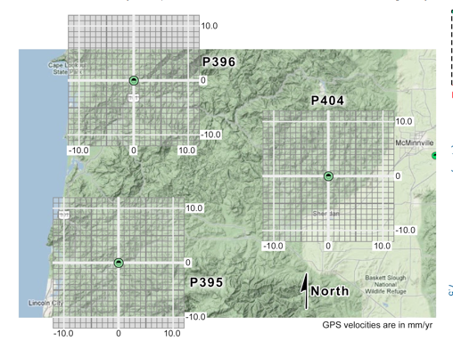

Figure 1. Example of a base map with grids placed over the GPS station symbol.

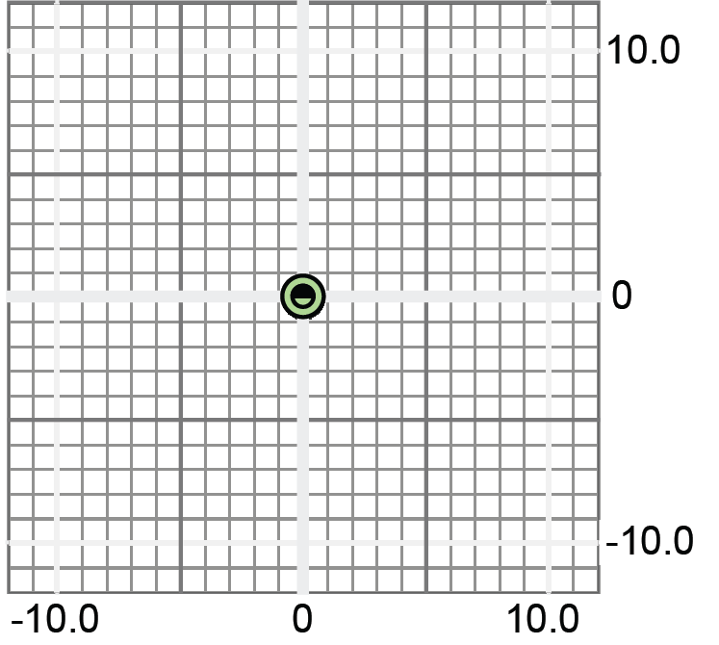

- Select three GPS stations from UNAVCO’s source for Plate Boundary Observatory (PBO) data. (Search for “PBO station finder.”)
- Once you have chosen three stations, use the Station Finder to make a base map. Enter Station IDs in the window with commas and no spaces. Your map should show only the three stations. Take a screen shot of the map using software such as Snagit or Grab. Leave space around the edges, or the next step becomes a challenge.
Figure 2. A grid upon which students draw velocity vectors.
- Insert the base map into the second page of the student labsheet. Under Format Picture, make the map about 50% transparent so that pencil lines can be seen. Also, set the Layout option to Square.
- Copy and paste the grid in Figure 2, also on the student sheet, over the icon for a GPS site. You can adjust with the grid’s transparency.
- Repeat for the other two stations.
- Replace “XXXX” on the student sheet with station names.
- Have your students do the exercise.
- Discuss, in small groups or as a class, what they can infer about strain in the area defined by the triangle of GPS stations—based solely on the horizontal velocity vectors.
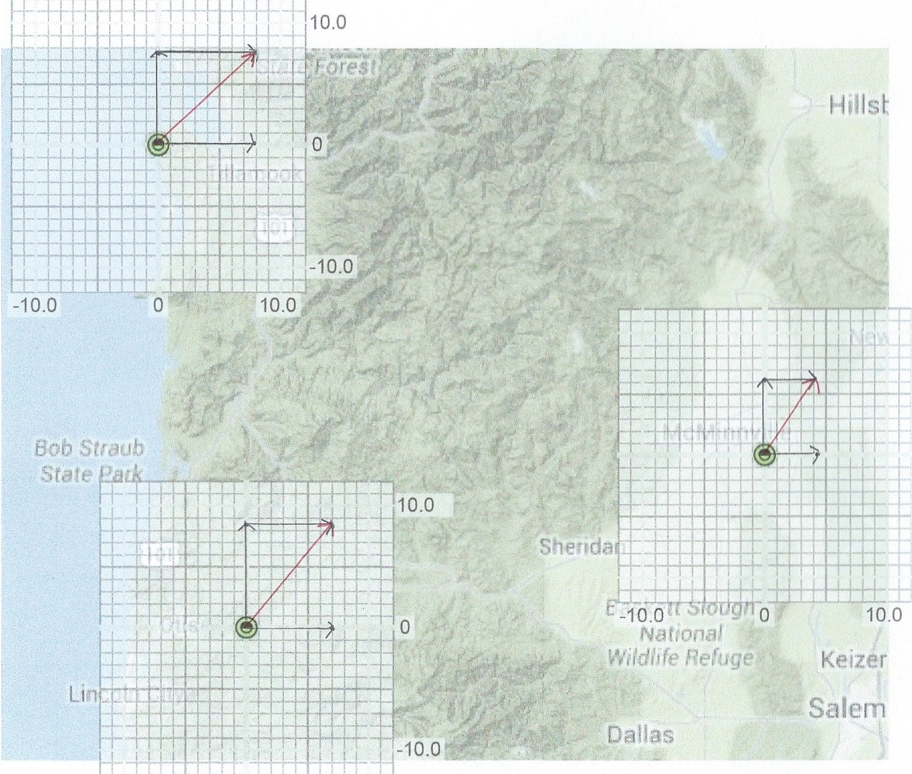
- Move on to the rest of “Determining strain graphically.” Students can stop with the graphical analysis or go all the way through the activity, culminating in quantitative analysis done by a spreadsheet calculator.
Figure 3. Example with Oregon stations CHZZ, P395, and P406.

Optional
Ask students also to get a sense of distances between sites. They could do this--
- on a map with a scale (although probably with grumbling);
- with the ruler tool on Google Earth. If students open the Add menu, they can add a placemark by entering latitude and longitude. They can then click and drag the ruler between two placemarks (showing as pushpins) to learn the distance and azimuth between them; or
- with an on-line calculator into which they plug in latitude and longitude. An example is the National Hurricane Center’s calculator. (Search for “NOAA latitude longitude calculator.”)

