Velocity maps
Nancy West, Beth Pratt-Sitaula, and Shelley Olds, expanded from work by Vince Cronin, Baylor University.
Research-grade GPS units measure horizontal motion precisely—they can detect millimeters of motion per year. Data from the Plate Boundary Observatory and other sources is available at no cost via UNAVCO. (Search for “PBO station finder.”) From plots of position over time, the average velocity in the north-south, east-west, and vertical directions is calculated for you, along with error in the measurements.
In this activity, you will analyze vectors that show crustal motion at three GPS stations. You will derive these vectors from time-series data. For help in understanding time series data, refer to "Finding location and velocity data for PBO GPS stations."

Velocity vectors
1. Carefully draw the N - S and E - W velocity vectors associated with each of the three GPS sites shown as green dots on the accompanying map. A negative north component is a vector pointing south, and a negative east component is a vector pointing west. The graphs are scaled in units of millimeters per year.
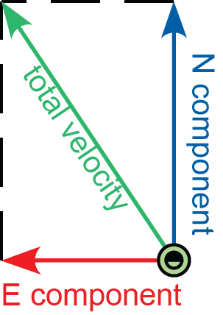
2. Now draw the total horizontal velocity vector for each site, and determine the horizontal speed (that is, the length of the total horizontal velocity vector) of each site. You can do this at least three ways.

You can add the vectors graphically and use the scale to measure the
length of the velocity vector.

Or, you can use the Pythagorean theorem, either by adding vectors and solving for the length of the velocity vector (a) or by treating the east and north components as two sides of a triangle and calculating the hypotenuse (b).
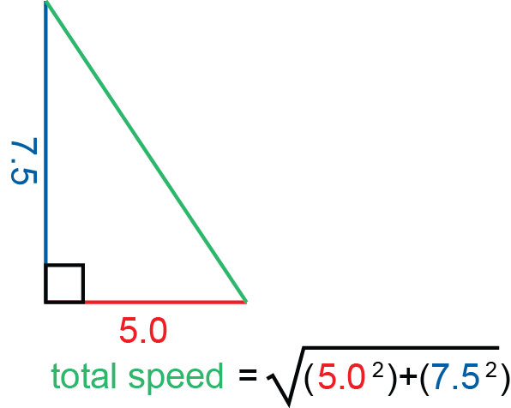
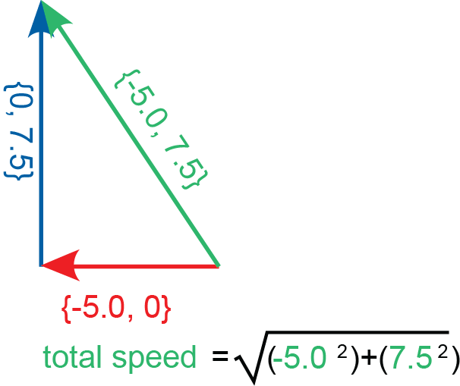

(a) (b)

Velocity map Name(s):________________________
[Instructors: Insert map with grids centered on each GPS station in this space.]
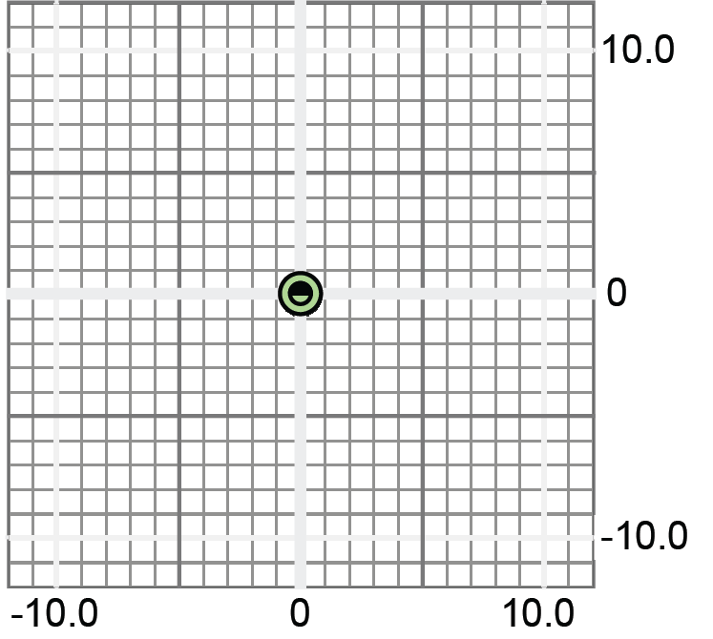

Total horizontal speeds: XXXX___________mm/yr; XXXX___________mm/yr; XXXX___________mm/yr.
Optional: Distances among stations:

