Strain
Nancy West, Beth Pratt-Sitaula, and Shelley Olds (UNAVCO) expanded from work by Vince Cronin (Baylor University)
In the realm of geology, strain is the distortion of Earth’s crust, whether seen in rocks from stresses long ago or measured with GPS as it happens today, this very day. Segments of the crust change their shape—they are strained—but they also move as a block (“translation”) and spin as a block (“rotation”). Strain, translation, and rotation comprise “deformation.”
Although this module on strain focuses on data generated by GPS units, each of the three sections of this article begins with finite strain—strain that occurred for long enough that rocks deformed in observable ways. This classic approach provides geological context for you. However, for each section, we suggest initiating instruction by having your students work with physical models. Although this text includes brief descriptions of the models, lab instructions for you and for your students are in “Physical Models of Strain.” A companion article, “Strain—for students,” can reinforce in-class instruction. These concrete examples—physical models and geological examples--teach measurements such as extension and concepts such as strain ellipses. Ultimately, your students will apply this new knowledge to GPS data, using simple geometry of triangles and a spreadsheet to calculate strain.
Why? What bearing does this have on society? A compelling reason is that crustal deformation threatens the safety of people in large swaths of the North America. The broader effects are not limited to the West: Even people who live in seismically quiet regions will feel the economic impact of a major quake in the US--our economic well-being would be at risk if a region from Seattle to Portland were heavily damaged.

1. One-dimensional strain

Extension or elongation—geological context
When a geologist has the good fortune of seeing a linear feature in nature that is broken into segments, she knows it has been strained. And, she can measure how much it has been pulled apart. Structural geology textbooks often show a fossil belemnite like those in Figure 1.
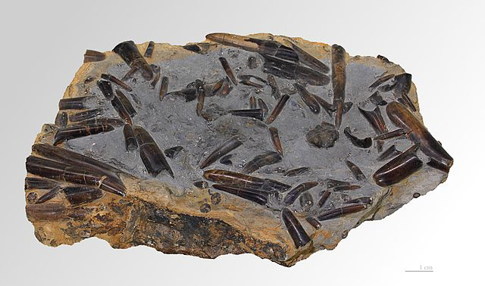

Figure 1. Unstrained belemnites scattered throughout a slab of sedimentary rock. Selim, 2011.

(As perhaps you have guessed, belemnites are in the family that includes squids.) Structural geology textbook authors usually choose a fossil that looks more like Figure 2—a belemnite that has been pulled into segments with some other material intervening. Your imagination can extract the intervening material and reconstruct the original shape and length of the belemnite. This fossil has obviously been pulled apart: it has been deformed, strained, extended, and stretched. Let’s define the last two terms.
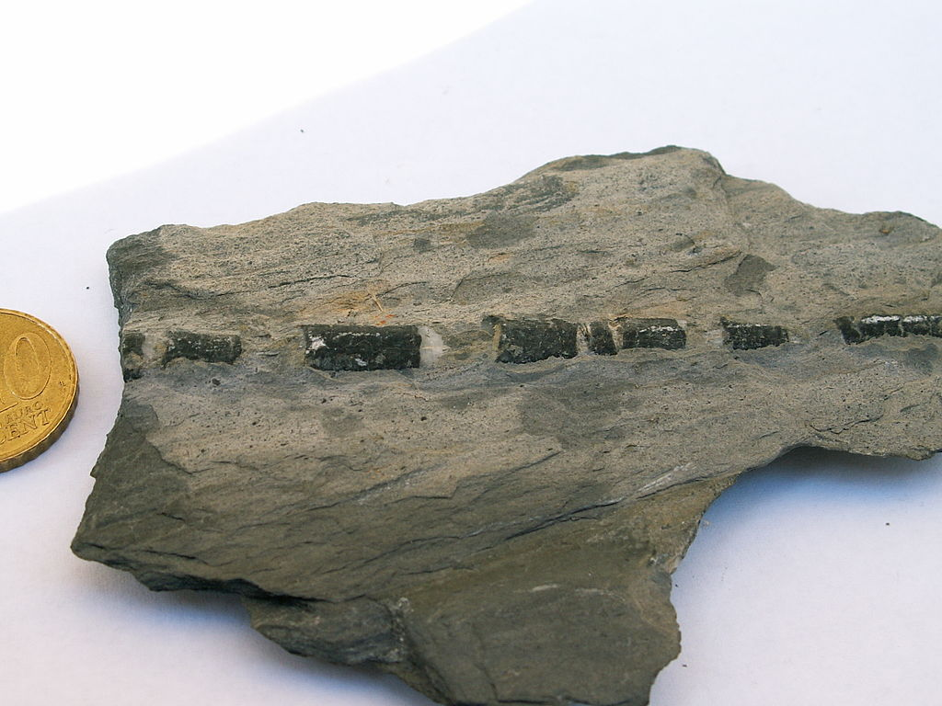

Figure 2. Photo of belemnite from the Alps. Jurassic. 10 Euro piece is about 2 cm in diameter. WeFt, 2007.

Extension (to a structural geologist) is the ratio between the change in length of a feature and its original length. In the case of the belemnite in Figure 2, you could add up the lengths of all of the gaps to determine the change in length. And you could add up the lengths of all of the pieces of fossil to know its original length. Divide the gaps by the pieces and you have the extension, e.

Physical models in one-dimension
Despite providing the geological example of belemnites first for you, we suggest having your students begin exploring extension with physical models. Sewing elastic or bungee cords will suit the purpose if you mark them different distances from the end, as in Figure 3a and 3b. If students tug one end of the bungee and measure 1) between the black threads, and 2) from the left-hand black thread to the red thread, they can discover that e is a constant ratio. (See “Physical Models of Strain” for a write-up of this exercise. We recommend that your students do this activity as an introduction to strain—before you teach them formally about extension or stretch.)
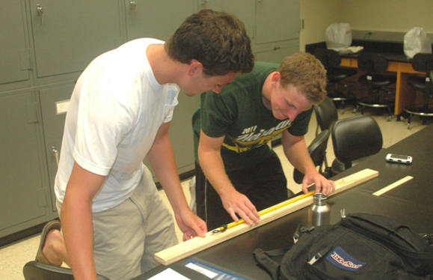
Figure 3a. Students measuring a bungee cord to determine extension.

Figure 3b. Detail showing black thread sewn in two places left of center and red thread to the right. Note the second peg for the hook on the far right. Cronin, 2012.

Let’s look at the measurement and calculation more generally.
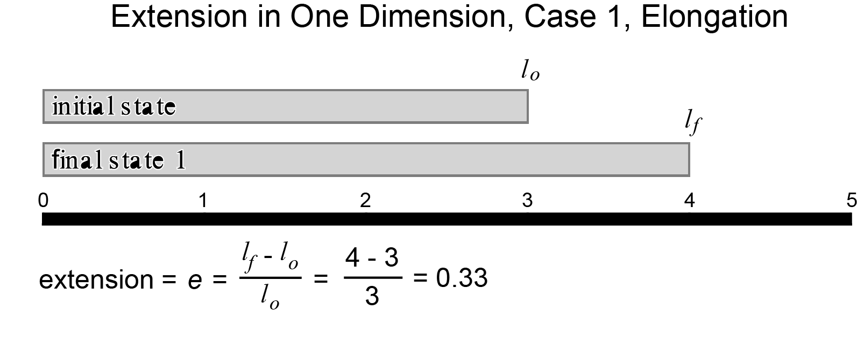

Figure 4. An idealized linear feature that has been extended—or elongated.
l_{o} is the original length.
l_{f} is the length after straining.
l_{f} - l_{o} is the difference between them--or the change in length.

In this more general example, l_{o} is 3. The feature is elongated so that l_{f} is equal to 4. The extension, e, is$\frac{l_{f }- l_{o}}{l_{o}}$ or 0.33.
What if the linear feature is shortened instead of lengthened? We will use the same equation. The only change is that the value representing extension is negative.
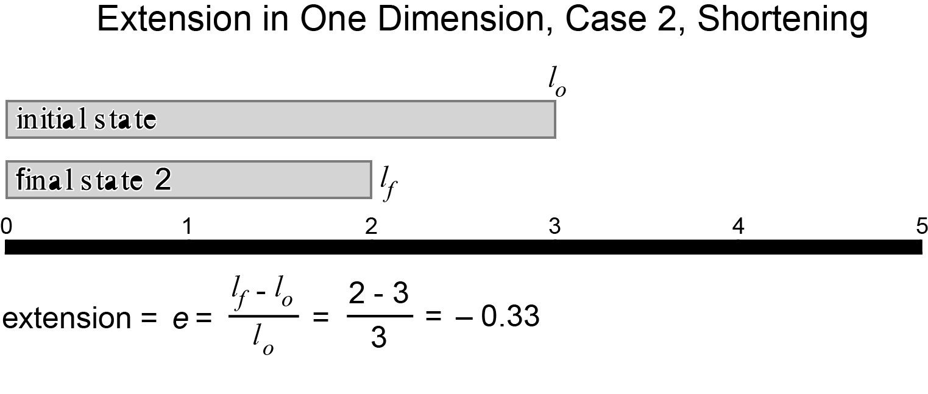

Figure 5. An idealized linear feature that has been shortened.
With the concept of extension in mind, let’s return to the belemnites briefly. Notice again the orientation of the belemnites in Figure 1. If the slab had been extended or stretched in any single direction, some of the belemnites would look like the belemnite in Figure 2. Others would have been skewed or distorted in some way because the atoms, ions, and molecules would have been pulled apart in the direction of the extension. Because we do not see that, we know that this slab has not been extended, elongated, stretched, or strained. (If it had been translated or rotated, it would be deformed--but not strained.)

An historical geological example
Belemnites are ancient; the examples shown in Figures 1 and 2 are from the lower Jurassic, 199.6 to 175.6 million years ago. An historical geological example from which your students can estimate extension and stretch is a result of the 1906 San Francisco earthquake, in Figure 6. Look carefully at the rails in the foreground: they were pulled apart as sediments underlying them spread during the magnitude 7.8 quake. (Note that this extension was a secondary effect of the strike-slip motion (shearing) along the San Andreas fault.) Perhaps with clever detective work on the dimensions of paving stones and rails used in 1906, students can estimate the extension and stretching that occurred in this area of San Francisco in the earthquake.

Figure 6. Rails separated by sediment settling during the 1906 San Francisco earthquake. Gilbert, 1906.

You have seen strain in linear objects like belemnites and train rails—one-dimensional examples. Let’s now broaden the applicability and work in two-dimensions.

2. Two-dimensional strain--description

Geological examples of strain in two-dimensions
When a tiny shell fragment rolls around below tropical seas, layers of calcium carbonate can build up on it. Round grains that look like cream of wheat ensue. They are called “ooids,” and the sedimentary rocks that form are “oolites.” You can view a slab of unstrained oolite in Figure 7. When oolites are strained, the round grains deform into ovoids in three dimensions and ovals or ellipses in two, as in Figure 8.
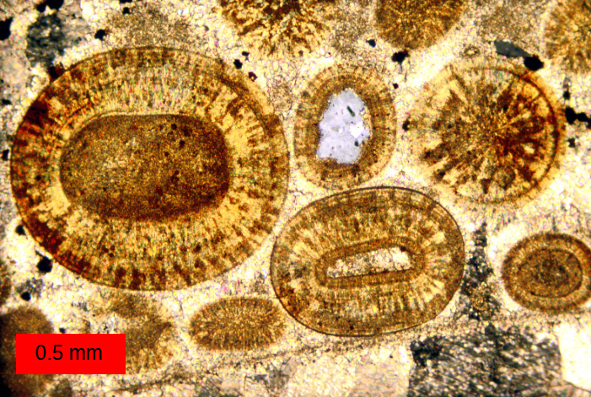
Figure 7. Photomicrograph of Jurassic ooids in the Carmel Formation, Utah. Wilson, 2008.

Figure 8. Photomicrograph of Cambro-Ordovician deformed ooids from South Mountain, Maryland. Cloos, 1947.

A physical model in two-dimensions
As with strain in one-dimension, students’ understanding of strain in two-dimensions can improve by playing with a physical model. You can find suitable materials in your local sports store or the athletic department of a discount store. The three students in Figure 9 are experimenting with strain in two dimensions. We recommend that students explore strain with the model before you formally teach two-dimensional strain. See “Physical Models of Strain” for a write-up of this activity.
Figure 9. Students tugging on stretchy tee-shirt fabric to see how a circle deforms.

Figure 10 idealizes students’ tugging on the T-shirt with a cartoon that uses vectors to show three corners pulled exactly evenly. In this special case, balanced pulling stretches the circle uniformly, and the circle dilates.
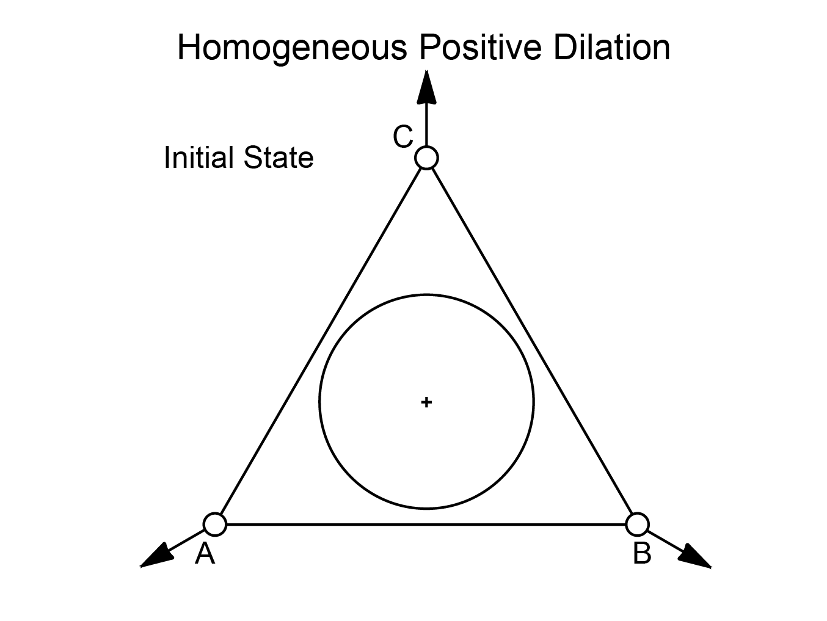
Figure 10. A more technical description and idealized rendition of the T-shirt strained by three students pulling against each other.

In a different idealized scenario, if one student were to pull hard while the other two kept their hands stationary, as indicated in Figure 11, they would see the circle elongate along the vertical axis, becoming an ellipse.

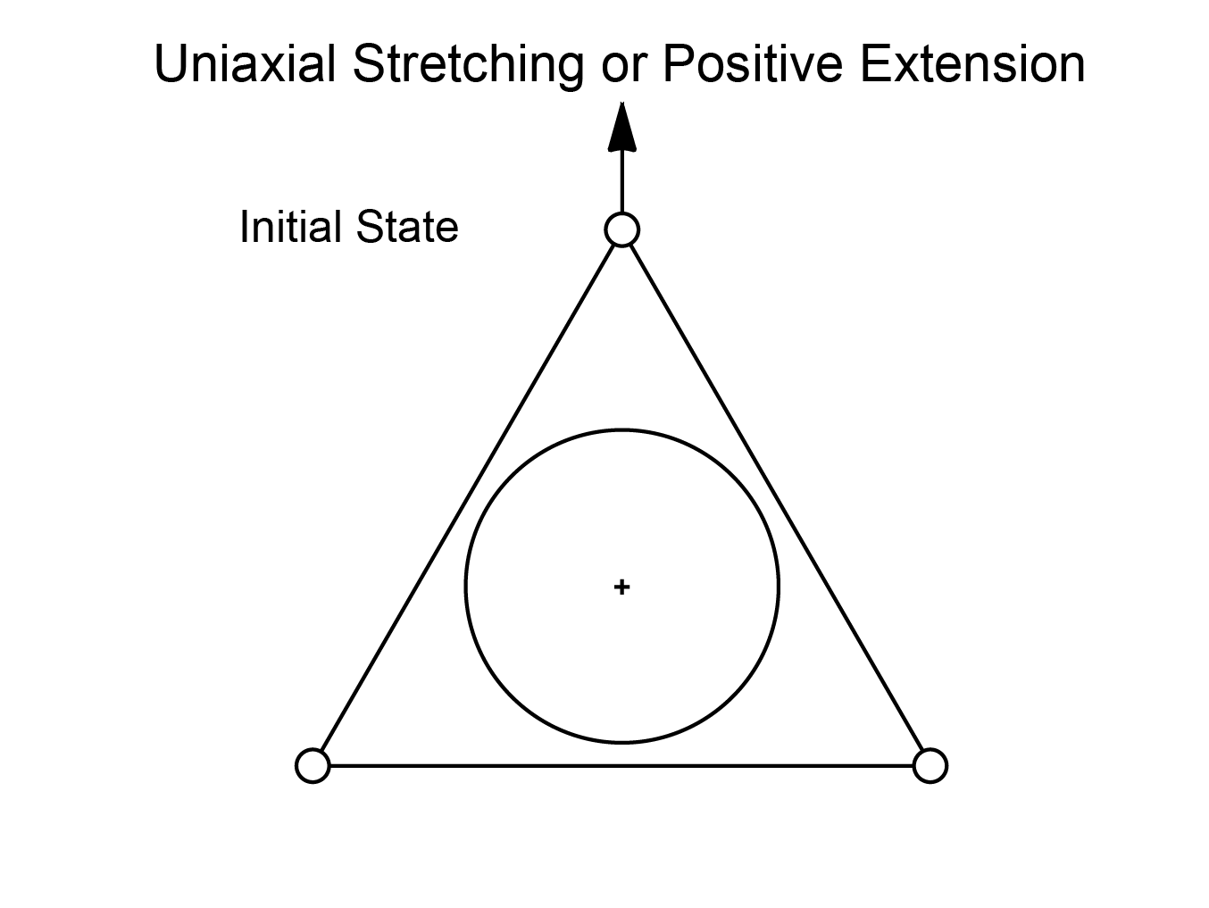
Figure 11. An idealized rendition of the tee shirt strained by one student pulling against two passive students.

3. Two-dimensional strain—mathematical descriptions and how it happens

Strain ellipses
Geologists describe the ellipses that develop when T-shirts, ooids, cartoon circles, Silly Putty® and stacks of cards distort by drawing two “strain axes.” They draw one axis the length of the ellipse and another across the ellipse. Figure 12 shows the distortion of dashed circles into ellipses. Stretch and strain can both be designated by an “S.” S₁ is along the longer dimension of the ellipse; it is called the “greater principal strain” and is shown as the “semi-major axis of the strain ellipse.” S₂ is along the shorter dimension. It is the lesser principal strain and the semi-minor axis of the strain ellipse.
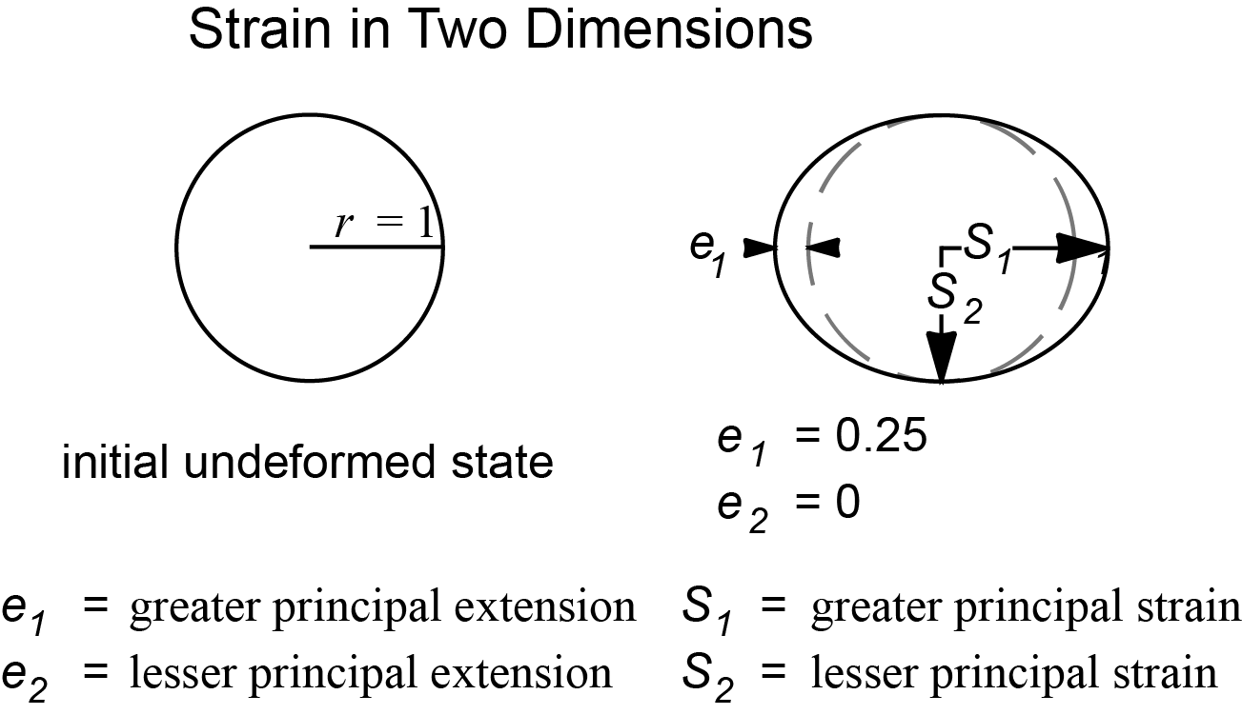

Figure 12. Depiction of strain axes in a case of uniaxial stretching. The values for S₁ and S₂ are the stretch depicted in this strain ellipse along the principal strain axes.

Pure and simple strain
From models and photographs of rocks, your students can visualize strain in one and two-dimensions. They can measure and describe extension, stretch, and strain mathematically with strain ellipses. You have introduced them to the image of vectors representing their pulling on the corners of a tee shirt with a triangle and an inscribed circle that changes shape and/or size. In short, they understand the concept of strain and have learned terminology. But, they probably do not know the idealized ways in which rocks or Earth’s crust strains. How do geologists describe the means by which strain occurs? There are two means: pure and simple.

Pure strain in two-ish dimensions
“Two-ish” because your students work with a three-dimensional cylinder of clay but see changes on a two-dimensional surface. They roll a thick cylinder of Silly Putty and flatten one side. They use a vial or narrow-necked bottle to imprint a circle on the flat side, set the cylinder on end, and wait. (Fig. 13)
Figure 13. Silly Putty that has sagged under the influence of gravity, as an example of pure strain. Cronin, 2012.

Strain occurs along a single axis that is perpendicular to the principle strain axis, S₁. The two axes remain perpendicular to each other during strain (and to reference axes). No rotation occurs. In short, the circle gets smooshed into an ellipse. Figure 14 formalizes this idea.

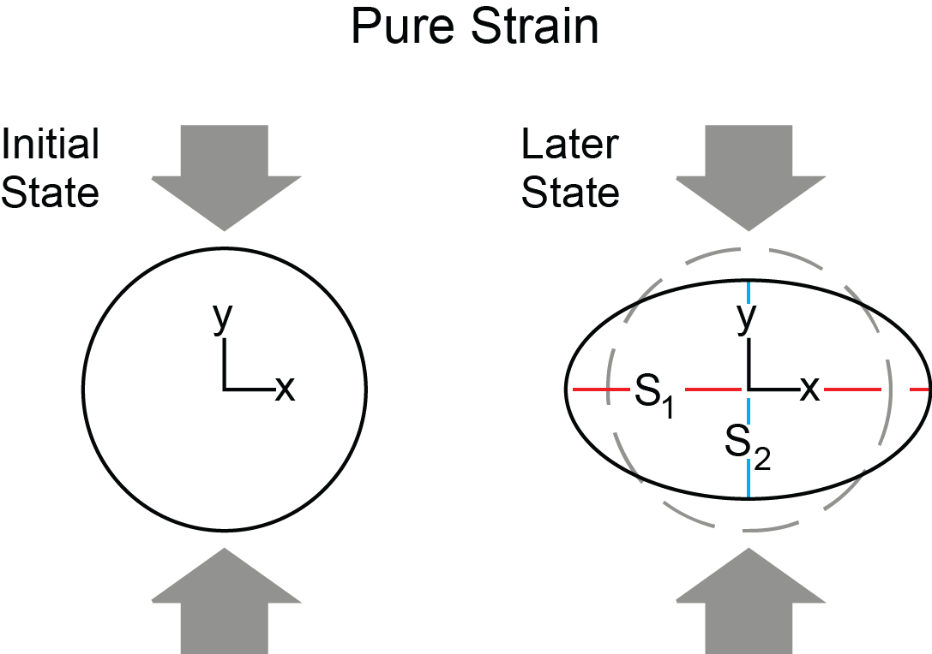

Figure 14. A strain ellipse resulting from pure strain.

Simple strain in two-ish dimensions
In this model, students use a stack of cards to see simple strain, but only follow a two-dimensional face of the cards. They draw a circle on the stack’s edge then shear the cards horizontally. Once the circle has turned into a nice ellipse, they draw a red axis the length of the ellipse (S₁) and a blue axis perpendicular to it (S₂). They measure the angle between S₁ and the table. Then they straighten and tidy the stack and measure the angle again (Figs. 15 and 16).

Figure 15. A strain ellipse and axes resulting from simple strain on a deck of cards. Cronin, 2012.

Figure 16. Strain axes after cards are restored to their original shape. Cronin, 2012.

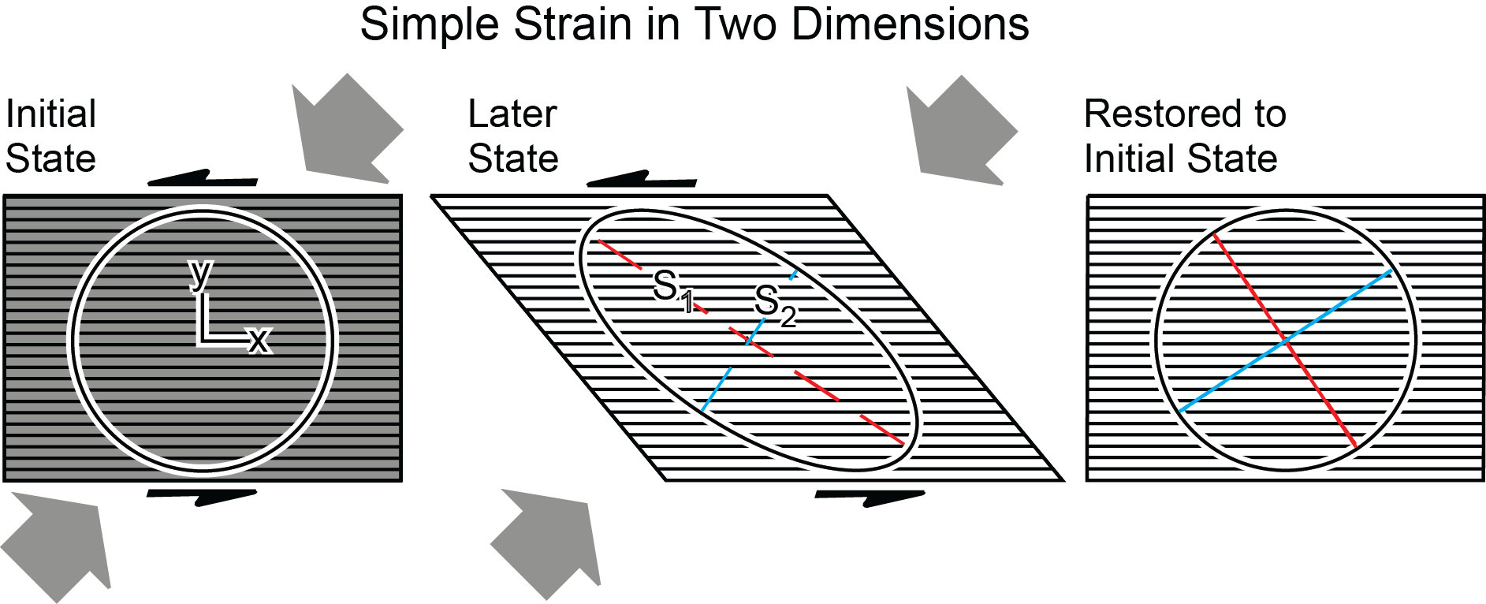
The physical model illustrates that the principle strain axes are perpendicular when drawn originally and when the stack is restored to its original shape. However, they are not perpendicular during the slipping-sliding of the cards. Figure 17 illustrates an idealized version of the cards, while Figure 18 formalizes the change in angle of the principle strain axes to the x-axis (or the reference coordinate system). That change in angle is a real rotation, Ω. It is the rotation contained in the rotational strain tensor—an output of the GPS strain calculator.

Figure 17. An idealized example of simple strain.

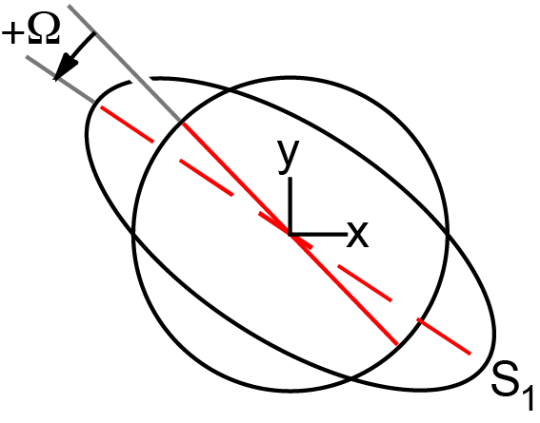

Figure 18. The angle between dashed and solid lines in Figure 17 is the rotation of the principle strain axes.

Summary and GPS
Strain involves the distortion of a shape which can be defined by as few as three points, as in Figures 10 and 11, where circles lie within triangles. You have seen how a circle becomes an ellipse when it is strained. Remember though that the triangle and circle can also move en masse—as a rigid block—in deformation as opposed to strain. We can measure both strain and deformation of modern crust. We are measuring them.
In this age of highly precise GPS units such as those maintained by UNAVCO, the triangles are made by three GPS stations. The triangles can be tens of kilometers on a side, with GPS units measuring mere millimeters of change of position in a year. When the position of an individual GPS station changes compared to a network of stations in North America, a vector indicates the distance and direction it has changed. Your students can manipulate this data (these vectors) from a trio of GPS stations on a map to determine how much translation and/or rotation of that rigid triangular piece of crust occurs in a year. And, although, there is no circle drawn on Earth’s crust within their triangles, they can determine strain graphically or with a spreadsheet-based strain calculator. When students plug their GPS data into the calculator, it uses matrix algebra to distort a hypothetical circle into a strain ellipse. Within the suite of its results, the calculator finds the principle strain axes, S₁ and S₂, their rotation, Ω, and other parameters as well. From these, students can make sense of strain and deformation within the region’s geological and tectonic context.

Sources:
Figure 1. Selim, Pierre. 2011. http://commons.wikimedia.org/wiki/File%3AMHNT_-_B%C3%A9lemnite_sp.jpg, via Wikimedia Commons. Retrieved 16 November 2012.
Figure 2. User:WeFt. 2007. http://commons.wikimedia.org/wiki/File%3ARostre_de_b%C3%A9lemnite_fractur%C3%A9_par_d%C3%A9formation_04.jpg via Wikimedia Commons. Retrieved 16 November 2012.
Figures 3 - 5. Cronin, Vince. 2012. Personal communication.
Figure 6. Gilbert, G.K. 1906. ID. Youd, T.L. U.S. Geological Survey Photographic Library http://libraryphoto.cr.usgs.gov/cgi-bin/show_picture.cgi?ID=ID.%20Youd,%20T.L.%20%20%2030. Retrieved16 November 2012.
Figure 7. Wilson, M.A. 2008. http://upload.wikimedia.org/wikipedia/commons/7/76/CarmelOoids.jpg via Wikimedia Commons. Retrieved 26 November 2012.
Figure 8. Cloos, E., 1947, “Oolite deformation in South Mountain fold, Maryland.” Geological Society of America Bulletin, v. 58, pp. 843-918. Plate 4, Figure 3.
Figures 9 - 18. Cronin, Vince. 2012. Personal communication.

