Strain
Nancy West, Beth Pratt-Sitaula, and Shelley Olds (UNAVCO) expanded from work by Vince Cronin (Baylor University)
Earth’s crust is deforming. While people who live through earthquakes know this from shaking, rolling ground that rumbles like thunder, the deformation can also be so subtle that you would never notice it. Unlike scientists measuring Earth in 1905 (Fig. 1), scientists can now use precise instruments to measure the changes. Global Positioning System (GPS) stations firmly affixed to the ground are one type of instrument used for this purpose (Fig. 2). These instruments are so sensitive they detect changes in their position as small as millimeters per year. Well over a 1000 permanent GPS stations have been installed throughout North America, but concentrated in the western United States. Much of their data is available on-line, at UNAVCO, for anyone to use, for free. (Search for "GPS velocity.")
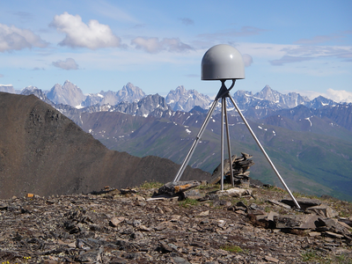
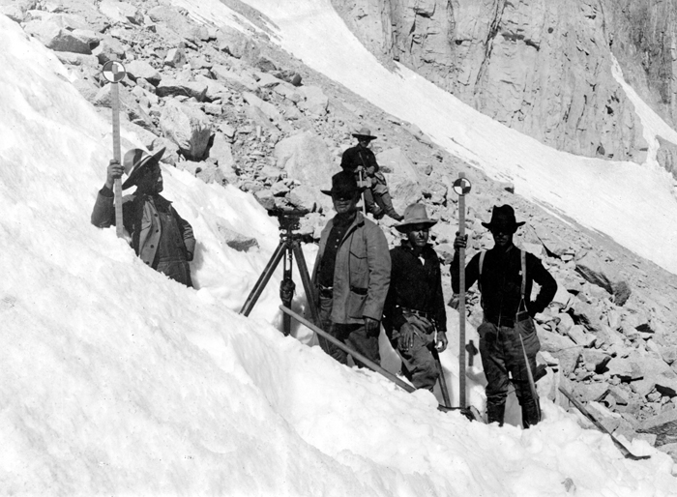
Figure 1. A surveying team in California. Department of Agriculture, 1905.

Figure 2. A modern GPS unit that is precise enough for research on crustal deformation.

This write-up is to help you understand deformation of the crust. In the realm of geology, strain refers to the distortion of Earth’s crust. You can see strain in rocks that were stressed long ago or measure it with GPSs as it happens today, this very day. Segments of the crust change their shape—they are strained—but they also move as a block (“translation”) and spin as a block (“rotation”). Strain, translation, and rotation are collectively called “deformation.”
Why would you care about strain? It builds up slowly over time, and if strain surpasses rock’s strength, they fail. Rocks snap, fracture, break, crack, buckle and release pent up energy in earthquakes. The energy released threatens the safety of people in swaths of North America, and not just in California. (Search for “historical damaging earthquakes” to learn where damaging quakes have occurred.) And, in the event of a damaging earthquake, even people who live far away can feel the economic and social impacts.
Although this unit on strain focuses on data from GPS units, this article begins with strain we can see in rocks you could hold in your hand. Strain occurred for long enough that the rocks changed shape—what is called “finite strain.” This way you can have examples in mind as you learn about strain occurring over geologically short periods like days or years that is measured by a GPS—“infinitesimal strain.” You will also work with physical models of strain to learn how geologists and geodesists (scientists who measure Earth) describe strain and deformation mathematically.

1. One-dimensional strain

Extension or elongation
When a geologist has the good fortune of seeing a linear feature in nature that is broken into segments, she knows that it ha been strained. And, she can measure how much it has been pulled apart. Examples are belemnites, fossil organisms related to squids. (Fig. 3.)
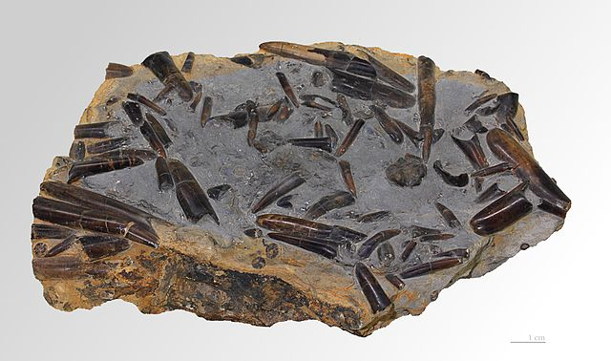
Figure 3. Belemnites scattered throughout a slab of sedimentary rock. These have not been strained. Selim, 2011.

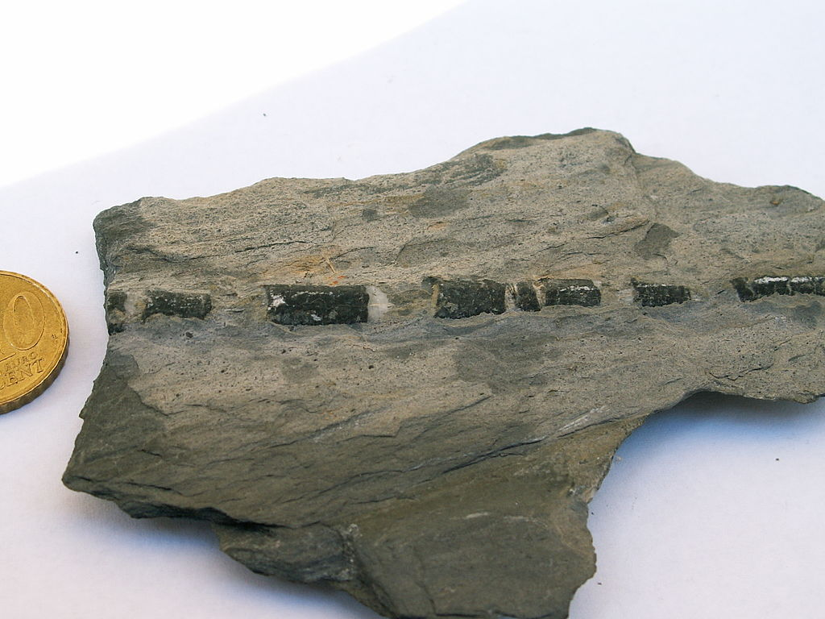
A belemnite that has been pulled into segments with some other material between them has been strained. (Fig. 4.) With your imagination you can extract the intervening material and reconstruct the original shape and length of the belemnite. This fossil has obviously been pulled apart: it has been deformed, strained, extended, and stretched. Let’s define the last two terms.

Figure 4. Photo of a belemnite from the Alps. Jurassic. Coin is 2 cm in diameter. WeFt, 2007.

You might have explored extension with physical models such as a bungee cord attached to a plank or a compressional spring. If you did those activities, you have already calculated extension. You have also seen how extension relates to GPS displacement vectors.
Let’s look at extension with this geological example of belemnites. You might recall that extension is defined as the ratio between the change in length of a feature and its original length. In the case of the belemnite in Figure 3, you could add up all of the gaps between fossils to determine the increase in length. And you could add up the lengths of all of the fossil pieces to know its original length. Divide the gaps by the pieces and you have the extension, e.
Let’s look at the measurement and calculation generally—for the bungee cord, belemnite, or crust as measured with GPS units. A linear feature has an initial length, l_{o,} and changes to a final length, l_{f}. (Fig.5.)

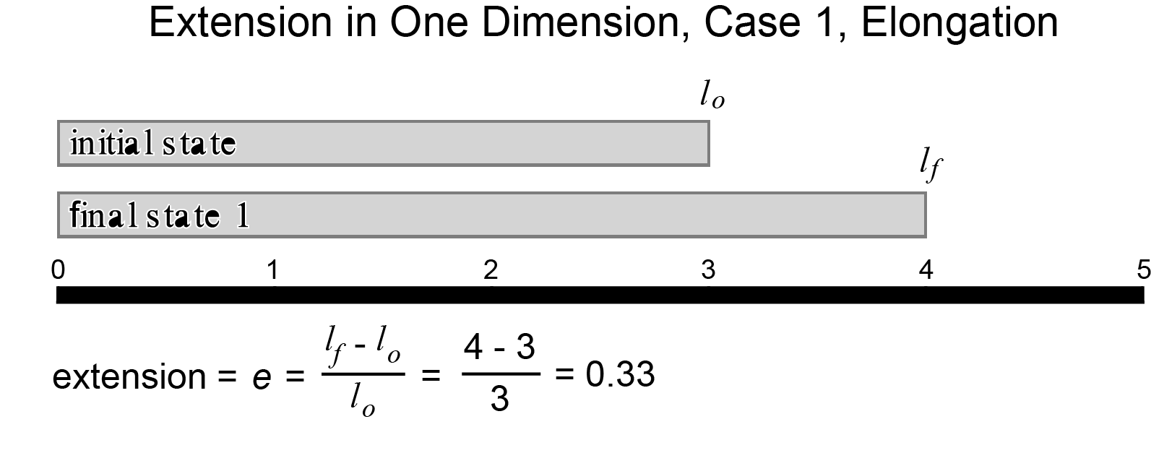

Figure 5. An idealized linear feature that has been extended—or elongated.
l_{o} is the original length.
l_{f} is the length after straining.
l_{f} - l_{o} is the difference between them--or the change in length.

In this more general example, l_{o} is 3. The feature is elongated so that l_{f} is equal to 4. The extension, e, is$\frac{l_{f }- l_{o}}{l_{o}}$ or 0.33. Try to calculate the extension of the belemnites in Figure 4. Do you need the scale?
What if the linear feature is shortened instead of lengthened, as with compressional springs? We use the same equation (Fig. 6). The only change is that the value representing extension is negative.
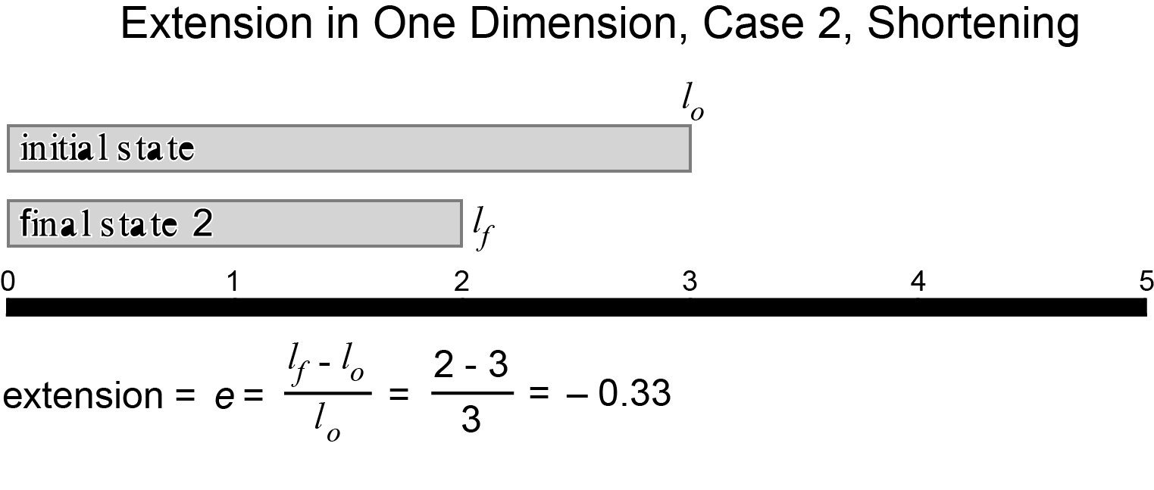

Figure 6. An idealized linear feature that has been shortened.
Now that you have measured extension and stretch and learned about them, let’s return to the belemnites briefly. Notice how the belemnites in Figure 3 lie every which way. If the rock slab had been extended or stretched in any single direction, some of the belemnites would look like the belemnite in Figure 4. Others would have been distorted in other ways because the atoms, ions, and molecules would have been pulled apart in the direction of the extension. But we don’t see that, so we can infer that this slab has not been extended, elongated, stretched, or strained. (If it’s been translated or rotated, it would be deformed—but not strained.)

An historical geological example
Belemnites are ancient; the examples shown in Figures 3 and 4 are from the lower Jurassic, 199.6 to 175.6 million years ago. You can see a more recent, but historical, example from the 1906 San Francisco earthquake (Fig. 7). Look carefully at the rails in the foreground: they were pulled apart as the sediments underlying them spread during the magnitude 7.8 quake. (Note that this extension was a secondary effect of the strike-slip motion (or “shearing)” along the San Andreas fault.) Perhaps with clever detective work on the dimensions of paving stones and rails used in 1906, you can estimate the extension and stretching that occurred in this area of San Francisco earthquake.

Figure 7. Rails separated when sediment settled during the 1906 San Francisco earthquake. Gilbert, 1906.

You’ve seen strain in linear objects like belemnites and train rails; these are one-dimensional examples. Let’s now broaden the idea of strain and work in two-dimensions.

2. Two-dimensional strain--description

Geological examples of strain in two-dimensions
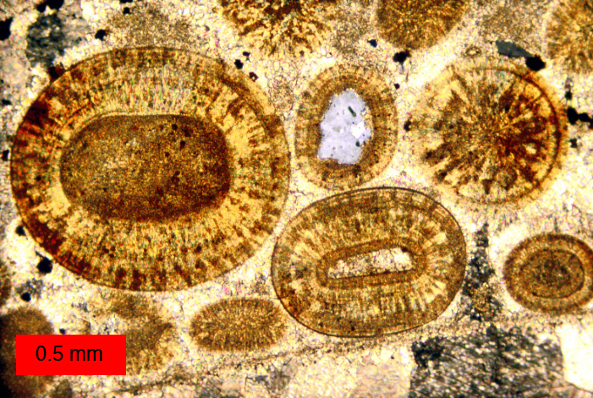
When a tiny shell fragment rolls around below tropical seas, layers of calcium carbonate (CaCO₃) can build up on them. Round grains that look like cream of wheat develop. They are called “ooids,” and the sedimentary rock that forms are “oolites.” (Fig.8.) When oolites are strained, the round grains deform into ovoids in three dimensions and ovals or ellipses in two, as in Figure 9.
Figure 8. Photograph through a microscope of Jurassic ooids in the Carmel Formation, Utah. Wilson, 2012.

Figure 9. Photomicrograph of Cambro-Ordovician deformed ooids from South Mountain, Maryland. Cloos, 1947.

A physical model in two-dimensions
To help you understand two-dimensional strain, you might have played with a physical model made from a high-tech stretchy T-shirt. Three students in Figure 10 are experimenting with strain in two dimensions with this setup.

Figure 10. Students tugging on stretchy tee-shirt to see how a circle deforms. Cronin, 2012.

Figure 11 idealizes their pulling—and your pulling-- with a cartoon that uses vectors to show three corners pulled exactly evenly. In this case, balanced pulling stretches the circle uniformly, and the circle dilates.
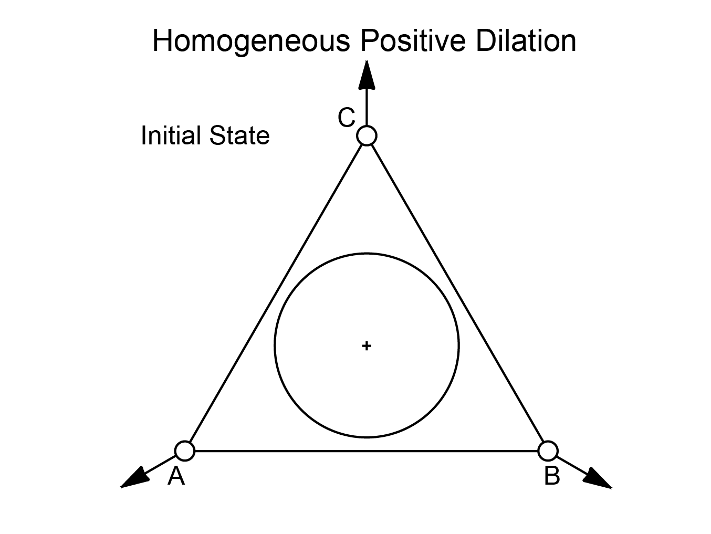
Figure 11. A more technical description and idealized rendition of the tee-shirt strained by three people pulling against each other.

In a different idealized scenario, if one student pulls hard while the other two keep their hands stationary the cartoon would look like Figure 12. What happens to the circle?

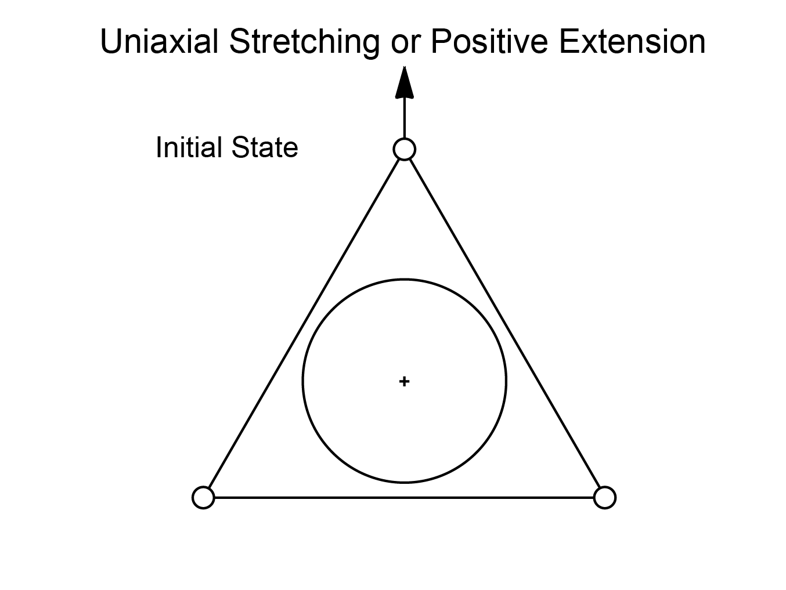
Figure 12. An idealized rendition of the tee-shirt pulled by one person, with the other two standing steady.

3. Two-dimensional strain—mathematical descriptions and how it happens

Strain ellipses
Geologists describe the ellipses that develop when tee-shirts, ooids, cartoon circles, Silly Putty® and stacks of cards distort by drawing two “strain axes.” They draw one axis the length of the ellipse and another across the ellipse. If you did the activities with Silly Putty® and the stack of cards, you saw circles deform to ellipses and (with the cards) the two axes change orientation.
Figure 13 shows the distortion of a circle into an ellipse. Stretch and strain can both be designated by an “S.” S₁ is along the longer dimension of the ellipse; it is called the “greater principal strain.” And, because it is only half the length of the major axis of the strain ellipse, it is called the “semi-major axis of the strain ellipse.” S₂ is along the shorter dimension and shows the lesser principal strain. It is the semi-minor axis of the strain ellipse.
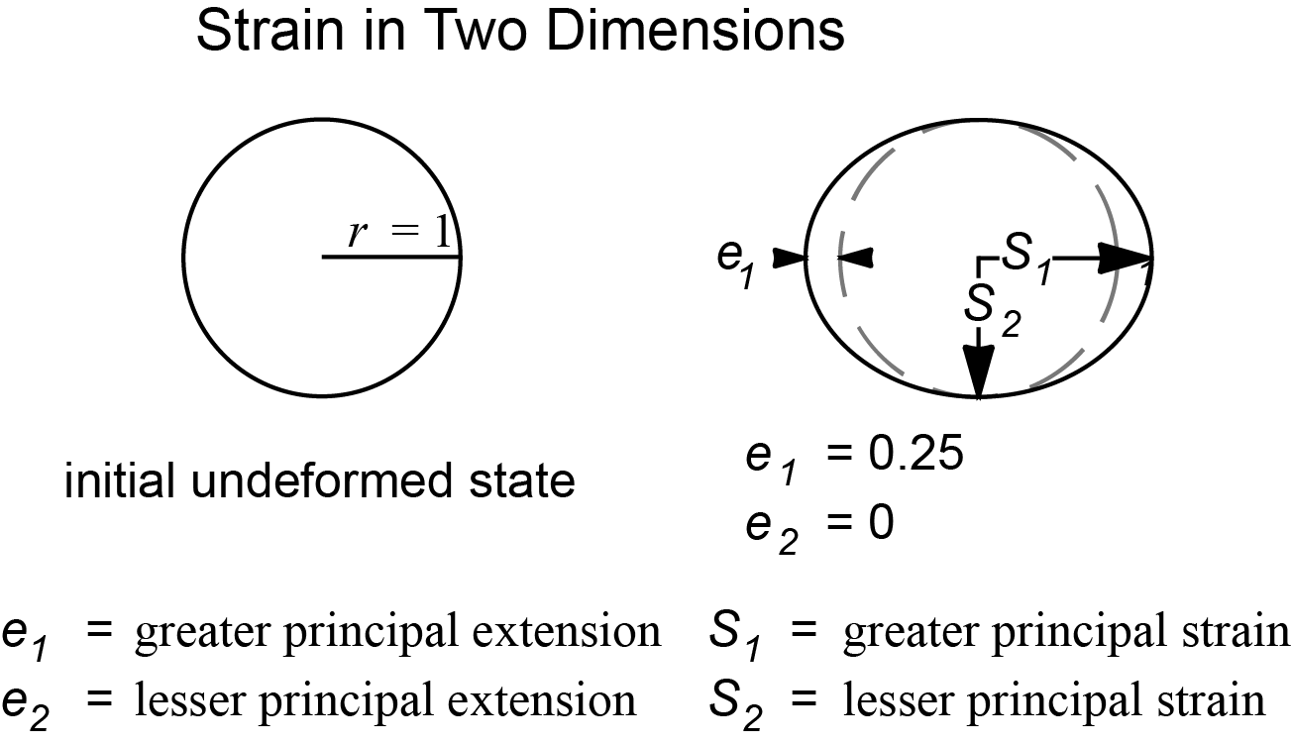
Figure 13. Depiction of strain axes in a case of uniaxial stretching. The values for S₁ and S₂ are the stretch shown in this strain ellipse. They are along the principal strain axes.

Pure and simple strain
How do geologists talk about the way strain occurs? They define two kinds: pure and simple strain. The two kinds are distinguished by how forces change an object’s shape and by what happens to the principal strain axes.

Pure strain in two-ish dimensions
With pure strain, the result is like the putty in Figure 14.
Figure 14. Silly Putty® that has sagged under the influence of gravity, as an example of pure strain. Cronin, 2012.

Pure strain occurs perpendicular to S1. The strain axes stay perpendicular to each other during strain, and the axes do not rotate. In short, the circle gets smooshed into an ellipse. (Fig. 15.)
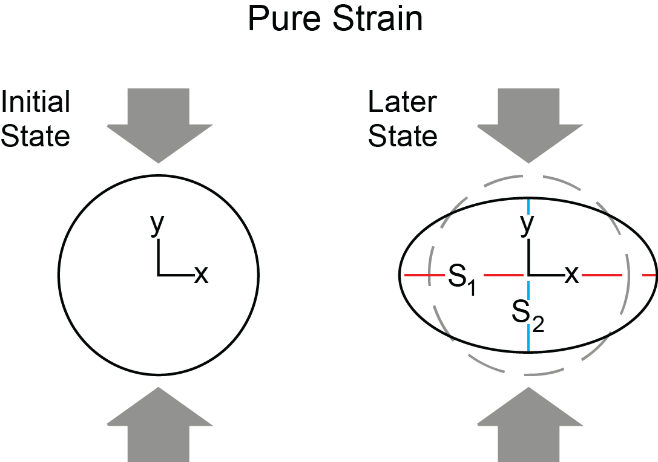

Figure 15. A strain ellipse resulting from pure strain.

Simple strain in two-ish dimensions
If you pushed over a stack of cards, you subjected them to simple strain, and the circle you drew on the side became an ellipse. The strain axes on the ellipse were perpendicular when you drew them on the tipped over stack (Fig. 16). They were also perpendicular when you restored the stack to its original shape (Fig. 17). However, as the cards slipped and slid past each other they were not perpendicular.

Figure 16. A strain ellipse and axes resulting from simple strain on a deck of cards. Cronin, 2012.

Figure 17. Strain axes after cards were restored to their original shape. Cronin, 2012.

Figure 18 illustrates an idealized version of the cards, while Figure 19 focuses on the angle made between the major axis of the strain ellipse and a reference such as the tabletop. In the activity you measured that angle twice. The difference between the two is a real rotation, Ω.
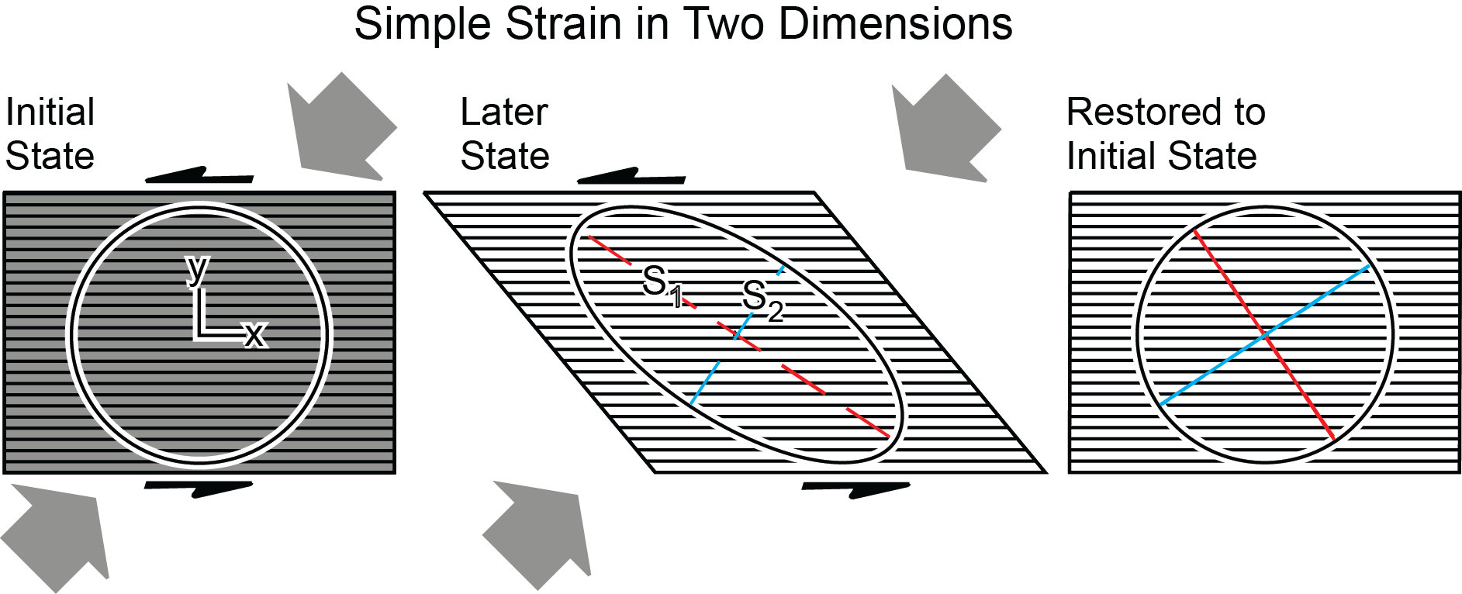

Figure 18. An idealized example of simple strain.

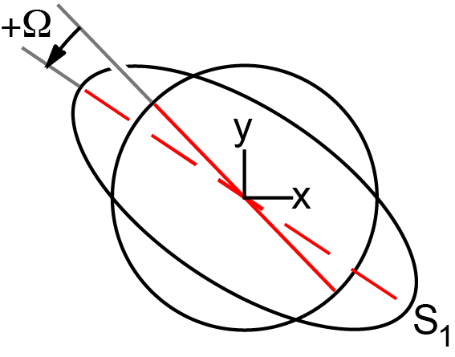

Figure 19. The angle between dashed and solid lines in Figure 16 is the rotation of the principle strain axes, Ω.

Summary and relating to GPS
Strain involves the distortion of a shape, and a shape can be defined by as few as three points, as in Figures 11 and 12, where circles lie within triangles. You have seen how a circle becomes an ellipse when it is strained. Remember though that the triangle and circle can also move en masse—as a rigid block. They can translate and rotate as a block as well as be strained. We can measure this deformation, whether it is strain, translation, rotation, or any combination of them.
We are measuring deformation with highly precise GPS units such as those maintained by UNAVCO (Fig. 2). Any three GPS stations form a triangle, and you can imagine a circle within them. The triangles can be tens of kilometers on a side, with the GPS units measuring mere millimeters of change of position in a year.
When an individual GPS station moves compared to the rest of North America, a vector indicates the distance and direction it has changed. You can use vectors from a triangle of GPS stations to learn how much translation and/or rotation occurs in a year. And, although there isn’t a circle drawn on Earth’s crust within the triangle, you can also figure out the strain within the triangle. You can figure it out graphically or algebraically. When you plug GPS data into a spreadsheet to calculate strain, it distorts a hypothetical circle into a strain ellipse. The spreadsheet finds the strain axes, S₁ and S₂, their rotation, Ω, and other parameters as well. These results allow you to make sense of strain and deformation within the region’s geology and tectonic setting.

Sources:
Figure 1. Department of Agriculture, Experiment Stations, Berkeley. 1905. US Geological Society Photographic Library. ”ID. Topography A 240.” http://libraryphoto.cr.usgs.gov/cgi-bin/show_picture.cgi?ID=ID.%20Topography%20A%202402 Retrieved 2 January 2012.
Figure 2. UNAVCO
Figure 3. Selim, Pierre. 2011. http://commons.wikimedia.org/wiki/File%3AMHNT_-_B%C3%A9lemnite_sp.jpg, via Wikimedia Commons. Retrieved 16 November 2012.
Figure 4. User:WeFt. 2007. http://commons.wikimedia.org/wiki/File%3ARostre_de_b%C3%A9lemnite_fractur%C3%A9_par_d%C3%A9formation_04.jpg via Wikimedia Commons. Retrieved 16 November 2012.
Figures 5 and 6. Cronin, Vince. 2012. Personal communication.
Figure 7. Gilbert, G.K. 1906. ID. Youd, T.L. U.S. Geological Survey Photographic Library http://libraryphoto.cr.usgs.gov/cgi-bin/show_picture.cgi?ID=ID.%20Youd,%20T.L.%20%20%2030. Retrieved16 November 2012.
Figure 8. Wilson, M.A., Department of Geology, The College of Wooster. 2008. http://upload.wikimedia.org/wikipedia/commons/7/76/CarmelOoids.jpg via Wikimedia Commons. Retrieved 26 November 2012.
Figure 9. Cloos, E., 1947, “Oolite deformation in South Mountain fold, Maryland.” Geological Society of America Bulletin, v. 58, pp. 843-918. Plate 4, Figure 3.
Figures 10 - 19. Cronin, Vince. 2012. Personal communication.

