Detecting Cascadia’s changing shape with GPS Data - streamlined
Student worksheet
Shelley Olds, UNAVCO Education and Outreach, Anne Sheehan, University of Colorado

In this activity you will work with GPS data to explore plate motion and deformation in the Pacific Northwest. By analyzing multiple GPS Time Series Plots you can determine the direction and rate of regional deformation.
Part I: Analyzing real time series data to calculate GPS velocity vectors
What’s happening in Cascadia? Earth trembling, Volcanoes rumbling, ground slipping.
Work in teams of 4. Each team member will work on her/his own worksheet with data from two GPS stations. One GPS station is completed for you.
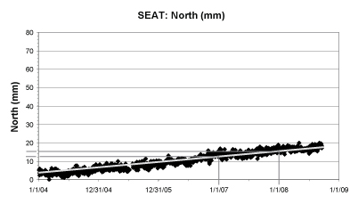 | On your graph paper, each block represents 1mm. Draw an arrow 3.1 blocks (mm) along the North axis  North  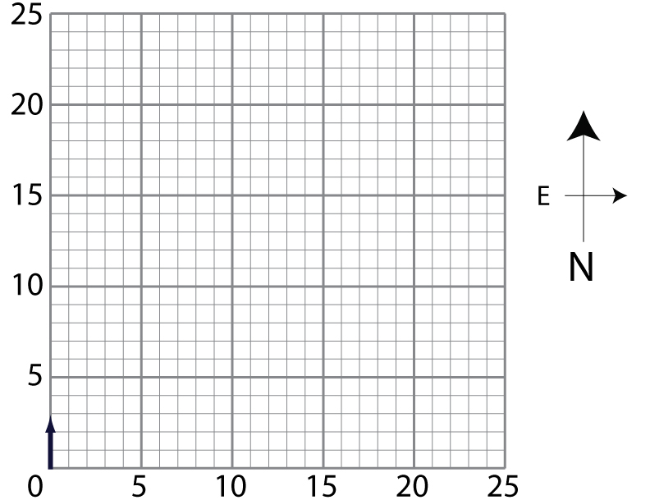  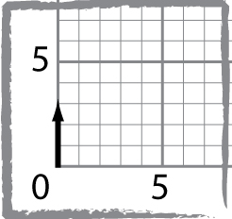  East
a) Average position on 1/1/2007 = __12.5___ mm  b) Average position on 1/1/2008 = __15.6___ mm  Yearly change in position (b-a)= 15.6-12.5= 3.1 mm/yr to the North / South (circle the direction) | 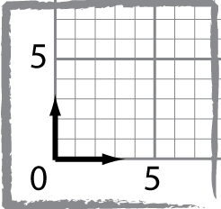  After calculating the yearly change in position for the East time series plot, draw an vector arrow 3.4 blacks (mm) along the East axis:
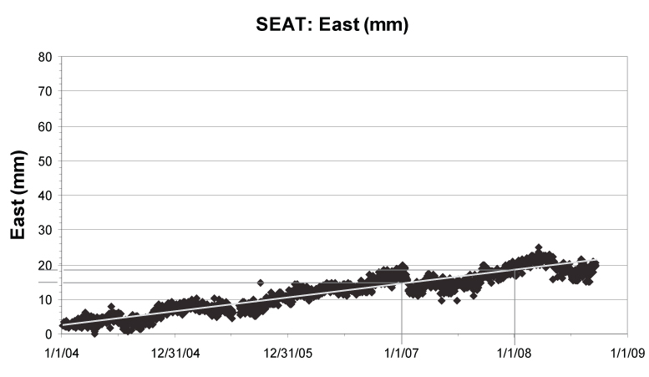 | 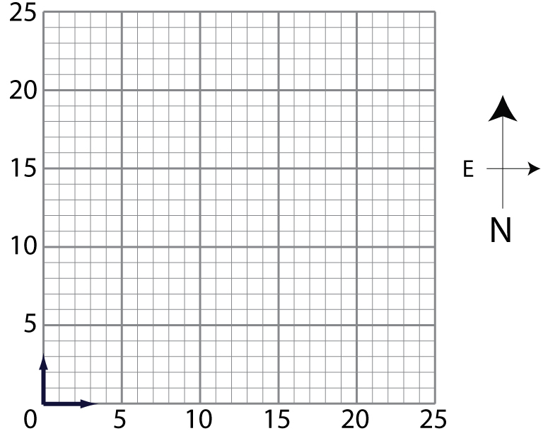  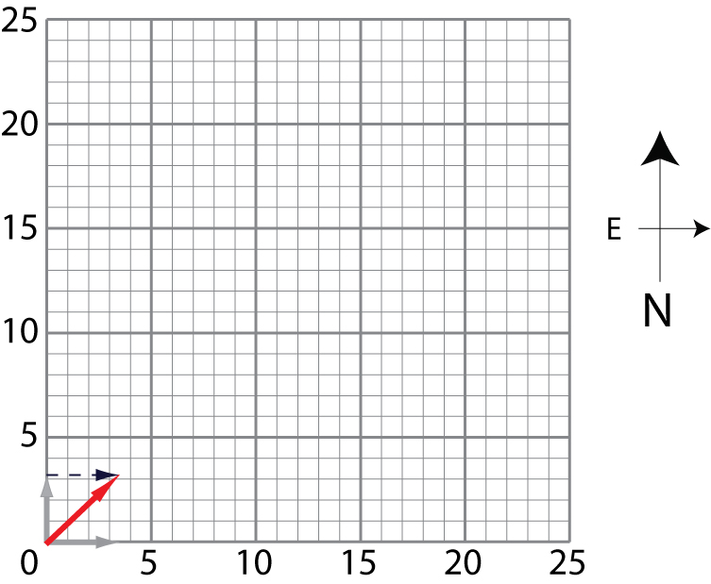  :
a) Average position on 1/1/2007 = __14.8___ mm  b) Average position on 1/1/2008 = __18.2___ mm  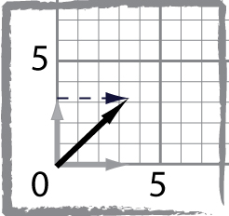  Yearly change in position (b-a) = 18.2 – 14.8 = 3.4 mm/yr to the West / East (circle the direction) | Add up your  vectors (tail to  head method)

Part I: Calculate vectors.
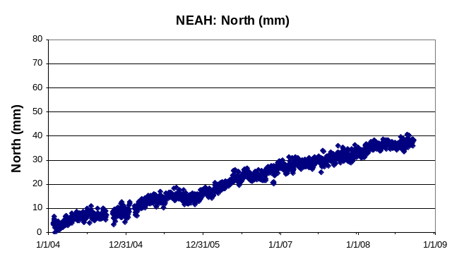 | 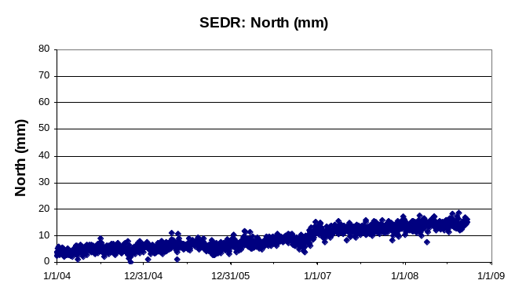
a) Average position on 1/1/2007 = _____ mm  b) Average position on 1/1/2008 = _____ mm  Yearly change in position (b-a) = ____ mm/yr to the North / South (circle the direction) | a) Average position on 1/1/2007 = _____ mm  b) Average position on 1/1/2008 = _____ mm  Yearly change in position (b-a) = ____ mm/yr to the North / South (circle the direction)
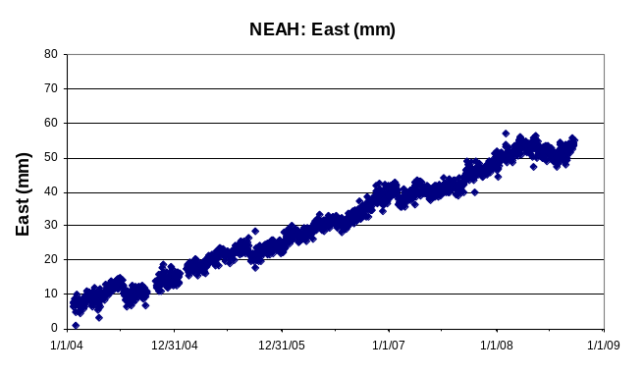 | 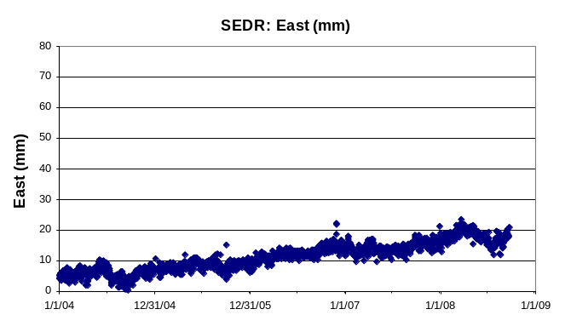
a) Average position on 1/1/2007 = _____ mm  b) Average position on 1/1/2008 = _____ mm  Yearly change in position (b-a) = ____ mm/yr to the West / East (circle the direction) | a) Average position on 1/1/2007 = _____ mm  b) Average position on 1/1/2008 = _____ mm  Yearly change in position (b-a) = ____ mm/yr to the West / East (circle the direction)
NEAH  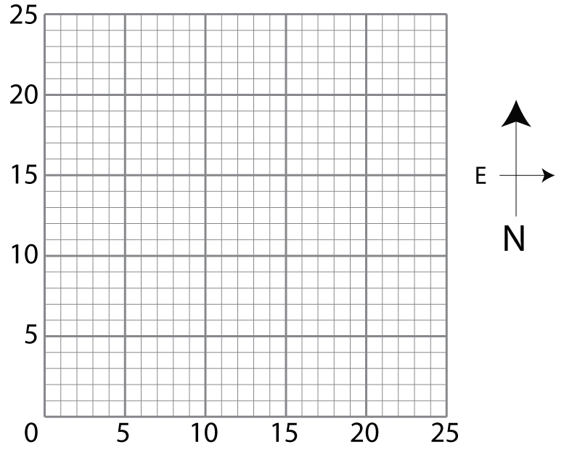 | SEDR
Part I: Calculate vectors.
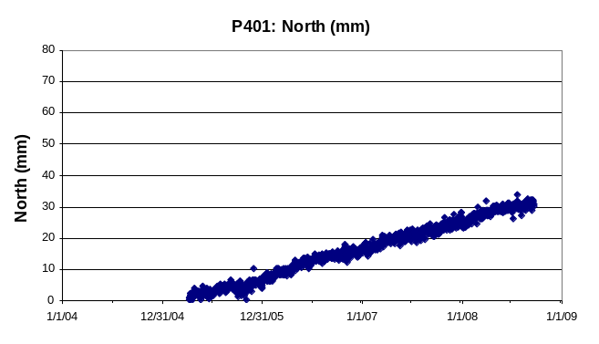 | 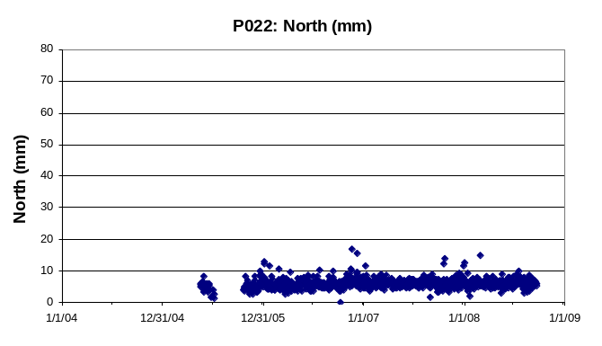
a) Average position on 1/1/2007 = _____ mm  b) Average position on 1/1/2008 = _____ mm  Yearly change in position (b-a) = ____ mm/yr to the North / South (circle the direction) | a) Average position on 1/1/2007 = _____ mm  b) Average position on 1/1/2008 = _____ mm  Yearly change in position (b-a) = ____ mm/yr to the North / South (circle the direction)
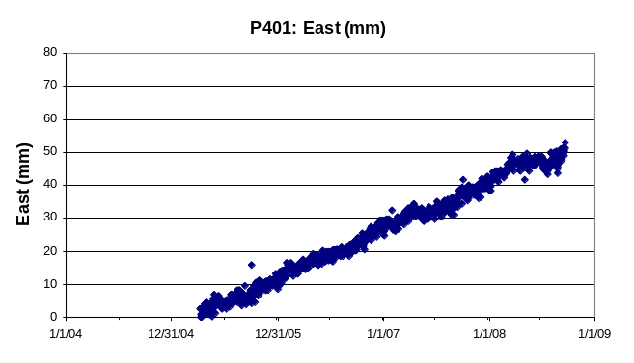 | 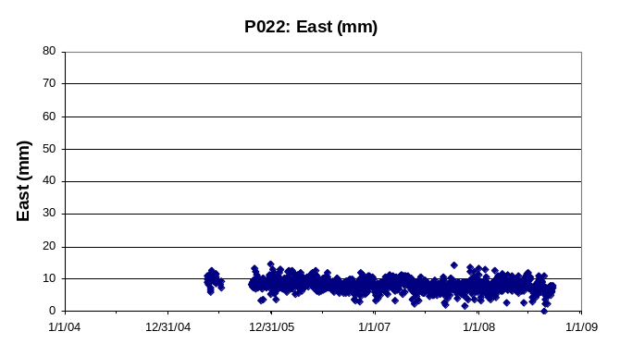
a) Average position on 1/1/2007 = _____ mm  b) Average position on 1/1/2008 = _____ mm  Yearly change in position (b-a) = ____ mm/yr to the West / East (circle the direction) | a) Average position on 1/1/2007 = _____ mm  b) Average position on 1/1/2008 = _____ mm  Yearly change in position (b-a) = ____ mm/yr to the West / East (circle the direction)
P401 | P022
Part I: Calculate vectors.
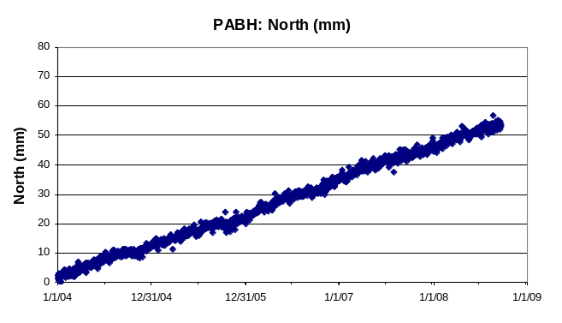 | 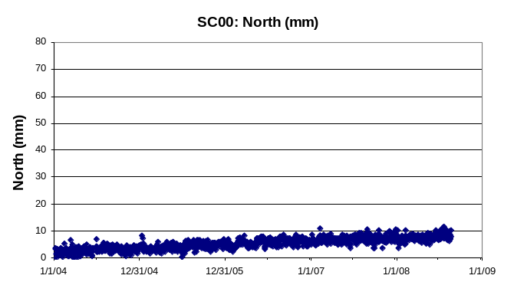
a) Average position on 1/1/2007 = _____ mm  b) Average position on 1/1/2008 = _____ mm  Yearly change in position (b-a) = ____ mm/yr to the North / South (circle the direction) | a) Average position on 1/1/2007 = _____ mm  b) Average position on 1/1/2008 = _____ mm  Yearly change in position (b-a) = ____ mm/yr to the North / South (circle the direction)
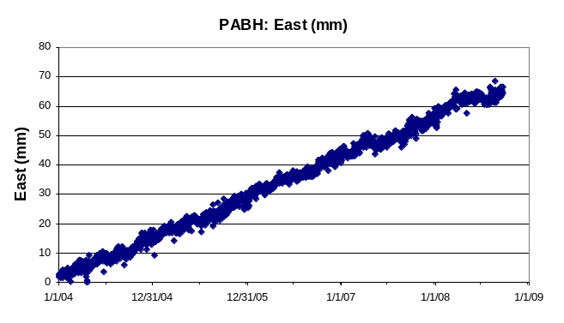 | 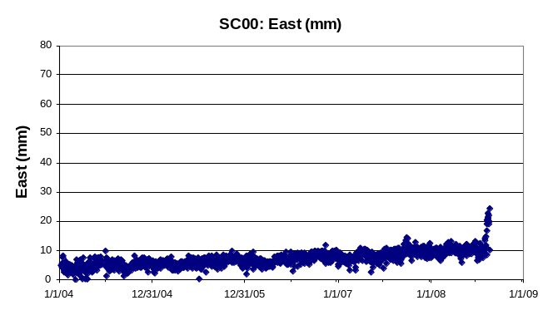
a) Average position on 1/1/2007 = _____ mm  b) Average position on 1/1/2008 = _____ mm  Yearly change in position (b-a) = ____ mm/yr to the West / East (circle the direction) | a) Average position on 1/1/2007 = _____ mm  b) Average position on 1/1/2008 = _____ mm  Yearly change in position (b-a) = ____ mm/yr to the West / East (circle the direction)
PABH | SC00
Part I: Calculate vectors.
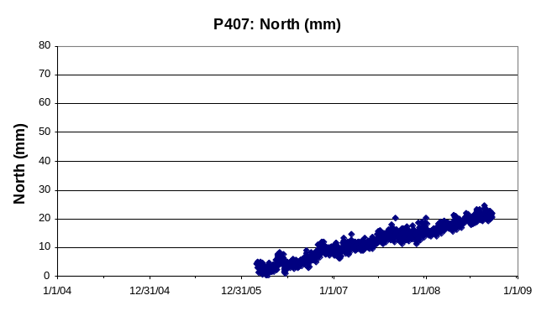 | 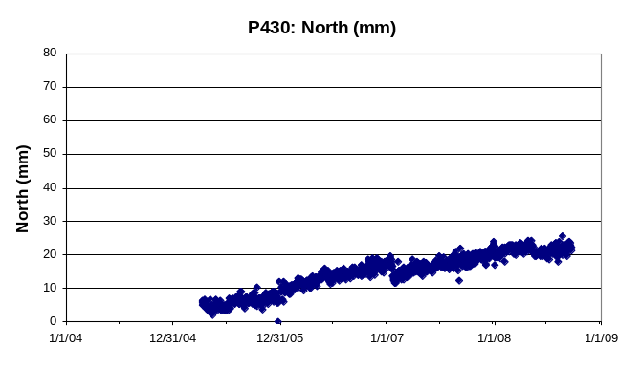
a) Average position on 1/1/2007 = _____ mm  b) Average position on 1/1/2008 = _____ mm  Yearly change in position (b-a) = ____ mm/yr to the North / South (circle the direction) | a) Average position on 1/1/2007 = _____ mm  b) Average position on 1/1/2008 = _____ mm  Yearly change in position (b-a) = ____ mm/yr to the North / South (circle the direction)
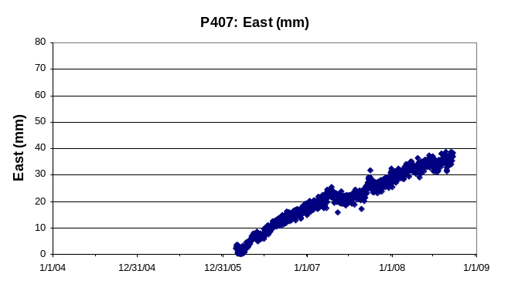 | 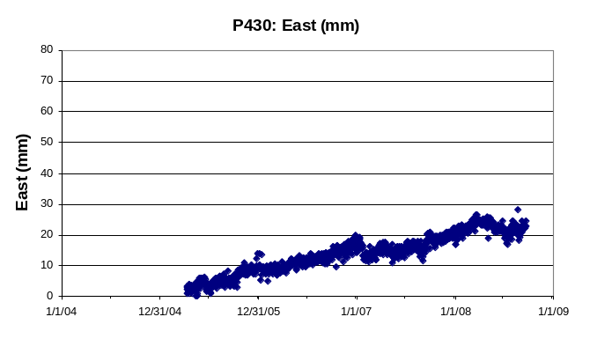
a) Average position on 1/1/2007 = _____ mm  b) Average position on 1/1/2008 = _____ mm  Yearly change in position (b-a) = ____ mm/yr to the West / East (circle the direction) | a) Average position on 1/1/2007 = _____ mm  b) Average position on 1/1/2008 = _____ mm  Yearly change in position (b-a) = ____ mm/yr to the West / East (circle the direction)
P407 | P430

Part II: Drawing your vectors on the map of Cascadia
Place the tail of the vector on the ‘point’ of the corresponding bubble and trace the arrow from your worksheet.

Drawing the GPS vectors on the map:

- Trace outline of the map box below & the coastlines of the amp below onto a transparency.
- Place a dot and label for each GPS station on the transparency (use the point of the bubble label as the GPS location).
- Place the transparency over the graph paper with the resultant vectors for the GPS stations you solved and trace the vectors onto the transparency. Place the tail of the vector on the dot and trace the vector from your worksheet.
- Do the same for your teammates’ vectors.

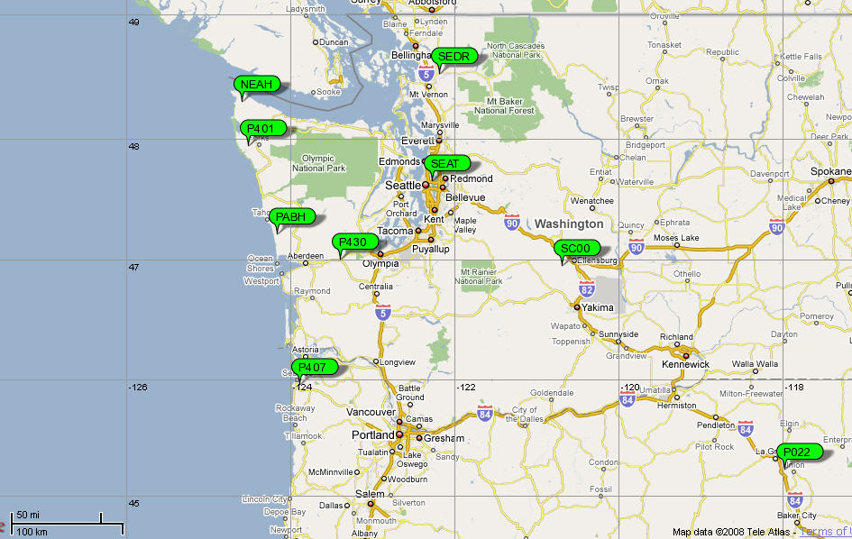

Part III: Questions

What do you notice about the velocities of the GPS stations and their geographic locations?

How do the velocities at each station change from west to east?

Which stations are moving the quickest?

In 500 years, how far will the stations along the coast have moved?

What possible outcomes can you imagine if different portions of the plate continue moving at different rates over hundreds of years?

Check your work!
- Go to Velocity Viewer: Start on the UNAVCO home page: http://www.unavco.org, click on Data for Educators at the bottom of the page, then under the map with the stations, click on the UNAVCO Velocity Viewer (Google search: UNAVCO velocity viewer )
- The first view is of southern California. Drag the map down to center on Washington and Oregon (At the top of the map Click on the map, hold the mouse, and drag down.)
- Zoom into the map once by double clicking on the map.
- Set up your map:
  - Change Velocity vector color to red
  - Change Velocity vector size scaling to size 5
  - Click Station labels with data boxes to on
  - And change How many symbols to show to Show all available
  - Click on Draw map. See the screen shot below:
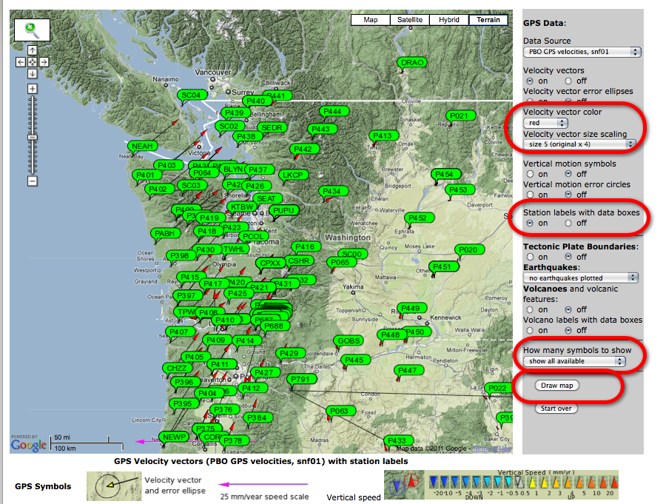
5) Find the GPS stations you worked on. Click on the green bubble for your GPS station – if the information opens and shuts very quickly, drag the map down some and try again (this is a known issue). The information window provides the speed components of East, North, and Up.

